Supplementary Materials for
Implementation Lessons Learned from the Benefits of Enhanced Terminal Room (BETR) Disinfection Trial - Process and Perceptions of Enhanced Disinfection with UV Devices

Supplementary Table 1. Checklist for Improved Utilization of Enhanced Terminal Room Disinfection Strategies
Checklist Item
- Obtain administrative support for use of enhanced terminal room disinfection
- Identify EVS and Infection Control champions
- Educate Bed Control – prioritize safety of patients
- Develop strategy for improved communication between EVS and Bed Control, potentially including
  - Daily discussion of potential discharges
  - Regular review of missed opportunities and/or prolonged cleaning times
- Educate EVS housekeepers and supervisors. Re-educate at regular intervals due to staff turnover.
- Review logistics of cleaning protocols, including
  - How EVS will identify target rooms
  - Who will be responsible for transport of machines
  - Who will be responsible for use of machines
  - Who will be responsible for routine maintenance of the machines
- Develop contingency planning for enhanced terminal disinfection during high volume shifts and hours
- Develop a standardized response to potential complaints about chemicals or machine (e.g., odor)
- Develop a system to monitor and feedback cleaning compliance, potentially including
  - Formalized data reports
  - Regular “collaborative calls” between EVS and Infection Control to trouble shoot problem areas and devise solutions
- Develop a system to monitor and feedback compliance with use of UV-C device, including review and discussion of eligible rooms that were missed
*EVS = environmental services

Supplementary Figure 1. Compliance* with use of the UV-C device in 9 study hospitals in the Benefits of Enhanced Terminal Room (BETR) Disinfection Study
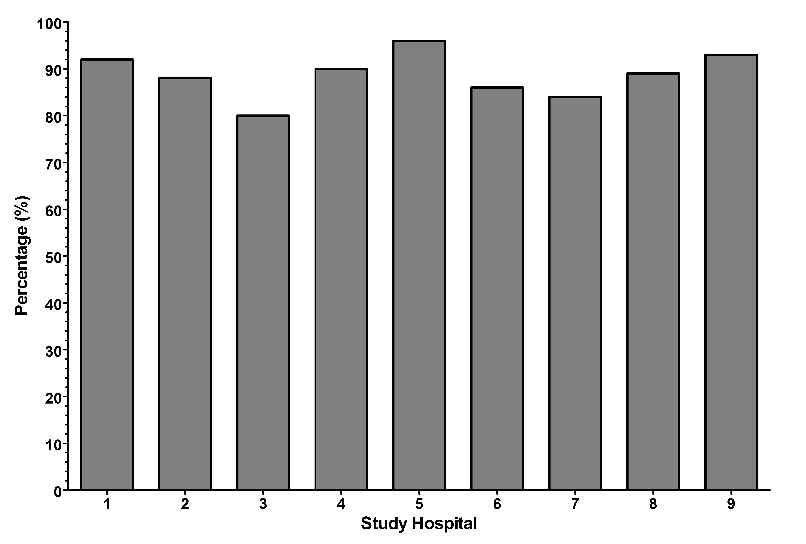
FOOTNOTE: *Data are provided as proportion of successful uses of the UV-C device in eligible rooms during the 28-month study period

