

**Supplementary Material for**

**The Antimicrobial Scrub Contamination and Transmission (ASCOT) Trial: a 3-Arm Blinded Randomized Controlled Trial with Crossover Design to Determine the Efficacy of Antimicrobial-Impregnated Scrubs to Prevent Healthcare Provider Contamination**

Supplement to the Methods

*Microbiological methods* - Environmental cultures of the patient rooms and the HCP clothing were obtained using RODAC plates containing DE Neutralizing Agar(Becton Dickinson, Sparks, MD), as previously validated.[1-3] Plates were aerobically incubated at 37oC for 48 hours. Colony forming units (CFU) of organisms on each plate were first quantified to estimate the overall bioburden.Each RODAC plate culture was then evaluated specifically and quantitatively for target pathogens. Each location was cultured in triplicate, providing a culture surface area of 75 cm2 for each individual location. Bacterial species were identified using standard microbiological techniques. In brief, species were identified and differentiated with routine selective medias including MacConkey Agar, Mannitol Salt Agar, Bile Esculin Agar, HardyCHROM ESBL Agar and Columbia CAN (Becton Dickinson, Sparks, MD; Hardy Diagnostics, Santa Maria, CA). Organisms classified by MacConkey (lactose fermenters and non-lactose fermenters) and HardyCHROM ESBL Agar underwent species identification via MALDI-TOF. The presence of *S. aureus* was confirmed by catalase and Staphaurex tests (REMEL, Lenexa, KS) following standard procedures. Antibiotic resistance of organisms was tested using Oxacillin Agar (REMEL, Lenexa, KS) (*S. aureus*), Vancomycin Agar (REMEL, Lenexa, KS) (*Enterococcus spp.*) and HardyCHROM ESBL agar (*E. coli, Klebsiella spp.,* and *Enterobacter spp.*). Environmental, patient, and clothing specimens were specifically evaluated for the presence of the following target pathogens: *S. aureus* (methicillin susceptible (MSSA) and MRSA), enterococci (vancomycin susceptible and VRE), *Acinetobacter spp.*, *Pseudomonas aeruginosa*, *E. coli*, and *Klebsiella spp.*

*Pulsed field gel electrophoresis* - DNA was prepared for PFGE using *XbaI* and *SmaI*. DNA was digested for two hours at 37°C with *XbaI* for *P. aeruginosa*, and *K. pneumoniae*, for two hours at 25°C with *SmaI* for *Acinetobacter spp*, for three hours at 25°C with *SmaI* for *S. aureus*, and for four hours at 25°C with *SmaI* for enterococci. PFGE profiles were analyzed by BioNumerics program (Applied Maths, Kortrijk, Belgium). PFGE genotypes were defined as having ≥0.85 relatedness.[4] Dice coefficients (pairwise similarity) were calculated for each pair of isolates; a dendrogram was constructed by the unweighted pair-group method of analysis, with an optimization value of 0.50% and a position tolerance of 1.25%–1.35% (end of the fingerprint).

Supplement to the Results

*Nurse Perceptions of Scrub Types -*Nurses believed the study scrubs did not feel similar to their regular clothing (Supplementary Table 2); 27 (68%) nurses reported that control scrubs were similar to their regular clothing compared to 15 (38%) for Scrub 1 and 9 (23%) for Scrub 2 (p=0.0016). Nurses reported higher frequency of itchiness (p=0.021) and heaviness (p=0.001) with study scrubs compared to control scrubs.

|  |  |  |  |  |  |  |
| --- | --- | --- | --- | --- | --- | --- |
|  | | | | | | |
|  | Randomization Sequence | | | | | |
|  | 1 | 2 | 3 | 4 | 5 | 6 |
| Shift/Day 1 | C | C | 1 | 1 | 2 | 2 |
| Shift/Day 2 | 1 | 2 | C | 2 | C | 1 |
| Shift/Day 3 | 2 | 1 | 2 | C | 1 | C |

Supplemental Table 1. Nurses were randomized to one of six sequences

C=Control arm; 1=Scrub 1 arm #1; 2=Scrub 2 arm

Supplemental Table 2. Nurse perceptions of study scrubs during the ASCOT trial

|  | **Control N=40**  **n (%)** | **Scrub 1 N=40**  **n (%)** | **Scrub 2 N=40**  **n (%)** | **P-value** |
| --- | --- | --- | --- | --- |
| These scrubs felt like wearing my normal scrubs |  |  |  | 0·0016* |
| Strongly disagree | 1 (2·5) | 2 (5) | 4 (10) |  |
| Disagree | 10 (25) | 12 (30) | 20 (50) |  |
| Neutral | 2 (5) | 11 (27·5) | 7 (17·5) |  |
| Agree | 18 (45) | 14 (35) | 6 (15) |  |
| Strongly agree | 9 (22·5) | 1 (2·5) | 3 (7·5) |  |
| Experienced itchiness related to the scrubs | 2 (5) | 4 (10) | 12 (30) | 0·021 |
| Experienced rash or skin redness related to the scrubs | 0 | 2 (5) | 2 (5) | 0·54** |
| Experienced heaviness related to the scrubs | 3 (7·5) | 10 (25) | 18 (45) | <0·001 |

* for comparison of dichotomized response “agree/strongly agree” vs “neutral/disagree/strongly disagree”

** Fisher’s exact test

Scrub 1 - scrubs contained a complex element compound with embedded silver-alloy; Scrub 2 – scrubs impregnated with an organosilane-based quaternary ammonium and a hydrophobic fluoroacrylate copolymer emulsion.

Supplemental Figure 1. Culturing strategy used during the ASCOT Trial. Cultures were obtained from 15 locations.



Supplemental Figure 2. Median and interquartile range colony forming units (CFU) at the beginning of shift, end of shift, and from the environment during 120 ICU shifts in the ASCOT trial.

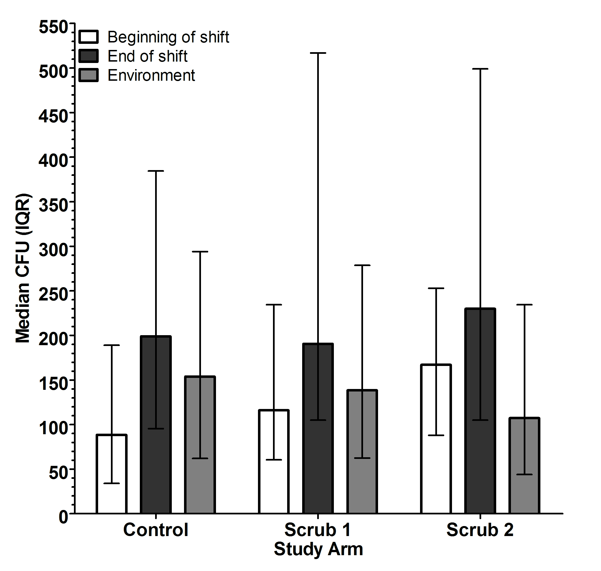

Scrub 1 - scrubs contained a complex element compound with embedded silver-alloy; Scrub 2 – scrubs impregnated with an organosilane-based quaternary ammonium and a hydrophobic fluoroacrylate copolymer emulsion.

1. Anderson DJ, Gergen MF, Smathers E, et al. Decontamination of targeted pathogens from patient rooms using an automated ultraviolet-C-emitting device. Infect Control Hosp Epidemiol **2013** May;34(5):466-71.

2. Rutala WA, Gergen MF, Sickbert-Bennett EE, Williams DA, Weber DJ. Effectiveness of improved hydrogen peroxide in decontaminating privacy curtains contaminated with multidrug-resistant pathogens. American journal of infection control **2014** Apr;42(4):426-8.

3. Rutala WA, Gergen MF, Weber DJ. Room decontamination with UV radiation. Infect Control Hosp Epidemiol **2010** Oct;31(10):1025-9.

4. Tenover FC, Arbeit RD, Goering RV, et al. Interpreting chromosomal DNA restriction patterns produced by pulsed-field gel electrophoresis: criteria for bacterial strain typing. Journal of clinical microbiology **1995** Sep;33(9):2233-9.