**APPENDIX**

**PREDICTION OF RECURRENT *CLOSTRIDIUM DIFFICILE* INFECTION USING COMPREHENSIVE ELECTRONIC MEDICAL RECORDS IN AN INTEGRATED HEALTHCARE DELIVERY SYSTEM**

Gabriel J. Escobar, MD1,3, Jennifer M. Baker, MPH, CHES2, Patricia Kipnis, PhD3,4, John D. Greene, MA3, T. Christopher Mast, PhD, MSc5, Swati B. Gupta, DrPH, MPH6, Nicole Cossrow, MPH, PhD5, Vinay Mehta, PhD5, Vincent Liu, MD, MS3,7, Erik R. Dubberke, MD8

1. Regional Director for Hospital Operations Research

Kaiser Permanente Northern California

Division of Research

2000 Broadway Avenue

Oakland, CA 94612

1. Public Health Program Specialist

Contra Costa Public Health Clinic Services

597 Center Ave., Ste. 150

Martinez, CA 94553

1. Systems Research Initiative

Kaiser Permanente Northern California

Division of Research

2000 Broadway Avenue

Oakland, CA 94612

1. Decision Support

Kaiser Permanente Northern California

1950 Franklin

Oakland, CA 94612

1. Merck Research Laboratories

Merck & Co. Inc.

PO Box 1000

UG-1D60

North Wales, PA 19454-1099 USA

1. Merck & Co., Inc.

Merck Vaccines

P.O. Box 4

West Point, PA 19486 USA

Title page (continued)

1. Santa Clara Medical Center and Medical Offices

Kaiser Permanente Northern California

700 Lawrence Expressway

Santa Clara, CA 95051

1. Washington University School of Medicine

660 S Euclid Avenue

St. Louis, MO 63110

**TABLE OF CONTENTS**

APPENDIX 1. Kaiser Permanente Northern California *Clostridium difficile* testing protocols….4

APPENDIX 2. Variables evaluated for inclusion in predictive models…………………………..5

2.1. Demographic Variables………………………………………………………………….5

2.2. Medications……………………………………………………………………………...5

2.3. Indices (see text for definitions of scores)………………………………………………6

2.4. Hospitalization-related variables………………………………………………………..7

2.5. Physiologic and Intensive Care Variables……………………………………………...7

2.6. Locus and Timing of CDI Onset……………………………………………………….8

2.7. High risk antibiotics……………………………………………………………………8

APPENDIX 3. Flow chart describing cohort assembly…………………………………………9

APPENDIX 4. Expanded cohort description…………………………………………………..10

APPENDIX 5. Additional detail on models’ calibration………………………………………16

* 1. Basic Model, 84-Day Outcome, Validation…………………………………………..17
  2. Zilberberg Model, 84-Day Outcome, Validation……………………………………..18
  3. Enhanced Model, 84-Day Outcome, Validation……………………………………...19

5.4 Automated Model, 84-Day Outcome, Validation…………………………………….20

APPENDIX 6. Sensitivity analyses with 30 day, instead of 84 day, follow-up……………….21

**APPENDIX 1: KAISER PERMANENTE NORHTERN CALIFORNIA *Clostridium difficile* TESTING PROTOCOLS**

The inclusion dates for our study cover 3 time periods during which testing for *Clostridium difficile* in Kaiser Permanente Northern California involved different methodologies, as is shown in the table below. **Presence of loose stool was mandatory for all tests in the 3 time periods.**

|  |  |  |
| --- | --- | --- |
| **TIME PERIOD** | **TEST(S) EMPLOYED** | **DEFINITION OF “POSITIVE”** |
| 1/1/2007 – 5/1/2011 | Meridian Bioscience Premier toxin A and B | Toxin detected |
| 5/2/2011 – 9/16/2014 | 1st: GDH EIA  Techlab C diff Chek 60  2nd: (if 1st test positive)  Cepheid Xpert C. difficile PCR | GDH result was positive ***AND*** subsequent PCR was also positive |
| 9/17/2014 - present | 1st: GDH + toxin B  Alere C diff Quik Chek  2nd: if 1st is indeterminate  Cepheid Xpert C. difficile PCR  Only indeterminate results go on to PCR testing | Both GDH and toxin B present in 1st test  ***OR***  1st test was indeterminate (GDH+ / TOX- or GDH - / TOX +) ***AND*** PCR was positive |

**APPENDIX 2. VARIABLES EVALUATED FOR INCLUSION IN PREDICTIVE MODELS**

We also tested over 100 interaction terms involving these variables; these are not shown.

**2.1. Demographic Variables**

Age >65

Age >75

Age 18 – 39

Age 40 – 49

Age 50 – 59

Age 60 – 69

Age 70 – 79

Age 80+

Age 18 – 59

Age 60 – 64

Age 65 – 69

Age 70 – 74

Age 75 – 79

Age 80+

Age

Age Squared

Splined Age

Race/Ethnicity: African American

Race/Ethnicity: Asian

Race/Ethnicity: Multi-Racial

Race/Ethnicity: Native American

Race/Ethnicity: White

**2.2. Medications**

CDI Antibiotic at T-Zero

CDI Antibiotic in Prior 30 Days

CDI Antibiotic in Prior 60 Days

CDI Antibiotic in Prior 90 Days

CDI Antibiotic up to 3 Days After T-Zero

CDI Antibiotic up to 4 Days After T-Zero

CDI Antibiotic up to 5 Days After T-Zero

Number of CDI Antibiotics at T-Zero

Number of CDI Antibiotics in Prior 30 Days

Number of CDI Antibiotics in Prior 90 Days

Number of CDI Antibiotics in Prior 90 Days

Number of CDI Antibiotics up to 3 Days After T-Zero

Number of CDI Antibiotics up to 4 Days After T-Zero

Number of CDI Antibiotics up to 5 Days After T-Zero

High Risk Antibiotic at T-Zero

High Risk Antibiotic in Prior 30 Days

High Risk Antibiotic in Prior 60 Days

High Risk Antibiotic in Prior 90 Days

High Risk Antibiotic up to 3 Days After T-Zero

High Risk Antibiotic up to 4 Days After T-Zero

High Risk Antibiotic up to 5 Days After T-Zero

Number of High Risk Antibiotics at T-Zero

Number of High Risk Antibiotics in Prior 30 Days

Number of High Risk Antibiotics in Prior 90 Days

Number of High Risk Antibiotics in Prior 90 Days

Number of High Risk Antibiotics up to 3 Days After T-Zero

Number of High Risk Antibiotics up to 4 Days After T-Zero

Number of High Risk Antibiotics up to 5 Days After T-Zero

Other Antibiotic at T-Zero

Other Antibiotic in Prior 30 Days

Other Antibiotic in Prior 60 Days

Other Antibiotic in Prior 90 Days

Other Antibiotic up to 3 Days After T-Zero

Other Antibiotic up to 4 Days After T-Zero

Other Antibiotic up to 5 Days After T-Zero

Number of Other Antibiotics at T-Zero

Number of Other Antibiotics in Prior 30 Days

Number of Other Antibiotics in Prior 90 Days

Number of Other Antibiotics in Prior 90 Days

Number of Other Antibiotics up to 3 Days After T-Zero

Number of Other Antibiotics up to 4 Days After T-Zero

Number of Other Antibiotics up to 5 Days After T-Zero

Laxatives at T-Zero

Laxatives in Prior 30 Days

Laxatives in Prior 60 Days

Laxatives in Prior 90 Days

Opiates at T-Zero

Opiates in Prior 30 Days

Opiates in Prior 60 Days

Opiates in Prior 90 Days

Proton Pump Inhibitors at T-Zero

Proton Pump Inhibitors in Prior 30 Days

Proton Pump Inhibitors in Prior 60 Days

Proton Pump Inhibitors in Prior 90 Days

New Proton Pump Inhibitors at T-Zero

Steroids at T-Zero

Steroids in Prior 30 Days

Steroids in Prior 60 Days

Steroids in Prior 90 Days

Fluoroquinolone at the onset of iCDI

**2.3. Indices (see text for definitions of scores)**

Charlson Score (1 pt increase)

COPS2 (10 pt increase)

COPS2 Splines

COPS2 > 124

LAPS2 (10 pt increase)

LAPS2 Splines

LAPS2 > 124

Partial LAPS2

NA Score (based on age, creatinine and WBC)

Zar Score (Zar 2007; based on age, temperature, albumin, WBC and ICU care)

*aCOPS: COmorbidity Point Score, version 2. The COPS2 is a 12-month longitudinal comorbidity burden score that includes history elements (e.g., recent surgery involving the gastrointestinal track). See text citations 22 for more details.*

*bLAPS2: Laboratory-based Acute Physiology Score, version 2. The LAPS2 is a composite severity of illness score and employs 16 laboratory tests, vital signs, pulse oximetry, and neurological status checks. See text citations 22 for more details.*

**2.4. Hospitalization-related variables**

Admit Category (4-Level measure based on ED visit Yes/No and Surgical Admit Yes/No)

Gastrointestinal Admit (admission for gastrointestinal illness) in Prior 30 Days

Gastrointestinal Admit (admission for gastrointestinal illness) in Prior 60 Days

Gastrointestinal Admit (admission for gastrointestinal illness) in Prior 90 Days

Gastrointestinal Surgery in Prior 30 Days

Gastrointestinal Surgery in Prior 60 Days

Gastrointestinal Surgery in Prior 90 Days

Gastrointestinal Surgery up to 5 Days After T-Zero

ICU at T-Zero

ICU in Prior 30 Days

Immuno-compromised

Inpatient Stay in Prior 30 Days

Inpatient Stay in Prior 60 Days

Inpatient Stay in Prior 90 Days

Inpatient Stay in Prior 180 Days

Inpatient Stay in Prior 365 Days

Number of Inpatient Stays in Prior 30 Days

Number of Inpatient Stays in Prior 60 Days

Number of Inpatient Stays in Prior 90 Days

Number of Inpatient Stays in Prior 180 Days

Number of Inpatient Stays in Prior 365 Days

≥2 hospitalizations within 60 days prior to T-Zero

Elapsed Length of Stay at iCDI

**2.5. Physiologic and Intensive Care Variables**

High Temperature up to 1 Day After T-Zero

High Temperature up to 4 Days After T-Zero

Low Temperature up to 4 Days After T-Zero

Last Temperature up to 4 Days After T-Zero

High Temperature up to 5 Days After T-Zero

Low Temperature up to 5 Days After T-Zero

Last Temperature up to 5 Days After T-Zero

Albumin up to 4 Days After T-Zero

Bilirubin up to 4 Days After T-Zero

BUN up to 4 Days After T-Zero

Creatinine up to 4 Days After T-Zero

BUN:Creatinine Ratio up to 4 Days After T-Zero

Hematocrit up to 4 Days After T-Zero

Lactate up to 4 Days After T-Zero

Arterial pH up to 4 Days After T-Zero

White blood cell count up to 4 Days After T-Zero

Experiencing assisted ventilation: At T-Zero

Experienced assisted ventilation: Never

Experienced assisted ventilation: Prior to T-Zero

**2.6. Locus and Timing of CDI Onset**

Community Onset, Community Associated

Community Onset, Healthcare Facility Associated

Hospital Onset, Healthcare Facility Associated

Entered from skilled nursing facility

Season: Autumn

Season: Spring

Season: Summer

Season: Winter

**2.7 High risk antibiotics**

Ciprofloxacin

Cephalexin

Amoxicillin

Clindamycin

Moxifloxacin

Cefpodoxime

Levofloxacin

Cefazolin

Gatifloxacin

Cefadroxil

Ceftriaxone

Ofloxacin

Penicillin

Ceftazidime

Cefepime

Ampicillin

Norfloxacin

Cefdinir

Levofloxacin/Dextrose

Cefaclor

Cefotaxime

Cefotetan

Cefoxitin

Ceftibuten

**APPENDIX 3. FLOW CHART DESCRIBING COHORT ASSEMBLY**

All CDI tests at KPNC between 2007 - 2014

363,094

41,499 positive CDI tests

Exclude

11,008

Exclude

1,890

Overlay antibiotic time windows

(recurrence cannot occur during a treatment window)

Keep only CDI episodes that occurred

during a hospitalization

Keep the first CDI episode for each

Medical Record Number

Exclude tests that occurred in a non-acute care facility of <3 months after EMR launch

2,811

Exclude tests that occurred in individuals < 18 years

15,871

Exclude negative CDI test results

302,912

Exclude unreliable data

1

11,251 incident CDI episodes

(1 CDI episode per patient)

Derivation

(2007-2013)

iCDI: 9,386

rCDI: 1,311 (14.0%)

Validation

(2014)

iCDI: 1,865

rCDI: 144 (7.7%)

Exclude tests that occur within the antibiotic treatment window

17,350

**APPENDIX 4. EXPANDED COHORT DESCRIPTION**

| TABLE 4.1: Incident *Clostridium difficile* (iCDI) cohort description | | |  |  |
| --- | --- | --- | --- | --- |
|  | Recurrence1 | No recurrence | Total | p value |
| N | 1,455 | 7,223 | 8,678 |  |
| Age2 | 74.0, 71.3 ± 15.4 | 69.0, 66.8 ± 17.2 | 70.0, 67.5 ± 17.0 | <.0001 |
| Female, N (%) | 831 (57.1) | 4,131 (57.2) | 4,962 (57.2) | 0.9557 |
| Non-white race, N (%) | 351 (24.1) | 2,068 (28.6) | 2,419 (27.9) | 0.0005 |
| Myocardial infarction, N (%) | 77 (5.3) | 250 (3.5) | 327 (3.8) | 0.0008 |
| Congestive heart failure, N (%) | 446 (30.7) | 1,678 (23.2) | 2,124 (24.5) | <.0001 |
| Peripheral vascular disease, N (%) | 519 (35.7) | 2,406 (33.3) | 2,925 (33.7) | 0.0823 |
| Chronic renal failure, N (%) | 562 (38.6) | 2,302 (31.9) | 2,864 (33.0) | <.0001 |
| COPD3, N (%) | 303 (20.8) | 1,249 (17.3) | 1,552 (17.9) | 0.0013 |
| Rheumatologic disease, N (%) | 105 (7.2) | 505 (7.0) | 610 (7.0) | 0.7594 |
| Moderate-to-severe liver disease, N (%) | 58 (4.0) | 284 (3.9) | 342 (3.9) | 0.9225 |
| Diabetes, any, N (%) | 513 (35.3) | 2,294 (31.8) | 2,807 (32.3) | 0.0093 |
| Paraplegia or hemiplegia, N (%) | 121 (8.3) | 511 (7.1) | 632 (7.3) | 0.0964 |
| Metastatic cancer and acute leukemia, N (%) | 68 (4.7) | 358 (5.0) | 426 (4.9) | 0.6487 |
| Lung, upper digestive tract, and other severe cancers, N (%) | 19 (1.3) | 139 (1.9) | 158 (1.8) | 0.1074 |
| Lymphatic, head and neck, brain, and other major cancers, N (%) | 56 (3.8) | 199 (2.8) | 255 (2.9) | 0.0242 |
| Breast, prostate, colorectal and other cancers and tumors, N (%) | 104 (7.1) | 513 (7.1) | 617 (7.1) | 0.9509 |
| Human immunodeficiency virus infection, N (%) | 6 (0.4) | 41 (0.6) | 47 (0.5) | 0.4616 |
| Charlson Score4 |  |  |  |  |
| 0-2, N (%) | 1,141 (78.4) | 5,817 (80.5) | 6,958 (80.2) | 0.0413 |
| 3-5, N (%) | 308 (21.2) | 1,394 (19.3) | 1,702 (19.6) |  |
| 6+, N (%) | 6 (0.4) | 12 (0.2) | 18 (0.2) |  |
| Community Onset, Community Associated5, N (%) | 315 (21.6) | 2,244 (31.1) | 2,559 (29.5) | <.0001 |
| Community Onset Healthcare Facility Associated5, N (%) | 766 (52.6) | 2,804 (38.8) | 3,570 (41.1) | <.0001 |
| Hospital Onset, Healthcare Facility Associated5, N (%) | 374 (25.7) | 2,175 (30.1) | 2,549 (29.4) | 0.0008 |
| Transport in6, N (%) | 27 (1.9) | 174 (2.4) | 201 (2.3) | 0.0008 |
| # Inpatient Stays in 60 days preceding incident infection |  |  |  |  |
| 0, N (%) | 581 (39.9) | 3,953 (54.7) | 4,534 (52.2) | <.0001 |
| 1, N (%) | 603 (41.4) | 2,252 (31.2) | 2,855 (32.9) |  |
| 2+, N (%) | 271 (18.6) | 1,018 (14.1) | 1,289 (14.9) |  |
| Lowest albumin (g/dL) at iCDI onset2 | 2.4, 2.5 ± 0.5 | 2.5, 2.6 ± 0.6 | 2.5, 2.5 ± 0.6 | 0.0005 |
| Albumin < 2.5 g/dL, N (%) | 226 (15.5) | 900 (12.5) | 1,126 (13.0) | 0.0015 |
| Lowest white blood cell count (k/mm3) at iCDI onset2 | 8.6, 9.5 ± 8.1 | 8.0, 8.9 ± 5.3 | 8.1, 9.0 ± 5.9 | 0.0047 |
| White blood cell count < 3,800/mm3, N (%) | 85 (5.8) | 505 (7.0) | 590 (6.8) | 0.1120 |
| Highest white blood cell count (k/mm3) at iCDI onset2 | 12.8, 14.8 ± 12.5 | 11.0, 13.0 ± 8.6 | 11.3, 13.4 ± 9.4 | <.0001 |
| White blood cell count > 9,800/mm3, N (%) | 19 (1.3) | 198 (2.7) | 217 (2.5) | 0.0014 |
| Lowest hemoglobin (g/dL) at iCDI onset2 | 9.9, 10.0 ± 1.5 | 10.0, 10.1 ± 1.7 | 10.0, 10.1 ± 1.7 | 0.1167 |
| Hemoglobin < 10.0 g/dL, N (%) | 693 (47.6) | 3,243 (44.9) | 3,936 (45.4) | 0.0563 |
| Highest creatinine at iCDI onset2 (median, mean ± SD) | 1.0, 1.6 ± 1.8 | 0.9, 1.6 ± 1.8 | 1.0, 1.6 ± 1.8 | 0.1542 |
| Creatinine > 1.5 mg/dL, N (%) | 1,265 (86.9) | 6,032 (83.5) | 7,297 (84.1) | 0.0011 |
| Patient in intensive care at iCDI onset, N (%) | 121 (8.3) | 853 (11.8) | 974 (11.2) | 0.0005 |
| New gastric acid suppression at iCDI onset (%) | 199 (13.7) | 1,117 (15.5) | 1,316 (15.2) | 0.0829 |
| Any antibiotics7 at iCDI onset, N (%) | 610 (41.9) | 3,170 (43.9) | 3,780 (43.6) | 0.1682 |
| High-risk antibiotics7 at iCDI onset, N (%) | 351 (24.1) | 1,764 (24.4) | 2,115 (24.4) | 0.8090 |
| Fluoroquinolone at iCDI onset, N (%) | 168 (11.5) | 687 (9.5) | 855 (9.9) | 0.0175 |
| Low-risk antibiotics7 at iCDI onset, N (%) | 127 (8.7) | 835 (11.6) | 962 (11.1) | 0.0017 |
| Intravenouse vancomycin at iCDI onset, N (%) | 47 (3.2) | 166 (2.3) | 213 (2.5) | 0.0361 |
| LAPS22,8 at iCDI onset | 75.0, 80.8 ± 43.4 | 76.0, 81.7 ± 45.3 | 76.0, 81.6 ± 45.0 | 0.4591 |
| COPS22,8 at iCDI onset | 58.0, 69.0 ± 54.0 | 45.0, 60.0 ± 52.6 | 48.0, 61.5 ± 52.9 | <.0001 |
| Surgery involving digestive tract in last 30 days, N (%) | 205 (14.1) | 1,377 (19.1) | 1,582 (18.2) | <.0001 |
| Immunosuppressed9, N (%) | 935 (64.3) | 4,517 (62.5) | 5,452 (62.8) | 0.2142 |
| Admitted from skilled nursing facility, N (%) | 260 (17.9) | 843 (11.7) | 1,103 (12.7) | <.0001 |
| Worst BUN:creatinine ratio2 (up to 4 days after iCDI onset) | 18.9, 21.2 ± 11.6 | 18.5, 20.7 ± 11.9 | 18.5, 20.8 ± 11.8 | 0.2120 |
| Worst bilirubin2 (up to 4 days after iCDI onset) | 0.5, 0.8 ± 1.0 | 0.6, 1.1 ± 2.1 | 0.6, 1.1 ± 2.0 | <.0001 |
| Worst lactate2 (up to 4 days after iCDI onset) | 1.4, 1.7 ± 1.0 | 1.4, 1.8 ± 1.2 | 1.4, 1.8 ± 1.2 | 0.0936 |
| Worst arterial pH2 (up to 4 days after iCDI onset) | 7.4, 7.4 ± 0.1 | 7.4, 7.4 ± 0.1 | 7.4, 7.4 ± 0.1 | 0.7904 |
| Lowest temperature (ºF)2 (up to 4 days after iCDI onset) | 97.2, 97.2 ± 1.0 | 97.3, 97.3 ± 1.0 | 97.2, 97.2 ± 1.0 | 0.0456 |
| Highest temperature(ºF)2 (up to 4 days after iCDI onset) | 99.3, 99.7 ± 1.3 | 99.1, 99.6 ± 1.3 | 99.2, 99.6 ± 1.3 | 0.0003 |
| Elapsed time in hospital (hours) at iCDI onset2 | 8.0, 108.4 ± 376.3 | 19.2, 91.3 ± 265.3 | 17.1, 94.2 ± 286.9 | 0.0993 |
| Type of admission at iCDI onset |  |  |  |  |
| Via emergency department, surgical, N (%) | 130 (8.9) | 703 (9.7) | 833 (9.6) | 0.0049 |
| Not via emergency department, surgical, N (%) | 77 (5.3) | 554 (7.7) | 631 (7.3) |  |
| Via emergency department, medical, N (%) | 1,135 (78.0) | 5,336 (73.9) | 6,471 (74.6) |  |
| Not via emergency department, medical, N (%) | 98 (6.7) | 527 (7.3) | 625 (7.2) |  |
| Hospital outpatient visit, N (%) | 15 (1.0) | 103 (1.4) | 118 (1.4) |  |

Footnotes to Appendix 4, Table 4.1:

1 Cohort consists of patients with incident *Clostridium difficile* infection. See text for details on how recurrence was defined.

2 Median, mean ± standard deviation.

3 Chronic obstructive pulmonary disease. See text and appendix for details on how we grouped International Classification of Diseases codes.

4 See citation 24 for details on how this score was assigned.

5 We employed the same definitions as Zilberberg et al. (see citation 25).

6 Refers to a hospitalization that began at a *non*-Kaiser Permanente Northern California hospital and ended at a Kaiser Permanente Northern California hospital.

7 We employed the same antibiotic classifications as Zilberberg et al. (see citation 25): intravenous vancomycin; fluoroquinolones (ciprofloxacin, levofloxacin); high risk antibiotics (all cephalosporins, clindamycin, and penicillins/aminopenicillins other than fluoroquinolones); low risk antibiotics (all other non-CDI treatment antibiotics not encompassed in the prior categories).

8 See text and citations 22 for extended definition of the Laboratory-based Acute Physiology Score, version 2 (LAPS2) and the COmorbidity Point Score, version 2 (COPS2). The univariate relationship of an admission LAPS2 with 30 day mortality is as follows: 0 – 59, 1.0%; 60 – 109, 5.0%, 110+, 13.7%; the univariate relationship of COPS2 with 30 day mortality is as follows: 0 – 39, 1.7%; 40 – 64, 5.2%, 65+, 9.0%.

9  A patient’s immunosuppression status was defined using algorithmic rules using ICD-9 diagnosis codes and immunocompromising medications and treatments used in the previous 6 months prior to initial clostridium difficile infection.

| TABLE 4.2: Incident *Clostridium difficile* (iCDI) cohort description | Derivation | Validation | p value |
| --- | --- | --- | --- |
| N | 7,189 | 1,489 |  |
| Recurrence Rate (%) | 1,311 (18.2) | 144 (9.7) | <.0001 |
| Age2 | 71.0, 67.7 ± 17.0 | 68.0, 66.5 ± 16.9 | 0.0129 |
| Female, N (%) | 4,118 (57.3) | 844 (56.7) | 0.6704 |
| Non-white race, N (%) | 1,979 (27.5) | 440 (29.6) | 0.1133 |
| Myocardial infarction, N (%) | 282 (3.9) | 45 (3.0) | 0.0967 |
| Congestive heart failure, N (%) | 1,774 (24.7) | 350 (23.5) | 0.3388 |
| Peripheral vascular disease, N (%) | 2,123 (29.5) | 802 (53.9) | <.0001 |
| Chronic renal failure, N (%) | 2,321 (32.3) | 543 (36.5) | 0.0018 |
| COPD3, N (%) | 1,293 (18.0) | 259 (17.4) | 0.5877 |
| Rheumatologic disease, N (%) | 487 (6.8) | 123 (8.3) | 0.0411 |
| Moderate-to-severe liver disease, N (%) | 272 (3.8) | 70 (4.7) | 0.0977 |
| Diabetes, any, N (%) | 2,271 (31.6) | 536 (36.0) | 0.0009 |
| Paraplegia or hemiplegia, N (%) | 515 (7.2) | 117 (7.9) | 0.3483 |
| Metastatic cancer and acute leukemia, N (%) | 345 (4.8) | 81 (5.4) | 0.2975 |
| Lung, upper digestive tract, and other severe cancers, N (%) | 130 (1.8) | 28 (1.9) | 0.8497 |
| Lymphatic, head and neck, brain, and other major cancers, N (%) | 217 (3.0) | 38 (2.6) | 0.3320 |
| Breast, prostate, colorectal and other cancers and tumors, N (%) | 534 (7.4) | 83 (5.6) | 0.0113 |
| Human immunodeficiency virus infection, N (%) | 39 (0.5) | 8 (0.5) | 0.9801 |
| Charlson Score4 |  |  |  |
| 0-2, N (%) | 5,915 (82.3) | 1,043 (70.0) | <.0001 |
| 3-5, N (%) | 1,262 (17.6) | 440 (29.6) |  |
| 6+, N (%) | 12 (0.2) | 6 (0.4) |  |
| Community Onset, Community Associated5, N (%) | 1,995 (27.8) | 564 (37.9) | <.0001 |
| Community Onset Healthcare Facility Associated5, N (%) | 3,009 (41.9) | 561 (37.7) | 0.0029 |
| Hospital Onset, Healthcare Facility Associated5, N (%) | 2,185 (30.4) | 364 (24.4) | <.0001 |
| Transport in6, N (%) | 153 (2.1) | 48 (3.2) | 0.0105 |
| # Inpatient Stays in 60 days preceding incident infection |  |  |  |
| 0, N (%) | 3,652 (50.8) | 882 (59.2) | <.0001 |
| 1, N (%) | 2,447 (34.0) | 408 (27.4) |  |
| 2+, N (%) | 1,090 (15.2) | 199 (13.4) |  |
| Lowest albumin (g/dL) at iCDI onset2 | 2.4, 2.5 ± 0.6 | 2.7, 2.7 ± 0.5 | <.0001 |
| Albumin < 2.5 g/dL, N (%) | 979 (13.6) | 147 (9.9) | <.0001 |
| Lowest white blood cell count (k/mm3) at iCDI onset2 | 8.2, 9.1 ± 6.1 | 7.5, 8.4 ± 4.6 | <.0001 |
| White blood cell count < 3,800/mm3, N (%) | 471 (6.6) | 119 (8.0) | 0.0445 |
| Highest white blood cell count (k/mm3) at iCDI onset2 | 11.6, 13.6 ± 9.7 | 9.9, 12.0 ± 7.6 | <.0001 |
| WBC > 9,800/mm3, N (%) | 176 (2.4) | 41 (2.8) | 0.4922 |
| Lowest hemoglobin (g/dL) at iCDI onset2 | 10.0, 10.1 ± 1.6 | 9.8, 9.9 ± 1.8 | <.0001 |
| Hemoglobin < 10.0 g/dL, N (%) | 3,207 (44.6) | 729 (49.0) | 0.0022 |
| Highest creatinine at iCDI onset2 (median, mean ± SD) | 1.0, 1.6 ± 1.8 | 1.0, 1.6 ± 1.9 | 0.2249 |
| Creatinine > 1.5 mg/dL, N (%) | 6,054 (84.2) | 1,243 (83.5) | 0.4815 |
| Patient in intensive care at iCDI onset, N (%) | 810 (11.3) | 164 (11.0) | 0.8661 |
| New gastric acid suppression at iCDI onset (%) | 1,118 (15.6) | 198 (13.3) | 0.0273 |
| Any antibiotics7 at iCDI onset, N (%) | 3,047 (42.4) | 733 (49.2) | <.0001 |
| High-risk antibiotics7 at iCDI onset, N (%) | 1,701 (23.7) | 414 (27.8) | 0.0007 |
| Fluoroquinolone at iCDI onset, N (%) | 723 (10.1) | 132 (8.9) | 0.1601 |
| Low-risk antibiotics7 at iCDI onset, N (%) | 761 (10.6) | 201 (13.5) | 0.0011 |
| Intravenous vancomycin at iCDI onset, N (%) | 170 (2.4) | 43 (2.9) | 0.2351 |
| LAPS22,8 at iCDI onset | 74.0, 80.8 ± 44.7 | 81.0, 85.3 ± 46.2 | 0.0004 |
| COPS22,8 at iCDI onset | 45.0, 59.4 ± 51.4 | 57.0, 71.4 ± 59.0 | <.0001 |
| Surgery involving digestive tract in last 30 days, N (%) | 1,280 (17.8) | 302 (20.3) | 0.0242 |
| Immunosuppressed9, N (%) | 4,374 (60.8) | 1,078 (72.4) | <.0001 |
| Admitted from skilled nursing facility, N (%) | 941 (13.1) | 162 (10.9) | 0.0198 |
| Worst BUN:creatinine ratio2 (up to 4 days after iCDI onset) | 18.6, 20.9 ± 11.8 | 18.2, 20.4 ± 11.8 | 0.1165 |
| Worst bilirubin2 (up to 4 days after iCDI onset) | 0.6, 1.0 ± 1.9 | 0.7, 1.4 ± 2.2 | 0.0011 |
| Worst lactate2 (up to 4 days after iCDI onset) | 1.4, 1.8 ± 1.2 | 1.5, 1.8 ± 1.2 | 0.4690 |
| Worst arterial pH2 (up to 4 days after iCDI onset) | 7.4, 7.4 ± 0.1 | 7.4, 7.4 ± 0.1 | 0.6179 |
| Lowest temperature (ºF)2 (up to 4 days after iCDI onset) | 97.2, 97.3 ± 1.0 | 97.2, 97.1 ± 0.8 | <.0001 |
| Highest temperature(ºF)2 (up to 4 days after iCDI onset) | 99.2, 99.6 ± 1.3 | 99.2, 99.6 ± 1.3 | 0.5974 |
| Elapsed time in hospital (hours) at iCDI onset2 | 16.8, 100.1 ± 296.6 | 19.7, 65.4 ± 232.6 |  |
| Type of admission at iCDI onset |  |  |  |
| Via emergency department, surgical, N (%) | 678 (9.4) | 155 (10.4) | 0.0019 |
| Not via emergency department, surgical, N (%) | 516 (7.2) | 115 (7.7) |  |
| Via emergency department, medical, N (%) | 5,344 (74.3) | 1,127 (75.7) |  |
| Not via emergency department, medical, N (%) | 541 (7.5) | 84 (5.6) |  |
| Hospital outpatient visit, N (%) | 110 (1.5) | 8 (0.5) |  |

Footnotes to Appendix 4, Table 4.2:

1 Cohort consists of patients with incident *Clostridium difficile* infection. See text for details on how recurrence was defined.

2 Median, mean ± standard deviation

3 Chronic obstructive pulmonary disease. See text and appendix for details on how we grouped International Classification of Diseases codes

4 See citation 24 for details on how this score was assigned

5 We employed the same definitions as Zilberberg et al. (see citation 25).

Footnotes to Appendix 4, Table 4.2 (continued):

6 Refers to a hospitalization that began at a *non*-Kaiser Permanente Northern California hospital and ended at a Kaiser Permanente Northern California hospital.

7 We employed the same antibiotic classifications as Zilberberg et al. (see citation 25): intravenous vancomycin; fluoroquinolones (ciprofloxacin, levofloxacin); high risk antibiotics (all cephalosporins, clindamycin, and penicillins/aminopenicillins other than fluoroquinolones); low risk antibiotics (all other non-CDI treatment antibiotics not encompassed in the prior categories).

8 See text and citations 22 for extended definition of the Laboratory-based Acute Physiology Score, version 2 (LAPS2) and the COmorbidity Point Score, version 2 (COPS2). The univariate relationship of an admission LAPS2 with 30 day mortality is as follows: 0 – 59, 1.0%; 60 – 109, 5.0%, 110+, 13.7%; the univariate relationship of COPS2 with 30 day mortality is as follows: 0 – 39, 1.7%; 40 – 64, 5.2%, 65+, 9.0%.

9  A patient’s immunosuppression status was defined using algorithmic rules using ICD-9 diagnosis codes and immunocompromising medications and treatments used in the previous 6 months prior to initial clostridium difficile infection.

**APPENDIX 5. ADDITIONAL DETAIL ON MODELS’ CALIBRATION**

The 4-panel figure provides a graphical illustration of the calibration of the various models we tested.

These figures present information as follows.

TOP LEFT: The X axis shows 10 mortality ranges (< 10%, 10 to < 20%, etc.), while the Y axis shows the actual observed rate of the outcome (with its associated 95% confidence interval) in the dataset for all observations with that predicted risk. The dotted line shows what would be found were calibration to be perfect.

TOP RIGHT: This figure shows the distribution of observations with a given probability of the outcome where the patient did not have the outcome (0, top) and those where the patient did (1, bottom). As can be seen by examining sequential figures of this type, as a model performs better, the “spread” between the two subsets will increase.

BOTTOM LEFT: This figure splits all observations in the validation dataset into 10 deciles on predicted probability of the outcome and shows the number of observations where the patient was expected to have the outcome (black bars) as well as the number of hospitalizations where the patient actually had the outcome (grey bars).

BOTTOM RIGHT: The X axis shows 10 probability ranges (< 10%, 10 to < 20%, etc.), while the Y axis shows the total number of observations that fell within each of these ranges.

* 1. **Basic Model, 84-Day Outcome, Validation**

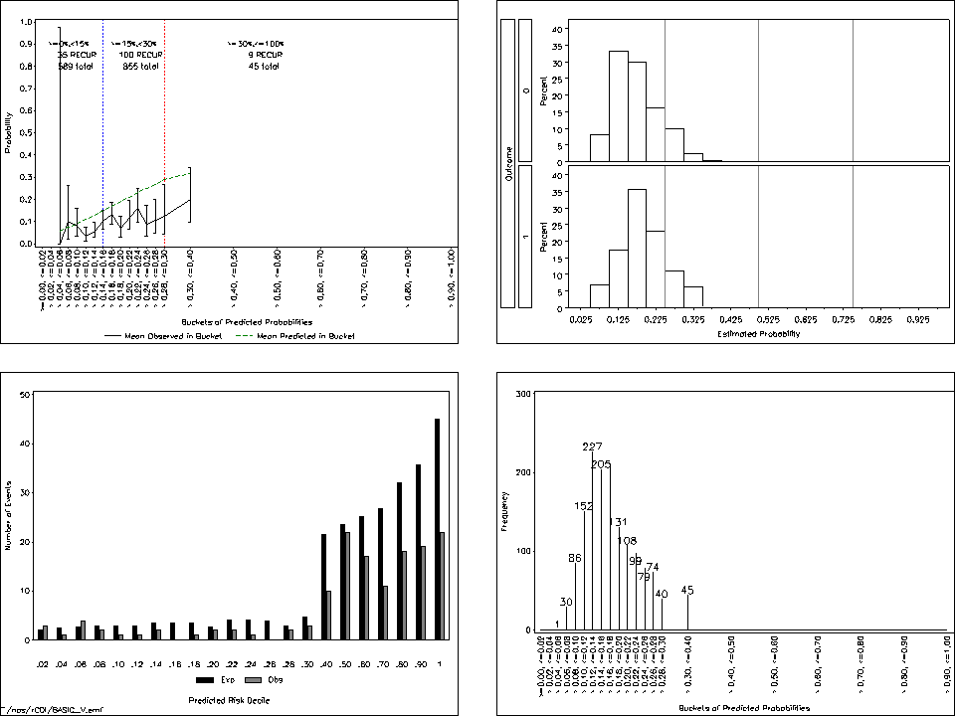

**5.2 Zilberberg Model, 84-Day Outcome, Validation**

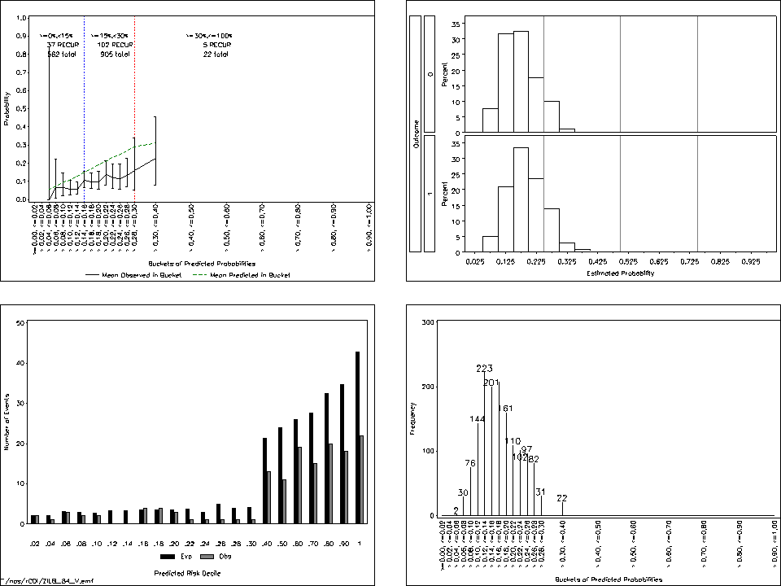

* 1. **Enhanced Model, 84-Day Outcome, Validation**



* 1. **Automated Model, 84-Day Outcome, Validation**

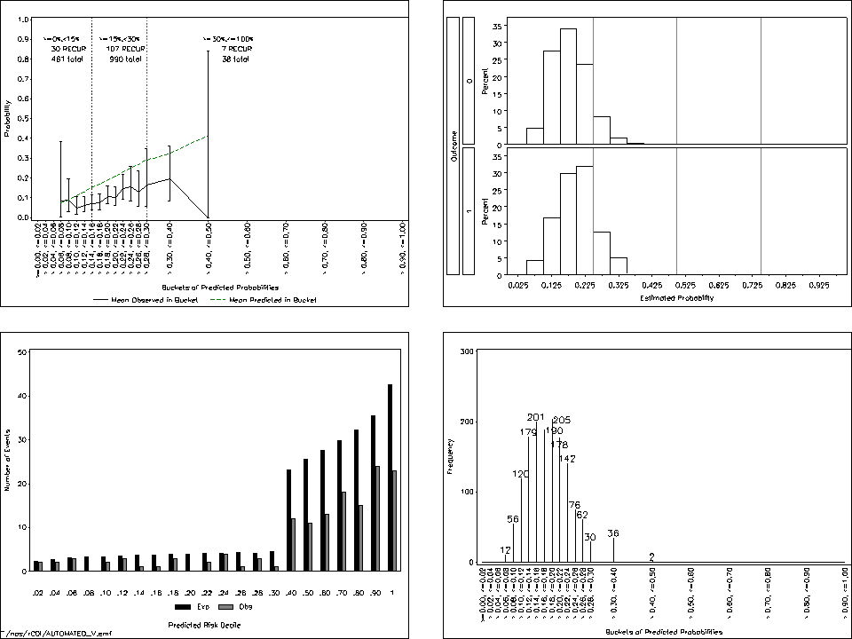

**APPENDIX 6. SENSITIVITY ANALYSES WITH 30 DAY (INSTEAD OF 84 DAY) FOLLOW-UP**

**30-day model at various risk thresholds / Validation dataset: 52 outcomes**

*≥15% Threshold*

|  |  |  |  |  |  |  |  |  |  |
| --- | --- | --- | --- | --- | --- | --- | --- | --- | --- |
| Model | c statistic | R2 | Brier score | PPV | NPV | % of All Patients  Flagged | Workup:  Detection Ratio | Sensitivity | Specificity |
| Basic | 0.580 | -0.0719 | 0.0322 | --* | --* | 0.00 | --* | --* | --* |
| Zilberberg | 0.557 | -0.0826 | 0.0323 | --* | --* | 0.00 | --* | --* | --* |
| Enhanced | 0.541 | -0.0678 | 0.0322 | 12.50 | 96.83 | 0.49 | 8.00 | 1.92 | 99.55 |
| Automated | 0.565 | -0.0818 | 0.0323 | 0.00 | 96.78 | 0.06 | --** | 0.00 | 99.94 |

* No patients with a predicted probability at this threshold

** PPV and Sensitivity = 0

*≥ 20% Threshold*

|  |  |  |  |  |  |  |  |  |  |
| --- | --- | --- | --- | --- | --- | --- | --- | --- | --- |
| Model | c statistic | R2 | Brier score | PPV | NPV | % of All Patients  Flagged | Workup:  Detection Ratio | Sensitivity | Specificity |
| Basic | 0.580 | -0.0719 | 0.0322 | --* | --* | 0.00 | --* | --* | --* |
| Zilberberg | 0.557 | -0.0826 | 0.0323 | --* | --* | 0.00 | --* | --* | --* |
| Enhanced | 0.541 | -0.0678 | 0.0322 | 0.00 | 96.78 | 0.06 | --** | 0.00 | 99.94 |
| Automated | 0.565 | -0.0818 | 0.0323 | --* | --* | 0.00 | --* | --* | --* |

* No patients with a predicted probability at this threshold

** PPV and Sensitivity = 0

*≥25% Threshold*

|  |  |  |  |  |  |  |  |  |  |
| --- | --- | --- | --- | --- | --- | --- | --- | --- | --- |
| Model | c statistic | R2 | Brier score | PPV | NPV | % of All Patients  Flagged | Workup:  Detection Ratio | Sensitivity | Specificity |
| Basic | 0.580 | -0.0719 | 0.0322 | --* | --* | 0.00 | --* | --* | --* |
| Zilberberg | 0.557 | -0.0826 | 0.0323 | --* | --* | 0.00 | --* | --* | --* |
| Enhanced | 0.541 | -0.0678 | 0.0322 | 0.00 | 96.78 | 0.06 | --** | 0.00 | 99.94 |
| Automated | 0.565 | -0.0818 | 0.0323 | --* | --* | 0.00 | --* | --* | --* |

* No patients with a predicted probability at this threshold

** PPV and Sensitivity = 0