Supplementary Appendix

This information has been provided by the authors to give readers additional information about their work.

SUPPLEMENTARY FIGURES

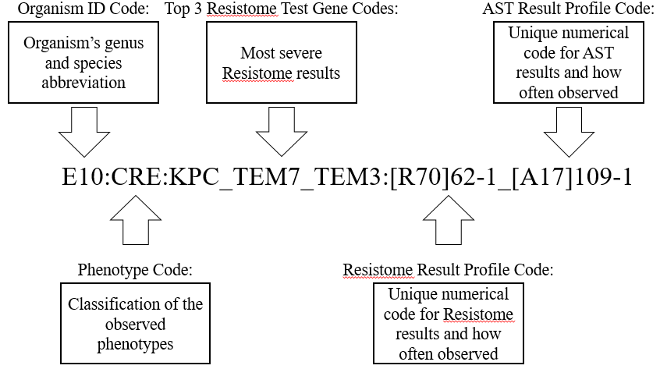
Supplementary Figure S1. Acuitas Lighthouse Profile Composition. The Lighthouse profile consists of five sections separated by colons that combine to form a unique fingerprint for an organism. The five sections of the profile are the organism ID code, phenotype code, the top three Resistome test gene codes, the Resistome result profile code, and the AST result profile code. The information for each of the five sections comes from the Acuitas line of tests provided by OpGen.

SUPPLEMENTARY TABLES
Supplementary Table S1. Acuitas Lighthouse Profiles of Selected Samples
Sample | Type | Acuitas Lighthouse Profile
 |  | Section 1: Organism ID Code | Section 2: Phenotype Code | Section 3:  Top 3 Resistome Test Gene Code | Section 4: Resistome Result Profile Code | Section 5: AST Result Profile Code
1 | I | E10: | CRE: | KPC_TEM7_TEM3: | [R70]62-2_ | [A17]109-2
2 | I | E10: | CRE: | KPC_TEM7_TEM3: | [R70]62-3_ | [A17]109-1
3 | I | E10: | CRE: | KPC_TEM7_TEM3: | [R70]62-4_ | [A17]109-3
4 | I | E10: | CRE: | KPC_TEM7_TEM3: | [R70]62-5_ | [A17]109-4
5 | I | E10: | CRE: | KPC_TEM7_TEM3: | [R70]62-6_ | [A17]109-5
6 | II | K1: | CRE: | KPC_CTXM1_SHV1: | [R70]66-1_ | [A17]90-7
7 | II | K1: | CRE: | KPC_CTXM1_SHV1: | [R70]66-3_ | [A17]90-9
8 | II | K1: | CRE: | KPC_CTXM1_SHV1: | [R70]66-2_ | [A17]127-1
9 | II | K1: | CRE: | KPC_CTXM1_SHV1: | [R70]66-4_ | [A17]127-2
10 | II | K1: | CRE: | KPC_CTXM1_SHV1: | [R70]66-5_ | [A17]130-1
11 | III | K1: | CRE: | KPC_SHV1_SHV5: | [R70]64-3_ | [A17]90-10
12 | III | K1: | CRE: | KPC_SHV1_SHV5: | [R70]64-2_ | [A17]101-2
13 | III | K1: | CRE: | KPC_SHV1_SHV5: | [R70]64-1_ | [A17]110-1
14 | IV | K1: | CRE: | KPC_SHV1_SHV5: | [R70]67-1_ | [A17]113-1
15 | IV | K1: | CRE: | KPC_SHV1_SHV5: | [R70]67-2_ | [A17]123-1
16 | IV | K1: | CRE: | KPC_SHV1_SHV5: | [R70]67-3_ | [A17]128-1
17 | V | K1: | CRE: | KPC_SHV4_SHV5: | [R70]70-3_ | [A17]101-1
18 | V | K1: | CRE: | KPC_SHV4_SHV5: | [R70]70-1_ | [A17]110-2

