Additional Sensitivity Analysis for Key Agent-Based Transmission Model Parameters
Hand Hygiene Compliance for Nurses
In the primary analysis, we estimated compliance with hand hygiene for nurses to be 80% based on observed data. However, hand hygiene compliance may vary greatly between centers and may be as low as 40% based on published reviews.¹ Thus, we generated results for scenarios in which nurses comply with hand hygiene less often than the baseline case, that is, on only 50% of visits to patients on entry and on exit. The trends for these results were similar to the baseline case, except that transmission increased proportionally due to this change. We summarize the prevalence-specific acquisition rates (dependent outcome) as a function of the microbiome effect and antibiotic usage in Figure 1. When considering a microbiome effect of 2.0 (i.e., that patients who received antibiotics were twice as likely to acquire or transmit an MDRO), reducing antibiotic usage from 75% to 65% reduced acquisition rates of high-prevalence MDROs by 13.3% from 12.35 to 10.72 acquisitions per 1000 patient days (p < 0.001). Reducing antibiotic usage from 75% to 50% reduced acquisition rates by 28.5% from 12.35 to 8.83 acquisitions per 1000 patient days (p < 0.001). For low-prevalence MDROs, absolute reductions in antibiotic usage by 10% and 25% reduced acquisition rates by 13.1% (p < 0.001) and 33.7% (p < 0.001), respectively. These reductions in acquisition rates—due to 10% and 25% absolute reductions in antibiotic usage—become consistently statistically significant (p < 0.05) at a microbiome effect of 1.3 and 1.1, respectively for high-prevalence MDROs. For low-prevalence organisms, the reductions in acquisition rates become consistently statistically significant (p < 0.05) at a microbiome effect of 1.4 for a 25% absolute reduction in antibiotic usage, but are not consistently significant until a microbiome effect of 1.9 for a 10% antibiotic reduction (although some statistically significant results are observed at microbiome effects as low as 1.6).
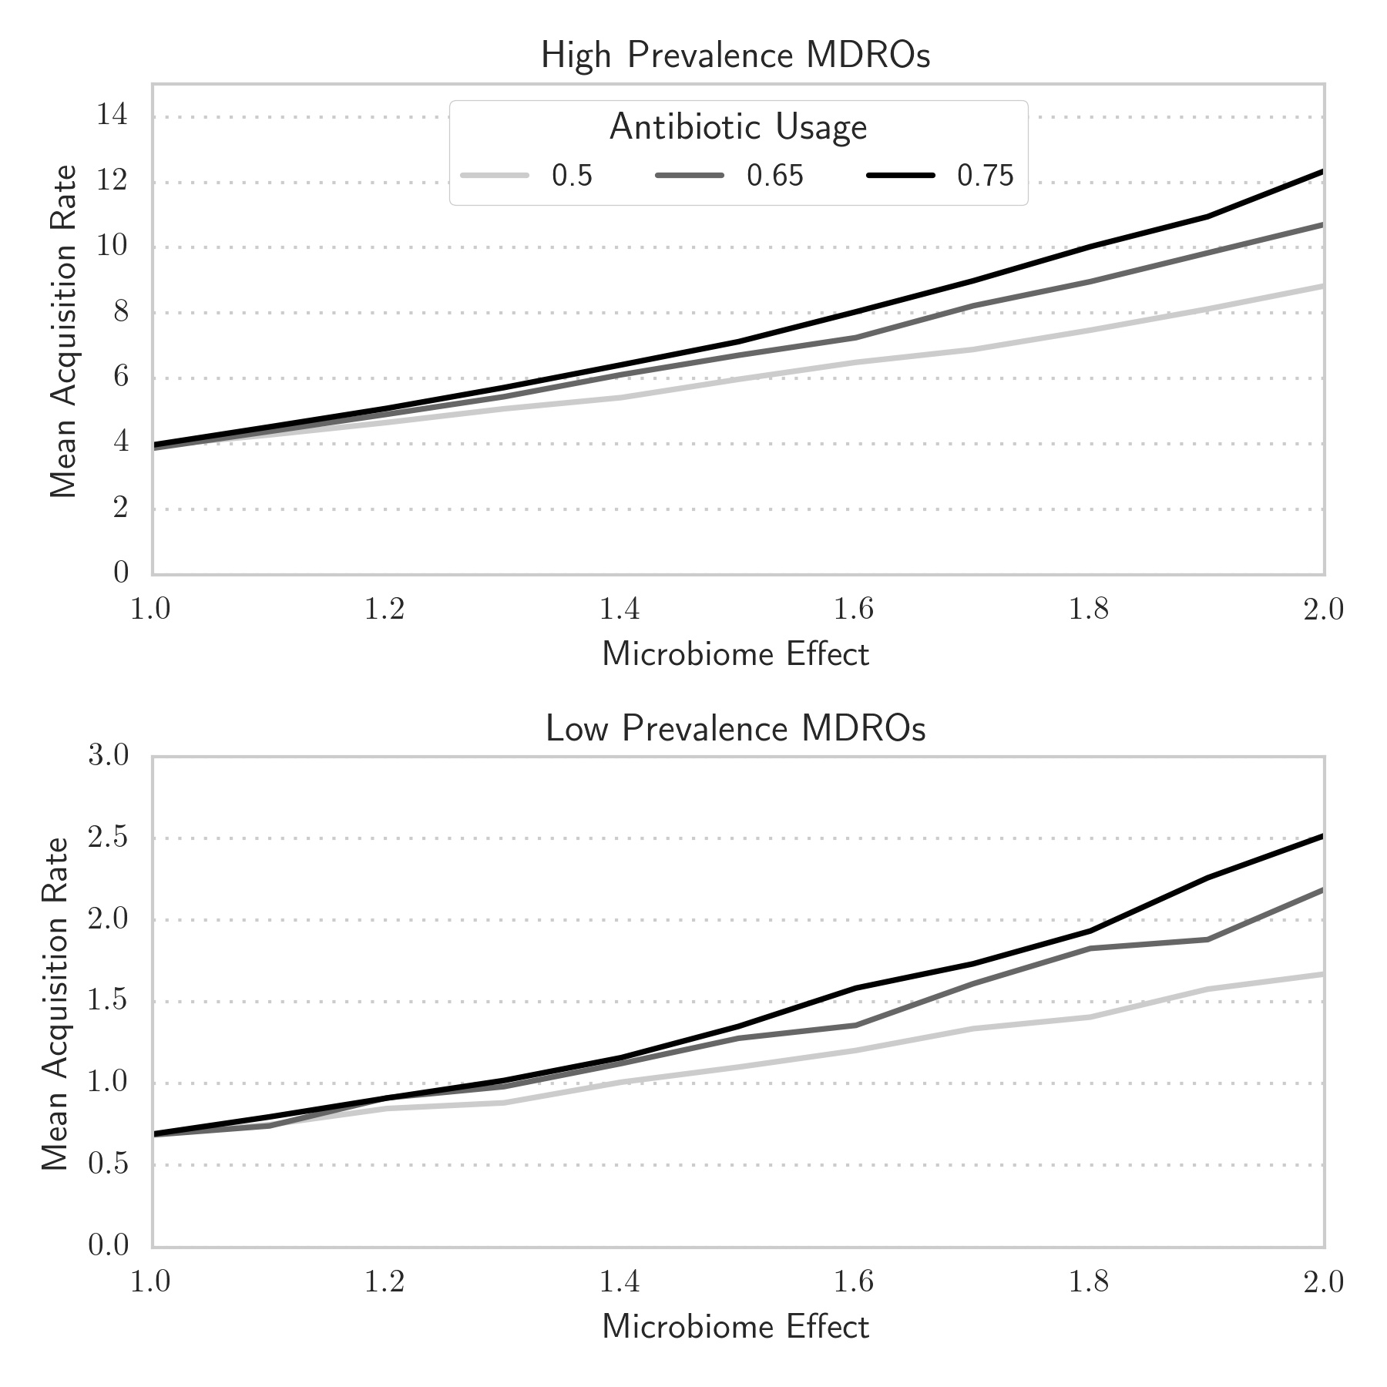
Figure 1. Prevalence-specific MDRO acquisition rates as a function of microbiome effect and antibiotic usage levels for nurse hand hygiene compliance levels of 50% on entry and on exit.

Mutation Effect for Patients Receiving Antibiotics
In addition to the effects of antibiotic exposure on the human microbiome, antibiotic exposure may also lead to the development of antibiotic resistance via genetic mutation (which we parameterize as the mutation effect). However, the actual proportion of patients who receive antibiotics and develop resistance through this mechanism is unknown. In the primary analysis, we estimated the mutation effect to be 1%; however, based on uncertainty in the literature, we include a sensitivity analysis of this parameter. We generated results for scenarios in which the mutation rate for patients receiving antibiotics was higher than the baseline case, that is, 5% instead of 1%. The trends for these results were similar to the baseline case, except that transmission increased proportionally due to this change. We summarize the prevalence-specific acquisition rates (dependent outcome) as a function of the microbiome effect and antibiotic usage in Figure 2. When considering a microbiome effect of 2.0 (i.e., that patients who received antibiotics were twice as likely to acquire or transmit an MDRO), reducing antibiotic usage from 75% to 65% reduced acquisition rates of high-prevalence MDROs by 9.08% from 11.84 to 10.77 acquisitions per 1000 patient days (p < 0.001). Reducing antibiotic usage from 75% to 50% reduced acquisition rates by 19.3% from 11.84 to 9.56 acquisitions per 1000 patient days (p < 0.001). For low-prevalence MDROs, absolute reductions in antibiotic usage by 10% and 25% reduced acquisition rates by 10.8% (p < 0.001) and 22.0% (p < 0.001), respectively. These reductions in acquisition rates—due to 10% and 25% absolute reductions in antibiotic usage—become consistently statistically significant (p < 0.05) at a microbiome effect of 1.4 for high-prevalence MDROs. For low-prevalence organisms, the reductions in acquisition rates become consistently statistically significant (p < 0.05) at a microbiome effect of 1.4 for a 25% absolute reduction in antibiotic usage, but are not consistently significant until a microbiome effect of 2.0 for a 10% antibiotic reduction (although some statistically significant results are observed at microbiome effects as low as 1.6).
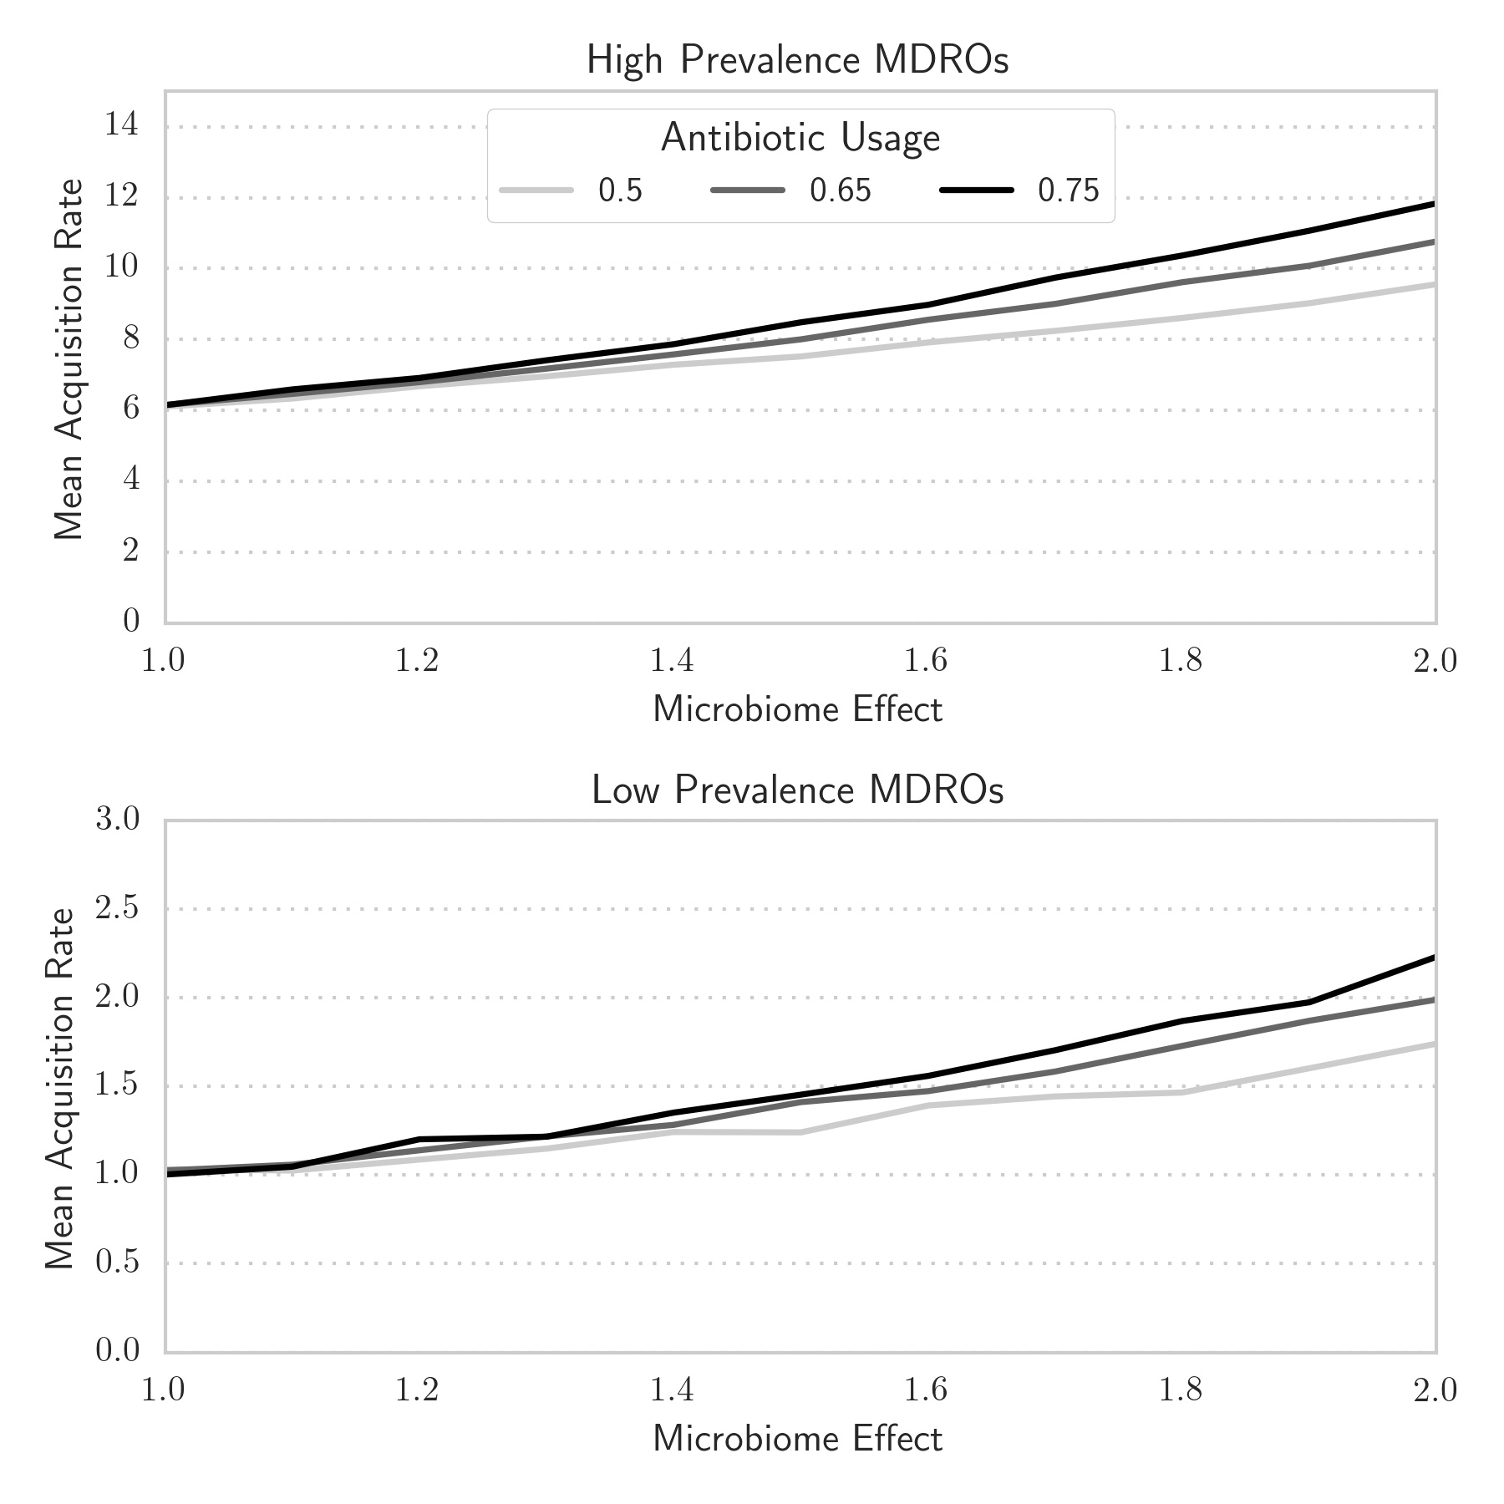
Figure 2. Prevalence-specific MDRO acquisition rates as a function of microbiome effect and antibiotic usage levels for a mutation rate of 5%.

References

1. Erasmus V, Daha TJ, Brug H, et al. Systematic review of studies on compliance with hand hygiene guidelines in hospital care. Infect Control Hosp Epidemiol 2010; 31(3): 283-94.

