Supplementary Material

Figure 1: Grouped cases of pulmonary pneumocystosis in solid organ transplant recipients, Grenoble University Hospital between 2012 and May 2015

Each rectangle represents one patient, numbering is chronological based on the date of diagnosis. Rectangles surrounded by a continuous black line correspond to patients from whom the same major strain was isolated (patients 4, 6, 7, 9, 10 and 11); the rectangle surrounded by a dashed black line corresponds to the patient for whom the same major strain was suspected of involvement (patient 2).
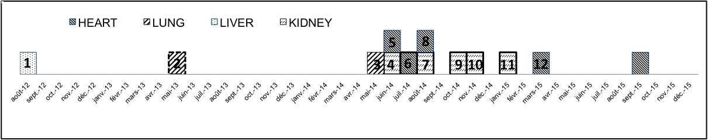

Table I: Main clinical and para-clinical characteristics of the 12 solid organ transplant recipients with pulmonary pneumocystosis at Grenoble University Hospital from 2012 to May 2015

Patient | Age | Organ transplanted | Age of transplant | Immunosuppressors | Total Ly (/L) | CD4 (/mm3) | Other risk factors | Time to diagnosis (d) | Diagnostic sample | Direct examination | PCR (Log cp/mL) | Pulm coinf | Severe¹ | Corticosteroids² | ICU | Mecanichal ventilation | Outcome
1 | 56 | Liver | 6 months | Ciclo, MMF, Pred 10 mg/d | 0.4 | NA | _ | NA* | BA | - | 5.53 | _ | YES | NO | NO (limitation of active care) | NO | Death  (HCV relapse on transplant)
2 | 51 | Lung | 21 months | Tac, MMF, Pred 7.5 mg/d | 1.1 | 250 | Acute rejection < 3 months | 5 | BAL | - | 3.75 | S. Aureus | YES | YES | NO | NO | Favourable
3 | 33 | Lung | 3 years | Ev, Tac, Aza, Pred 4 mg /d | 0.7 | 110 | _ | 4 | BAL | + | 9.03 | P. Aeruginosa | YES | YES | YES | YES | Death
4 | 59 | Heart  then Kidney | Heart 25 years,  Kidney 2 months | ATG, Tac, MMF, Pred > 20 mg/d | 0.3 | NA | MissMatch CMV | 3 | BAL | - | 8.59 | _ | YES | YES | YES | YES | Favourable
5 | 57 | Heart | 10 years | Tac, Ev, MMF | 0.5 | 200 | _ | 4 | BAL | Re-read + | 8.43 | SAMR | YES | NO | YES | YES | Death
6 | 64 | Heart | 3 years | Tac, MMF | 0.6 | 370 | CMV reactivation | 7 | BAL | + | 8.18 | P. aeruginosa | YES | NO | YES | YES | Death
7 | 66 | Kidney | 4 months | Tac, MMF | 0.2 | NA | MissMatch CMV | 14 | Induced sputum | - | 10.52 | _ | NO | NO | NO | NO | Favourable
8 | 48 | Heart | 6 years | Ciclo, MMF, Pred 2 mg/d | 1 | NA | _ | 15 | BAL | Re-read + | 6.01 | _ | YES | YES | NO | NO | Favourable
9 | 74 | Kidney | 10 years | Tac, MMF | 3.3 | NA | _ | 20 | BAL | + | 7.30 | _ | YES | YES | YES | YES | Death
10 | 48 | Kidney | 2.5 years | Tac, MMF | 0.4 | 300 | _ | 11 | BAL | + | 6.94 | _ | NO | NO | NO | NO | Favourable
11 | 68 | Kidney | 18 years | Ciclo, MMF | 0.4 | NA | _ | NA | Induced sputum | - | 5.07 | _ | NO | NO | NO | NO | Favourable
12 | 61 | Heart | 9 years | Ev, Pred 2 mg/d | 4.2 | 700 | _ | 8 | BAL | - | 3.49 | _ | YES | YES | NO | NO | Favourable
TOTAL | Median 58 |  | Median 38.5 months |  | Median 0.55 G/L | Median 275/mm3 | 4/12 | Median 7.5 | LBA or BA 10/12 | Direct + 6/12 | Median 7.12 | 4/12 | 9/12 | 6/12  (severe 6/9) | 5/12 | 5/12 | Deaths 5/12
ICU : Intensive Care Unit, Tac: Tacrolimus, Ciclo: Ciclosporin, MMF: mycophenolate mofetil, Pred: Prednisone, Ev: Everolimus. NA: data Not Available
1 : severe = PaO2 < 70 mmHg
2 : Corticosteroids ≥ 1 mg/kg per day, ≥ 5 days
* : patient presented to hospital with astheniae and rapidly multi-organ distress.

