SUPPLEMENTARY APPENDIX:
- Figure A. University (UH, green) and community hospitals (CH, red) participating in the ANRESIS-BSI Study.
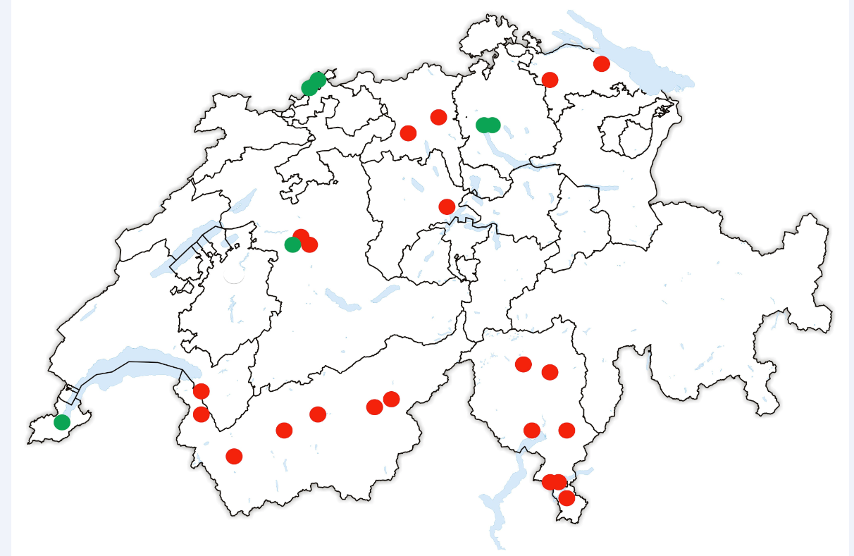

-List of hospitals participating in this study (beds in 2011):
Community hospitals: Aarau Kantonsspital (602), Acquarossa Ospedale Bleniese (50), Aigle Hopital de Zone (33), Baden Kantonsspital (377), Bellinzona Ospedale San Giovanni (222), Bern Salemspital (169), Bern Sonnenhof-Klinik Bern (107), Brig Spitalzentrum Oberwallis (116), Faido Ospedale distrettuale (56), Frauenfeld Kantonsspital (270) , Locarno Ospedale La Carità (160), Lugano Cardiocentro (30), Lugano Ospedale Civico (291), Luzern Kantonsspital (579), Martigny Centre Hospitalier du Centre de Valais (140), Mendrisio Ospedale Beata Vergine (146), Monthey Réseau Santé Valais - Centre Hospitalier du Chablais (115), Münsterlingen,Kantonsspital (206), Sierre Centre Hospitalier du Centre de Valais (116), Sion Centre Hospitalier du Centre de Valais (214), Visp Spitalzentrum Oberwallis (157)
University hospitals: Basel Universitätsspital* (826), Bern Inselspital (991), Genève Hôpitaux Universitaires (1908), Zürich Universitätsklinik Balgrist (141) and Zürich Universitätskinderklinik and Zürich Universitätsspital (860)
* merger in 2011 between the academic pediatric clinic and the adults university hospital of Basel
- List of contaminants: Actinomyces bovis, Actinomyces denticolens, Actinomyces europaeus, Actinomyces funkei, Actinomyces georgiae, Actinomyces gerencseriae, Actinomyces graevenitzii, Actinomyces hordeovulneris, Actinomyces howellii, Actinomyces hyovaginalis, Actinomyces israelii, Actinomyces meyeri, Actinomyces naeslundii, Actinomyces neuii, Actinomyces odontolyticus, Actinomyces oris, Actinomyces propionica, Actinomyces radingae, Actinomyces slackii, Actinomyces species, Actinomyces turicensis, Actinomyces urogenitalis, Actinomyces viscosus, Anaerococcus hydrogenalis, Anaerococcus murdochii, Anaerococcus prevotii, Anaerococcus species, Anaerococcus tetradius, Anaerovorax odorimutans, Atopobium minutum, Atopobium parvulum, Atopobium rimae Atopobium species Atopobium vaginae, Bacillus amyloliquefaciens, Bacillus anthracis, Bacillus badius, Bacillus cereus, Bacillus circulans, Bacillus coagulans, Bacillus cohnii, Bacillus fastidiosus, Bacillus firmus, Bacillus insolitus, Bacillus lentus, Bacillus licheniformis, Bacillus megaterium, Bacillus mucilaginosus, Bacillus mycoides, Bacillus naganoensis, Bacillus pumilus, Bacillus simplex, Bacillus species, Bacillus sphaericus, Bacillus subtilis, Bacillus thermoamylovorans, Bacillus thuringiensis, Bifidobacterium adolescentis, Bifidobacterium animalis, Bifidobacterium bifidum, Bifidobacterium breve, Bifidobacterium catenulatum, Bifidobacterium dentium, Bifidobacterium gallicum, Bifidobacterium infantis, Bifidobacterium longum, Bifidobacterium pseudolongum, Bifidobacterium species, Clostridium acetobutylicum, Clostridium aldrichii, Clostridium baratii, Clostridium beijerinckii, Clostridium bifermentans, Clostridium botulinum, Clostridium bryantii, Clostridium butyricum, Clostridium cadaveris, Clostridium celerecrescens, Clostridium chauvoei, Clostridium clostridioforme, Clostridium difficile, Clostridium fallax, Clostridium ghonii, Clostridium glycolicum, Clostridium haemolyticum, Clostridium hastiforme, Clostridium hathewayi, Clostridium histolyticum, Clostridium indolis, Clostridium innocuum, Clostridium limosum, Clostridium methylpentosum, Clostridium novyi, Clostridium oxalicum, Clostridium paraputrificum, Clostridium perfringens, Clostridium putrefaciens, Clostridium putrificum, Clostridium ramosum, Clostridium rectum, Clostridium septicum, Clostridium sordellii, Clostridium species, Clostridium sphenoides, Clostridium sporogenes, Clostridium subterminale. Clostridium symbiosum, Clostridium tertium, Clostridium tetani, Clostridium thermopalmarium, Clostridium tyrobutyricum, Collinsella aerofaciens, Corynebacterium accolens, Corynebacterium afermentans, Corynebacterium ammoniagenes, Corynebacterium amycolatum, Corynebacterium appendicis, Corynebacterium argentoratense, Corynebacterium asperum, Corynebacterium aurimucosum, Corynebacterium auris, Corynebacterium bovis, Corynebacterium confusum, Corynebacterium coyleae, Corynebacterium cystitidis, Corynebacterium diphtheria, Corynebacterium durum, Corynebacterium falsenii, Corynebacterium fascians, Corynebacterium flavescens, Corynebacterium glucuronolyticum, Corynebacterium imitans, Corynebacterium jeikeium, Corynebacterium kroppenstedtii, Corynebacterium kutscheri, Corynebacterium lipophiloflavum, Corynebacterium macginleyi, Corynebacterium mastitidis, Corynebacterium matruchotii, Corynebacterium minutissimum, Corynebacterium mucifaciens, Corynebacterium mycetoides, Corynebacterium pilosum, Corynebacterium propinquum, Corynebacterium pseudodiphtheriticum, Corynebacterium pseudogenitalium, Corynebacterium pseudotuberculosis, Corynebacterium pyruviciproducens, Corynebacterium renale, Corynebacterium resistens, Corynebacterium riegelii, Corynebacterium seminale, Corynebacterium simulans ,Corynebacterium singular, Corynebacterium species, Corynebacterium striatum, Corynebacterium sundsvallense, Corynebacterium tuberculostearicum, Corynebacterium ulcerans, Corynebacterium urealyticum, Corynebacterium ureicelerivorans, Corynebacterium xerosis, Eggerthella lenta, Eubacterium brachy, Eubacterium budayi, Eubacterium combesii, Eubacterium contortum, Eubacterium cylindroides, Eubacterium dolichum, Eubacterium limosum, Eubacterium moniliforme, Eubacterium moorei, Eubacterium nitritogenes, Eubacterium nodatum, Eubacterium plautii, Eubacterium rectale, Eubacterium saburreum, Eubacterium species, Eubacterium sulci, Eubacterium tenue, Eubacterium tortuosum, Eubacterium ventriosum, Eubacterium yurii, Finegoldia magna, Finegoldia species, Holdemania species, Lactobacillus acidophilus, Lactobacillus agilis, Lactobacillus alimentarius ,Lactobacillus amylophilus, Lactobacillus amylovorus, Lactobacillus animalis, Lactobacillus bifermentans, Lactobacillus brevis, Lactobacillus buchneri, Lactobacillus casei, Lactobacillus catenaformis, Lactobacillus collinoides, Lactobacillus coryniformis, Lactobacillus crispatus, Lactobacillus curvatus, Lactobacillus delbrueckii, Lactobacillus farciminis, Lactobacillus fermentum, Lactobacillus fructivorans, Lactobacillus gasseri, Lactobacillus helveticus, Lactobacillus hilgardii, Lactobacillus homohiochii, Lactobacillus intestinalis, Lactobacillus jensenii, Lactobacillus kefiri, Lactobacillus lindneri, Lactobacillus malefermentans, Lactobacillus mali, Lactobacillus murinus, Lactobacillus parabuchneri, Lactobacillus paracasei, Lactobacillus pentosus, Lactobacillus plantarum, Lactobacillus rennanqilfy, Lactobacillus reuteri, Lactobacillus ruminis, Lactobacillus sakei, Lactobacillus salivarius, Lactobacillus sanfranciscensis, Lactobacillus sharpeae, Lactobacillus species, Lactobacillus suebicus, Lactobacillus vaccinostercus, Lactobacillus vitulinus, Micromonas micros, Mobiluncus curtisii, Mobiluncus mulieris, Mobiluncus species, Mogibacterium timidum, Peptococcus niger, Peptococcus species, Peptoniphilus asaccharolyticus, Peptoniphilus indolicus, Peptostreptococcus anaerobius, Peptostreptococcus species, Peptostreptococcus stomatis, Propionibacterium acnes, Propionibacterium avidum, Propionibacterium freudenreichii, Propionibacterium granulosum, Propionibacterium lymphophilum, Propionibacterium propionicus, Propionibacterium species, Pseudoramibacter alactolyticus, Ruminococcus gnavus, Ruminococcus hansenii, Ruminococcus productus, Ruminococcus species, Staphylococcus arlettae, Staphylococcus auricularis, Staphylococcus capitis, Staphylococcus caprae, Staphylococcus carnosus, Staphylococcus chromogenes, Staphylococcus cohnii, Staphylococcus condiment, Staphylococcus delphini, Staphylococcus epidermidis, Staphylococcus equorum, Staphylococcus felis, Staphylococcus fleurettii, Staphylococcus gallinarum, Staphylococcus haemolyticus, Staphylococcus hominis, Staphylococcus hyicus, Staphylococcus intermedius, Staphylococcus kloosii, Staphylococcus lentus, Staphylococcus lugdunensis, Staphylococcus pasteuri, Staphylococcus pseudintermedius, Staphylococcus saccharolyticus, Staphylococcus saprophyticus, Staphylococcus schleiferi, Staphylococcus sciuri, Staphylococcus simulans, Staphylococcus warneri, Staphylococcus xylosus, Staphylococcus coagulase-negative, Staphylococcus coagulase-negative not saprophyticus, Streptococcus alactolyticus, Streptococcus anginosus, Streptococcus bovis, Streptococcus bovis group , Streptococcus constellatus, Streptococcus cremoris, Streptococcus equinus, Streptococcus gordonii, Streptococcus intermedius, Streptococcus milleri group, Streptococcus mitis, Streptococcus mitis group, Streptococcus mutans, Streptococcus oralis, Streptococcus parasanguinis, Streptococcus salivarius, Streptococcus sanguinis, Streptococcus vestibularis, Streptococcus viridans group, Veillonella parvula, Veillonella species, Weissella confusa, Weissella halotolerans, Weissella kandleri, Weissella minor, Weissella paramesenteroides, Weissella viridescens.

