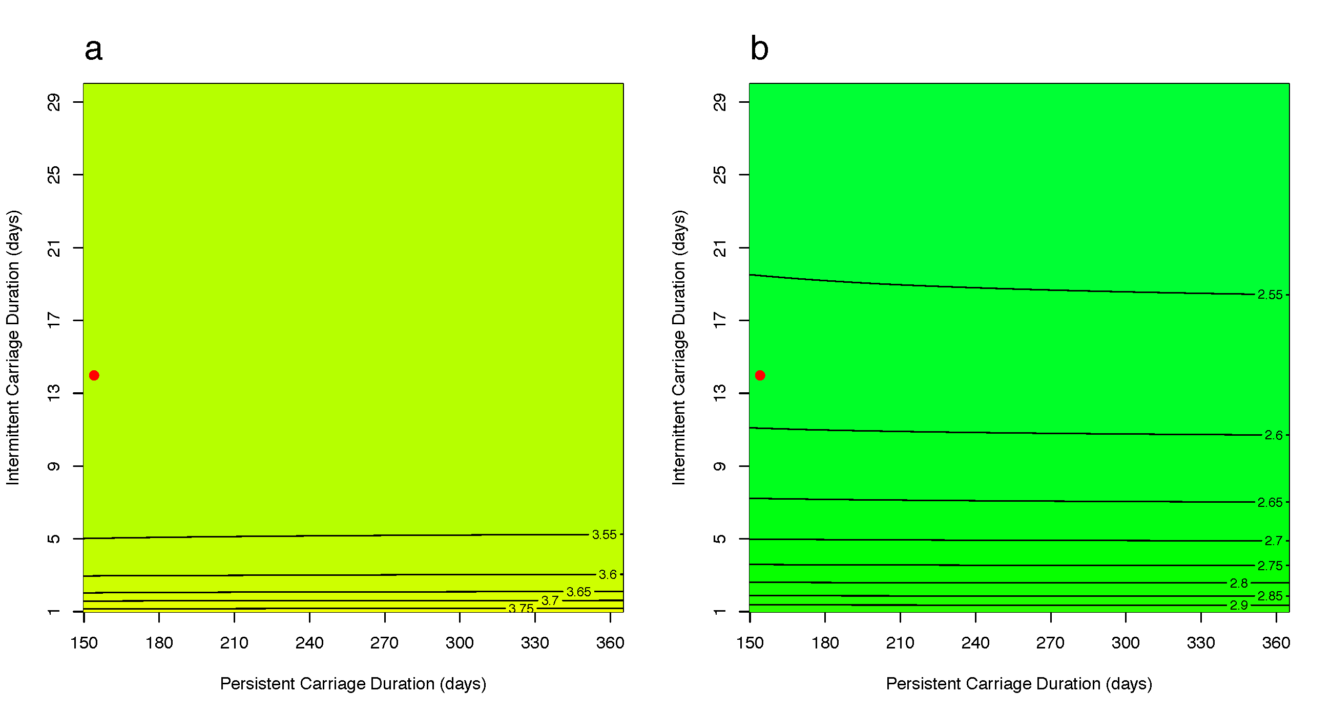

Figure S2: A heat-map of the ratios of carriage prevalence in the heterogeneous model to the homogeneous model when varying persistent and intermittent carriage durations under Scenario B (all individuals are uncolonized at admission) and intervention of (a) reducing β* parameter (see Table 1) by 25% and (b) setting δ parameter to 1/21 day⁻¹. The ratio represents the magnitude of difference between the models, with >1 indicating that the heterogeneous model predicts higher carriage prevalence compared to the homogeneous model. The red dot represents assumed carriage durations of each carrier type for the initial analysis.

