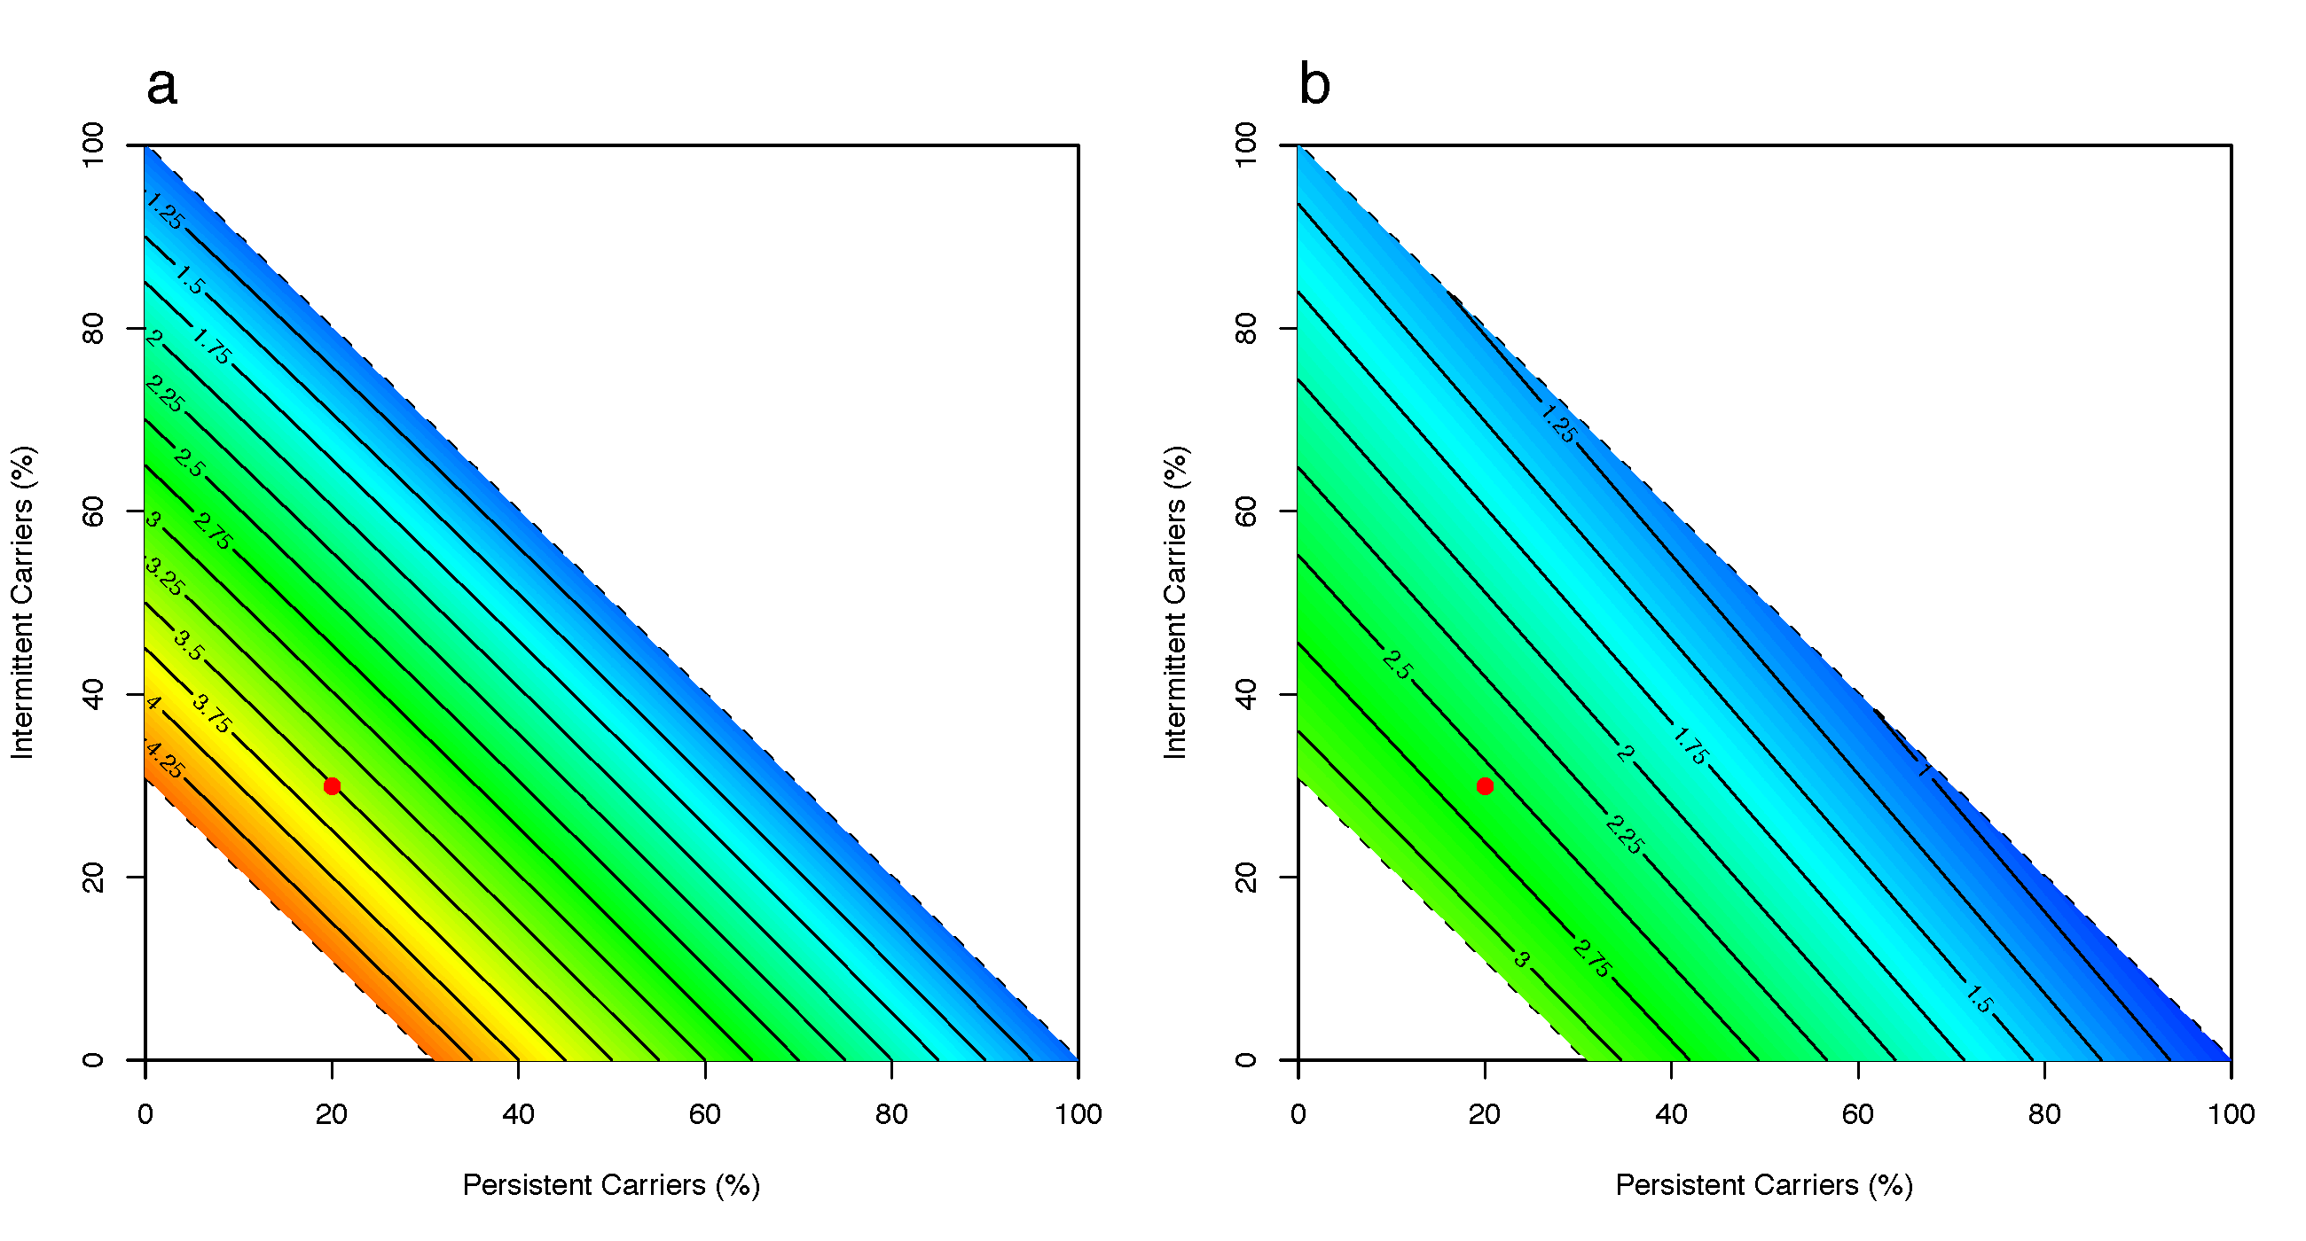

Figure S1: A heat-map of the ratios of carriage prevalence in the heterogeneous model to the homogeneous model when varying proportions of carrier classes under Scenario B (all individuals are uncolonized at admission) and intervention of (a) reducing β* parameter (see Table 1) by 25% and (b) setting δ parameter to 1/21 day⁻¹. The ratio represents the magnitude of difference between the models, with >1 indicating that the heterogeneous model predicts higher carriage prevalence compared to the homogeneous model. The dotted lines enclose all possible combinations of the proportions of persistent, intermittent, and non- carriers. The red dot represents assumed proportions of each carrier type for the initial analysis.

