Supplementary Tables
Supplementary Table 1. HBV, HCV, and HIV Assays Used by Facility A, Facility B, and PHRL.
 | Facility A | Facility B | PHRL
HBsAg HBsAb  HBcAb | Pre 4/1/2014 –  Abbott Architect  Post 4/1/ 2014 –  Advia Centaur XP | Immunochemiluminometric Siemens Centaur XP | Not Applicable
HCV Ab | Same as above | Not Applicable | Not Applicable
HBV viral load | Not Applicable | Not Applicable | ARUP Laboratories;  PHRL in-house real time PCR
HCV viral load | Not Applicable | COBAS AmpliPrep  COBAS Taqman | Quest Diagnostics;  ARUP Laboratories
HIV Ab  HIV viral load | BioRad GS HIV1/HIV2+ EIA | Immunochemiluminometric Siemens Centaur XP  COBAS AmpliPrep  COBAS Taqman | Not Applicable

Supplementary Table 2. Demographic Breakdown of Facility A and B as well as Total Cohort in Total as well as Newly Identified Infections.
 | Facility A | Facility A Newly Identified Positives*  (N=22) | Facility B | Facility B Newly Identified Positives*  (N=47) | Total Cohort | Total Cohort Newly Identified Positives*  (N=68)
Unique Patients | 718 | 21** | 1073 | 47 | 1791 | 67
Male (%): Female (%) | 695 (97%):23 (3%) | 20 (95%):1(5%) | 1039 (97%):34 (3%) | 46 (98%):1(2%) | 1734 (97%): 57 (3%) | 65 (97%):2(3%)
Median Age (Range) | 66 (23-95) | 70 (50-94) | 66 (22-96) | 64 (39-83) | 66(22-96) | 66 (39-94)
*Newly identified positive result for one or more viral infections
**One patient was positive for HBV and HCV

Supplementary Table 3. Percent Nucleotide Difference between HCV Sequences in Genotype 1a Patients from Site A.
 | Median Percent Nucleotide Difference Between HCV Sequences
Pt. | B1 | B2 | B3 | B4 | B5 | B6* | B7 | B8 | B9 | B10 | B15 | ENR1ª | ENR2ª
B1 | 3.3
B2 | 14.3 | 1.7
B3 | 14.6 | 14.0 | 2.7
B4 | 20.6 | 19.3 | 19.3 | 2.0
B5 | 13.5 | 15.3 | 15.3 | 22.6 | 0.9
B6* | 20.9 | 20.6 | 17.9 | 14.3 | 21.3 | 3.0
B7 | 20.6 | 17.6 | 19.6 | 13.3 | 19.6 | 14.6 | 0.7
B8 | 13.6 | 12.6 | 13.6 | 20.3 | 13.2 | 19.6 | 17.3 | 3.6
B9 | 20.3 | 18.9 | 18.3 | 14.3 | 20.9 | 16.3 | 18.3 | 19.3 | 2.0
B10 | 14.6 | 12.0 | 14.0 | 19.3 | 15.0 | 17.9 | 19.3 | 10.6 | 17.6 | 3.0
B15 | 13.3 | 12.3 | 14.0 | 19.3 | 15.0 | 19.6 | 20.6 | 14.0 | 17.6 | 12.0 | 1.0
ENR1ª | 15.2 | 14.5 | 16.2 | 18.8 | 19.1 | 20.1 | 20.5 | 13.9 | 17.5 | 13.2 | 12.2 | 0.7
ENR2 ª | 15.5 | 13.2 | 14.9 | 17.2 | 14.9 | 19.1 | 18.2 | 13.2 | 17.5 | 12.2 | 13.2 | 12.8 | 2.0
Values represent the median percent nucleotide difference between pairwise comparisons of HCV single genome sequences from each patient (mean = 20 sequences per patient, range 10-24 sequences). Strains with greater than 5% nucleotide difference were considered unrelated ³³.
*Newly found to be infected patient
ªENR = epidemiologically non-related patient

Supplementary Table 4. Percent Nucleotide Difference between HCV Sequences in Genotype 1b Patients from Site A.

 | Median Percent Nucleotide Difference Between HCV Sequences
Pt. | B11 | B12* | B13 | B14 | B16 | B17 | B18 | B19 | ENR3ª | ENR4ª
B11 | 3.7
B12* | 14.0 | 1.0
B13 | 16.6 | 16.6 | 1.0
B14 | 14.6 | 17.3 | 14.0 | 0.7
B16 | 13.8 | 15.8 | 13.8 | 13.5 | 3.9
B17 | 14.0 | 14.6 | 14.6 | 15.9 | 17.1 | 1.3
B18 | 15.9 | 16.4 | 14.0 | 13.0 | 14.1 | 15.9 | 0.3
B19 | 13.3 | 14.6 | 12.6 | 14.0 | 12.8 | 15.3 | 14.6 | 0.7
ENR3 ª | 15.9 | 16.9 | 15.9 | 15.6 | 16.1 | 16.9 | 16.2 | 16.9 | 8.0
ENR4 ª | 18.7 | 16.8 | 16.8 | 16.1 | 13.2 | 18.7 | 16.8 | 15.2 | 18.4 | 0.6
Values represent the median percent nucleotide difference between pairwise comparisons of HCV single genome sequences from each patient (mean = 21 sequences per patient, range 15-24 sequences). Strains with greater than 5% nucleotide difference were considered unrelated³³.
*Newly found to be infected patient
ªENR = epidemiologically non-related patient

Supplementary Table 5: Percent Nucleotide Difference between HCV Sequences in Genotype 2b Patients from Site B.
 | Median Percent Nucleotide Difference Between HCV Sequences
Pt. | Pt. D | Pt. S | Pt. H | ENR 54 | ENR 19
Pt. D | 1.0
Pt. S | 20.3 | 2.7
Pt. H* | 21.0 | 24.0 | 0.3
ENR 54 ª | 20.7 | 20.3 | 23.3 | 0.3
ENR 19 ª | 23.3 | 24.0 | 21.3 | 25.3 | 1.3

Values represent the median percent nucleotide difference between pairwise comparisons of HCV single genome sequences from each patient. Strains with greater than 5% nucleotide difference were considered unrelated³³
*Newly found to be infected patient
ªENR = epidemiologically non-related patient

Supplementary Figures
Supplementary Figure 1: Patient Flow Diagram for HBV, HCV, and HIV for Facility A

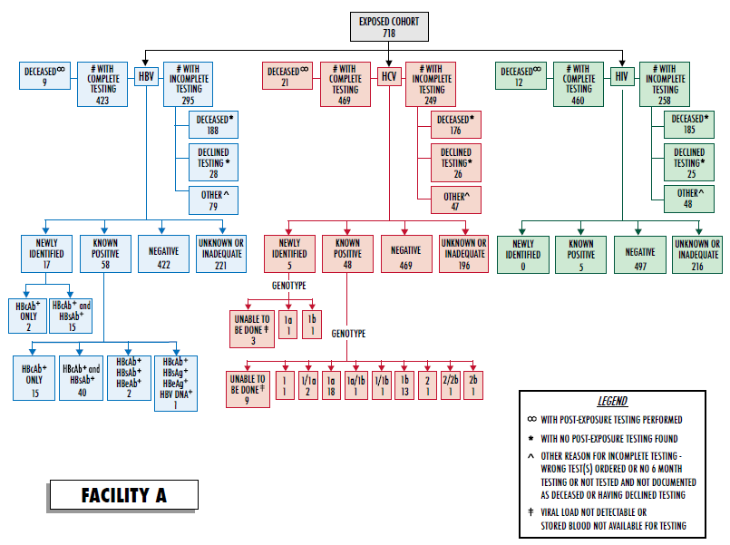

Supplementary Figure 2. Patient Flow Diagram for HBV, HCV, and HIV for Facility B

