Constitutionalism with Adjectives:
Conceptual Innovation in the Comparative Study of Law
Diana Kapiszewski, Deborah Groen, and Katja Newman
Methodological Appendix

Appendix A: Publications Search

Initial Phase

Our initial search strategy involved a preliminary screening of JSTOR and the University of California, Irvine online library catalog (Antpac). Specifically, we searched on “constitutionalism” in JSTOR and Antpac and scanned the titles of all publications the search returned (primarily published scholarly articles and books) to identify adjective-constitutionalism combinations (ACCs). This search identified 117 unique ACCs in published articles and books. Convinced that this search had failed to identify many ACCs, we decided to conduct our search using Google Scholar.

Google Scholar Parameters

Google Scholar’s “Inclusion Guidelines” detail the various criteria a piece of scholarship must meet to be included in the Google Scholar database, as well as the frequency with which new work is added to the database. Articles and books from “all fields of research, all languages, all countries, and over all time periods” are included in the database. Google Scholar uses “search robots” to comb the internet for scholarly work. For these robots to source a given website it must have “scholarly articles” and must show abstracts or the full text of articles. All work captured by Google Books is also included in the Google Scholar database. Once an individual author, journal publisher, or other entity uploads a new article to their website, it is automatically included in Google Scholar within “several weeks.”

Google Scholar thus identifies all scholarship that political science and legal journals, JSTOR, and other outlets, publish or make findable digitally. As an example, the first issue of the American Political Science Review, published in 1906, is available in PDF format on JSTOR. The first article in that issue, “The Usurped Powers of the Senate” by A. Maurice Low, also appears in Google Scholar when searched.

Google Scholar Search Phases

As noted in the text of the paper, our original Google Scholar search for ACCs in scholarship published since 1945 was carried out between February and June 2013. We began by searching on “constitutionalism,” restricting the date range to 1945 to 2013; this returned approximately 40,000 references. However, Google only displays the first 1,000 entries per search due to a server-side default. Review of the first 1,000 entries identified over 450 ACCs. The fact that we were looking at only one-fortieth of the references Google Scholar had identified (and that some references from the JSTOR/Antpac search did not appear in these first 1,000 Google Scholar references) suggested that there were potentially many more ACCs.

Thus, we decided to divide the time period of interest (1945-2013) into sub-intervals that resulted in fairly similar numbers of search results: 2009-2013 (15,700 results), 2004-2008 (16,000 results), 1999-2003 (14,200 results), 1989-1998 (13,700 results), and 1945-1988 (8,600 results). We were confident that the search had turned up all mentions of an ACC in the title or abstract of articles, and the first page of the introduction/first chapter of books/dissertations, published between 1945 and 2012 and available on the internet.

Given the timing of the search, however, it only included literature that had been published in the first half of 2013. In order to address this, in February 2014 we conducted an adjunct Google Scholar search of “constitutionalism” limited to the year 2013. This produced approximately 7,000 citations, of which we searched the first 1,000 entries that Google Scholar makes available using the same procedures as used in the original search, adding into our dataset all mentions that were not yet included there. After this search our dataset included 149 mentions of an ACC in 124 articles, books, and dissertations published in 2013, a large jump from 2012.

The very large number of mentions we identified suggested (a) that searching by individual year rather than by sub-intervals (as we had previously done) allows for deeper access to publications from that year; and (b) that we had likely missed some ACCs when we searched by sub-interval. Yet we were confident that our 1945-2012 dataset was internally consistent: we had no reason to believe that mentions were disproportionately under-identified for any particular year or were systematically missing along any relevant parameter (geographic focus, purpose the adjective is serving, etc.).

We thus decided to bring our search of work published in 2013 in line with the searches of all other years, all of which were done by sub-interval. In August 2014 we re-did the 2009-2013 interval search. We chose not to analyze the results from 2009, 2010, 2011, and 2012 because we were confident that the results returned for those years would match those returned in our original search (i.e., that few of the results from those years would be “displaced” by the new 2013 results in the first 1,000 returned entries). Nonetheless, we should acknowledge that those years may be very slightly over-represented in the dataset because they were identified via a search of 2009-2013 when only half of the 2013 publications ultimately indexed by Google Scholar had been indexed.

This search of 2009-2013 returned 15,900 total results (the original search of that interval had returned 15,700 results). As before, by the time we reached the last of the 1,000 entries that Google Scholar displays, there were no longer publications that met our selection criteria (e.g., Google Scholar was returning publications in a foreign-language, or book chapters). The interval search of 2009-2013 turned up only 45 of the 149 mentions of an ACC found in the individual search of 2013; it also turned up nine new mentions of an ACC not found in the individual search of 2013, which we attribute to the six months that passed between the individual search of 2013 and the search of the 2009-2013 interval. In order to standardize our findings, we added the nine new mentions and deleted the references that were returned via the 2013-only search but were not found via the 2009-2013 interval re-search (N=104).

The project was subsequently put on hold for several years.

Between January and July of 2020, we extended our publications search (using the same search process, i.e., employing Google Scholar) to identify ACCs in work published between 2014 and 2019. To align this search with previous searches, we divided the time period into two sub-intervals: 2014-2016 and 2017-2019. The 2014-2016 Google Scholar search returned 19,300 results, and the 2017-2019 search returned 16,200 results. We reviewed the available 1,000 results for each of these time segments. For each sub-interval, we no longer found results that met our selection criteria beyond the first 700-800 results, meaning our search was well-aligned with our previous searches.

This 2014-2019 Google Scholar search identified 617 ACCs in titles or abstracts of articles, or titles or first pages of books. These results were fairly evenly divided between 2014-2016 and 2017-2019. This is a major increase in relevant results (compared to the 1,032 results found for 1945-2013). Two factors likely contributed to this increase: an over-time increase in scholars using ACCs, and recent scholarship being more likely to be indexed by Google, and thus more heavily represented on Google Scholar. In addition, Google Scholar search algorithms may have changed between 2014 and 2020 in ways that produced more results for 2014-2019.

With this final publications search complete, we had identified 1,649 ACC instances in books and articles published between 1945 and 2019. To make our data even more robust, we reviewed the 1,032 ACC instances that we had identified during the 2013 and 2014 searches (relating to work published between 1945 and 2013) to see if any books and articles that had been inaccessible (or only partially accessible) in 2013 and 2014 were fully (or at least partially) accessible in 2020, allowing us to code and analyze them. Specifically, we updated the “accessibility” code, (re)coding each ACC in our dataset as “No access,” “Partial (abstract),” “Partial (first page),” “Partial (partial article),” “Partial (partial chapter),” and “Full.” We found that dozens of books and articles published between 1945 and 2013 that previously had been inaccessible or only partially accessible were partially or fully accessible in 2020. We collected the relevant information from each (see Appendix B for more details). This greater accessibility allowed us to add 16 new ACC instances to our dataset.

Cleaning the publications dataset also entailed identifying entries that needed to be removed. The most common reasons for removal were publications being chapters in edited works, book reviews, articles not in published in English, or working papers. Additionally, we removed some entries due to ambiguity as to whether a word or phrase was functioning as an adjective. Adhering consistently to our inclusion criteria also required removing entries in which there were several words surrounding “constitutionalism” in a publication that were acting as adjectives, e.g., “Canadian model of Constitutionalism,” “From the top down Constitutionalism,” “Constitutionalism in Botswana,” “Constitutionalism in disguise,” and “Twilight of Constitutionalism.” We should note that we did not systematically search the entire dataset for entries to remove. However, any remaining entries that do not fully match our selection criteria are unlikely to systematically bias our analysis. Finally, we systematically identified and removed duplicate entries in the dataset.

After cleaning, our dataset included 1,621 ACCs from books and articles published between 1945 and 2019.

Additional Caveats and Checks

A few additional caveats are worth mentioning. First, it is unlikely that someone seeking to reproduce our data collection process would get results identical to ours. For example, the first 1,000 entries for a given time block (i.e., searchable results) could shift, so that the 1,000 results returned when we searched the 2014-2016 time period in 2020 would not be the same as the first 1,000 results the same search would return in 2025. Moreover, digital accessibility of books and articles changes over time (with online access extending and being retracted). Our data collection (both what publications and ACCs we identified and the parameters on which we could code them) depended on the level of accessibility of the books and articles in Google Scholar results. We doubt any such skew is systematic or biases our analysis.

The number of search results changes with time. Below we see the number of results when we ran our initial Google Scholar searches in 2013, and when we re-ran the search in January 2021:
2013 2021
2009-2013 (15,700) 2009-2013 (24,300)
2004-2008 (16,000) 2004-2008 (21,600)
1999-2003 (14,200) 1999-2003 (15,100)
1989-1998 (13,700) 1989-1998 (15,100)
1945-1988 (8,600) 1945-1988 (13,300)

While these numerical changes are worth noting, we do not believe they are systematic in ways that impugn our findings. Additionally, as noted above, in each of our searches (2013, 2014, 2020) we identified sub-intervals to search such that after the 700th or 800th result (of the 1,000 results Google returns for any search), the results no longer met our selection criteria. Thus, even if the total number of results for each time period increased over time, we expect that those that are relevant for us are more stable.

Finally, we sought to evaluate the possibility that the increasing scholarly activity focused on constitutionalism was not related to any underlying empirical phenomena and instead simply resulted from a general increase in the overall number of scholarly publications over time. To do so, we employed Google Books “NGram viewer” (which allows a user to search for any term that appears in a given language on Google Books) to analyze trends in the use of various concepts and terms in work captured by Google Books. We performed searches for “Cold War”, “Congress”, “democracy”, and “constitutionalism”. If the increase in the prevalence of constitutionalism in the literature simply reflected conceptual innovation that typically occurs in any field over time, we would expect that constitutionalism, as a percentage of scholarship, would not increase in frequency over time (using the entire NGram dataset as a control). To the contrary, we found that constitutionalism experienced a net increase in frequency from 1947 to 2008, with a dip from 1965 to 1981. Moreover, the trend lines of the other three terms differed dramatically from that of constitutionalism: the term “democracy” has experienced a net decrease in frequency from 1947 to 2008, with a slight uptick from 1990 to 2000. The term “Cold War” experienced a near monotonic increase from 1947 to 2000 when it leveled off. Finally, Congress increased from 1947 until 1970 when it began a steady decline in frequency to 2008. This suggests that the proliferation in ACCs is not simply a reflection of the conceptual innovation that any field undergoes, nor simply due to an overall increase in the number of scholarly publications over time, nor just an artefact of measuring publications through Google Scholar. These findings lend credence to an interpretation of that proliferation as tracking empirical reality.

Appendix B: Data Collection, Coding, Intercoder Reliability

Appendix B outlines how we extracted from the literature in our publications dataset the data we needed to code each identified ACC on the central features of interest, how the coding was carried out, and how we developed intercoder reliability for the coding that was done by multiple co-authors. We emphasize that the level of access we had to the work in our publications dataset varied significantly—from full access (usually of articles) to no access (i.e., only title, author, and publishing details available). When an article or book was not fully searchable online, we still tried to extract as much information as possible from available excerpts / the abstract (which was usually available) as long as it was clear that the abstract had been written by the author(s) (not, e.g., a publisher).

Our initial extraction of data from the books and articles in our dataset, and coding, entailed finding and logging various kinds of identifying information for each: the adjective (to which “constitutionalism” was adjacent), year of publication, author(s), title of publication, URL, form (book or article), and the journal or press that published the article or book. We categorized each journal and press as falling under the umbrella of “law,” “social science,” “other.” We coded journals based on their name (e.g., X Law Review/Journal was assumed to be a legal journal). We used “other” to denote inter-disciplinary or other non-legal/non-social science journals, when a journal’s name did not communicate the category to which it should belong (and searching the journal’s website for its stated mission did not reveal dispositive information), and when it was unclear whether a publication should be labeled “legal” or “social science”. We coded books as “other” when we could not determine whether a publisher should be coded as “law” or “social science”.

Our subsequent extraction of data from the books and articles in our dataset, and coding, were more substantive. We coded each publication on the geographic and temporal context on which it focused, and the definition of constitutionalism the author offered. We coded each ACC with regard to the author’s purpose in adding an adjective, the adjective itself, and the definition of the ACC. These are discussed in more detail in the subsequent sub-sections of Appendix B.

Overall, we sought to be overinclusive when extracting information from the publications in our dataset. This choice was most pertinent when deciding whether particular passages of the publications should be considered a definition (of constitutionalism or an ACC) or a statement of an author’s purpose in adding an adjective. Our rationale was that we could decide later whether collected information qualified for coding on these parameters. When coding these sometimes-over-inclusive columns, we agreed upon standards by which to determine whether content should be analyzed and coded.

Coding Geographic Context

We coded each publication on the geographic context on which the author was focusing or to which they referred. Specifically, we used three types of “geography” coding: “geographic,” “geographic focus,” and “geographic category.”

For “geographic,” we searched for the geographic focus (foci) or referent(s) of each publication by manually skimming accessible articles in their entirety, and the first chapter of books/dissertations, identifying the names of specific countries or world regions mentioned.

To code publications on “geographic focus”, we drew on the “geographic” coding to place publications into one of the following categories: Africa, Asia, Australia/NA, Europe, Latin America, Multi-continent (which includes articles with a global focus), US/Canada, None (No Geographic Focus), and NA (not enough information to make a determination). Occasionally, a publication did not fit perfectly into one of these categories. We coded publications focusing on “Latin America” (which were thus simultaneously “Multi-continent”) as “Latin America” (such that “Multi-continent” does not include publications focusing on Latin America). We coded as “Multi-content” the few publications focused on “US/Mexico” or “US/Canada/Mexico”. Finally, for Russia and Turkey, which straddle two continents, we labeled Russia as “Europe” and Turkey as “Asia.”

We also drew on the “geographic” coding to code publications on “geographic category”. "Geographic category” refers to whether a publication had “no geographic focus”, focused on a single country or multiple countries, or had a global focus; publications were coded “NA” when there was not enough information to make a determination. When we could not determine in which category to place a publication from its “geographic” coding, we examined its title and scanned its text (when accessible) in search of information that would help us to place the publication in a geographic category.

Coding Temporal Context
We coded each publication on the temporal context on which the author was focusing or to which they referred. We searched for a specific “time period” of focus by manually skimming the text of articles in their entirety, and the first chapter of books/dissertations, and picking up the earliest year or century mentioned, as well as the most recent year or century mentioned. Some publications therefore discuss a range of time, e.g., "1789 to 2013."
We drew on this “time period” coding to score publications on “time category”, placing each in one of the following categories: “Contemporary” (focus on the post-World War II period), “Historical” (focus on the period previous to or during World War II), “Comparative Mixed” (focus on both the periods before and after, or during and after, World War II), and “No Time Period” (NTP) (for instance, if the publication was mainly conceptual not empirical). We applied NTP sparingly, seeking to place publications into the time period categories into which they logically fit. We coded publications as “NA” on time category when the “time period” information was not available (e.g., due to the publication not being accessible, or its scanned portion not mentioning a time period). When we could not discern a time category from the information we had entered for “time period,” we consulted the publication title, and scanned the article or book/dissertation (if accessible) in search of information that would help us code it on time category.

Coding Definitions of Constitutionalism, Authors’ Purpose in Deploying an ACC, ACC Definitions; and Categorizing Adjectives

When the text of an article or book/dissertation was searchable electronically, we searched the entire text (using “Ctrl/Command+F”) for the word “constitutionalism” and an attendant definition, and for each ACC the author deployed to identify text discussing the purpose(s) the author was pursuing in deploying the ACC, and the definition of the ACC provided by the author. This type of search was possible for most articles (the majority of our sample) but was less often possible for books/dissertations. When it was not possible for an article, we manually skimmed the entire article. When it was not possible for a book/dissertation, we manually skimmed the first substantive chapter, if available (usually the introduction or chapter one, and occasionally an in-depth preface). While the definitions we were seeking may have been elsewhere in the books/dissertations in our dataset, we believed we were most likely to find them in the sections we skimmed. Our strategy for identifying definitions was best able to identify fairly short and direct definitions of constitutionalism and ACCs. The word searches and skimming done by coders did not necessarily pick up on several-page discussions that an author might reasonably argue was his or her definition of constitutionalism or an ACC.

Coding Definitions of Constitutionalism

Searching the 1,405 articles and books/dissertations in our dataset for the word “constitutionalism” and an attendant definition allowed us to identify 322 definitions of constitutionalism containing sufficient content to code them on their substance. We extracted the relevant text, and inductively created a set of substantive codes to characterize the definitions. A high-level coding of all 322 definitions resulted in the following percentages and counts of definitions associated with each code (with some definitions coded with more than one code):
- "Commitment to interpreting / following / instituting / implementing the constitution” (11.80%, 38)
- "Establish legitimacy / empower government / rules/law / institutions/al / supremacy/application of written constitution” (77.02%, 248)
- "Limit government / protect citizens / accountability” (40.37%, 130)
- "Popular will/sovereignty / people / democracy” (17.70%, 57)
- "Rights / freedom / liberty” (21.74%, 70)
- "Justice / equality” (2.48%, 8)
- “Process / procedure / practice / debate” (4.97%, 16)
- "Judicial / courts” (10.56%, 34)
- “Global / transnational” (1.24%, 4)
- “Other” (6.21%, 20)
- “Insufficient Information” (5.59%, 18)

Coding Authors’ Purpose(s) in Deploying an ACC

We examined the text surrounding each of the ACCs that we identified in the 1,405 articles and books/dissertations in our dataset for discussion of why the author was writing about that particular type of constitutionalism, i.e., the purpose for which the author wrote the article/book specifically with regard to the ACC. If we could not find such a statement, we looked for discussion of the purpose for which the author was utilizing the specific ACC, i.e., the author’s purpose in appending the relevant adjective to constitutionalism. We extracted the relevant text, and subsequently assigned one (or two) of six pre-determined “purpose” codes based on that text:

Code | Definition
conceptual innovation | * arguing for a new ACC / type of constitutionalism (i.e., scholar is suggesting the ACC is new)
conceptual development / revision | * speaking to an ongoing debate about the meaning of an ACC  * suggesting a revision to an existing understanding of an ACC
normative / judgmental | * (may be empirical or abstract)  * judging an ACC as good/bad  * judging a particular type of constitutionalism (i.e., a particular ACC)  * judging whether scholars have been using a particular ACC correctly  * evaluating the way other scholars have used an ACC
descriptive | * (must be empirical)  * considering whether the ACC applies in/to a particular context;  * considering how a particular ACC applies or does not apply in/to a particular context;  * applying ACC to real-world circumstances and settings
prescriptive | * (may be empirical or abstract)  * suggesting (or discouraging) a constitutional path for a country;  * advocating for the practical adoption of tenets of a particular type of constitutionalism
explanatory | * (may be empirical or abstract; causal language must be used)  * explaining why a particular type of constitutionalism emerges  * identifying the causes or consequences of a particular type of constitutionalism
NC | * when the text we extracted was insufficient to discern the author’s purpose in appending the adjective to constitutionalism

Coding Adjectives

To develop an initial sense of how scholars were specifying or precising “constitutionalism”, we inductively created a set of codes to designate the nominal emphasis of each adjective. The codes, and percentages and counts of the 564 unique adjectives to which we applied each code are as follows (some but few adjectives received more than one code):
- Geography - specific region / country / province/state / city (21.28%, 120)
- Geography - American (confederate) (2.66%, 15)
- Geography - global / international / transnational (cosmopolitan)” (4.26%, 24)
- Geography - generic state / nation / post national / subnational / federal / local (4.43%, 25)
- Time period (specific) (3.19%, 18)
- Personal (referring to particular person) (4.96%, 28)
- Popular / populist / of the people (2.13%, 12)
- Social / of society (religion) (civic) (indigenous) (7.80%, 44)
- Economic / monetary / financial (3.19%, 18)
- Political / regime type / branch of government / political party / political philosophy (7.62%, 43).
  - Authoritarian was considered a regime type.
- Law / legal / legal system / institutions (rights) (4.96%, 28)
- Administrative / rules / procedures (1.24%, 7)
- Environmental (1.77%, 10)
- Change / transformation / transition (revolution) (5.14%, 29).
  - Change might refer to accommodating change or causing change.
- Liberal / illiberal / conservative / post-liberal / progressive (4.61%, 26)
- New (neo) (3.72%, 21)
- Modern / post-modern / contemporary / ancient / early / traditional / historical (3.72%, 21)
- Normative valence / positive (6.03%, 34).
  - Used if an adjective was not otherwise coded and had an obvious positive connotation; these codings are somewhat subjective.
- Normative valence / negative (7.62%, 43).
  - Used if an adjective was not otherwise coded and had an obvious negative connotation; these codings are somewhat subjective).
- Other (15.78%, 89)

Coding ACC Definitions and Inter-Rater Reliability

Searching the 1,405 articles and books/dissertations in our publications dataset for ACCs and an attendant definition allowed us to identify 790 ACC definitions. With the plan of dividing the coding of these 790 definitions among the three co-authors, we met throughout May and June 2021 to develop our codes, codebook, and coding methodology. We developed (largely inductively) a list of common elements mentioned in ACC definitions (i.e., “content codes”; see table below).

We engaged in multiple rounds of “practice coding” in order to align our coding practices. Specifically, we repeated the following steps approximately 12 times: each co-author independently coded the same selection of approximately 20 ACCs (gathered from throughout the dataset); we then met to compare our coding. In those meetings, we recorded and discussed how each ACC had been coded by each co-author and decided on a consensus coding for each. In this way we iteratively developed our codes, codebook, and coding methodology, and clarified our joint understanding of how each code should be applied.

Our goal was to attain 80% coincidence in how all three co-authors coded ACC definitions prior to beginning formal coding. Once we had attained some degree of consistency, we began to calculate inter-rater reliability (IRR). We did so using an ACC as the unit: our goal was to apply codes to each ACC with 80% coincidence across all three coders. To calculate IRR for each ACC, we subtracted the number of codes that were not used consistently by all three coders from the total number of codes (22), and then divided the difference by the total number of codes (22). (In this calculation, we counted “entirely unique” and “insufficient information” as one code; and excluded “uncoded content”.) For example, if for a given ACC two codes were used inconsistently, the IRR would be 90.9%.

Our overall average across the last 50 ACCs we coded during practice coding was 88.9%. We attained greater than 80% coincidence on 45 of the 50 ACCs (i.e., 90% of the rows). Of the five ACCs for which our coincidence was less than 80%, we attained 77.3% coincidence for four and 72.7% coincidence for the fifth. Given the overall high coincidence rate of our final 50 practice rows, we determined their coding to be final.

Thereafter we divided the remaining 740 ACC definitions among us and commenced formal coding using the codes in the table below. ACC definitions often included multiple elements. In order to capture as much of each definition’s essence as possible, we applied each code that was relevant to each definition; accordingly, many ACCs were coded using more than one code. That said, we only applied a code if the definition explicitly mentioned the relevant element.

Attribute Name | Description
rights | Constitutionalism creates a set of rights for individuals that protects them from government; “guarantees” civil/political rights or equality or liberties or affords individuals positive rights (e.g., social, economic equality)
rights_limiting | Constitutionalism limits, abuses, undermines guarantees of, rescinds individual or positive rights
government_limit | Constitutionalism sets and defines limits on the whole domestic government at any level possibly but not necessarily vis-à-vis the ruled (people, corporations, organizations, etc.)
government_neutral / empowering | Constitutionalism sets the parameters for / arranges / structures / organizes the whole domestic government at any level OR empowers the whole domestic government at any level / emphasizes the whole domestic government at any level vis-à-vis the ruled (people, corporations, etc.)
government_ responsibility | Constitutionalism assigns to the state, and/or the domestic government, or a part thereof, at any level, the responsibility for / calls on the state / the whole domestic government at any level to (1) proactively pursue equality, (2) proactively pursue justice, (3) fulfill basic needs, and/or (4) make rights real
justice_equality | Constitutionalism addresses / includes / refers to any kind of justice including racial / ethnic / social / economic / distributional and/or freedom from want and/or economic distribution; advances social / economic equality
illiberal | Constitutionalism involves a political system that is power-centralizing, non-democratic, autocratic AND involves or implies that citizens’ / non-government actors’ voices are diminished or not taken into account; or citizens/non-government actors play a less active or no role in interpreting constitutional law / governance
societal | Constitutionalism involves the structure, organization, hierarchy, or relationships within society OR some attributes or characteristics of society; OR some issues, questions, interests, needs in society (without reference to the state, or government or government roles or citizen participation therein)
relationship_ state / society  (includes  political_ engagement) | Constitutionalism manages or establishes the relationship between society and the state within a nation-state, or between society and one or more branches of gov’t.
 | Constitutionalism involves a political system in which citizens’ / non-government actors’ voices are considered and/or in which citizens’ / non-government actors have an active and engaged role in forming / interpreting constitutional law or in governance (e.g., through elections).
Relationship_  intra-government | Constitutionalism manages the relationship between branches or levels of government within a nation-state, e.g., legislative and judicial, executive and judicial, etc.; government needs to be at least strongly implied.
plural | Constitutionalism manages legal, political, or social differences between groups of nations or several components of a nation/group through multiple spheres of law/regulation – allowing the persistence of difference
universal | Constitutionalism manages legal and political differences between groups of nations or several components of a nation/group through some blurring, homogenizing or unifying of difference
transnational | Constitutionalism that spreads / extends / applies beyond a particular polity / reaches across polities / calls on something beyond a particular polity; extension must be explicitly referenced in the definition; use also to code the propagation of a particular type of constitutionalism in more than one polity
relationship_ domestic/ global | Constitutionalism manages the / establishes a relationship between domestic government (a part of the whole) and international / transnational government
judicial_neutral / empowering | Constitutionalism entails courts (neutral), or empowers courts (i.e., removes power from the realm of domestic politics [e.g., legislators and citizens] and puts it into the hands of the courts)
judicial_less / limiting | Constitutionalism entails less power for courts or limits power of courts (i.e., removes power from courts and gives it to executive, legislators, citizens)
change | Constitutionalism generates change, e.g., creates new rules and rights / transforms a country’s political and social institutions / furnishes the mechanism for new rules and rights to be created or reflects / adapts to change in political or social reality once constitutionalism has emerged (not change from before); definition needs to explicitly mention some type of change.
economic | Constitutionalism entails some reference to / an element of economic organization, structure, system, model or a specific / formal economic function (e.g., “taxation”)
environmental | Constitutionalism entails some reference to the environment, protection / maintenance or other action toward the environment; nature, ecology, natural landscape
religion | Constitutionalism entails some sort of system of faith / worship
rules | Constitutionalism specifically refers to rule of law; consists of written laws / rules; rules / laws must be explicitly mentioned
entirely unique | DOES NOT FIT IN ANY OF THE CATEGORIES ABOVE.
insufficient_ information | CANNOT BE CODED BECAUSE ACC IS NOT DEFINED or there is not enough substance in the definition to code

Appendix C: Correlation Matrix

To examine which attributes appeared together most often, we generated a correlation matrix of our 21 attributes (depicted below in four sections). The pairs most likely to appear together out of the 210 possibilities are highlighted in grey; our “most correlated” pairs had a correlation with a value between 0.213 and 0.411. Because dozens of pairs have substantively no correlation, we did not focus our consideration on the handful of pairs that were technically (but not meaningfully) the “least correlated”.

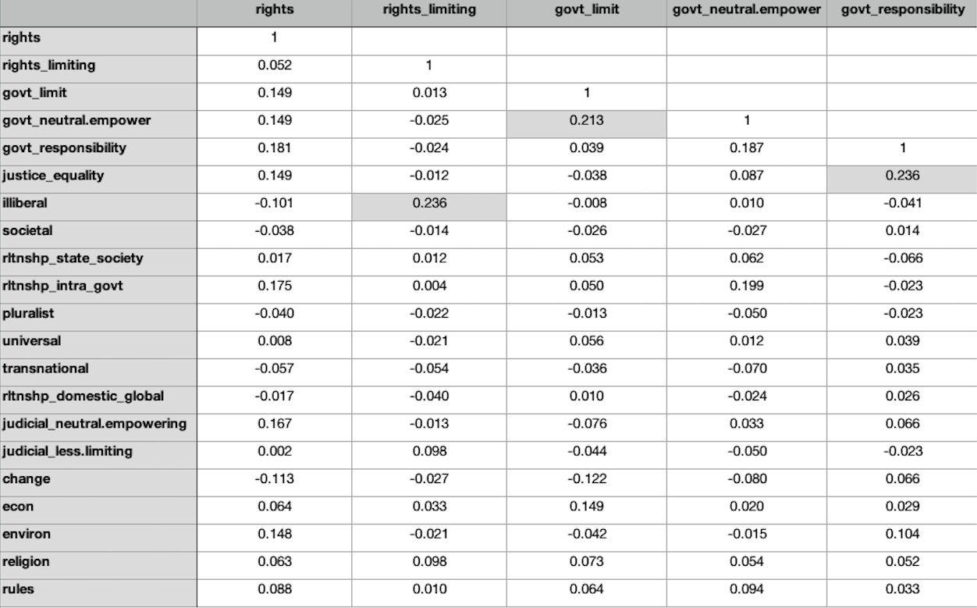

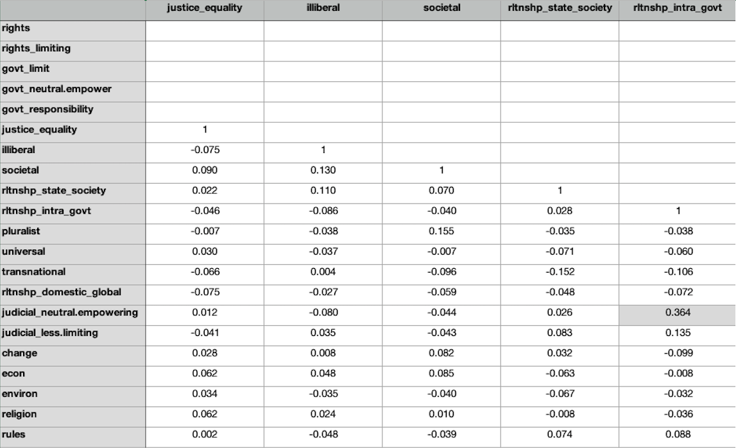

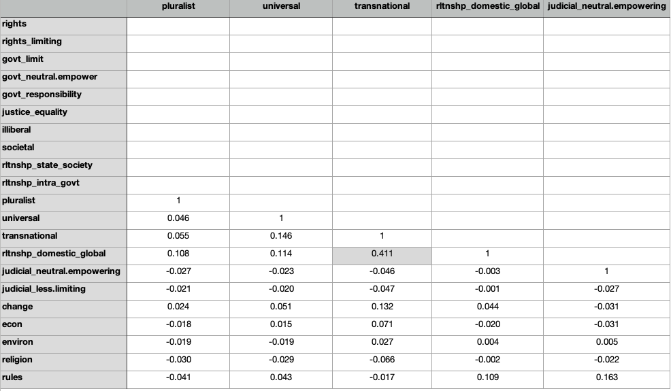

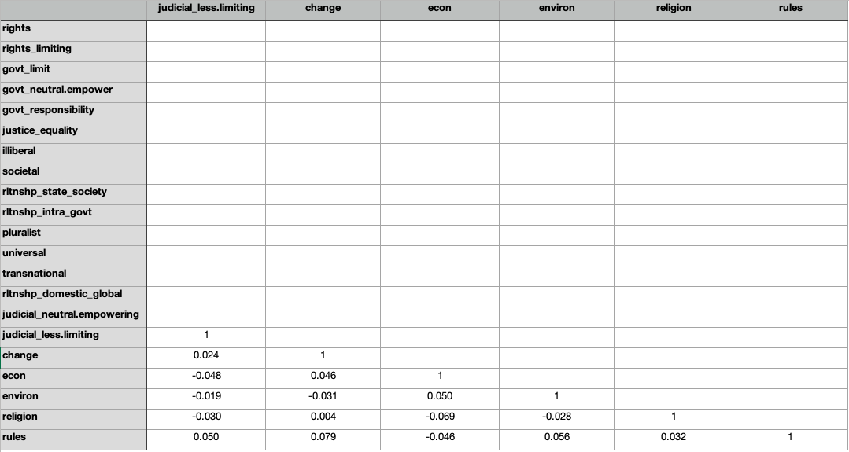

https://scholar.google.com/intl/en/scholar/inclusion.html#content
https://scholar.google.com/scholar?q=+%22The+Usurped+Powers+of+the+Senate%22&btnG=&hl= en&as_sdt=0%2C47
This figure includes ACCs in many publications that we ultimately dropped from the sample, including 75 articles in Chinese as well as at least 50 publications that were book reviews, conference papers, or were unattributed.
Some publications included two ACCs.
In particular, searching 2013 by itself returned 32 publications in which an ACC appeared in the abstract or on the first page (rather than in the title) that Google Scholar did not then return when the 2009-2013 interval was re-searched, as described below.
It was of course also possible that we missed ACCs because a publication (of any year) began to be indexed by Google Scholar only after we conducted our search. Again, we had no reason to believe this would be the case, disproportionately, for any one year.

