Online Appendix

FIGURE A1

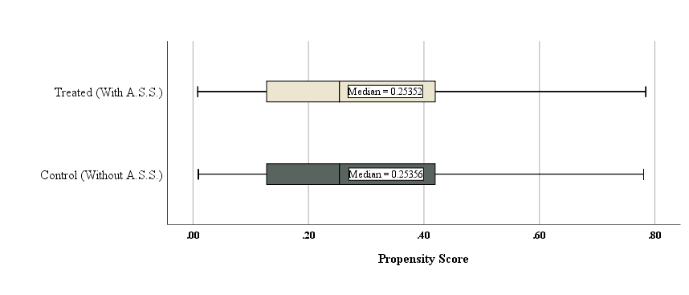

FIGURE A1.

Distribution of PS (PS Box Plot) - Weighted Matched Sample.
Note. This figure displays the distribution of the propensity scores of the two groups (with and without activatable suspended sentences) for the entire sample. The box plots show that the distributions of the two groups are very similar and hence, they are well balanced.

FIGURE A2

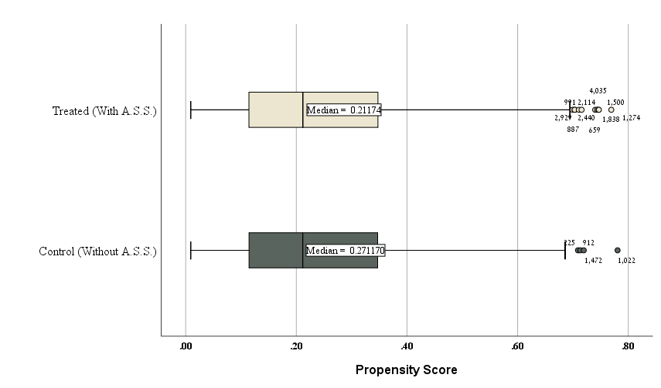

FIGURE A2.
Distribution of PS (PS Box Plot) - Weighted Matched Sample - Minor Offenses.
Note. This figure displays the distribution of the propensity scores of the two groups for minor offenses. The box plots show that the distributions of the two groups are very similar and hence, they are well balanced.

FIGURE A3
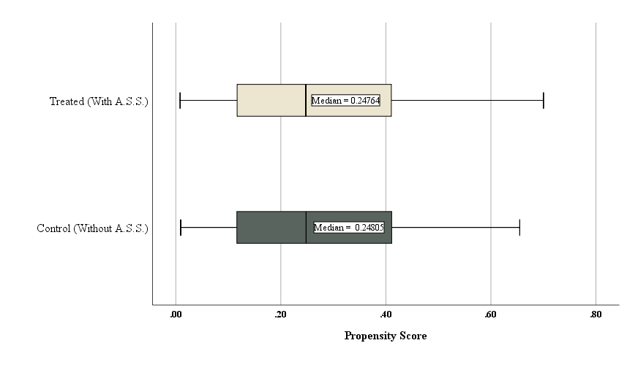
FIGURE A3.
Distribution of PS (PS Box Plot) - Weighted Matched Sample – Mid-range Offenses.

Note. This figure displays the distribution of the propensity scores of the two groups for the mid-range offenses. The box plots show that the distributions of the two groups are very similar and hence, they are well balanced.

FIGURE A4

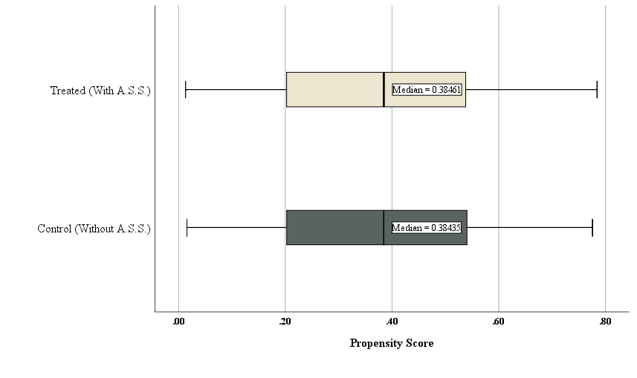

FIGURE A4.
Distribution of PS (PS Box Plot)- Weighted Matched Sample - Serious Offenses.

Note. This figure displays the distributions of propensity scores of the two groups for the serious offenses. The box plots show that the distributions of the two groups are very similar and hence, they are well balanced.

FIGURE A5

FIGURE A5.
Rates of Imprisonment by Research Group and Offense Severity Unmatched Sample.
Note. This figure displays the proportion of sentences which includes immediate imprisonment for defendants with and without an activatable suspended sentence (A.S.S.), for the three different offense severity categories in the unmatched sample.

TABLE A1

TABLE A1. Mann-Whitney Test to Compare Differences Between Two Independent Groups (With and Without an Activatable Suspended Sentence [A.S.S.]) by Offense Severity (Continuous Dependent Variables)
Offense Severity | Variables | Research Groups | N | Median (Q1, Q3) | Mean (SD) | Z | P (2-tailed)
Minor | Age | Without an A.S.S. | 2,424 | 36 (28, 45) | 37.51 (11.29) | -1.24 | 0.214
 |  | With an A.S.S. | 2,424 | 36 (29, 46) | 38.06 (11.83)
 | Total Offenses | Without an A.S.S. | 2,424 | 1 (1, 2) | 1.67 (1.07) | -0.19 | 0.847
 |  | With an A.S.S. | 2,424 | 1 (1, 2) | 1.63 (0.91)
 | Minor OS | Without an A.S.S. | 2,424 | 0.165 (0.04, 0.24) | 0.160 (0.10) | -0.87 | 0.383
 |  | With an A.S.S. | 2,424 | 0.165 (0.04, 0.24) | 0.163 (0.10)
Mid-range | Age | Without an A.S.S. | 958 | 35 (27, 45) | 36.75 (11.64) | -0.25 | 0.803
 |  | With an A.S.S. | 958 | 35 (27, 45) | 36.96 (12.00)
 | Total Offenses | Without an A.S.S. | 958 | 2 (1, 3) | 2.06 (1.21) | -0.34 | 0.738
 |  | With an A.S.S. | 958 | 2 (1, 3) | 2.04 (1.09)
 | Mid-range OS | Without an A.S.S. | 958 | 0.448 (0.42, 0.61) | 0.497 (0.10) | -0.34 | 0.736
 |  | With an A.S.S. | 958 | 0.453 (0.42, 0.61) | 0.498 (0.09)
Serious | Age | Without an A.S.S. | 1,193 | 32 (26, 42) | 34.66 (10.95) | -0.46 | 0.645
 |  | With an A.S.S. | 1,193 | 32 (26, 42) | 34.50 (11.01)
 | Total Offenses | Without an A.S.S. | 1,193 | 2 (1, 3) | 2.27 (1.57) | -1.653 | 0.098
 |  | With an A.S.S. | 1,193 | 2 (1, 3) | 2.33 (1.45)
 | Serious OS | Without an A.S.S. | 1,193 | 0.792 (0.72, 0.87) | 0.793 (0.09) | -1.08 | 0.281
 |  | With an A.S.S. | 1,193 | 0.792 (0.69, 0.87) | 0.788 (0.10)

Note. This table presents the balance of the main continuous variables (age, number of offenses and offense severity) before they were converted to categorical variables. Since the dependent variables are not normally distributed, we used a Mann Whitney test for these variables and found no significant differences between the two groups.

TABLE A2

TABLE A2. Logistic Regression of the Likelihood of an Imprisonment Sentence After Matching for the Serious Offenses
Dependent Variable = Imprisonment (ref. No)
 | Serious Offense – Weighted Matched Sub-sample
 | B | SE | OR | 95% CI
With an Activatable Suspended Sentence | -0.54*** | 0.12 | 0.58 | 0.46, 0.74
Intercept | 1.90*** | 0.09 | 6.71
N | 1,769
N (Weighted) | 2, 112
***p≤0.001

Note. This table presents the results of logistic regression after removing the matched pairs in which at least one of the cases (either treatment or control) has Instance = 0 or Previous Aiding Illegal Aliens Offense = 1. The effect of the treatment after this removal is stronger than the effect found in Table 6, indicating that removing these variables from the matching process did not bias the result.

TABLE A3

TABLE A3. Logistic Regression of the Likelihood of Imposing Imprisonment – Before Matching
Number of Observation = 31,423
Dependent Variable = Imprisonment (ref. No)
OR | SE | B
2.44 | 0.06 | 0.89*** | With an Activatable Suspended Sentence (A.S.S.)
 |  |  | Offense Severity (OS) (ref. up to .34)
15.73 | .060 | 2.76*** | OS 0.66+
4.44 | 0.05 | 1.49*** | OS 0.341–0.65
 |  |  | OS x with an A.S.S.
0.17 | 0.12 | -1.80*** | OS 0.66+ x with an A.S.S.
0.43 | .110 | -0.85*** | OS 0.341–0.65 x with an A.S.S.
0.36 | 0.10 | -1.02*** | Female defendant
0.88  1.03  1.04 | 0.07  0.07  0.06 | -0.13⁺  0.03  0.04 | Age (ref. 18–24)  45+  35–44  25–34
0.70 | 0.04 | -0.36*** | Jewish defendant
0.93 | 0.04 | -0.08* | Parenthood
1.55 | 0.05 | 0.44*** | Previous activating S.S. (ref. without)
2.31 | 0.04 | 0.84*** | Previous Imprisonment
1.02 | 0.00 | 0.02*** | Previous convictions
1.07 | 0.04 | -0.01 | Previous Juvenile Record
1.07 | 0.04 | 0.06 | Previous Property Offense
1.14 | 0.04 | 0.13*** | Previous Bodily Harm Offense
0.97 | 0.04 | -0.04 | Previous Drug Offense
1.22 | 0.09 | 0.20⁺ | Previous Aiding illegal aliens Offense
0.98 | 0.04 | -0.02 | Previous Judicial Authority Offense
1.11 | 0.04 | 0.10** | Previous Other Offense
1.35  0.90  1.88  1.62  1.39 | 0.06  0.06  0.06  0.06  0.06 | 0.30***  -0.10⁺  0.63***  0.49***  0.33*** | Court Regions (ref. Southern District)  Central District  Haifa District  Jerusalem District  Northern District  Tel Aviv District
5.59  1.57  1.39  1.57  2.92 | 0.10  0.07  0.06  0.06  0.08 | 1.72***  0.45***  0.33***  0.45***  1.07*** | Principal Offense Type (ref. Drug Offenses)  Aiding illegal aliens Offense  Bodily Harm Offenses  Property Offenses  Public Order Offenses  Other Offenses
1.70 | 0.04 | 0.50*** | Multiple Charges (ref. One)  More than One
1.70  2.90 | 0.04  0.05 | 0.53***  1.06*** | Additional minor Offenses (ref. without)  One  More than One
1.00 | 0.00 | -0.01*** | First Offense to Sentencing (month)
9.45 | 0.04 | 2.25*** | Remand
0.66  0.65 | 0.05  0.07 | -0.41***  -0.43*** | Plea Bargain (ref. without)  With  Unknown
0.14 | 0.14 | -1.97*** | Instance (ref. Appeal Court)  First Instance
0.30 | 0.17 | -1.22*** | Intercept
 |  | 23320.83 | -2 Log likelihood
 |  | 17795.07*** | Chi square
 |  | 0.592 | Nagelkerke R square
⁺p<0.1; *p<0.05; **p<0.01; ***p≤0.001

TABLE A4

TABLE A4. Logistic Regression of the Likelihood of Imposing Imprisonment After Matching for Serious Offense
Dependent Variable = Imprisonment (ref. No)
 | Sub-sample 1: Cases with a Relatively Short Activatable Suspended Sentence and the Cases Matched to them |  |  |  | Sub-sample 2: Cases with a Relatively Long Activatable Suspended Sentence and the Cases Matched to them
 | B | SE | OR | 95% CI | B | SE | OR | 95% CI
With an Activatable Suspended Sentence | -0.14 | 0.20 | 0.87 | 0.59, 1.29 | -0.68*** | 0.14 | 0.51 | 0.38, 0.66
Intercept | 1.89*** | 0.14 | 6.63 |  | 1.93*** | 0.11 | 6.90
N | 802 |  |  |  | 1,305
N (Weighted) | 854 |  |  |  | 1,532
***p≤0.001

Note. This table displays the results of logistic regression of the likelihood of imprisonment for two sub-samples of the serious offenses sample: First, for cases in which the term of the activatable suspended sentence is shorter than or equal to the median sentence for the principal offense; Second, for cases with an activatable suspended sentence which is longer than the median immediate prison sentence for the principal offense.

TABLES A5 (A & B)

TABLE A5(A). Greenland Sensitivity Analysis for the Entire Sample - Assuming Positive Association of the Unobserved Confounding Variable on the Outcome (Imprisonment)
P_{U1} | P_{U0} | OR_{XU} |  | OR_{YU}
 |  |  |  | 1.5 | 2 | 3 | 4 | 5
0.05 | 0.20 | 0.21 | OR_{XY*CU=} | 1.34 (1.23, 1.46) | 1.42 (1.31, 1.55) | 1.59 (1.45, 1.73) | 1.73 (1.59, 1.90) | 1.87 (1.71, 2.05)
0.10 | 0.05 | 2.11 |  | 1.22 (1.12, 1.32) | 1.19 (1.09, 1.29) | 1.14 (1.05, 1.24) | 1.10 (1.01, 1.20) | 1.07 (0.98, 1.16)
0.10 | 0.30 | 0.26 |  | 1.37 (1.25, 1.49) | 1.47 (1.35, 1.61) | 1.66 (1.52, 1.82) | 1.82 (1.66, 2.00) | 1.96 (1.78, 2.15)
0.10 | 0.40 | 0.17 |  | 1.42 (1.30, 1.56) | 1.59 (1.45, 1.74) | 1.87 (1.70, 2.05) | 2.11 (1.92, 2.32) | 2.31 (2.10, 2.55)
0.20 | 0.10 | 2.25 |  | 1.19 (1.09, 1.29) | 1.14 (1.05, 1.24) | 1.07 (0.98, 1.16) | 1.01 (0.93, 1.11) | 0.97 (0.89, 1.06)
0.20 | 0.40 | 0.38 |  | 1.36 (1.25, 1.48) | 1.45 (1.33, 1.58) | 1.60 (1.47, 1.75) | 1.71 (1.57, 1.88) | 1.80 (1.64, 1.97)
0.20 | 0.50 | 0.25 |  | 1.42 (1.30, 1.55) | 1.56 (1.43, 1.70) | 1.78 (1.62, 1.95) | 1.95 (1.77, 2.14) | 2.08 (1.89, 2.29)
0.30 | 0.10 | 3.86 |  | 1.14 (1.04, 1.24) | 1.05 (0.97, 1.15) | 0.94 (0.86, 1.02) | 0.85 (0.78, 0.93) | 0.79 (0.72, 0.87)
0.30 | 0.30 | 1.00 |  | 1.25 (1.15, 1.35) | 1.25 (1.15, 1.36) | 1.25 (1.14, 1.36) | 1.25 (1.14, 1.36) | 1.25 (1.14, 1.36)
0.30 | 0.50 | 0.43 |  | 1.35 (1.24, 1.47) | 1.44 (1.32, 1.57) | 1.56 (1.43, 1.70) | 1.64 (1.50, 1.79) | 1.70 (1.55, 1.86)
0.40 | 0.10 | 6.00 |  | 1.09 (1.00, 1.19) | 0.98 (0.90, 1.07) | 0.83 (0.76, 0.91) | 0.74 (0.67, 0.81) | 0.67 (0.61, 0.74)
0.40 | 0.20 | 2.67 |  | 1.14 (1.05, 1.24) | 1.07 (0.98, 1.16) | 0.97 (0.89, 1.06) | 0.91 (0.83, 0.99) | 0.86 (0.79, 0.95)
0.40 | 0.50 | 0.67 |  | 1.30 (1.19, 1.41) | 1.34 (1.23, 1.45) | 1.38 (1.27, 1.51) | 1.42 (1.30, 1.55) | 1.44 (1.32, 1.57)
0.50 | 0.20 | 4.00 |  | 1.10 (1.01, 1.20) | 1.00 (0.91, 1.09) | 0.87 (0.80, 0.96) | 0.80 (0.73, 0.88) | 0.75 (0.68, 0.82)
0.50 | 0.30 | 2.33 |  | 1.15 (1.05, 1.25) | 1.08 (0.99, 1.18) | 1.00 (0.91, 1.09) | 0.95 (0.87, 1.04) | 0.91 (0.83, 1.00)
0.50 | 0.40 | 1.50 |  | 1.20 (1.10, 1.30) | 1.16 (1.07, 1.27) | 1.12 (1.03, 1.22) | 1.10 (1.01, 1.20) | 1.08 (0.99, 1.18)

Note. This table presents the estimated OR_{XY*CU} and confidence interval (95% CI) using Greenland sensitivity analysis assuming positive association of the unobserved confounding variable on the outcome (imprisonment) (where c = the variables included in the PS model; u = the unobserved binary confounder; P_{U1} and P_{U0} represent the choice of the prevalence of the unobserved confounding variable among treated and untreated, and OR_{YU} represents the unobserved confounding variable and imprisonment odds ratio).
This table shows that, for a positive association and an OR_{YU} of 3 and above, the relationship between an activatable suspended sentence and imprisonment may change direction to negative for some of the combinations.

TABLE A5(B). Greenland Sensitivity Analysis for the Entire Sample - Assuming Negative Association of the Unobserved Confounding Variable on the Outcome (Imprisonment)
P_{U1} | P_{U0} | OR_{XU} |  | OR_{YU}
 |  |  |  | 0.67 | 0.5 | 0.33 | 0.25 | 0.20
0.05 | 0.20 | 0.21 | OR_{XY*CU=} | 1.18 (1.09, 1.29) | 1.15 (1.06, 1.25) | 1.12 (1.03, 1.22) | 1.10 (1.01, 1.20) | 1.09 (1.00, 1.19)
0.10 | 0.05 | 2.11 |  | 1.27 (1.17, 1.38) | 1.28 (1.18, 1.39) | 1.29 (1.19, 1.40) | 1.30 (1.19, 1.41) | 1.30 (1.20, 1.41)
0.10 | 0.30 | 0.26 |  | 1.16 (1.07, 1.26) | 1.12 (1.02, 1.21) | 1.07 (0.98, 1.16) | 1.05 (0.96, 1.14) | 1.03 (0.94, 1.12)
0.10 | 0.40 | 0.17 |  | 1.12 (1.03, 1.22) | 1.05 (0.96, 1.15) | 0.98 (0.90, 1.07) | 0.94 (0.86, 1.03) | 0.92 (0.84, 1.01)
0.20 | 0.10 | 2.25 |  | 1.29 (1.19, 1.40) | 1.32 (1.21, 1.43) | 1.34 (1.23, 1.46) | 1.36 (1.25, 1.48) | 1.37 (1.25, 1.49)
0.20 | 0.40 | 0.38 |  | 1.16 (1.06, 1.26) | 1.11 (1.02, 1.21) | 1.05 (0.97, 1.15) | 1.03 (0.94, 1.12) | 1.01 (0.93, 1.10)
0.20 | 0.50 | 0.25 |  | 1.11 (1.02, 1.22) | 1.04 (0.95, 1.13) | 0.96 (0.88, 1.05) | 0.92 (0.84, 1.00) | 0.89 (0.81, 0.97)
0.30 | 0.10 | 3.86 |  | 1.34 (1.23, 1.46) | 1.39 (1.28, 1.52) | 1.46 (1.34, 1.59) | 1.49 (1.37, 1.62) | 1.51 (1.38, 1.65)
0.30 | 0.30 | 1.00 |  | 1.25 (1.15, 1.35) | 1.25 (1.15, 1.35) | 1.25 (1.15, 1.36) | 1.25 (1.14, 1.36) | 1.25 (1.14, 1.36)
0.30 | 0.50 | 0.43 |  | 1.16 (1.06, 1.26) | 1.10 (1.01, 1.20) | 1.04 (0.95, 1.13) | 1.01 (0.92, 1.10) | 0.98 (0.90, 1.08)
0.40 | 0.10 | 6.00 |  | 1.39 (1.27, 1.52) | 1.48 (1.36, 1.62) | 1.59 (1.45, 1.74) | 1.65 (1.51, 1.80) | 1.69 (1.54, 1.84)
0.40 | 0.20 | 2.67 |  | 1.34 (1.23, 1.46) | 1.40 (1.29, 1.53) | 1.47 (1.35, 1.61) | 1.51 (1.39, 1.65) | 1.54 (1.41, 1.68)
0.40 | 0.50 | 0.67 |  | 1.20 (1.10, 1.30) | 1.17 (1.07, 1.27) | 1.13 (1.04, 1.23) | 1.11 (1.02, 1.21) | 1.10 (1.01, 1.20)
0.50 | 0.20 | 4.00 |  | 1.39 (1.28, 1.52) | 1.50 (1.37, 1.63) | 1.62 (1.49, 1.77) | 1.70 (1.55, 1.85) | 1.74 (1.59, 1.91)
0.50 | 0.30 | 2.33 |  | 1.34 (1.24, 1.46) | 1.41 (1.30, 1.54) | 1.50 (1.37, 1.63) | 1.55 (1.42, 1.69) | 1.58 (1.44, 1.73)
0.50 | 0.40 | 1.50 |  | 1.30 (1.19, 1.41) | 1.33 (1.22, 1.45) | 1.37 (1.26, 1.49) | 1.40 (1.28, 1.52) | 1.41 (1.29, 1.54)

Note. This table presents the estimated OR_{XY*CU} and confidence interval (95% CI) using Greenland sensitivity analysis assuming negative association of the unobserved confounding variable on the outcome (imprisonment) (where c = the variables included in the PS model; u = the unobserved binary confounder; P_{U1} and P_{U0} represent the choice of the prevalence of the unobserved confounding variable among treated and untreated, and OR_{YU} represents the unobserved confounding variable and imprisonment odds ratio).
This table shows that, for a negative association with the unobserved confounding variable, the result is somewhat more stable, but it is still not robust.
TABLES A6 (A & B)

TABLE A6(A). Greenland Sensitivity Analysis for the Serious Offenses (OS ≥0.66) - Assuming Positive Association of the Unobserved Confounding Variable on the Outcome (Imprisonment)
P_{U1} | P_{U0} | OR_{XU} |  | OR_{YU}
 |  |  |  | 1.5 | 2 | 3 | 4 | 5
0.05 | 0.20 | 0.21 | OR_{XY*CU=} | 0.65 (0.52, 0.81) | 0.69 (0.55, 0.87) | 0.77 (0.61, 0.97) | 0.84 (0.67, 1.06) | 0.90 (0.72, 1.14)
0.10 | 0.05 | 2.11 |  | 0.59 (0.47, 0.74) | 0.58 (0.46, 0.72) | 0.55 (0.44, 0.69) | 0.53 (0.43, 0.67) | 0.52 (0.41, 0.65)
0.10 | 0.30 | 0.26 |  | 0.66 (0.53, 0.83) | 0.71 (0.57, 0.90) | 0.80 (0.64, 1.02) | 0.88 (0.70, 1.12) | 0.95 (0.75, 1.20)
0.10 | 0.40 | 0.17 |  | 0.69 (0.54, 0.87) | 0.77 (0.60, 0.98) | 0.90 (0.71, 1.15) | 1.02 (0.80, 1.30) | 1.12 (0.87, 1.44)
0.20 | 0.10 | 2.25 |  | 0.58 (0.46, 0.72) | 0.55 (0.44, 0.69) | 0.52 (0.41, 0.65) | 0.49 (0.39, 0.62) | 0.47 (0.37, 0.59)
0.20 | 0.40 | 0.38 |  | 0.66 (0.52, 0.83) | 0.70 (0.56, 0.88) | 0.78 (0.62, 0.98) | 0.83 (0.66, 1.05) | 0.87 (0.69, 1.10)
0.20 | 0.50 | 0.25 |  | 0.69 (0.54, 0.87) | 0.75 (0.60, 0.95) | 0.86 (0.68, 1.09) | 0.94 (0.74, 1.20) | 1.01 (0.79, 1.28)
0.30 | 0.10 | 3.86 |  | 0.55 (0.44, 0.69) | 0.51 (0.41, 0.64) | 0.45 (0.39, 0.62) | 0.41 (0.33, 0.52) | 0.38 (0.30, 0.49)
0.30 | 0.30 | 1.00 |  | 0.60 (0.48, 0.75) | 0.60 (0.48, 0.75) | 0.60 (0.48, 0.76) | 0.60 (0.48, 0.76) | 0.60 (0.48, 0.76)
0.30 | 0.50 | 0.43 |  | 0.66 (0.52, 0.82) | 0.70 (0.55, 0.87) | 0.76 (0.60, 0.95) | 0.79 (0.63, 1.00) | 0.82 (0.65, 1.04)
0.40 | 0.10 | 6.00 |  | 0.53 (0.42, 0.67) | 0.47 (0.73, 0.60) | 0.40 (0.32, 0.51) | 0.36 (0.28, 0.46) | 0.33 (0.25, 0.42)
0.40 | 0.20 | 2.67 |  | 0.55 (0.44, 0.70) | 0.52 (0.41, 0.65) | 0.47 (0.37, 0.59) | 0.44 (0.35, 0.56) | 0.42 (0.33, 0.53)
0.40 | 0.50 | 0.67 |  | 0.63 (0.50, 0.79) | 0.65 (0.52, 0.81) | 0.67 (0.53, 0.84) | 0.68 (0.54, 0.86) | 0.70 (0.55, 0.88)
0.50 | 0.20 | 4.00 |  | 0.53 (0.42, 0.67) | 0.48 (0.38, 0.61) | 0.42 (0.33, 0.54) | 0.39 (0.30, 0.49) | 0.36 (0.28, 0.46)
0.50 | 0.30 | 2.33 |  | 0.56 (0.44, 0.70) | 0.52 (0.42, 0.66) | 0.48 (0.38, 0.61) | 0.46 (0.36, 0.58) | 0.44 (0.35, 0.56)
0.50 | 0.40 | 1.50 |  | 0.58 (0.46, 0.72) | 0.56 (0.45, 0.71) | 0.54 (0.43, 0.68) | 0.53 (0.42, 0.67) | 0.52 (0.41, 0.66)
Note. This table presents the estimated OR_{XY*CU} and confidence interval (95% CI) using Greenland sensitivity analysis assuming positive association of the unobserved confounding variable on the outcome (imprisonment) (where c = the variables included in the PS model; u = the unobserved binary confounder; P_{U1} and P_{U0} represent the choice of the prevalence of the unobserved confounding variable among treated and untreated, and OR_{YU} represents the unobserved confounding variable and imprisonment odds ratio).
This table shows that, for serious offenses, the results are robust with respect to the existence of a potential unobserved confounding variable. For a positive association only when the OR_{YU} is equal to or larger than 4 and the difference in prevalence is 30 percent, the relationship between an activatable suspended sentence and imprisonment may change direction to positive, but the result is not significant. It should be emphasized that, in those cases, the OR_{XY*CU} is only slightly higher than one.
TABLE A6(B). Greenland Sensitivity Analysis for Serious Offenses (OS ≥0.66) - Assuming Negative Association of the Unobserved Confounding Variable on the Outcome (Imprisonment)
P_{U1} | P_{U0} | OR_{XU} |  | OR_{YU}
 |  |  |  | 0.67 | 0.5 | 0.33 | 0.25 | 0.20
0.05 | 0.20 | 0.21 | OR_{XY*CU=} | 0.57 (0.46, 0.72) | 0.56 (0.44, 0.70) | 0.54 (0.43, 0.68) | 0.53 (0.42, 0.67) | 0.53 (0.42, 0.67)
0.10 | 0.05 | 2.11 |  | 0.61 (0.49, 0.77) | 0.62 (0.50, 0.77) | 0.63 (0.50, 0.78) | 0.63 (0.50, 0.79) | 0.63 (0.50, 0.79)
0.10 | 0.30 | 0.26 |  | 0.56 (0.45, 0.71) | 0.54 (0.43, 0.68) | 0.52 (0.41, 0.65) | 0.51 (0.40, 0.64) | 0.50 (0.39, 0.63)
0.10 | 0.40 | 0.17 |  | 0.54 (0.43, 0.69) | 0.51 (0.40, 0.64) | 0.47 (0.37, 0.60) | 0.46 (0.36, 0.58) | 0.45 (0.35, 0.57)
0.20 | 0.10 | 2.25 |  | 0.62 (0.50, 0.78) | 0.64 (0.51, 0.80) | 0.65 (0.52, 0.81) | 0.66 (0.52, 0.82) | 0.66 (0.53, 0.83)
0.20 | 0.40 | 0.38 |  | 0.56 (0.45, 0.70) | 0.54 (0.43, 0.67) | 0.51 (0.40, 0.64) | 0.50 (0.39, 0.63) | 0.49 (0.39, 0.62)
0.20 | 0.50 | 0.25 |  | 0.54 (0.43, 0.68) | 0.50 (0.40, 0.64) | 0.46 (0.37, 0.59) | 0.44 (0.35, 0.57) | 0.43 (0.34, 0.55)
0.30 | 0.10 | 3.86 |  | 0.70 (0.56, 0.89) | 0.67 (0.54, 0.85) | 0.70 (0.56, 0.89) | 0.72 (0.57, 0.91) | 0.73 (0.58, 0.92)
0.30 | 0.30 | 1.00 |  | 0.60 (0.48, 0.75) | 0.60 (0.48, 0.75) | 0.60 (0.48, 0.76) | 0.60 (0.48, 0.76) | 0.60 (0.48, 0.76)
0.30 | 0.50 | 0.43 |  | 0.56 (0.45, 0.70) | 0.53 (0.42, 0.67) | 0.50 (0.40, 0.63) | 0.49 (0.39, 0.62) | 0.48 (0.38, 0.60)
0.40 | 0.10 | 6.00 |  | 0.67 (0.53, 0.85) | 0.72 (0.57, 0.91) | 0.77 (0.61, 0.97) | 0.80 (0.63, 1.01) | 0.82 (0.64, 1.03)
0.40 | 0.20 | 2.67 |  | 0.65 (0.52, 0.81) | 0.68 (0.54, 0.85) | 0.71 (0.57, 0.90) | 0.73 (0.58, 0.92) | 0.75 (0.59, 0.94)
0.40 | 0.50 | 0.67 |  | 0.58 (0.46, 0.73) | 0.57 (0.45, 0.71) | 0.55 (0.44, 0.69) | 0.54 (0.43, 0.68) | 0.53 (0.42, 0.67)
0.50 | 0.20 | 4.00 |  | 0.64 (0.53, 0.85) | 0.72 (0.57, 0.91) | 0.79 (0.62, 0.99) | 0.82 (0.65, 1.04) | 0.84 (0.67, 1.07)
0.50 | 0.30 | 2.33 |  | 0.65 (0.52, 0.82) | 0.68 (0.54, 0.86) | 0.72 (0.58, 0.91) | 0.75 (0.59, 0.94) | 0.76 (0.60, 0.97)
0.50 | 0.40 | 1.50 |  | 0.63 (0.50, 0.78) | 0.64 (0.51, 0.81) | 0.66 (0.53, 0.83) | 0.68 (0.54, 0.85) | 0.68 (0.54, 0.86)
Note. This table presents the estimated OR_{XY*CU} and confidence interval (95% CI) using Greenland sensitivity analysis assuming negative association of the unobserved confounding variable on the outcome (imprisonment) (where c = the variables included in the PS model; u = the unobserved binary confounder; P_{U1} and P_{U0} represent the choice of the prevalence of the unobserved confounding variable among treated and untreated, and OR_{YU} represents the unobserved confounding variable and imprisonment odds ratio).
This table shows that, for serious offenses, the results are robust with respect to the existence of a potential unobserved confounding variable. For a negative association only when the OR_{YU} is equal to or lower than 0.25 and the difference in prevalence is 30 percent, the OR_{YX*CU} loses its significance, but still does not change the direction.

Further Sensitivity Analysis – Optimal Matching Sample

To further strengthen the robustness and validity of the results, we have created an additional sample by using optimal matching without replacement. In this method we matched every defendant with an activatable suspended sentence to a defendant without an activatable suspended sentence (PSM 1:1), resulting in the smallest possible average difference in propensity score between the defendants in each pair over all pairs (Stuart 2010,10). The advantage of this method is that it includes the treatment group in its entirety. In matching without replacement each control case can be used as a match only once. Once again, we required exact matching in the most substantial confounds: the type of principal offense and the severity of the principal offense (measured by the maximum sentence prescribed for that offense). This process resulted in a dataset of 4,580 pairs (that is, 9,160, half of which with an activatable suspended sentence and the other half without).
Before presenting the results of logistic regression on the probability of imposing imprisonment, we examined whether the propensity score analysis indeed provided balanced samples that eliminated the differences between the groups. Table A7 below presents the standardized differences in percentages (%) for all the covariates included in the propensity score model before and after matching at the different levels of the offense severity variable. Before matching, the two groups were unbalanced at each level of offense severity. The situation is different after matching: At the minor and mid-range severity levels, all the variables were well balanced. The absolute values of the standardized differences were lower than 10 percent. Again, this is a relatively strict standard (see Apel and Sweeten 2010, 543, who indicated that if the absolute values of standardized differences are lower than 20 percent across all variables, the result is considered well balanced). A good balance is also found in the category of serious offenses. Except for the variables remand and time from first offense to sentencing, in which the standardized differences in absolute value were greater than 10 percent but much smaller than 20 percent (Standardized Differences = |12 percent| and |11.44 percent| respectively), in the remaining variables, the standardized differences in absolute value were less than 10 percent.

TABLE A7

TABLE A7. Standardized Differences % - By an Activatable Suspended Sentence: Before and After Matching (Optimal Matching)
With and Without an Activatable Suspended Sentence
 | Minor Offenses |  | Mid-range Offenses |  | Severe Offenses
Variables | Before Matching  N= 19,012 | Matched  N= 4,852 | Before Matching  N= 7,013 | Matched  N= 1,920 | Before Matching  N= 5,397 | Matched  N= 2,388
Female | 4.74 | -0.71 | -1.63 | 3.63 | 1.71 | -2.74
45+ | 10.42 | -4.90 | 6.74 | -0.93 | 3.32 | -1.03
35-44 | 1.50 | 3.17 | 5.42 | 1.89 | 3.28 | 3.37
25-34 | -14.88 | 1.34 | -8.10 | 1.11 | -2.44 | 2.45
18-24 | -4.40 | -0.79 | 4.80 | 2.70 | 3.90 | -1.70
Jewish | -11.21 | 2.50 | 1.30 | 2.09 | 0.02 | 0.50
With Minor Child | 16.26 | -1.24 | 14.70 | 5.85 | 22.06 | 5.42
Previous Imprisonment | -52.49 | -2.81 | -67.77 | -5.55 | -81.22 | -6.90
Remand | -59.00 | 0 | -70.83 | -4.65 | -47.88 | -12.00
Central District | -3.36 | -2.22 | 1.23 | -1.92 | 0.30 | 4.25
Haifa District | 8.87 | 0.86 | 3.50 | 0.89 | -7.67 | -5.98
Jerusalem District | 10.53 | 1.00 | 17.86 | 0.33 | 9.15 | 2.10
Northern District | 5.62 | 0.13 | 1.68 | -0.34 | 4.41 | -1.86
Tel Aviv District | -3.07 | 1.35 | -0.33 | 3.69 | 5.52 | 3.09
Southern District | 13.70 | 0.50 | 18.50 | 2.00 | 8.00 | 1.80
Without Plea Bargain | 6.50 | 2.80 | -2.30 | -4.20 | -1.00 | 2.90
With Plea Bargain | -0.90 | 1.79 | -1.47 | -4.38 | -6.45 | 3.10
Unknown Plea Bargain | 8.00 | 0.50 | -0.55 | 1.29 | 8.63 | -0.85
With Previous A.S.S. | -39.10 | 1.53 | -29.52 | -7.18 | -58.11 | -9.40
Previous Property Offense | -37.36 | 1.70 | -28.70 | -2.77 | -47.14 | -5.42
Previous Bodily Offense | -43.26 | 1.25 | -60.15 | -0.65 | -25.28 | 3.67
Previous Drug Offense | -42.45 | 0.53 | -7.75 | 1.25 | -52.27 | -3.82
Previous Judicial Authority Offense | -30.83 | 1.82 | -30.62 | -3.25 | -32.21 | -0.90
Previous Other Offense | -34.48 | 2.38 | -43.40 | 0 | -30.12 | -3.01
Previous Juvenile Record | -8.02 | 1.95 | -6.13 | -1.80 | -26.00 | -2.71
Multiple Charges (more than one) | 2.60 | 4.00 | 8.68 | 1.28 | 25.34 | 5.03
Without Additional Minor Offenses | -13.80 | 0.43 | -30.00 | -1.30 | -11.80 | -6.10
One Additional Minor Offenses | -8.57 | 0.29 | -17.49 | 2.47 | -7.74 | -5.37
More than One Additional Offenses | -9.64 | 0.28 | -16.81 | -4.40 | -5.10 | -1.15
First Offense to Sentencing (months) | -15.35 | 0.87 | -33.03 | -4.43 | -41.78 | -11.44
Principal Offense Penalty (months) | 43.43 | -0.35 | 7.81 | -1.86 | 4.08 | 0.08
Previous Convictions | 30.51 | 2.24 | 19.43 | -2.33 | 41.40 | 6.40

Note. Before Matching: Unbalanced variables (that is, standardized differences that were larger in absolute values than 10 percent) were highlighted in dark gray. Balanced variables (that is, standardized differences of less than 10 percent in absolute values) were highlighted in light gray.

Table A8 presents the results of a logistic regression for a sample after matching, using optimal matching methods. The results show that the trend is similar and consistent with the matched sample with caliper and with replacement.
According to Table A8 for minor offenses (OS ≤ 0.34) the odds ratio of an imprisonment sentence is 1.73 times higher for defendants with an activatable suspended sentence. A smaller but similar effect in direction is found for mid-range offenses (OR = 1.25, p = 0.03) (This result was calculated by subtracting the interaction effect (-0.33) from the coefficient of the main effect (0.55) = e^{0.55-0.33} = 1.25 (95 percent CI 1.02, 1.51).
Again, the opposite effect is found for serious offenses (OS ≥ 0.66). By subtracting the interaction effect (-0.97) from the coefficient of the main effect (0.55), we find that defendants with an activatable suspended sentence are less - not more – likely to be sentenced to a term of imprisonment than similar defendants without an activatable suspended sentence (e^{0.55-0.97}= 0.66 (95 percent CI 0.53, 0.81)). This consistent result reinforces the conclusion that a suspended sentence does, in fact, reduce the likelihood of imprisonment, as we hypothesized, for serious offenses.

TABLE A8

TABLE A8. Logistic Regression of the Likelihood of Imposing Imprisonment – Samples After Matching (With and Without a Caliper)
Dependent Variable = Imprisonment (ref. No)
 | Matched ¹ |  |  |  | Optimal Matching²
 | B | SE | OR | 95% CI | B | SE | OR | 95% CI
With an A.S.S. | 0.51*** | 0.06 | 1.66 | 1.47, 1.87 | 0.55*** | 0.06 | 1.73 | 1.53, 1.95
Offense Severity (OS) (ref. up to .34)
OS 0.66+ | 2.79*** | 0.09 | 14.25 | 11.84, 17.14 | 2.75*** | 0.10 | 15.64 | 12.98, 18.86
OS 0.341–0.65 | 1.53*** | 0.08 | 4.09 | 3.50, 4.77 | 1.59*** | 0.08 | 4.91 | 4.19, 5.77
OS x with an A.S.S.
OS 0.66+ x with an A.S.S. | -1.02*** | 0.13 | 0.41 | 0.32, 0.53 | -0.97*** | 0.13 | 0.38 | 0.30, 0.49
OS 0.341–0.65 x with an A.S.S. | -0.28* | 0.11 | 0.87 | 0.69, 1.08 | -0.33** | 0.12 | 0.72 | 0.57, 0.90
Intercept | -0.88*** | 0.05 | 0.42 |  | -0.91*** | 0.05 | 0.40
N  N (Weighted) | 8,013  9,150 |  |  |  | 9,160
-2 Log likelihood | 10698.14 |  |  |  | 10710.31
Chi square | 1902.46*** |  |  |  | 1912.11***
Nagelkerke R square | 0.251 |  |  |  | 0.252
*p<0.05; **p<0.01; ***p≤0.001
¹ After matching with caliper and with replacement.
² Optimal Matching (without caliper and without replacement).

Sensitivity Analysis – Rosenbaum Bounds Primal Approach
In the article, we used the Greenland sensitivity analysis. Another frequently used robustness check for matching without replacement where the outcome is binary is the Rosenbaum bounds (R-bounds) primal approach. It should be mentioned that the main reason for using Greenland's approach for the main sample (matched with caliper and with replacement) is that Rosenbaum bounds (R-bounds) primal approach is suitable for matching without replacement (Becker and Caliendo 2007, 6). For the purpose of testing the robustness of our results, we restrict the sensitivity analysis only to serious offenses sub-sample, since in this sub-sample the results of the Greenland sensitivity test show that it is unlikely that a potential unobserved variable explains the relations between an activatable suspended sentence and imprisonment.
In short, the R-bounds primal approach (for a review of other R-bounds methods, see Liu, Kuramoto, and Stuart 2014) assumes that there is an unobserved variable that is a perfect predictor of the outcome. The goal of the R-bounds primal approach is thus to find the thresholds of the association between the unobserved variable and the treatment (with an activatable suspended sentence) (OR_{XU}) that would lead to a non-significant effect of the treatment on the outcome in a crude matched analysis of the PSM sample. A higher value of (OR_{XU}) required to render the upper-bound p-value non-significant (for example, p > 0.05) is preferred, as it indicates that OR_{YX*CU} is more robust to unobserved bias, that is, a stronger association between the unobserved confounder and the treatment is necessary for the OR_{YX*CU} to become non-significant (Liu, Kuramoto, and Stuart 2014, 6–7). The R-bounds approach only uses the discordant pairs (those where the outcomes differ within the pair (as T) (meaning the treated did not have an outcome and the untreated had an outcome, and in which the treated had an outcome and the untreated did not (as a)) (see Liu, Kuramoto, and Stuart 2014, 6). In the matched sample for the serious offenses sub-sample, the estimations of a and T are 191 and 121, respectively.
After including the discordant pairs (a = 191, T = 121), the results of the R-bounds primal approach indicate that when OR_{XU} ≥ 3.93, the relationship between the treatment (with an activatable suspended sentence) and the outcome (imprisonment) loses its significance (with a value (p-value 0.051)). In other words, if there were an omitted variable with the odds of 3.93 or more predicting treatment selection, which was also highly correlated with imprisonment, then including this unobserved covariate in the matching analysis for a serious sub-sample would have rendered the difference between the groups on the likelihood of imposing imprisonment.
To illustrate the magnitude of hidden bias that would render our findings spurious, the critical levels of OR_{XU} ≥ 3.93 can be compared with the impact on being in the treatment group (with an activatable suspended sentence) of observed variables. Table A9 below presents the range of (OR_{XU}) after running logistic regression where the outcome is to be with an activatable suspended sentence.

TABLE A9
TABLE A9. Logistic Regression to Determine the Range of Odds Ratio (OR_{S}) (Before Matching – Serious Offenses)
Number of Observation = 5,39 7
Dependent Variable = With an A.S.S. (ref. Without)
OR | SE | B
1.62 | 0.25 | 0.48⁺ | Female defendant
1.01  1.01  0.91 | 0.17  0.14  0.11 | 0.01  0.00  -0.10 | Age (ref. 18–24)  45+  35–44  25–34
0.93 | 0.08 | -0.08 | Jewish defendant
0.78 | 0.09 | -0.25** | Parenthood
1.45 | 0.09 | 0.37*** | Previous Activating S.S. (ref. without)
3.03 | 0.09 | 1.11*** | Previous Imprisonment
1.01 | 0.01 | 0.01⁺ | Previous Convictions
0.99 | 0.09 | -0.01 | Previous Juvenile Record
1.32 | .090 | 0.28** | Previous Property Offense
1.15 | .080 | 0.14⁺ | Previous Bodily Harm Offense
2.09 | .080 | 0.74*** | Previous Drug Offense
1.22 | .240 | 0.20 | Previous Aiding Illegal Aliens Offense
1.04 | .080 | 0.03 | Previous Judicial Authority Offense
1.00 | .090 | 0.00 | Previous Other Offense
1.19  1.22  1.07  1.02  0.99 | .120  .120  0.14  .160  .120 | 0.18  0.20  0.07  0.02  -0.01 | Court Regions (ref. Southern District)  Central District  Haifa District  Jerusalem District  Northern District  Tel Aviv District
0.62  0.76  1.05 0.62  .400 | .350  0.12  .100  .190  .210 | -0.48  -0.27*  0.04  -0.48*  -0.91*** | Principal Offense Type (ref. Drug Offenses)  Aiding Illegal Aliens Offense  Bodily Harm Offenses  Property Offenses  Public Order Offenses  Other Offenses
.440 | 0.10 | -0.81*** | Multiple Charges (ref. One)  More than One
1.23  1.44 | 0.09  0.10 | 0.21*  0.36*** | Additional Minor Offenses (ref. without)  One  More than One
0.99 | 0.00 | -0.00 | First Offense to Sentencing (month)
2.39 | 0.11 | 0.87*** | Remand
0.97  0.75 | 0.10  0.16 | -0.03  -0.29⁺ | Plea Bargain (ref. without)  With  Unknown
1.19 | .200 | 0.17 | Instance (ref. Appeal Court)  First Instance
⁺p<0.10; *p<0.05; **p<0.01; ***p≤0.001

Table A9 shows that the ORs between the observed confounding variables and the treatment (with an activatable suspended sentence) range from 0.40 to 3.03, with the strongest factors being the previous imprisonment variable. In other words, none of the observed variables exceed the critical levels of OR_{XU} ≥ 3.93. Thus, it is very unlikely that a potential unobserved variable explains the relation between an activatable suspended sentence and imprisonment.

