**Supplementary materials**

**Additional analyses: Product prices and their differences deflated by CPI**

**MILK**



**Source**: TURKSTAT (2021c), and authors’ calculations

**EGGS**



**Source**: TURKSTAT (2021c), and authors’ calculations

**LEMONS**



**Source**: TURKSTAT (2021c), and authors’ calculations

**OLIVES**



**Source**: TURKSTAT (2021c), and authors’ calculations

|  |  |  |  |  |  |  |  |
| --- | --- | --- | --- | --- | --- | --- | --- |
| **Appendix: Household consumption by quintiles**  **Exchange rates**  Figure A1 shows the movements of CPI and the Manufacturing Producer Price Index (MPPI). Figure A2 shows that the continuous and rapid depreciation of the Turkish lira against the US dollar and euro that began in 2010 is the most crucial supply-side factor affecting prices. Virtually every sector in Turkey, including the agricultural sector, relies heavily on imported chemicals and energy. Since most agricultural input prices are tied to the US dollar, the cost of agricultural production has increased continuously since 2010. The weak Turkish lira also exacerbated the situation, further contributing to the steady increase of input costs, especially energy costs.  **Table A1:** Distribution of household consumption expenditure by quintiles | | | | | | | |
|  |  |  | **Quintiles ordered by income** | | | | |
| **Year** | **Expenditure types** | **Total** | **1. %20** | **2. %20** | **3. %20** | **4. %20** | **5. %20** |
| **2003** | Food and non-alcoholic beverages | 27.5 | 40.6 | 35.9 | 32.3 | 28.1 | 19.5 |
| Housing and rent | 28.3 | 29.7 | 30.2 | 29.7 | 28.6 | 26.6 |
| Transportation | 9.8 | 4.2 | 5.5 | 6.5 | 8.8 | 14.3 |
| **2007** | Food and non-alcoholic beverages | 23.6 | 34.8 | 29.2 | 26.0 | 22.6 | 18.3 |
| Housing and rent | 28.9 | 28.7 | 32.1 | 31.0 | 30.8 | 25.6 |
| Transportation | 11.1 | 5.9 | 7.9 | 9.4 | 11.2 | 14.4 |
| **2011** | Food and non-alcoholic beverages | 20.7 | 30.9 | 24.9 | 22.7 | 20.2 | 16.0 |
| Housing and rent | 25.8 | 31.1 | 30.1 | 28.0 | 25.2 | 22.2 |
| Transportation | 17.2 | 8.5 | 12.5 | 14.9 | 18.7 | 21.4 |
| **2015** | Food and non-alcoholic beverages | 20.2 | 30.2 | 26.3 | 22.6 | 20.5 | 14.6 |
| Housing and rent | 26.0 | 32.0 | 29.6 | 27.2 | 25.5 | 23.3 |
| Transportation | 17.0 | 8.2 | 11.9 | 15.9 | 17.3 | 21.0 |
| **2016** | Food and non-alcoholic beverages | 19.5 | 28.9 | 24.9 | 22.0 | 19.5 | 14.2 |
| Housing and rent | 25.2 | 32.0 | 28.4 | 26.9 | 25.0 | 21.7 |
| Transportation | 18.2 | 8.9 | 13.9 | 15.9 | 18.5 | 22.8 |
| **2017** | Food and non-alcoholic beverages | 19.7 | 28.6 | 24.9 | 22.6 | 19.3 | 14.6 |
| Housing and rent | 24.7 | 31.9 | 28.6 | 26.4 | 24.2 | 20.9 |
| Transportation | 18.7 | 10.2 | 12.5 | 15.9 | 19.7 | 23.9 |
| **2018** | Food and non-alcoholic beverages | 20.3 | 28.7 | 25.8 | 22.6 | 19.6 | 15.4 |
| Housing and rent | 23.7 | 31.4 | 27.6 | 24.9 | 22.6 | 20.3 |
| Transportation | 18.3 | 9.3 | 14.4 | 16.4 | 20.3 | 21.6 |
| **2019** | Food and non-alcoholic beverages | 20.8 | 30.7 | 26.8 | 22.6 | 20.6 | 15.3 |
| Housing and rent | 24.1 | 31.2 | 28.2 | 25.7 | 23.8 | 20.1 |
| Transportation | 16.5 | 9.0 | 12.2 | 16.5 | 16.3 | 20.0 |

**Source**: TURKSTAT (2021d)

**Figure A1:** Consumer price index and manufacturing producer price index (2015=100**)**



**Source**: OECD.Stat (2021) and Central Bank of the Republic of Turkey Electronic Data Delivery System (2021a)

**Figure A2:** Nominal exchange rates



**Source**: Central Bank of the Republic of Turkey Electronic Data Delivery System (2021b)

**Figure A3:** Value added in retail sector by employee size

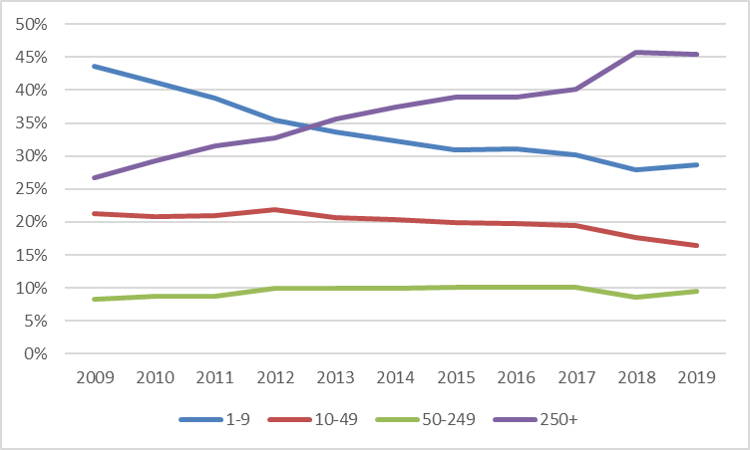

**Source:** TURKSTAT (2021e)