Supplementary material
Supplementary Figure S1. Sequence alignment of a fragment of ALS gene of resistant (R), susceptible accession from Wisconsin (SW) and susceptible accession from Illinois (SI). Resistant individuals have the nucleotide ‘W’ indicating the presence of T or A nucleotide while sensitive individuals have an A nucleotide. Red arrow depicts a change from T (GAT) to A (GAC) resulting in aspartic acid to glutamic acid substitution. Blue arrows depict representative nucleotide ambiguities shared across accessions.

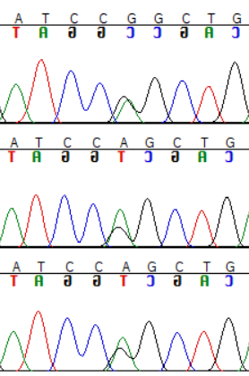
SW
R

Supplementary Figure S2. Representative nucleotide ambiguity (observed double peaks) in sequence chromatogram of both susceptible (SW) and resistant (R) fall panicum accessions.

Supplementary Figure S3. PCR products obtained from fall panicum samples following digestion with MboI restriction enzyme. The letters ‘L’, ‘R’, SW’ and ‘SI’ are used to represent 50 bp ladder, resistant individuals, susceptible individuals from Wisconsin and susceptible individual from Illinois, respectively. P is used to indicate the single resistant parent that was self-pollinated to obtain progenies. Resistant individuals are delimited from sensitive individuals by the presence of three bands. Expected amplicon sizes are indicated with orange arrows next to the images.

