Supplementary Materials
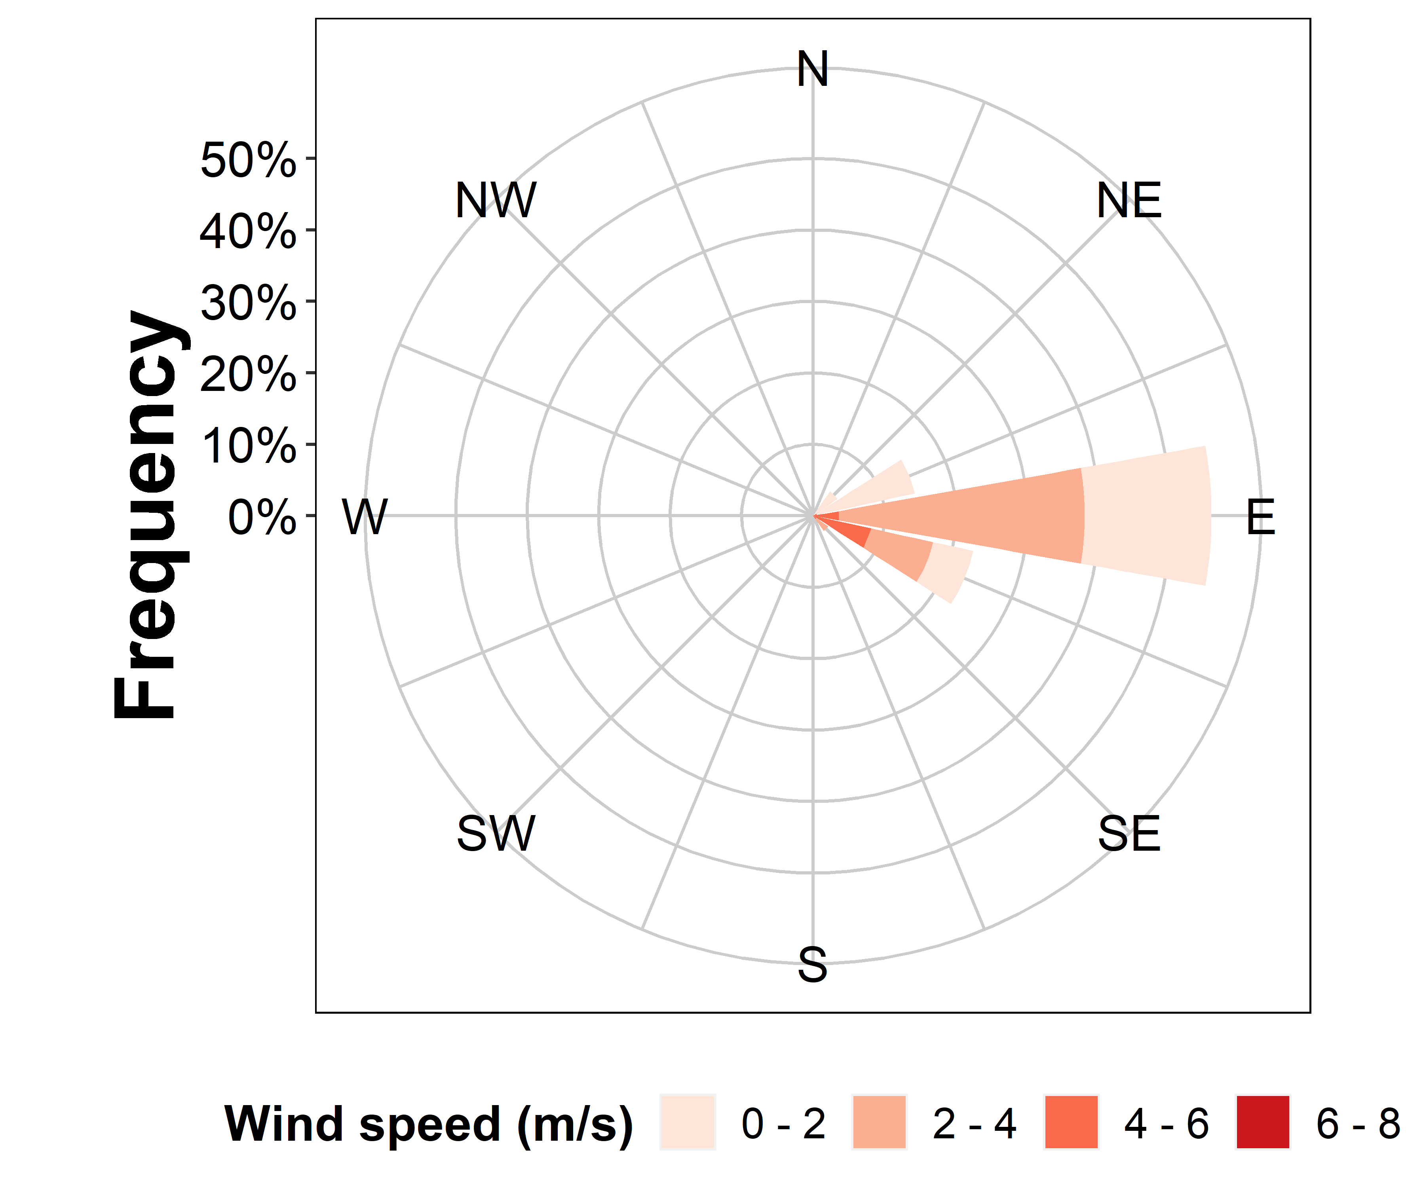
Supplementary Figure 1. Injury and weather conditions for early application, experiment 1. Top, raw injury data at distances collected from plot center for 2,4-D-choline, DGA+VG (diglycolamine salt of dicamba with VaporGrip®), and NA+DIF (sodium salt of dicamba with diflufenzopyr); Bottom left, relationship between 1 m air temperature and wind speed for 0 to 48 h following application; and bottom right, wind rose diagram for 0 to 48 h following application, indicating wind speed and directional frequency.
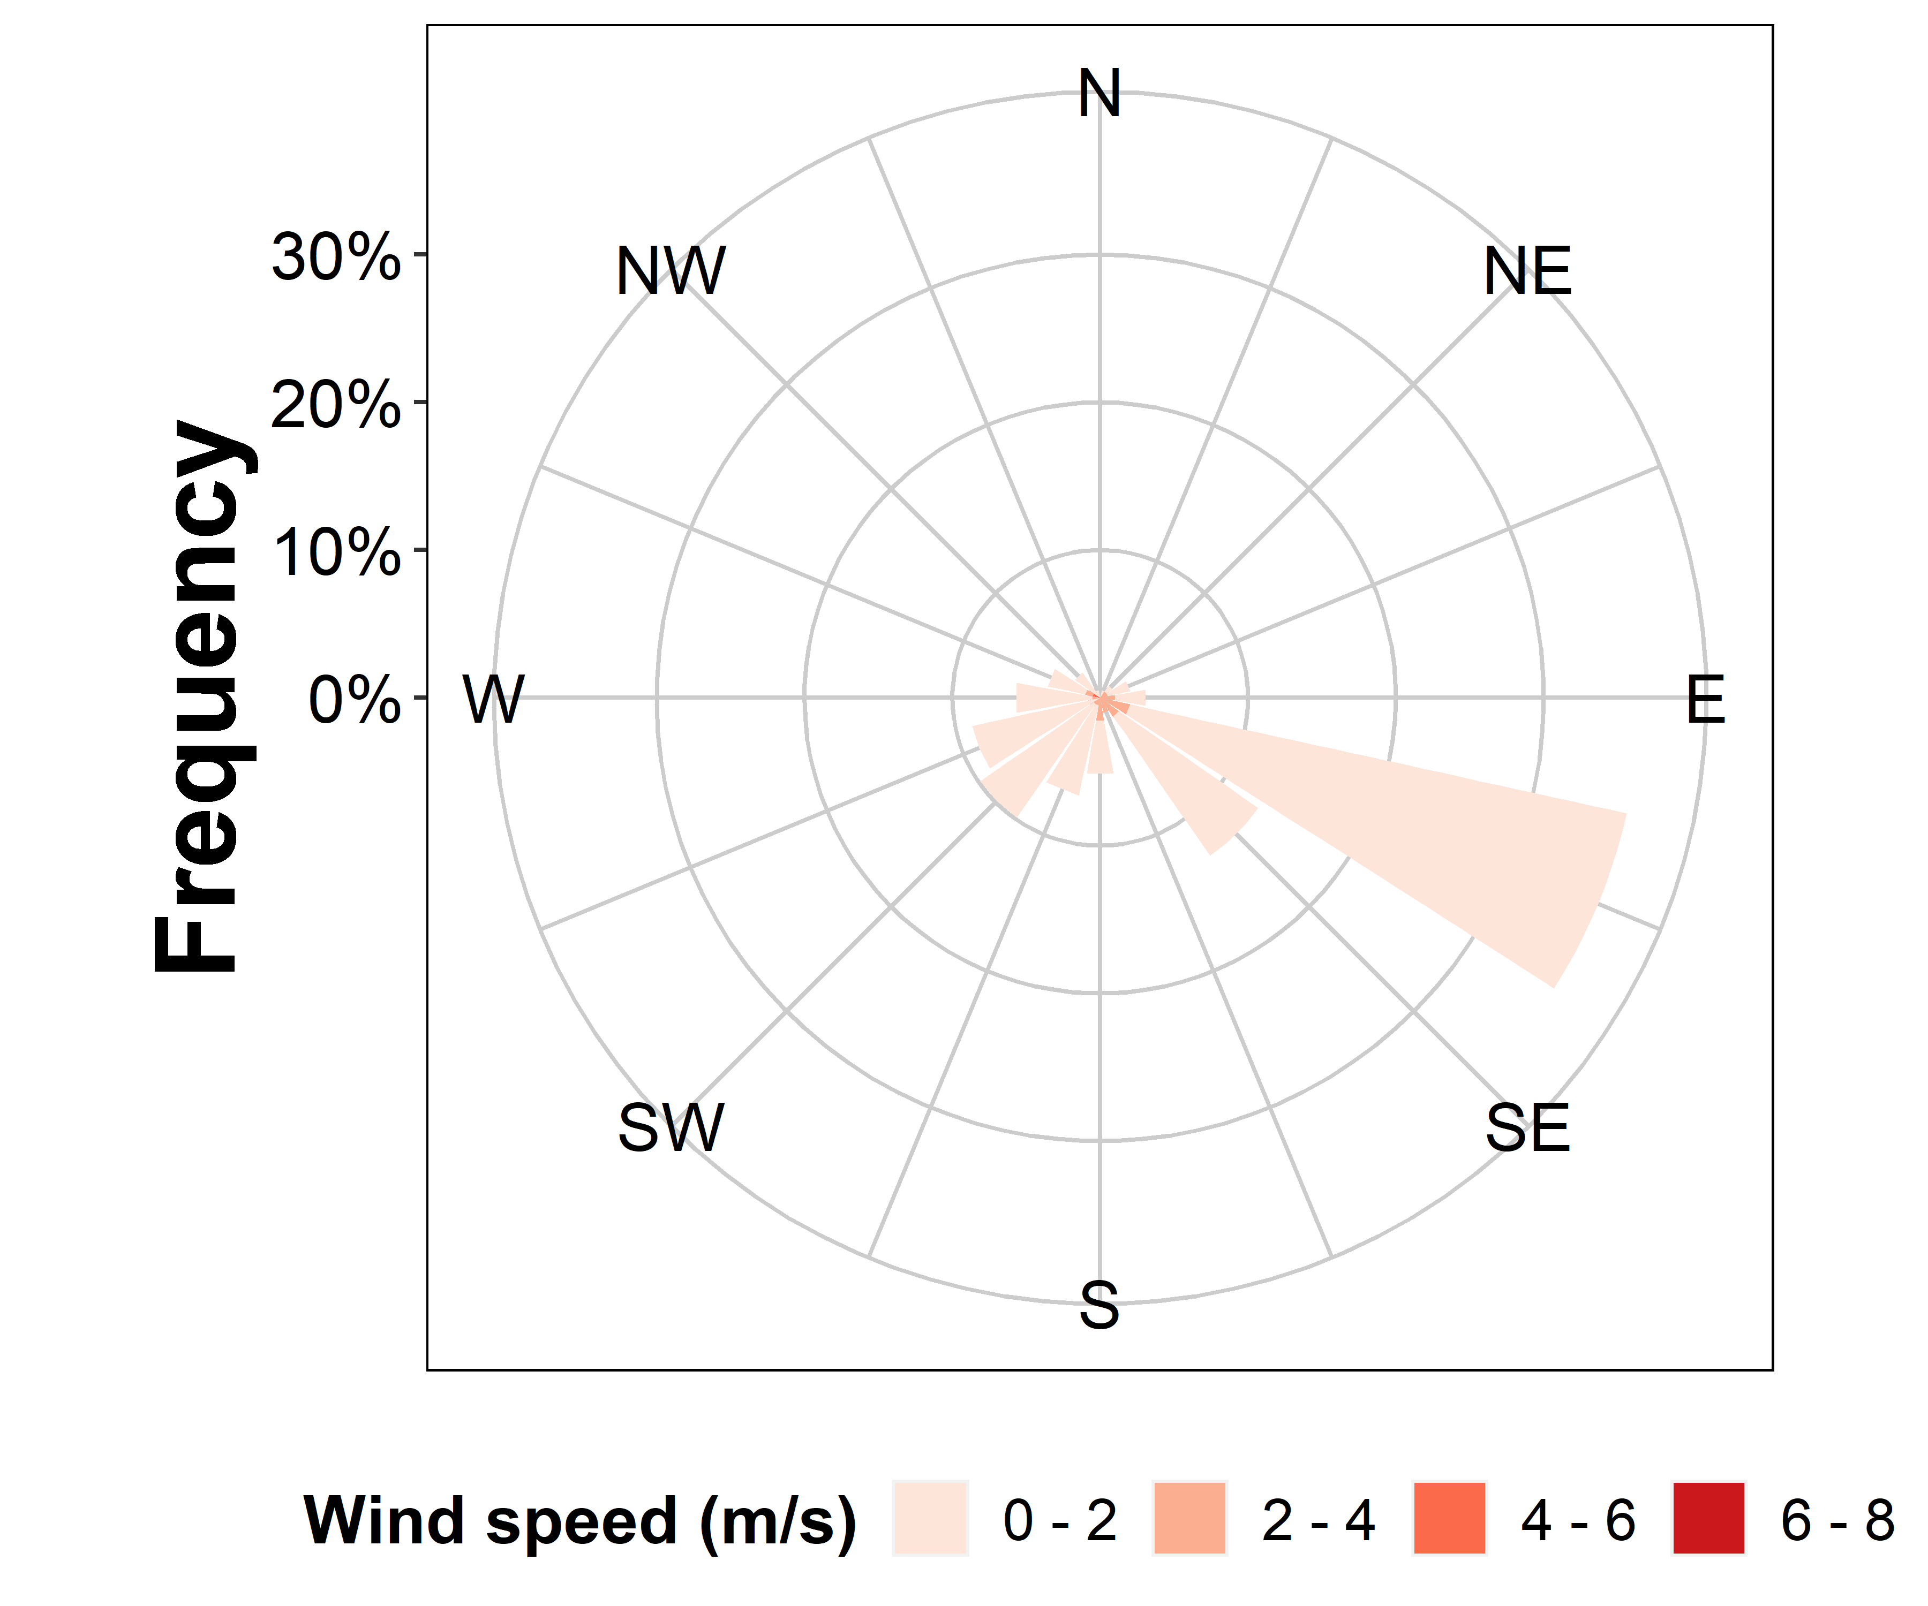
Supplementary Figure 2. Injury and weather conditions for early application, second experimental run. Top, raw injury data at distances collected from plot center for 2,4-D-choline, DGA+VG (diglycolamine salt of dicamba with VaporGrip®), and NA+DIF (sodium salt of dicamba with diflufenzopyr); Bottom left, relationship between 1 m air temperature and wind speed for 0 to 48 h following application; and bottom right, wind rose diagram for 0 to 48 h following application, indicating wind speed and directional frequency.
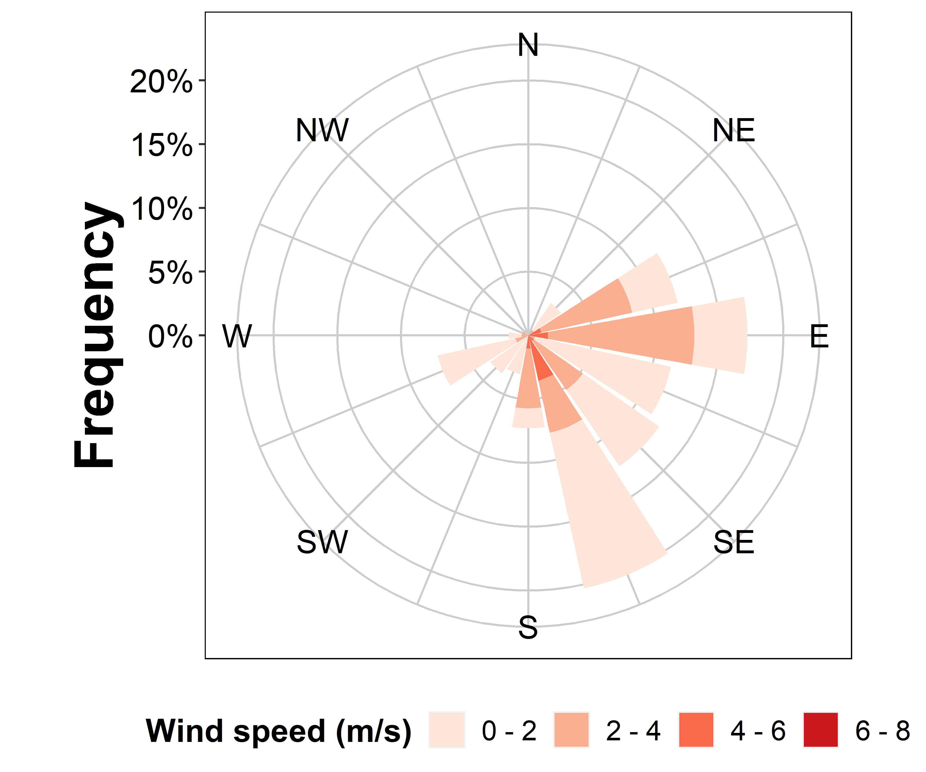
Supplementary Figure 3. Injury and weather conditions for late application, first experimental run. Top, raw injury data at distances collected from plot center for 2,4-D-choline, DGA+VG (diglycolamine salt of dicamba with VaporGrip®), and NA+DIF (sodium salt of dicamba with diflufenzopyr); Bottom left, relationship between 1 m air temperature and wind speed for 0 to 48 h following application; and bottom right, wind rose diagram for 0 to 48 h following application, indicating wind speed and directional frequency.
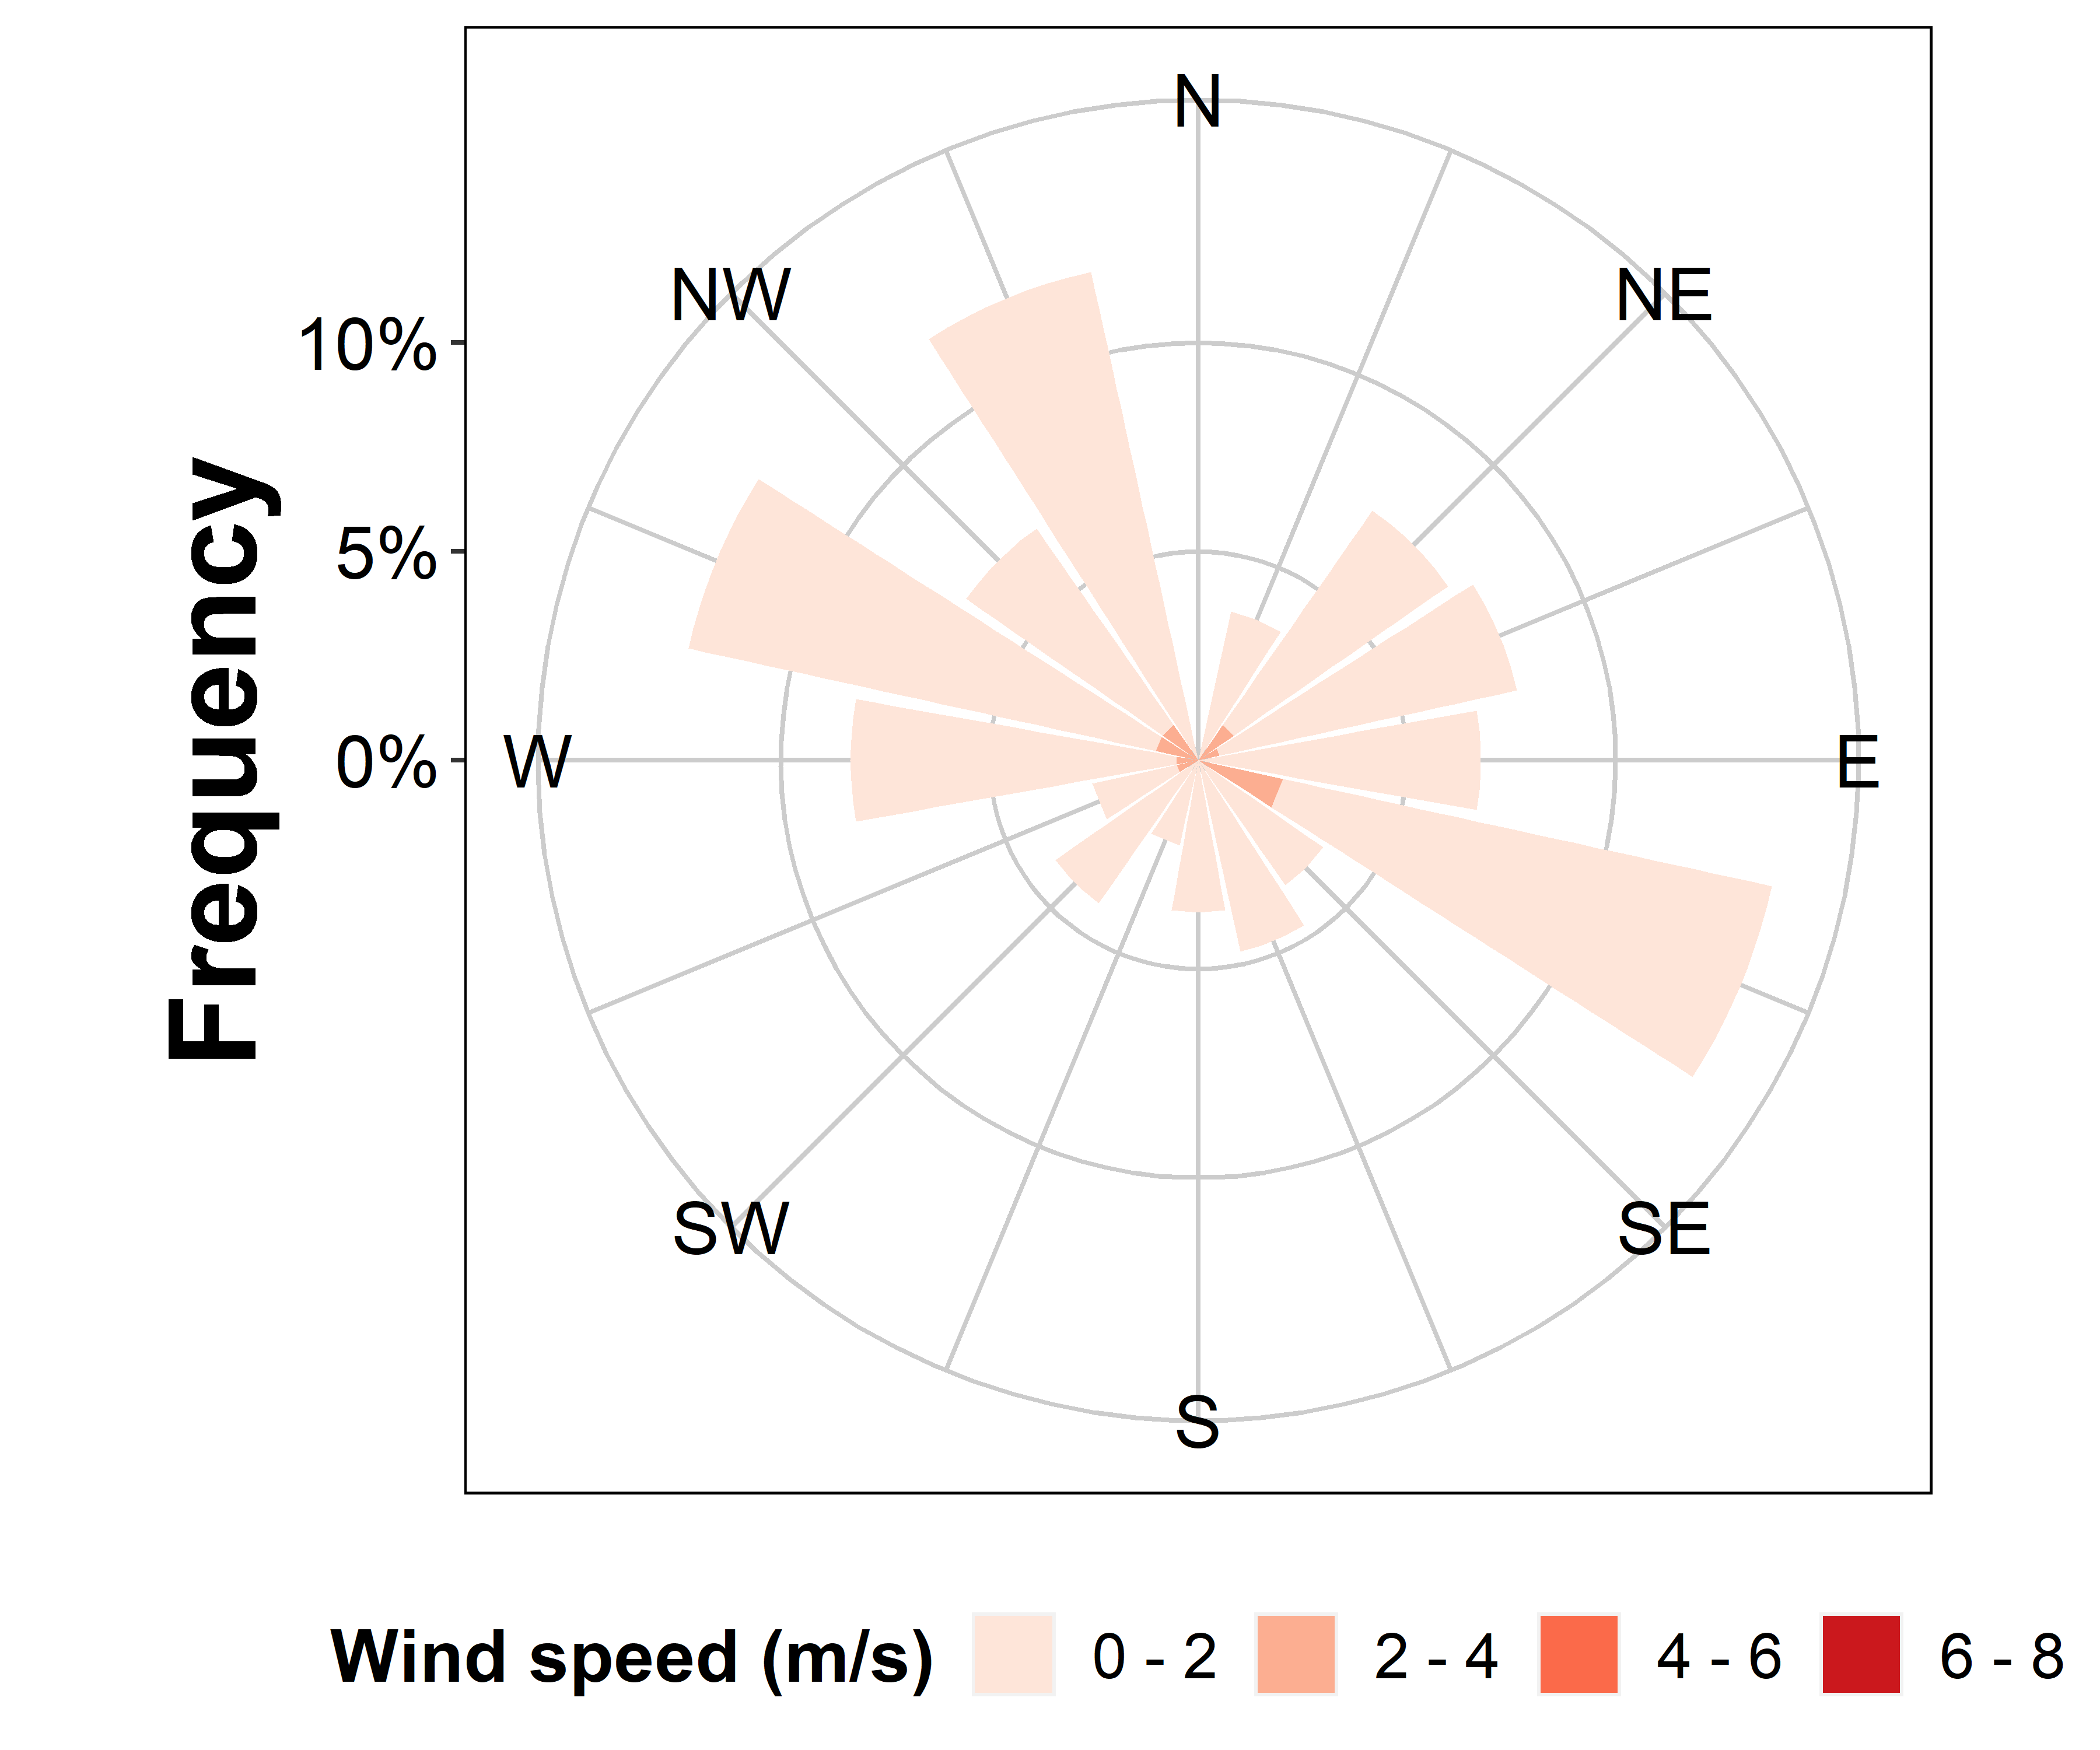
Supplementary Figure 4. Injury and weather conditions for late application, second experimental run. Top, raw injury data at distances collected from plot center for 2,4-D-choline, DGA+VG (diglycolamine salt of dicamba with VaporGrip®), and NA+DIF (sodium salt of dicamba with diflufenzopyr); Bottom left, relationship between 1 m air temperature and wind speed for 0 to 48 h following application; and bottom right, wind rose diagram for 0 to 48 h following application, indicating wind speed and directional frequency.

