Questionnaire in relation with weed management behaviors of tea growers

Location of interview:
Latitude: Longitude: Altitude:
Sex of the respondent: ⎕male, ⎕ female
1. Age of the respondent: ⎕21 – 30, ⎕31– 40, ⎕41 – 50, ⎕51 – 60, ⎕>60
2. Property attribute of holding tea gardens:
⎕ Self-employed, ⎕ co-operative, ⎕ company
3. Experience of taking farmer training on tea garden weed management:
⎕ Have, ⎕ no
4. Want to participate on training about weed management of tea garden:
⎕ Yes, ⎕ no
5. Area of tea gardens managed:
6. Frequency of weed control on tea garden (times per year):
7. Cost of weed control on tea garden (RMB￥ per mu.):
(Note: 1 mu. = 666.7 m²)

8. Major method of weed control:
⎕ Manual remove, ⎕herbicide, ⎕Other________________________

9. Month conducting weed control (multiple selection):
⎕Jan, ⎕Feb, ⎕Mar, ⎕Apr, ⎕May, ⎕Jun,
⎕Jul, ⎕Aug, ⎕Sep, ⎕Oct, ⎕Nov, ⎕Dec

10. Herbicides used in the past two years:
⎕Yes, herbicide:______________________________________________, ⎕No

11. How will the cost of weed control on tea gardens ranges five years later compared with now?
⎕Increase (by > 50% or 10% - 50%), ⎕Decrease (by > 50% or 10% - 50%),
⎕Relatively stable (range within10%)

12. Most troublesome weed species (multiple selection):
⎕ Bracken fern, ⎕ Horseweed, ⎕ Tall fleabane,
⎕ Common pokeweed , ⎕ Ragleaf , ⎕ Shaggy soldier,
⎕ Asiatic dayflower , ⎕ Japanese stiltgrass , ⎕ Vestita starwort,
⎕ Creeping woodsorrel ⎕Other weed species_____________________________

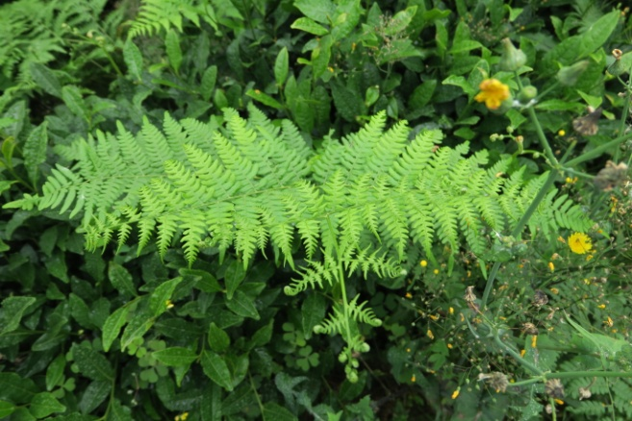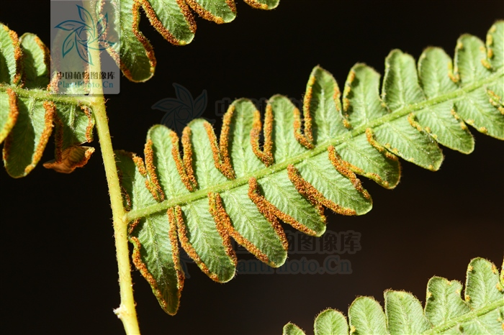
Bracken fern（Note: the right photo cited from: http://ppbc.iplant.cn/tu/357436）

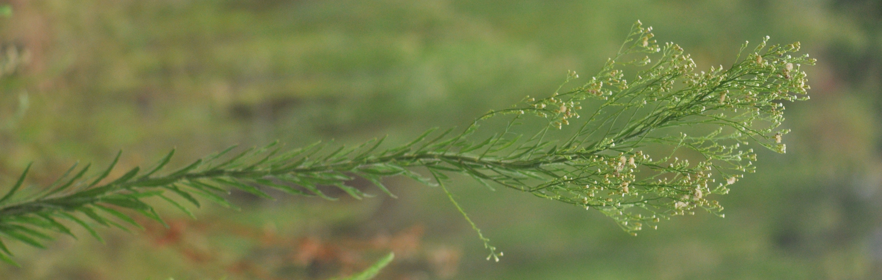
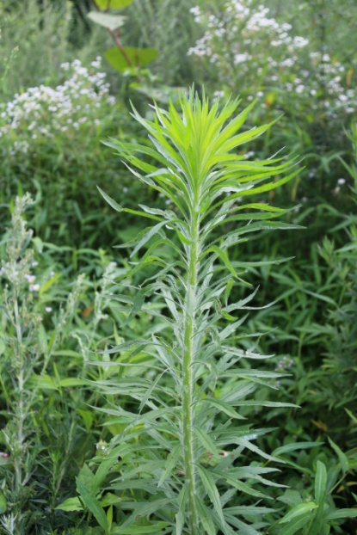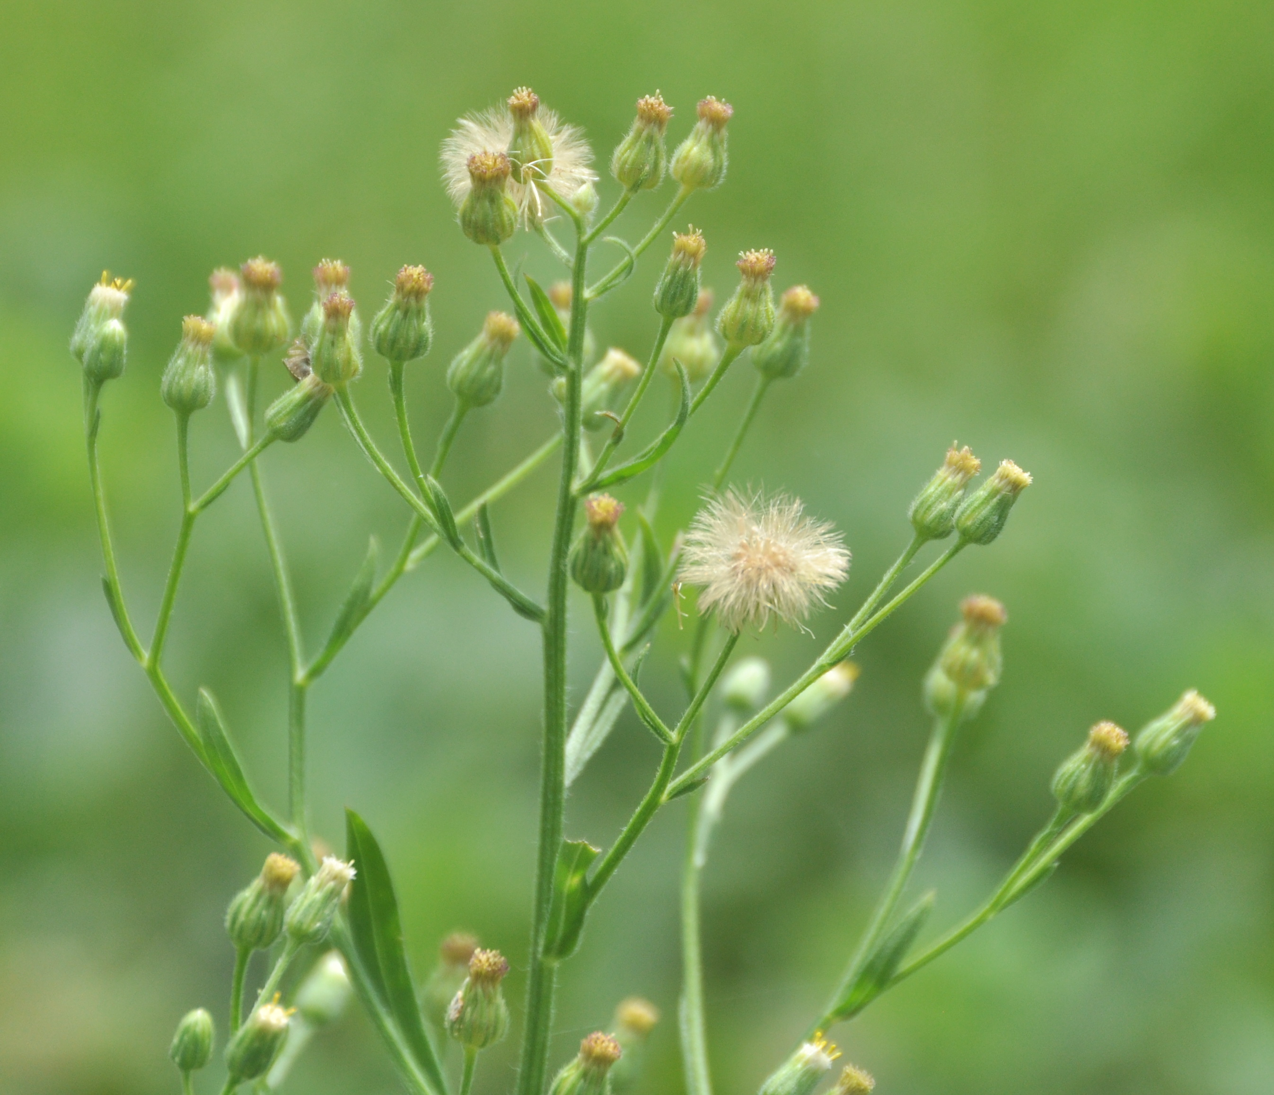
Horseweed
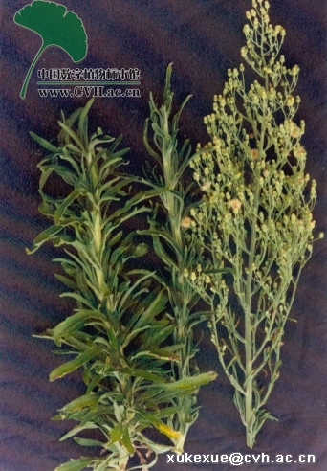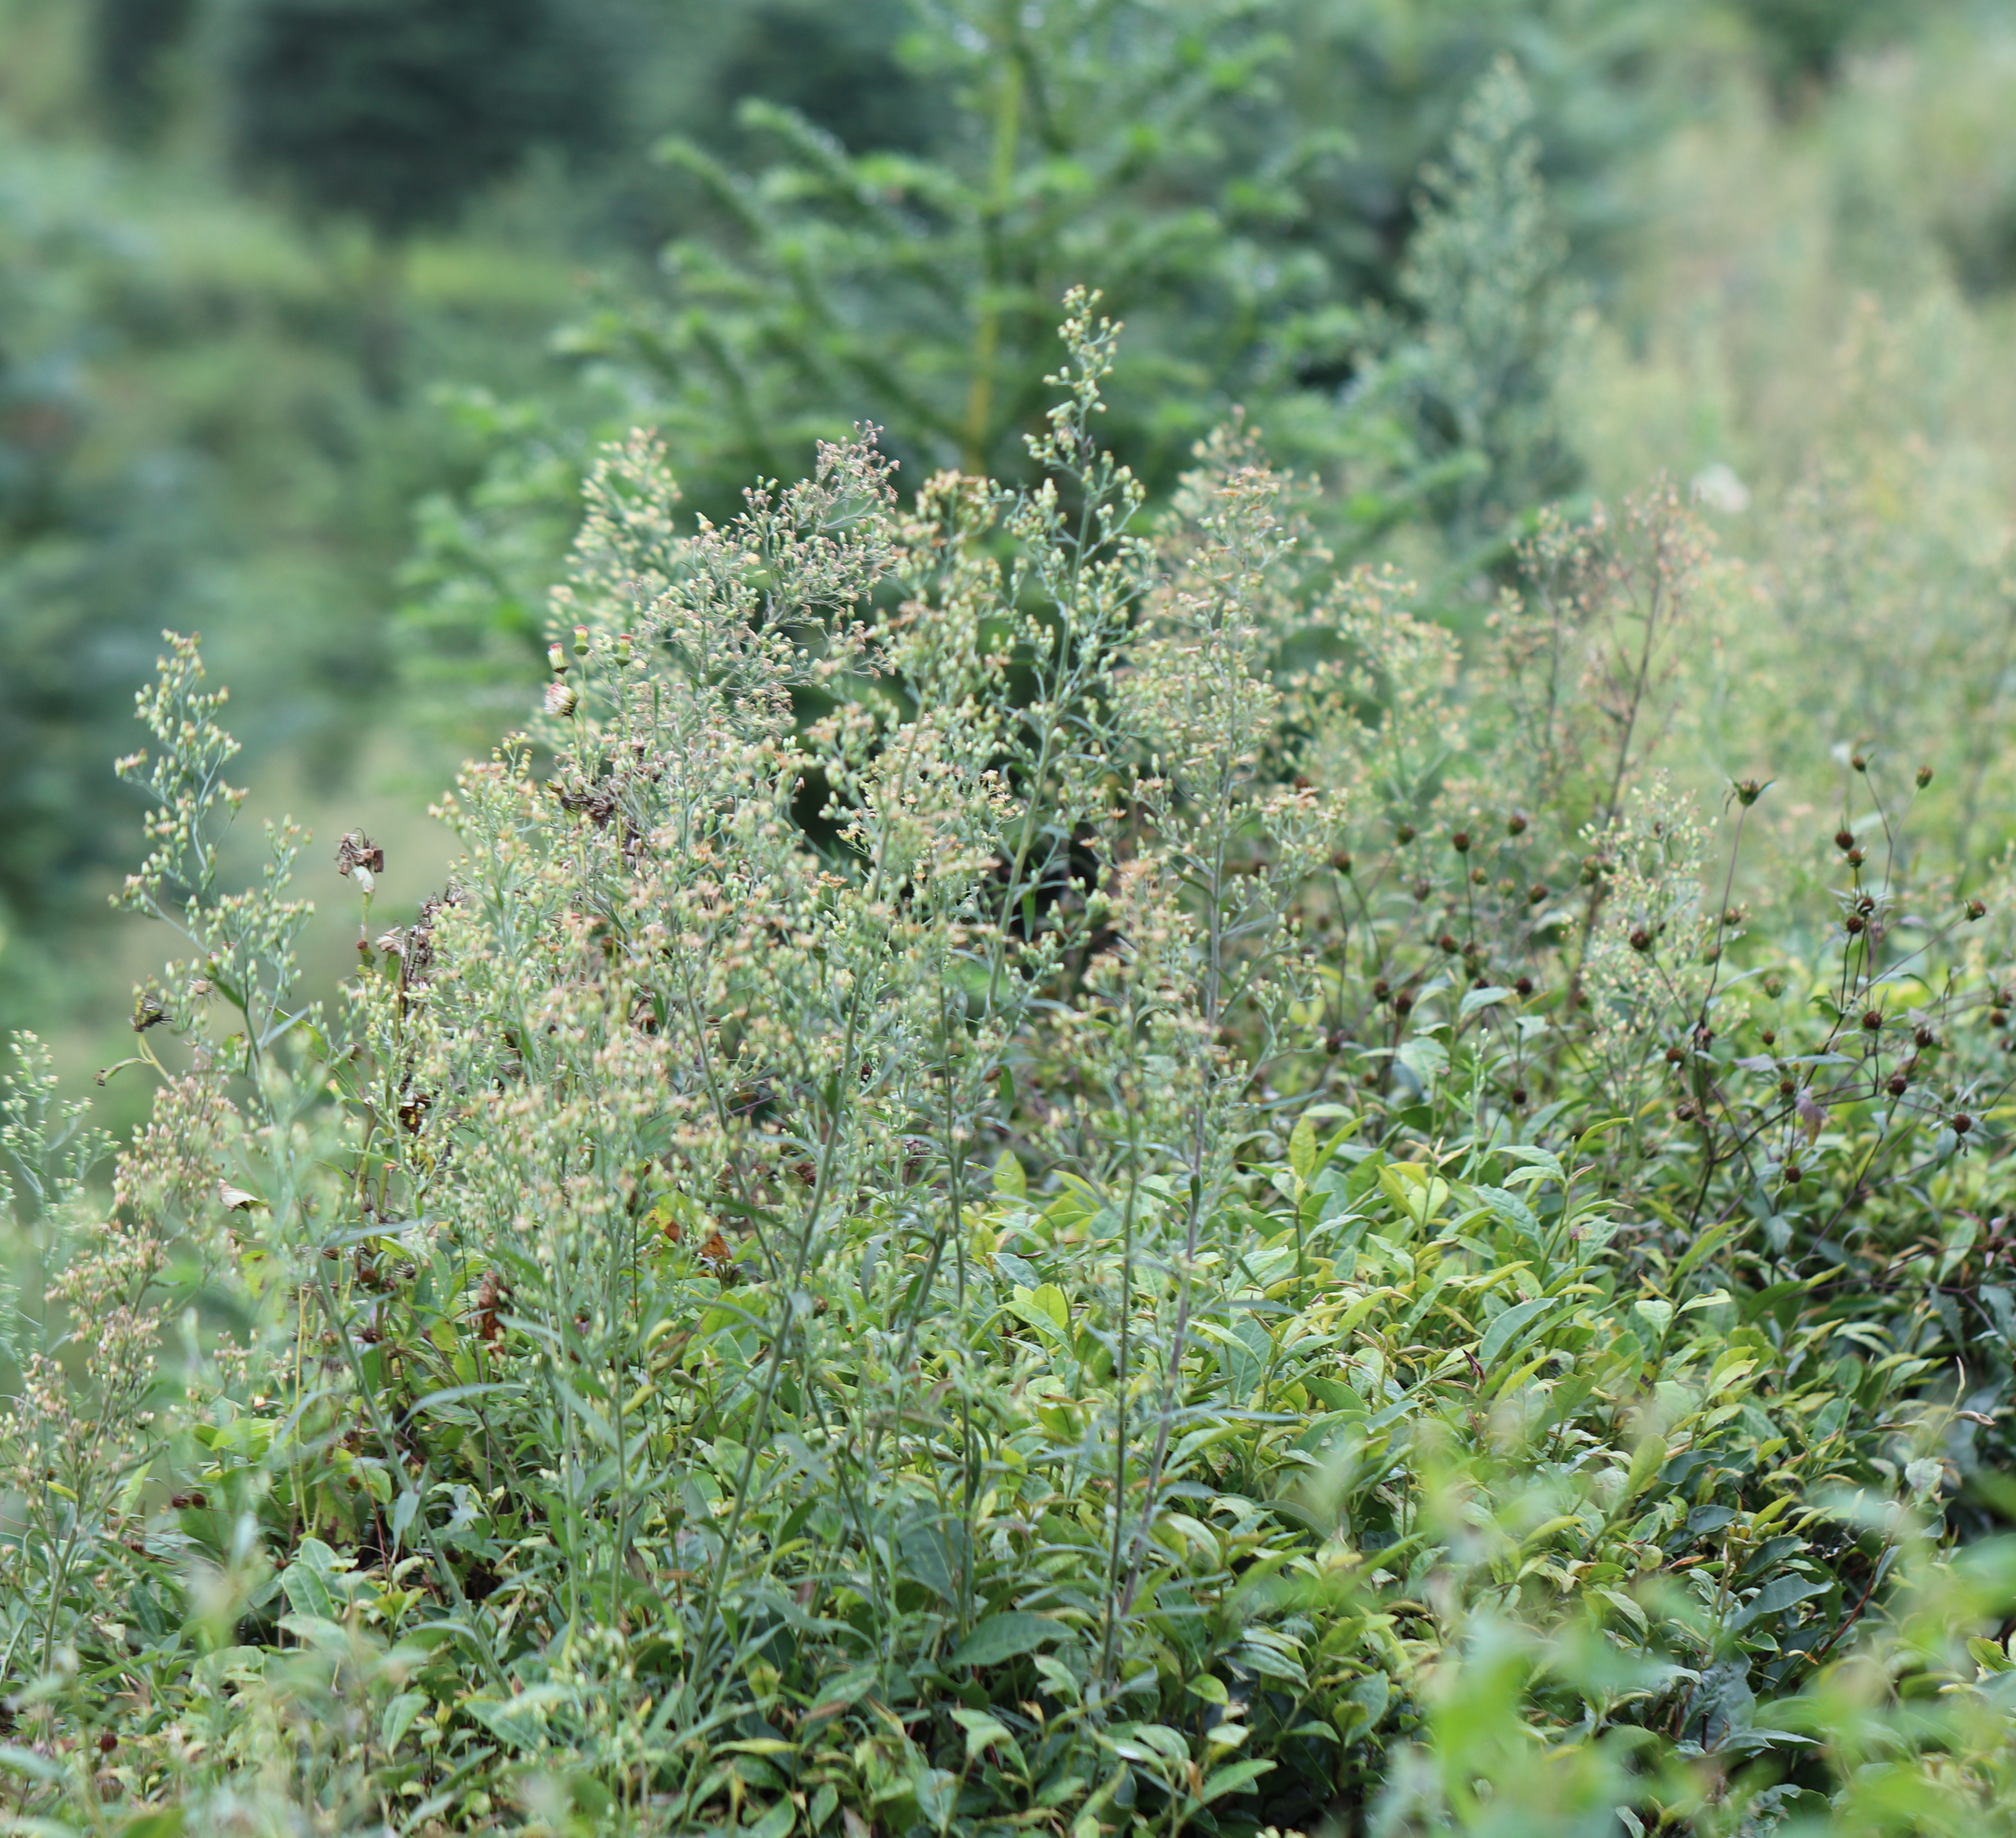
Tall fleabane（Note: the left photo is cited from: http://ppbc.iplant.cn/tu/40828）

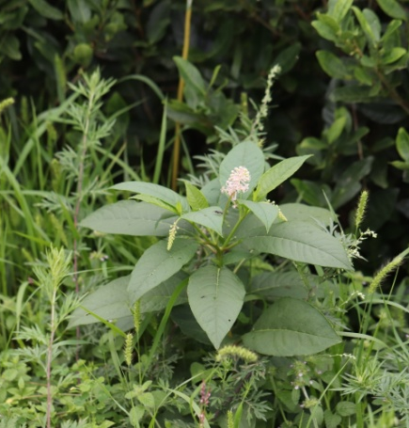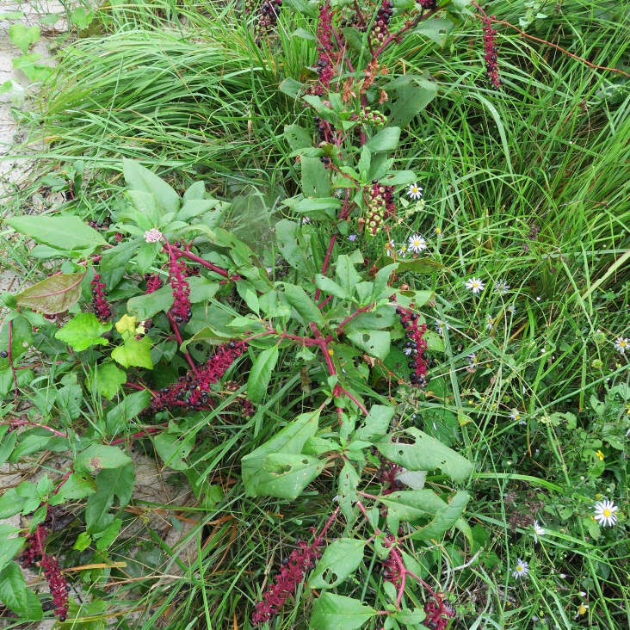
Common pokeweed
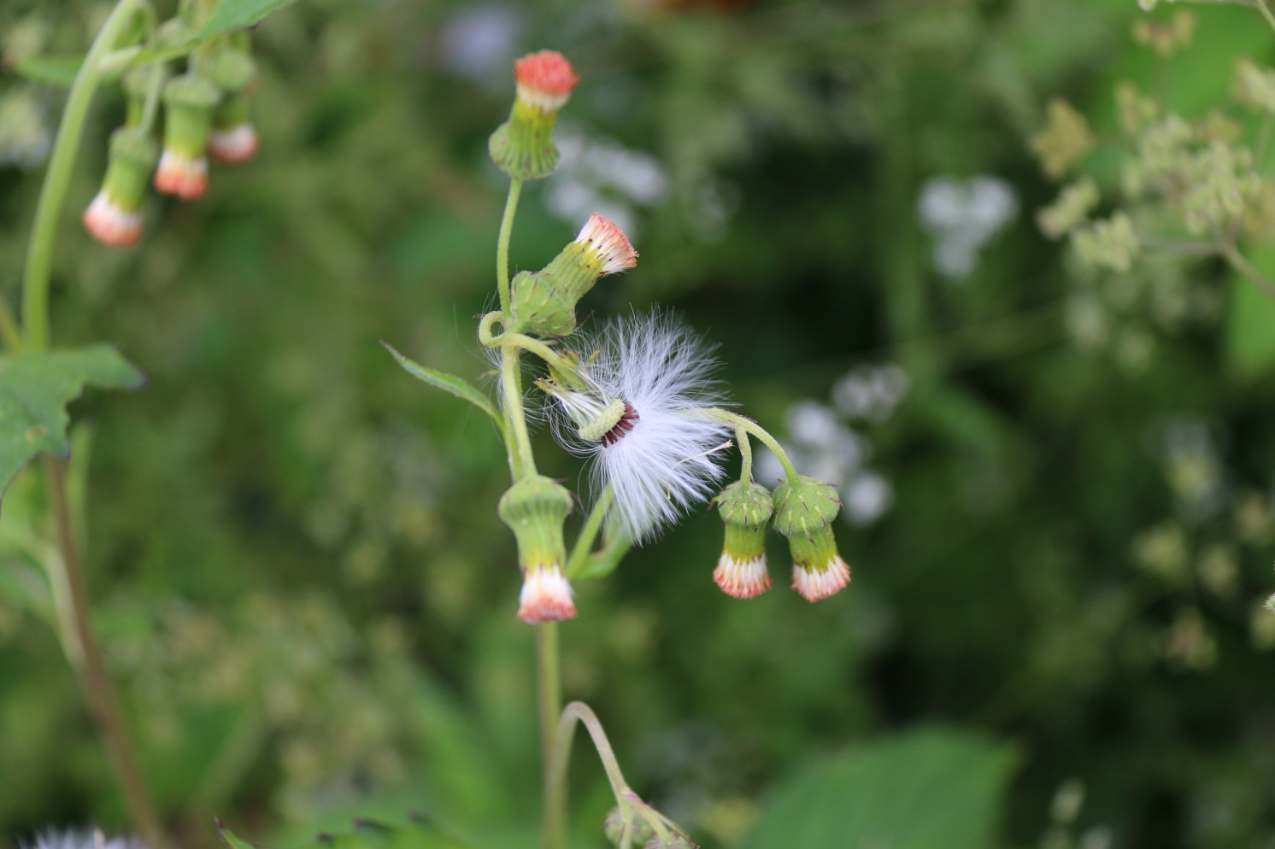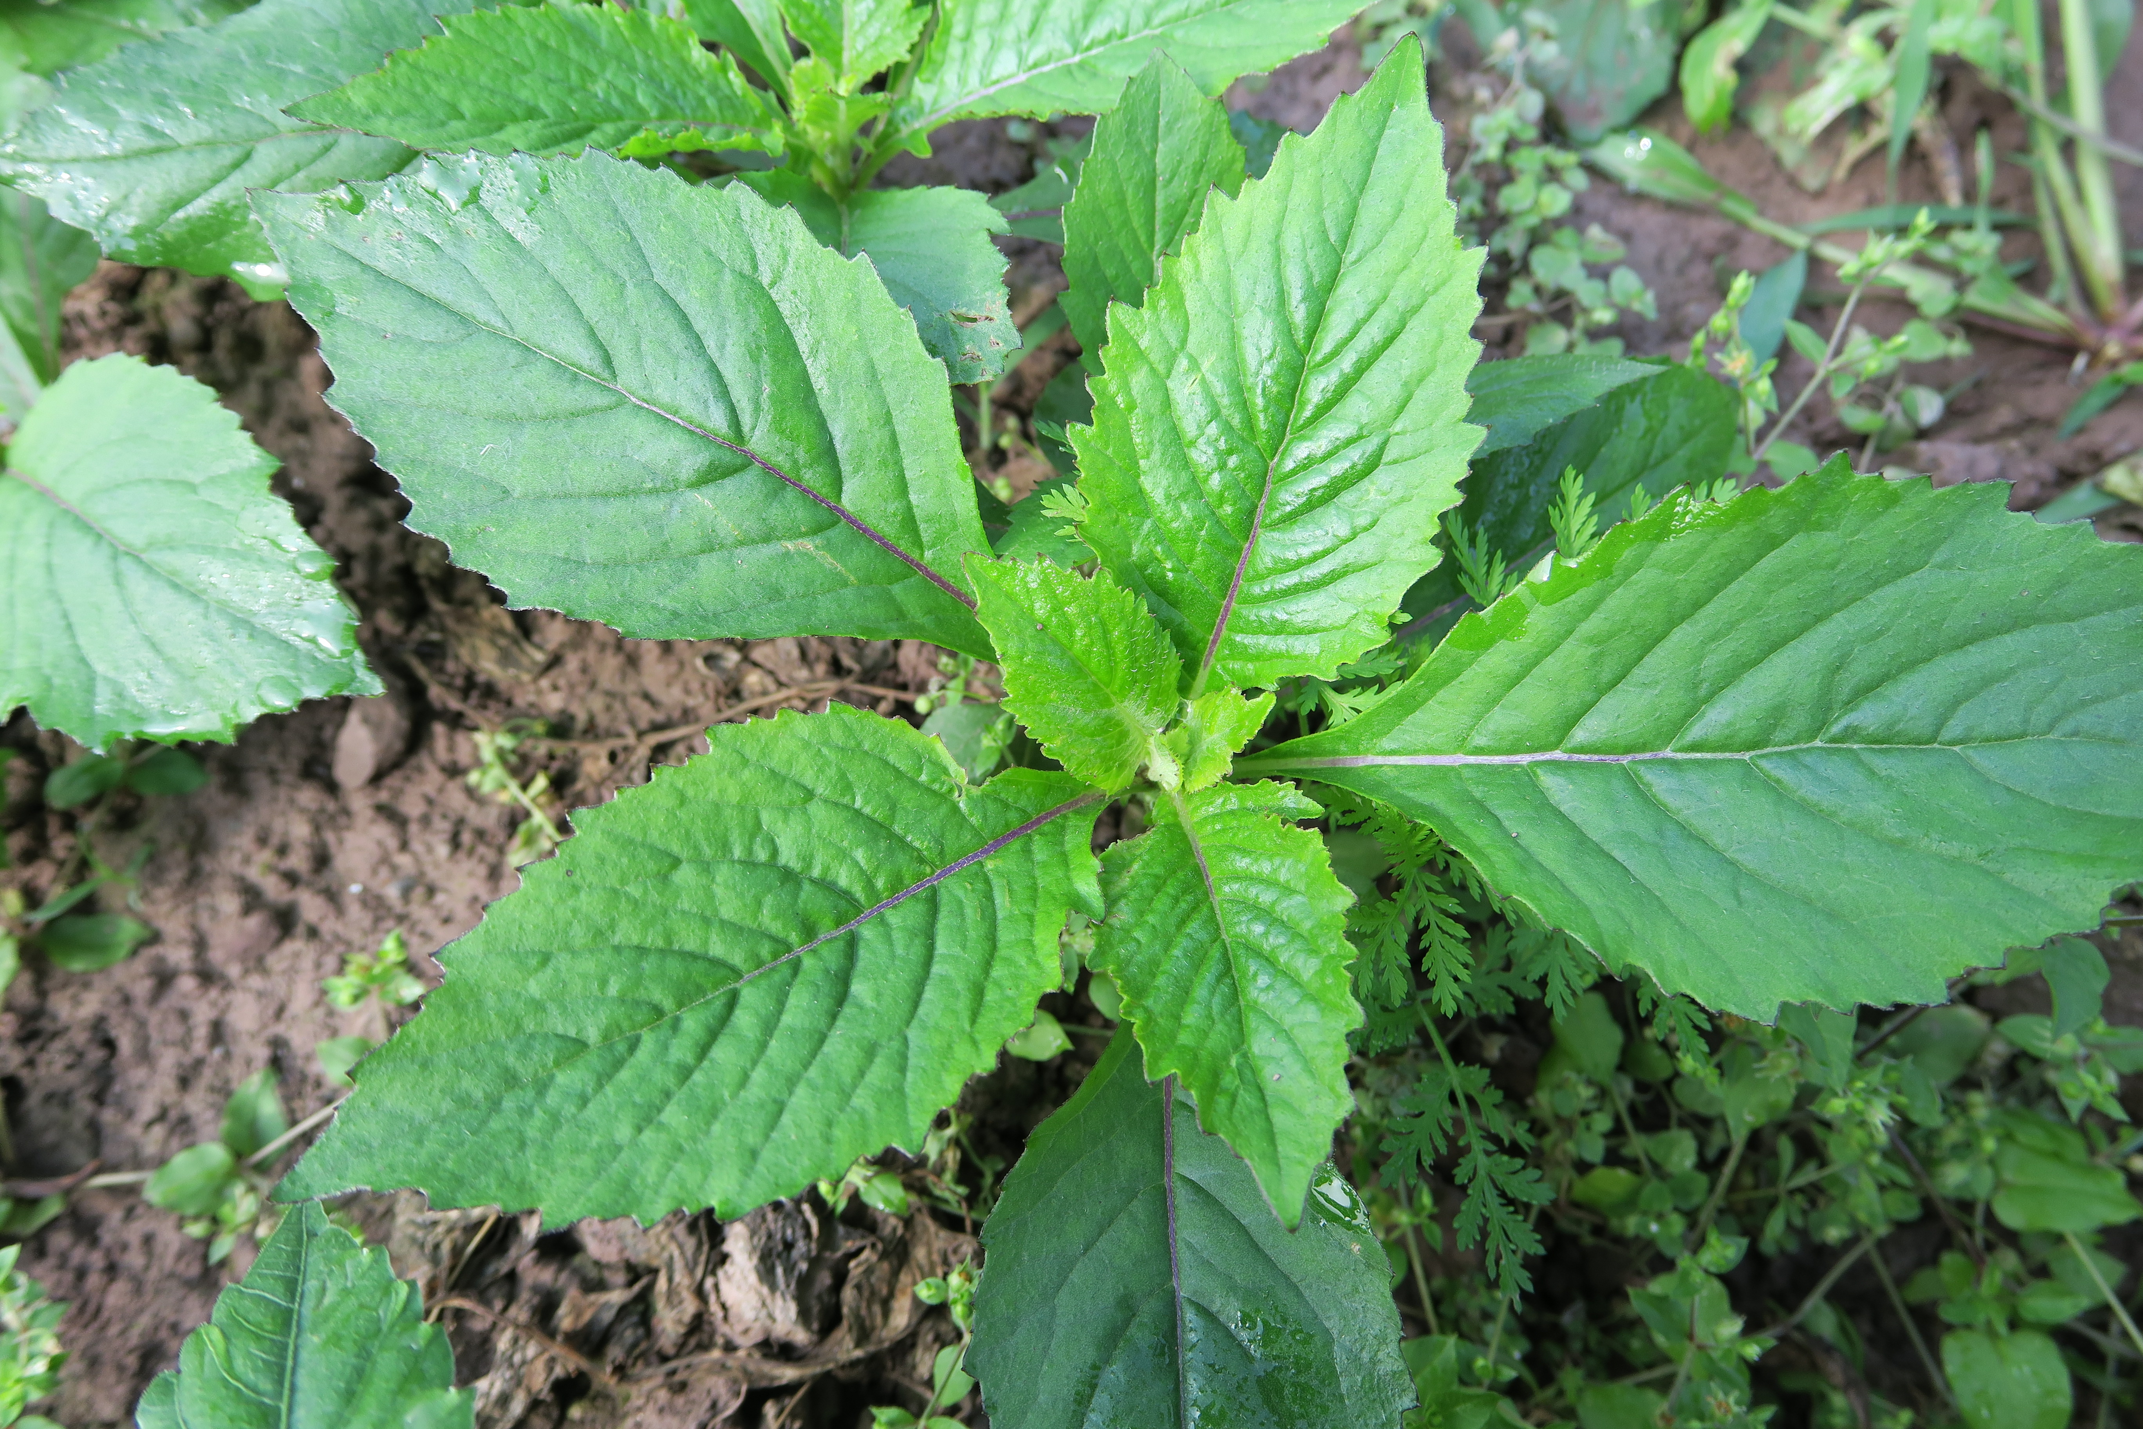
Ragleaf

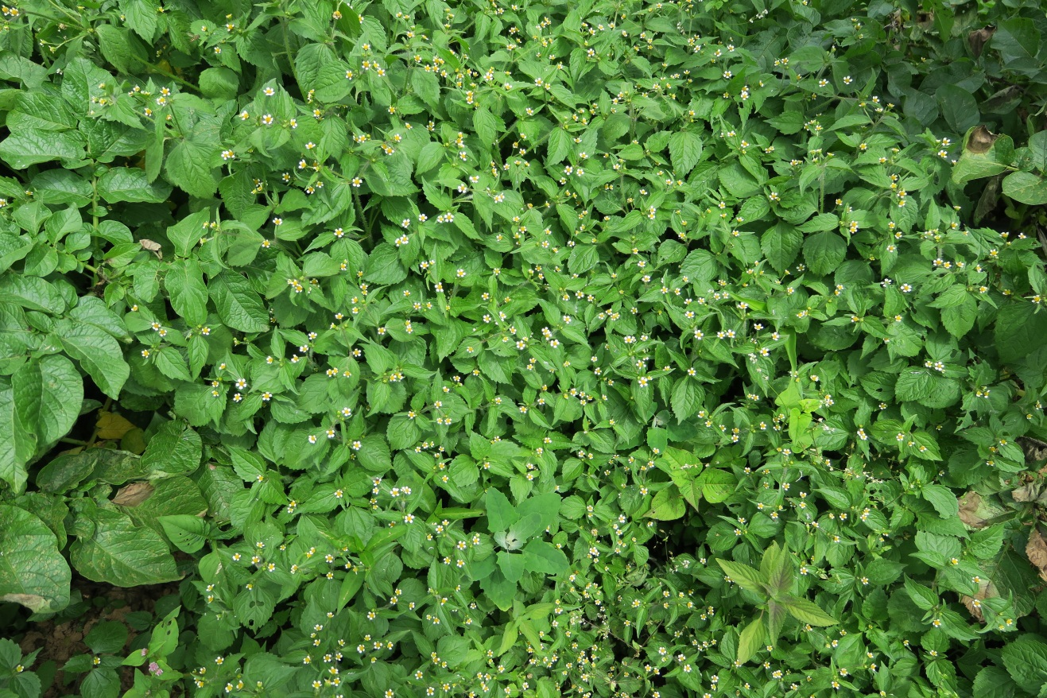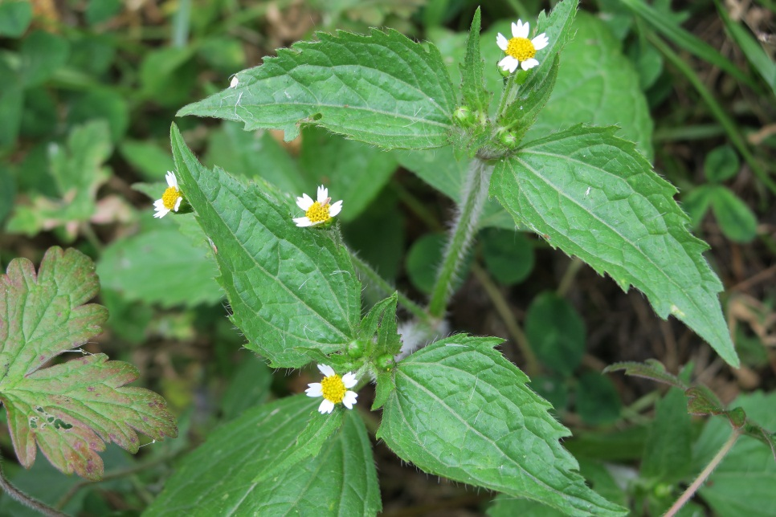
Shaggy soldier
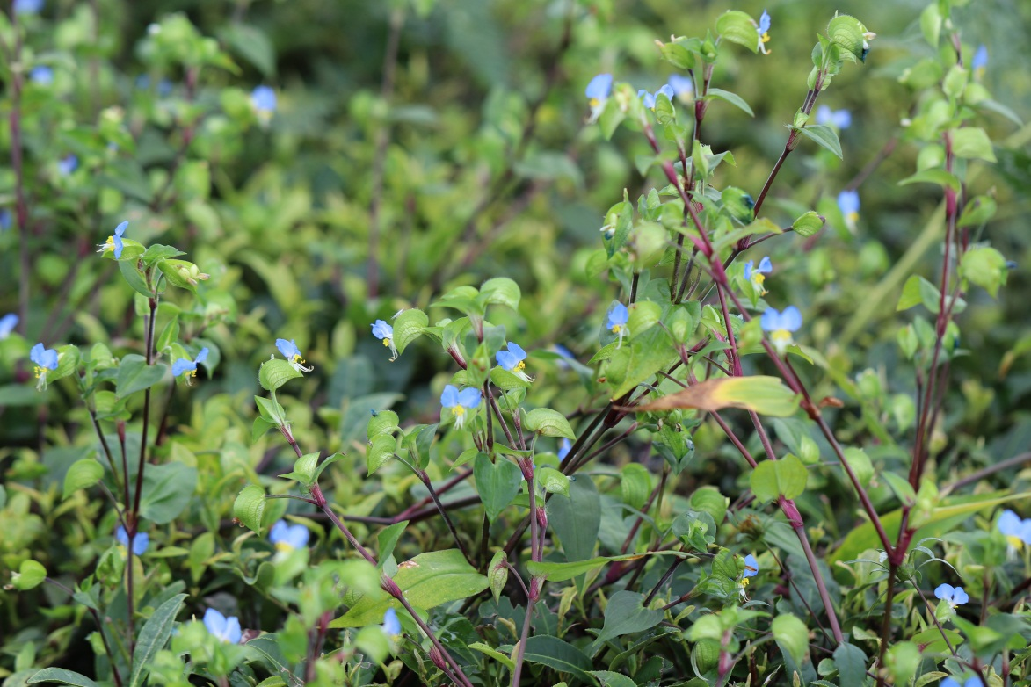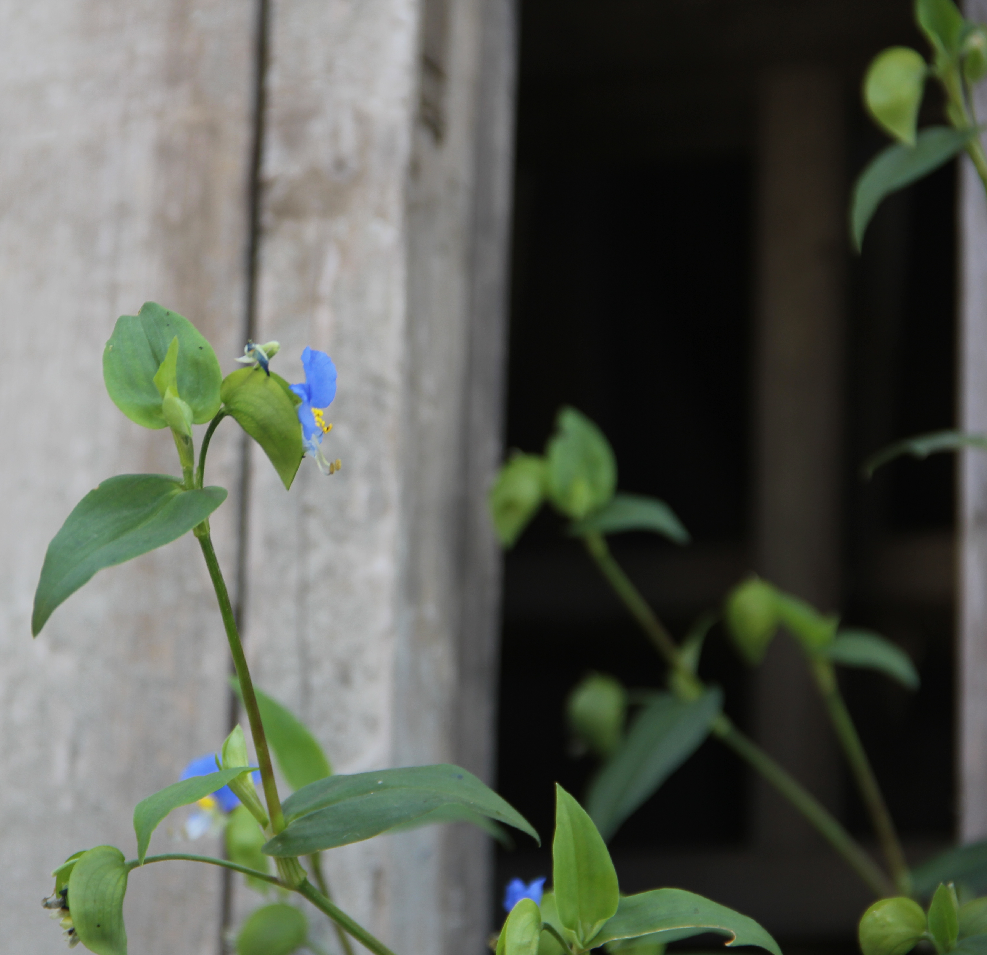
Asiatic dayflower
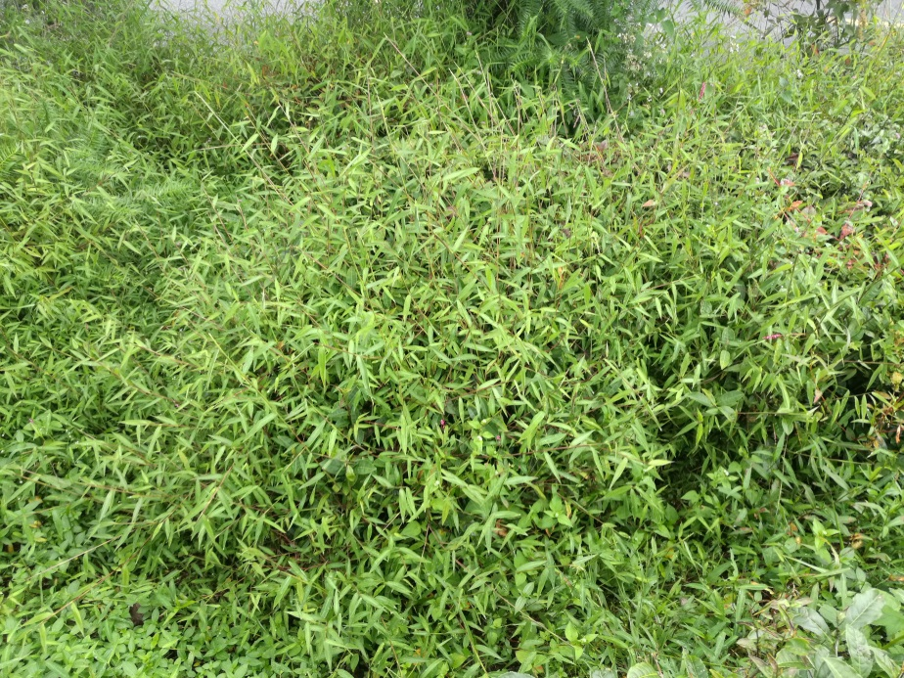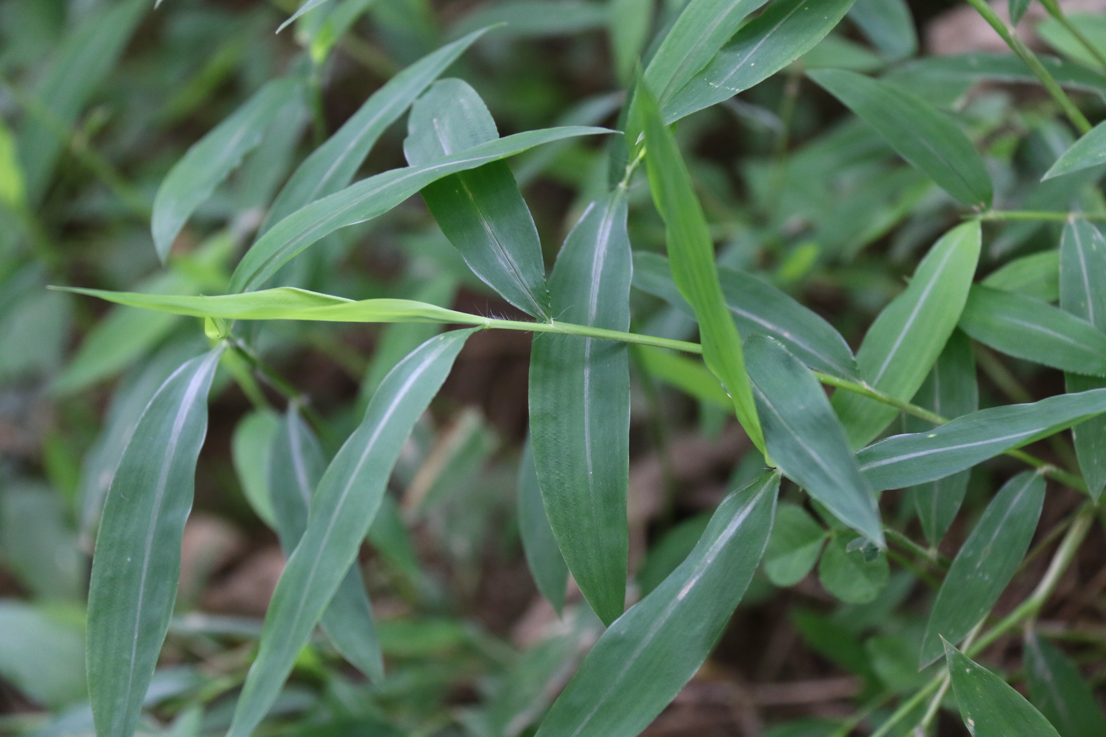
Japanese stiltgrass
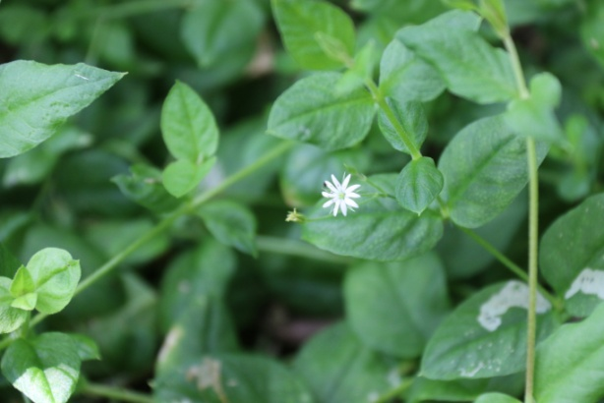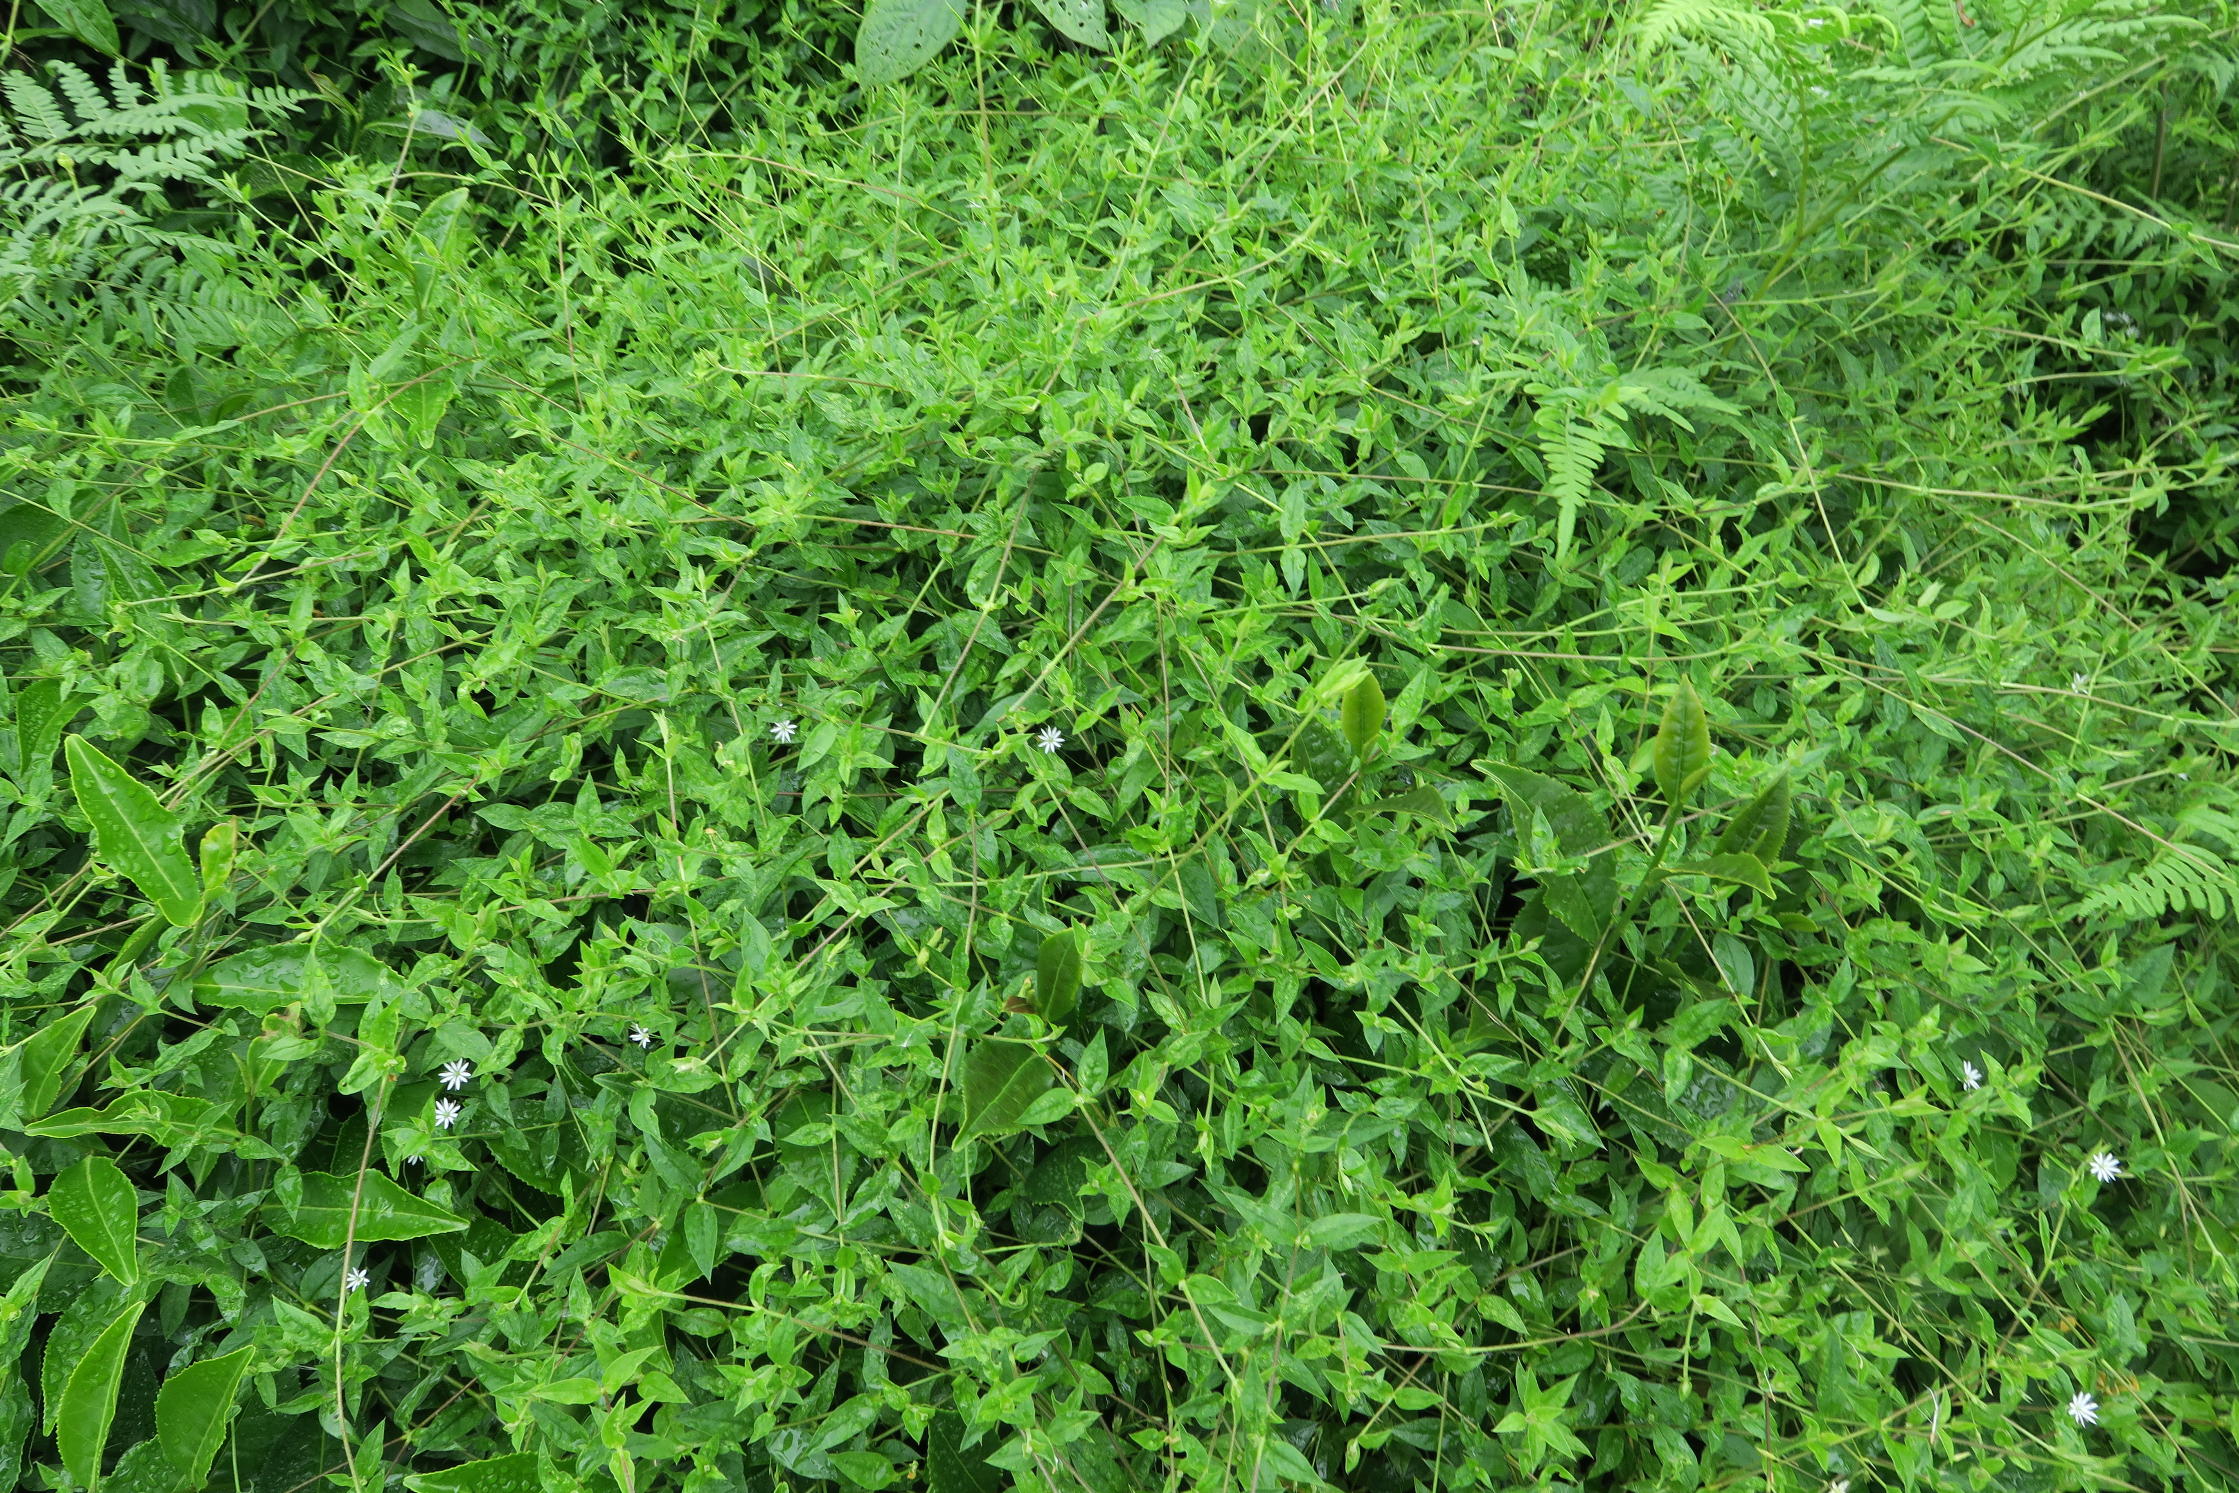
Vestita starwort
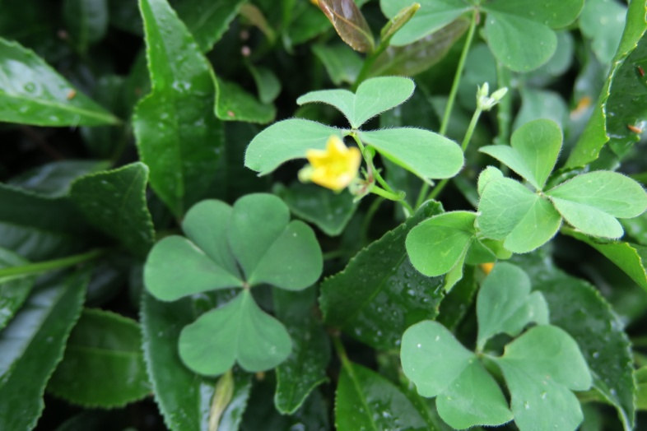
Creeping woodsorrel

