SUPPLEMENTARY MATERIAL
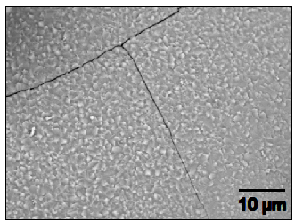

Figure 1: SEM image of Li₄Ti_{4.95}Al_{0.05}O₁₂.

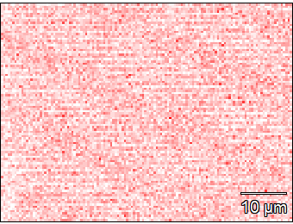

Figure 2: EDS image of Li₄Ti_{4.95}Al_{0.05}O₁₂ indicated aluminium (left) and titanium (right) detected.

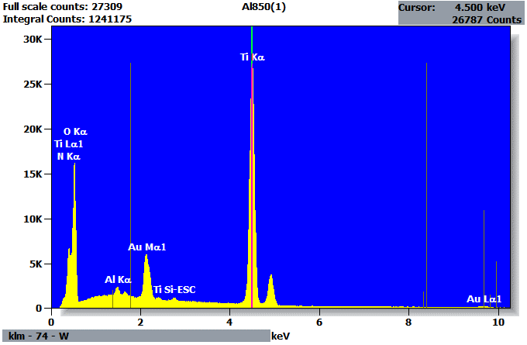

Figure 3: EDS spectrum of Li₄Ti_{4.95}Al_{0.05}O₁₂ indicating presence of aluminium and titanium.

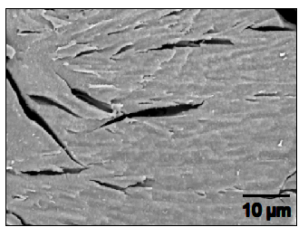

Figure 4: SEM image of Li₄Ti_{4.95}Mg_{0.05}O₁₂.

Figure 5: EDS image of Li₄Ti_{4.95}Mg_{0.05}O₁₂ indicated magnesium (left) and titanium (right) detected.

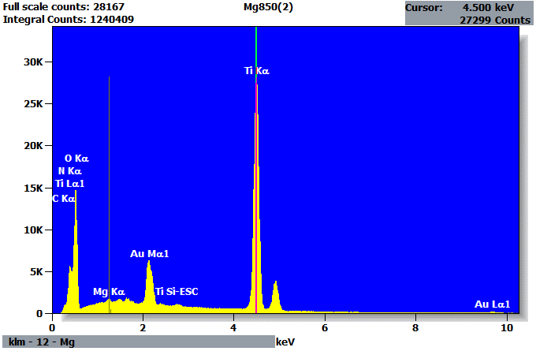

Figure 6: EDS spectrum of Li₄Ti_{4.95}Mg_{0.05}O₁₂ indicating presence of magnesium and titanium.

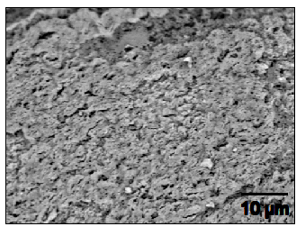
Figure 7: SEM image of Li₄Ti_{4.95}Ni_{0.05}O₁₂.

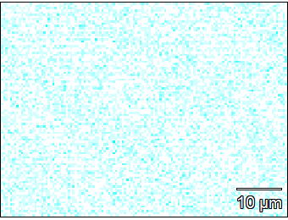

Figure 8: EDS image of Li₄Ti_{4.95}Ni_{0.05}O₁₂ indicated nickel (left) and titanium (right) detected.

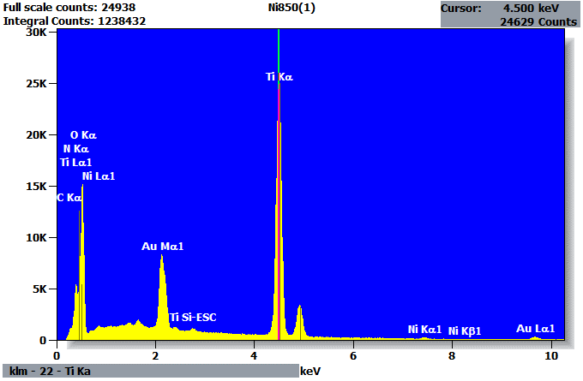

Figure 9: EDS spectrum of Li₄Ti_{4.95}Ni_{0.05}O₁₂ indicating presence of nickel and titanium.

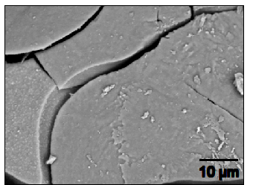

Figure 10: SEM image of Li₄Ti_{4.95}Co_{0.05}O₁₂.

Figure 11: EDS image of Li₄Ti_{4.95}Co_{0.05}O₁₂ indicated cobalt (left) and titanium (right) detected.

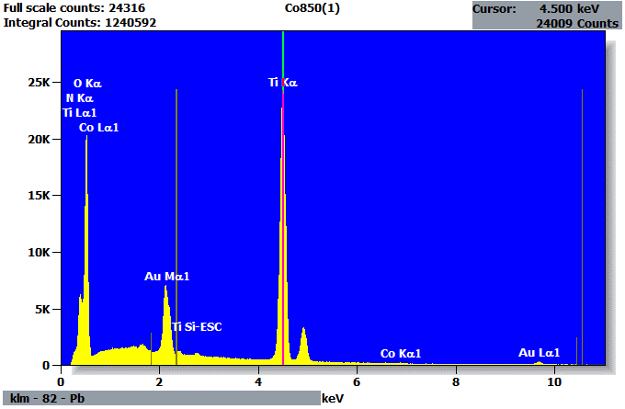

Figure 12: EDS spectrum of Li₄Ti_{4.95}Co_{0.05}O₁₂ indicating presence of cobalt and titanium.

