Multiple component quantitative on-sampling filter analysis for crystalline and amorphous materials in inhalable dusts using X-Ray Diffraction with Rietveld.
Peter Stacey
Supplementary Information S1: X-ray diffraction external standard calibrations on quartz fibre filters and a comparison of the external standard and Rietveld methods measuring calcite and gypsum in a four component mixture of quartz, calcite, gypsum and wood.
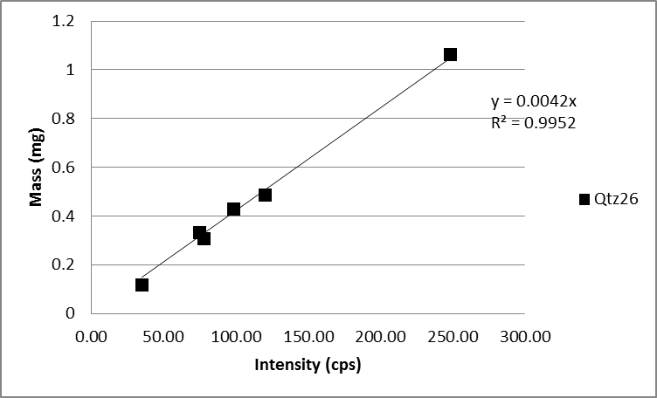
Figure S1. Calibration for quartz reflection at 26.6 degrees two theta
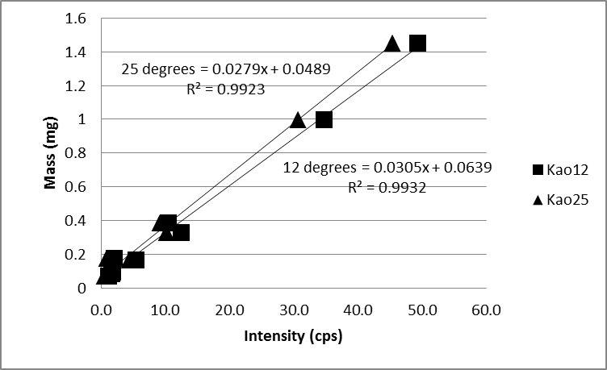
Figure S2. Calibration for kaolinite reflections at 12.3 (Kao12) and 25 (Kao25) degrees two theta
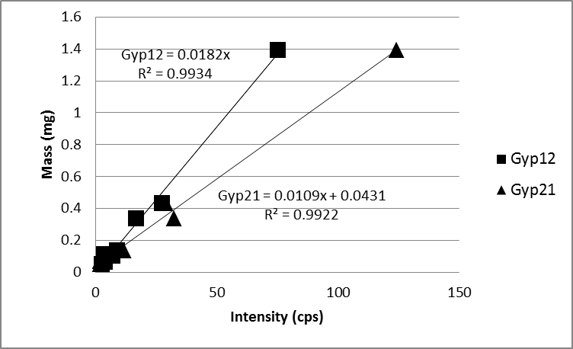
Figure 3S. Calibration for gypsum reflections at 11.9 (Gyp12) and 20.9 (Gyp21) degrees two theta

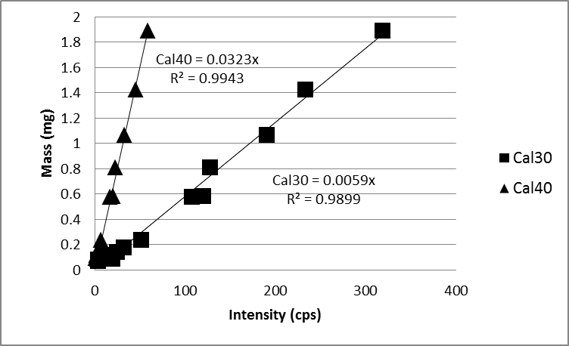
Figure S4. Calibrations for calcite reflections at 29.5 (Cal30) and 39.5 (cal40) degrees two theta

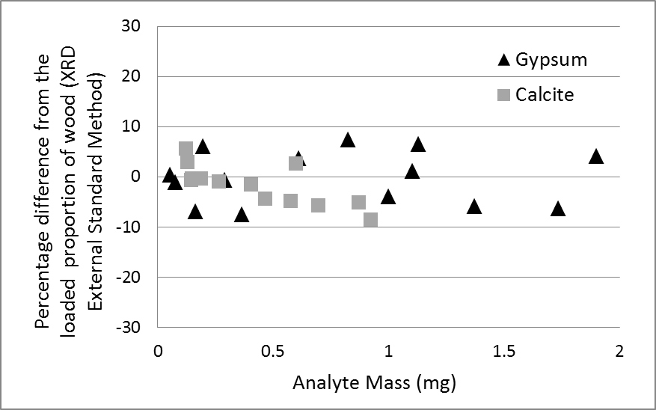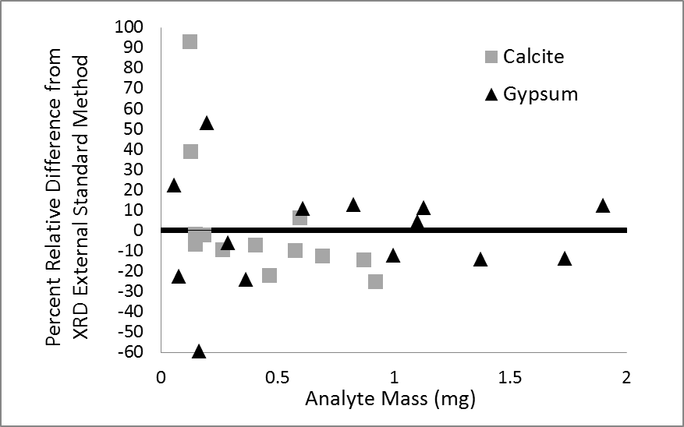
Figure 5S. Comparison of the absolute and relative differences in proportion of gypsum and calcite reported by Rietveld with that measured by external standard method in a four component mixture of calcite, gypsum, quartz and wood. Quartz was used as an internal standard to calculate the amorphous content (wood). The results for wood are shown in chart A in Figure 4.

