Supplementary:

In-situ high-temperature X-ray Diffraction studies of reduction of K₂CrO₄ and the formation of K_{x}CrO_{y} compounds

Shu-ting Liang, Hong-ling Zhang, Min-ting Luo, Yu-lan Bai, Hong-bin Xu, Yi Zhang

National Engineering Laboratory for Hydrometallurgical Cleaner Production Technology,
Institute of Process Engineering,
Chinese Academy of Science,
Beijing 100190, China

Supplementary 1: Evolution of XRD patterns during the reduction of K₂CrO₄

Figure S1 (a) The XRD pattern of K₂CrO₄ at 30 °C; (b) The XRD pattern of K₃CrO₄ at 480 °C; (c) The XRD pattern of the amorphous intermediate at 520 °C; (d) The XRD pattern of KCrO₂+K_{x}CrO₂ at 660 °C. (An Ni peak was attributed to the nickel (Ni) boat in the detection).

Figure S2. Evolution of XRD patterns during the reduction of K₂CrO₄ in hydrogen at 500 °C for 270 min.

Figure S3. (a) The XRD pattern of K₂CrO₄ at a reduction temperature of 30 °C; (b) The XRD pattern of K₃CrO₄ at a reduction temperature of 500 °C; (c) The XRD pattern of the amorphous intermediate at a reduction temperature of 600 °C for 2 min; (d), (e), (f), (g) The XRD pattern of KCrO₂+K_{0.7}CrO₂ at a reduction temperature of 600 °C for 30 min, 60 min, 180 min, 270 min, respectively. (An Ni peak was attributed to the nickel (Ni) boat in the detection).

Figure S4. Evolution of XRD patterns during the reduction of K₂CrO₄ in hydrogen at 700 °C for 240 min.

Supplementary 2: The In-situ high-temperature X-ray Diffraction experiment

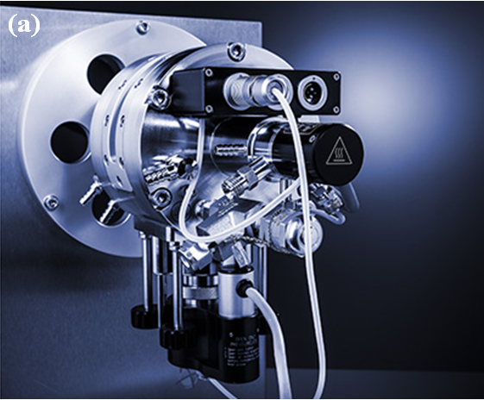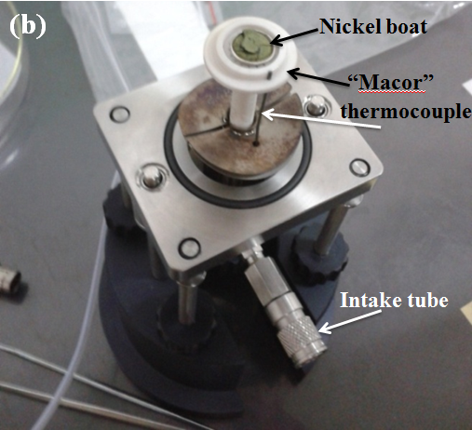
Figure S5. (a) The In situ X-ray diffractometer; (b)The sample holder.

The In situ XRD experiments were carried out using a SmartLab X-ray diffractometer (a XRK-900 Anton Paar ). A mixture of gas was compose of 3.55% hydrogen and 96.45% helium. The temperature was ranging from 30 to 700 °C. The temperature rise rate was 10 °C /min or 1 °C /min. The holding time was 10min. The pressure was 1atm and the flow rate was 300mL/min.
A machinable “Macor” glass ceramic was used as a sample holder. A very small nickel (Ni) boat was placed on the top of the Macor to preventing the Macor contact with the molten reduction product KOH. The temperature was measured using a thermocouple contacting with the sample holder.

Supplementary 3: The In-situ high-temperature FTIR experiment

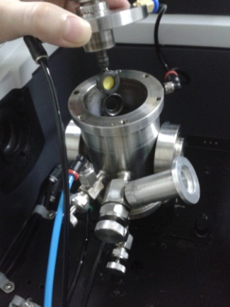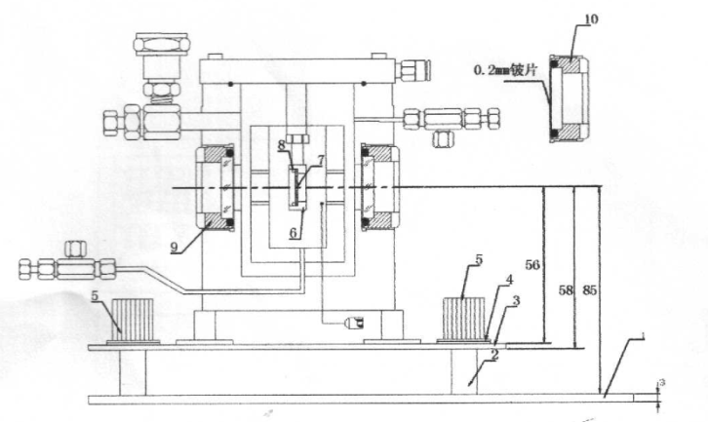
(b)
(a)
Figure S6. (a) The IR-X-01 In-situ pool; (b)The section view of IR-X-01.

The in situ FT-IR experiments were performed using a Nicolet 6700 FT-IR spectrometer. The pure K₂CrO₄ sample wafer was then sealed with stainless steel gaskets. A mixture of gas was compose of 3.55% hydrogen and 96.45% helium. From 30 °C to 600 °C, the temperature was increased at 10 °C per minute.

Supplementary 4: the Characterization of KCrO₂
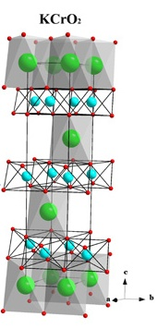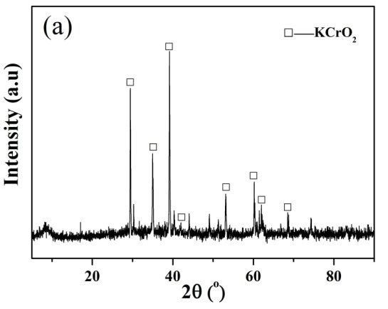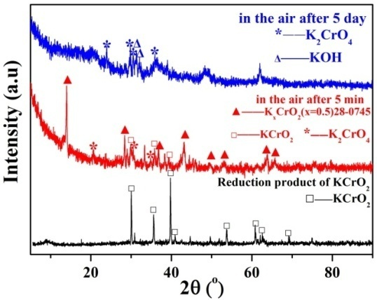
(c)
(a)
(b)
Figure S7. (a) The crystal structure of KCrO₂, K (green spheres), Cr (blue spheres), O (red spheres); (b) The XRD data of KCrO₂;
(c)The XRD data for the oxidation of KCrO₂ in air at a room temperature after 5 min and 5 days.

As shown in Figure S.3 (b), the XRD spectra of the reduction product, shows that all diffraction peaks can be indexed to the rhombohedral KCrO₂, indicating that the product has a single crystalline phase. Oxidation reaction of KCrO₂ occur naturally at room temperature in air. Figure S. 3(c) shows the XRD results for the oxidation of KCrO₂. After exposing to air for 5 min, the KCrO₂ is converted to K_{x}CrO₂ (0.50≤ x ≤ 0.60) and K₂CrO₄. The phase transition from K_{0.5}CrO₂ to K₂CrO₄ was observed, and the complete conversion takes place after 5 days in air. Therefore, in an atmosphere of air, the most likely process is the conversion of KCrO₂ to K_{0.5}CrO₂ and then K_{0.5}CrO₂ to K₂CrO₄. Research on the oxidation of the KCrO₂ in air is important for guiding the whole process.

Supplementary 5: The Characterization of K₃CrO₄

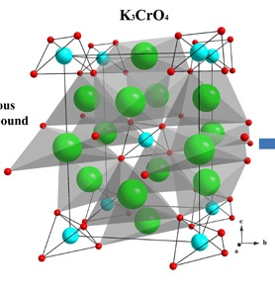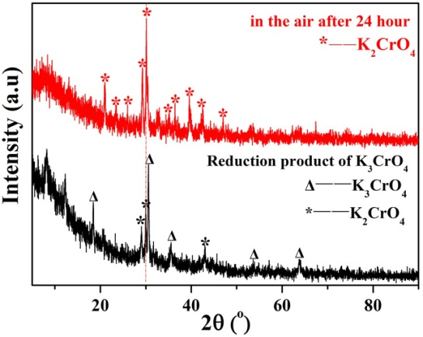
(b)
(a)

Figure S8. (a)The crystal structure of K₃CrO₄, K (green spheres), Cr (blue spheres), O (red spheres);
(b) The XRD data for the oxidation of K₃CrO₄ in air at a room temperature after 24 hours.

The dark-green K₃CrO₄ is also highly hygroscopic and sensitive, and it is spontaneous oxidation at room temperature. Figure S. 4 (b) shows the XRD results for the oxidation of K₃CrO₄ in air at room temperature. We found the oxidation of K₃CrO₄ is an easy process. The diffraction for K₃CrO₄ completely disappears, whereas the diffraction for K₂CrO₄ appears. After exposing the K₃CrO₄ and K₂CrO₄ system to air for 24 hours, only the K₂CrO₄ remained.

