An investigation into the temperature phase transitions of synthesized materials with Al and Mg doped lithium manganese oxide spinels by in-situ powder x-ray diffraction

C.D. Snyders¹, E.E. Ferg¹ and D. Billing²
¹Department of Chemistry, Nelson Mandela Metropolitan University, P.O. Box 77000, Port Elizabeth 6031, South Africa
²School of Chemistry, University of the Witwatersrand, Private Bag 3, Johannesburg 2000, South Africa
SUPPLIMENTARY INFORMATION:
TABLE SI: Topas Rietveld results of Li_{1.03}Mn_{1.97}O₄
Temperature (°C) | Rwp | GoF
400 | 5.19 | 1.21
500 | 5.20 | 1.23
600 | 5.11 | 1.18
700 | 5.16 | 1.16
800 | 5.22 | 1.19
Room temperature (29°C) | 5.92 | 1.42

TABLE SII: Topas Rietveld results of Li_{1.03}Mg_{0.2}Mn_{1.77}O₄
Temperature (°C) | Rwp | GoF
400 | 2.86 | 1.11
500 | 2.74 | 1.07
600 | 3.21 | 1.05
700 | 3.26 | 1.09
800 | 2.76 | 1.09
Room temperature (29°C) | 2.68 | 1.05

TABLE SIII: Topas Rietveld results of LiAl_{0.4}Mn_{1.6}O₄
Temperature (°C) | Rwp | GoF
400 | 5.65 | 1.27
500 | 5.81 | 1.28
600 | 5.76 | 1.26
750 | 6.30 | 1.35
800 | 6.12 | 1.31
Room temperature (29°C) | 5.71 | 1.34
Figures S1 to S6 are a representation of the Topas Rietveld refinement plots for one of the oxide materials investigated (Li_{1.03}Mn_{1.97}O₄).
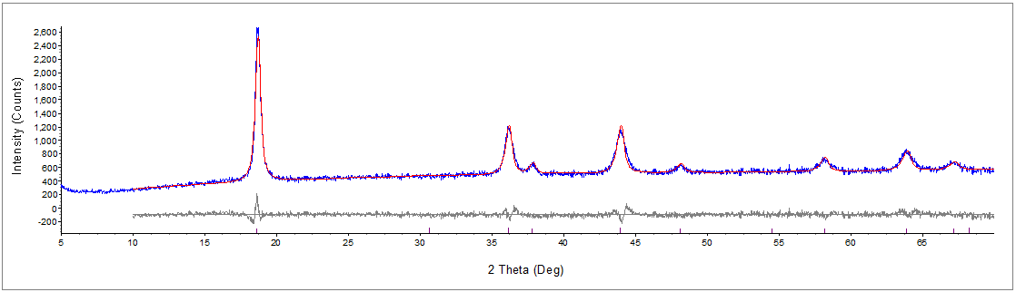
Figure S1: Topas Rietveld refinement graph of Li_{1.03}Mn_{1.97}O₄ at 400 °C
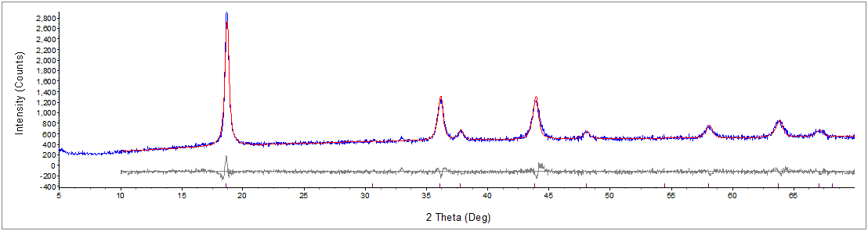
Figure S2: Topas Rietveld refinement graph of Li_{1.03}Mn_{1.97}O₄ at 500 °C
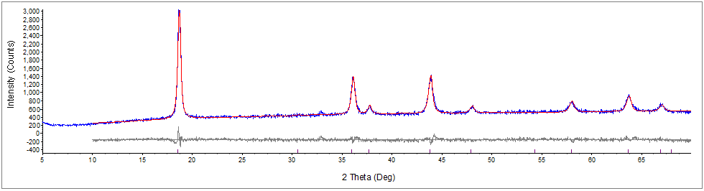
Figure S3: Topas Rietveld refinement graph of Li_{1.03}Mn_{1.97}O₄ at 600 °C
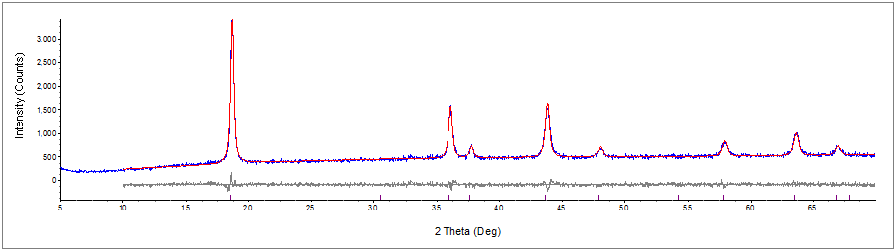
Figure S4: Topas Rietveld refinement graph of Li_{1.03}Mn_{1.97}O₄ at 700 °C
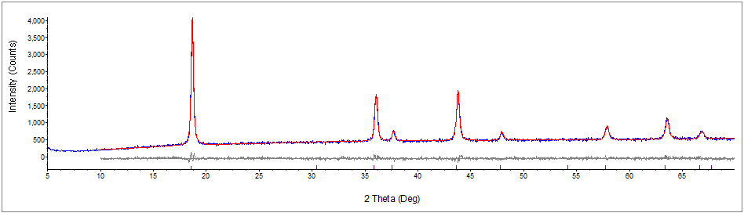
Figure S5: Topas Rietveld refinement graph of Li_{1.03}Mn_{1.97}O₄ at 800 °C
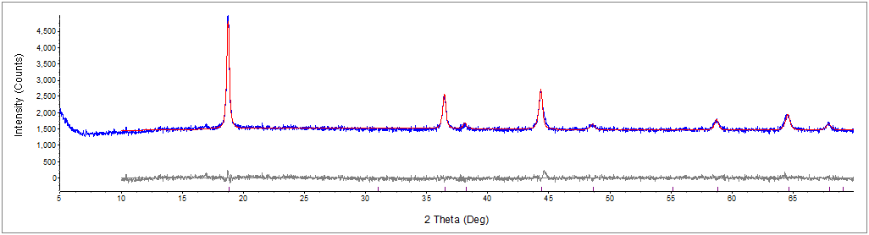
Figure S6: Topas Rietveld refinement graph of Li_{1.03}Mn_{1.97}O₄ at 29 °

*Corresponding author’s contact information: E-mail address: Charmelle.Snyders@nmmu.ac.za

