Support Information

Content
Figure S1 the Infrared Radiation spectra of Palbociclib …………………….………2
Figure S2 ¹H-NMR(400MHz, DMSO) spectra of Palbociclib………………..……..3
Figure S3 High Resolution Mass spectrum of Palbociclib…………………………....4
.
Figure S1 the Infrared Radiation spectra of Palbocilib

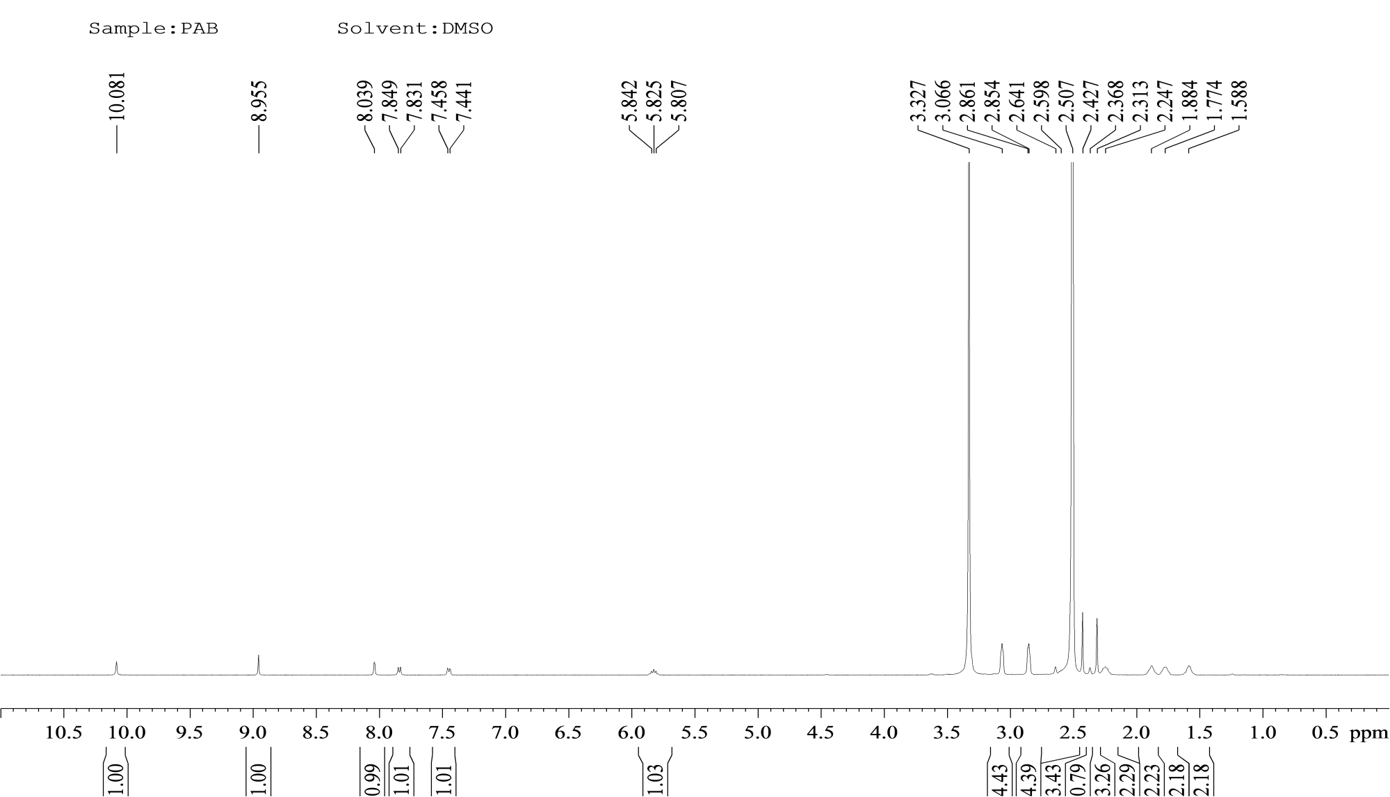
Figure S2 ¹H-NMR(400MHz, DMSO) spectra of Palbocilib

Figure S3 The High Resolution Mass spectrum of Palbociclib

