Synthesis, characterization and crystal structure of two zinc linear dicarboxilates

Berenice Torruco Bacaa, Luis Felipe del Castillo Dávilaa, Paula Vera-Cruza, Rubén A. Toscanob, Joelis Rodríguez-Hernándeza, Jorge Balmasedaa*

# INFRARED SPECTRA



FIGURE S1. IR spectra for ZnAdp and ZnSc samples.

# THERMOGRAVIMETRIC ANALYSIS



FIGURE S2. Thermogravimetric curve (green) and it temperature derivative (blue) of ZnAdp.



FIGURE S3. Thermogravimetric curve (green) and it temperature derivative (blue) of ZnSc.

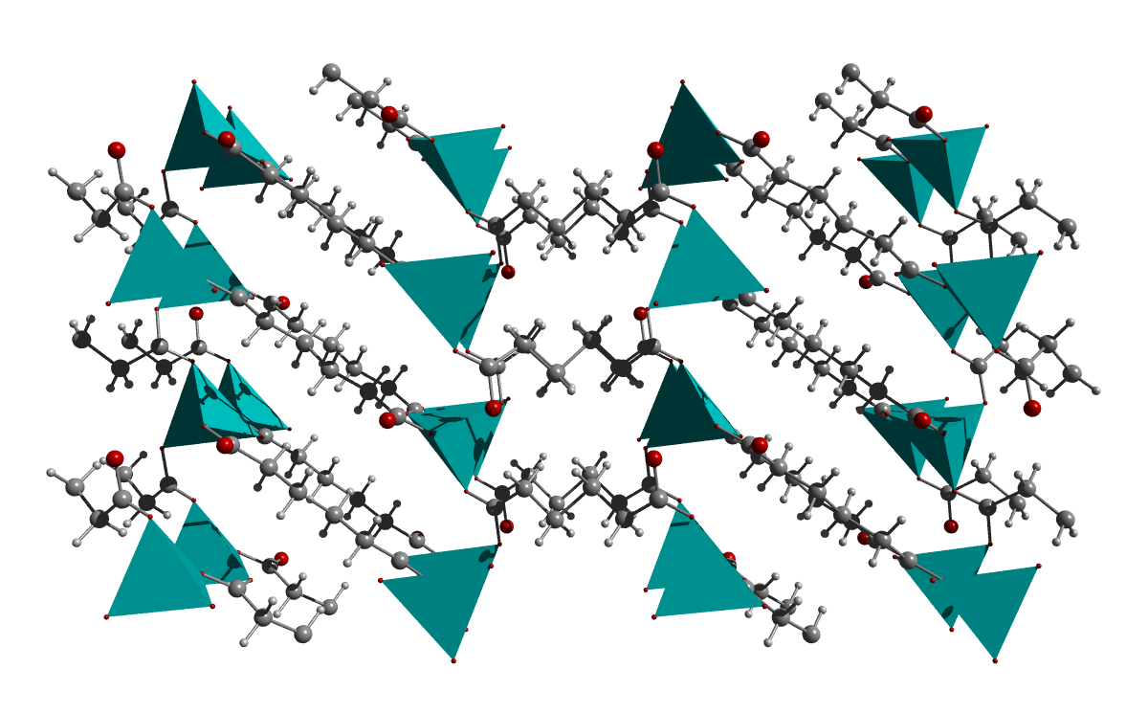

FIGURE S4. Inorganic sheets of ZnO4 distorted octahedra pillared by adipate ligands in a 2×2×2 supercell of ZnAdp shown in **b** direction.

# CRYSTAL STRUCTURE

TABLE S1. Atomic positions, temperature and occupation factors derived from the Rietveld refined crystal structure for: ZnAdp and ZnSc.

| Atom | site | x | y | z | Biso | Occ |
| --- | --- | --- | --- | --- | --- | --- |
| Zn2(C6H8O4)2 (ZnAdp) | | | | | | |
| Zn1 | 2a | 0.753(2) | 1.047(1) | 0.277(3) | 1.85(2) | 1 |
| Oc1 | 2a | 0.651(2) | 0.861(3) | 0.209(4) | 2.38(3) | 1 |
| Oc2 | 2a | 0.721(4) | 0.479(2) | 0.262(3) | 2.38(3) | 1 |
| Oc3 | 2a | 0.850(3) | 0.930(3) | 0.168(4) | 2.38(3) | 1 |
| Oc4 | 2a | 0.781(2) | 1.027(2) | 0.482(5) | 2.38(3) | 1 |
| C1 | 2a | 0.660(3) | 0.598(4) | 0.201(1) | 2.38(3) | 1 |
| C2 | 2a | 0.597(3) | 0.428(3) | 0.119(5) | 2.38(3) | 1 |
| C3 | 2a | 0.529(1) | 0.599(2) | 0.044(4) | 2.38(3) | 1 |
| C4 | 2a | 0.840(4) | 0.886(2) | 0.035(3) | 2.38(3) | 1 |
| C5 | 2a | 0.902(3) | 0.699(4) | -0.040(4) | 2.38(3) | 1 |
| C6 | 2a | 0.964(2) | 0.553(3) | 0.058(4) | 2.38(3) | 1 |
| Zn2(OH)2(C4H4O4) (ZnSc) | | | | | | |
| Zn | 2d | 0.9600(1) | 0.6676(1) | 0 | 0.0159(2) | 1 |
| Oc1 | 2d | 0.1683(7) | 0.5879(2) | 0 | 0.0266(8) | 1 |
| Oc2 | 2d | 0.5597(6) | 0.6423(2) | 0 | 0.0238(8) | 1 |
| Oh | 2d | 0 | 0.7128(2) | 0.75 | 0.0190(7) | 1 |
| H3 | 1d | 0.857(10) | 0.736(3) | -0.253(10) | 0.029 | 0.5 |
| H3A | 1d | 0.7091 | 0.5282 | 0.1159 | 0.022 | 0.5 |
| C1 | 2d | 0.4328(8) | 0.5906(2) | 0 | 0.016(1) | 1 |
| C2 | 2d | 0.5913(9) | 0.5295(2) | 0 | 0.018(1) | 1 |

TABLE S2. Calculated Bond lengths (Å) and angles (°) from the refined structure for samples studied

|  | Bond lengths (Å) | Angles (°) | |
| --- | --- | --- | --- |
| ZnAdp | Zn-Oc1= 1.970(2) | Oc1-Zn-Oc2= 102.19(1) | Oc1-C1-C2= 119.44(2) |
| Zn-Oc2= 2.138(1) | Oc1-Zn-Oc3= 112.43(3) | Oc2-C1-C2= 120.33(2) |
| Zn-Oc3= 1.958(1) | Oc1-Zn-Oc4= 118.37(2) | Oc3-C4-C5= 118.04(2) |
| Zn-Oc4= 1.955(1) | Oc2-Zn-Oc3= 116.24(1) | Oc4-C4-C5= 124.43(2) |
| Oc1-C1= 1.266(1) | Oc2-Zn-Oc4= 99.32(2) | C1-C2-C3= 114.83(3) |
| Oc2-C1= 1.268(1) | Oc3-Zn-Oc4= 107.88(2) | C4-C5-C6= 115.06(2) |
| Oc3-C4= 1.244(1) | Zn-Oc1-C1= 112.08(2) |  |
| Oc4-C4= 1.158(1) | Zn-Oc2-C1= 130.62(2) |  |
| C1-C2= 1.506(1) | Zn-Oc3-C4= 116.74(2) |  |
| C2-C3= 1.527(1) | Zn-Oc4-C4= 125.34(2) |  |
| C4-C5= 1.516(1) | Oc1-C1-Oc2= 120.21(3) |  |
| C5-C6= 1.525(2) | Oc3-C4-Oc4= 117.16(3) |  |
| ZnSc | Zn-Oh= 1.937(2) | Oh-Zn-Oc2= 103.2(1) | Oc1-Zn-Oc2= 105.0(1) |
| Zn-Oc1= 1.962(3) | Oh-Zn-Oc1= 112.1(1) | Oh’-Zn-Oh= 119.4(2) |
| Zn-Oc2= 1.992(3) |  |  |

# CRYSTALLOGRAPHIC DATA FOR ZnAdp

TABLE S3. Miller indices, calculated and observed angles, d spacing in Angstroms and relative intensities for reflections for ZnAdp.

|  |  |  |  |  |  |  |  |
| --- | --- | --- | --- | --- | --- | --- | --- |
| h | k | l | 2thetaobs | 2thetacalc | dhkl | I/Io | Δ2theta |
| 2 | 0 | 0 | 10.921 | 10.911 | 8.101 | 100 | 0.01 |
| 0 | 1 | 0 | 18.547 | 18.543 | 4.781 | 9 | 0.004 |
| 0 | 0 | 2 | 19.136 | 19.134 | 4.634 | 11 | 0.002 |
| 1 | 1 | 0 | 19.337 | 19.341 | 4.585 | 5 | -0.004 |
| -1 | 0 | 2 | 19.918 | 19.879 | 4.462 | 4 | 0.039 |
| 1 | 0 | 2 | 19.940 | 4.449 | -0.022 |
| 2 | 1 | 0 | 21.575 | 21.564 | 4.117 | 67 | 0.011 |
| -1 | 1 | 1 | 21.590 | 4.113 | -0.015 |
| -2 | 0 | 2 | 22.043 | 22.023 | 4.032 | 40 | 0.02 |
| 2 | 0 | 2 | 22.145 | 22.133 | 4.012 | 21 | 0.012 |
| -2 | 1 | 1 | 23.623 | 23.598 | 3.767 | 9 | 0.025 |
| 2 | 1 | 1 | 23.650 | 3.758 | -0.027 |
| 3 | 1 | 0 | 24.862 | 24.851 | 3.579 | 10 | 0.011 |
| -3 | 0 | 2 | 25.242 | 25.228 | 3.527 | 18 | 0.014 |
| 3 | 1 | 1 | 26.751 | 26.706 | 3.335 | 8 | 0.045 |
| 0 | 1 | 2 | 26.768 | 3.327 | -0.017 |
| -1 | 1 | 2 | 27.333 | 27.315 | 3.262 | 1 | 0.018 |
| 1 | 1 | 2 | 27.360 | 3.257 | -0.027 |
| 4 | 1 | 0 | 28.914 | 28.864 | 3.090 | 8 | 0.05 |
| -2 | 1 | 2 | 28.941 | 3.083 | -0.027 |
| 2 | 1 | 2 | 29.011 | 29.027 | 3.073 | 5 | -0.016 |
| 4 | 0 | 2 | 29.366 | 29.342 | 3.041 | 5 | 0.024 |
| 4 | 1 | 1 | 30.492 | 30.504 | 2.928 | 4 | -0.012 |
| 3 | 1 | 2 | 31.609 | 31.612 | 2.828 | < 1 | -0.003 |
| 5 | 1 | 0 | 33.363 | 33.375 | 2.682 | 2 | -0.012 |
| -5 | 0 | 2 | 33.641 | 33.627 | 2.663 | 4 | 0.014 |
| 4 | 1 | 2 | 34.942 | 34.936 | 2.566 | 4 | 0.006 |
| -1 | 1 | 3 | 34.962 | 2.564 | -0.02 |
| 2 | 1 | 3 | 36.359 | 36.375 | 2.468 | < 1 | -0.016 |
| 0 | 2 | 0 | 37.561 | 37.595 | 2.390 | 7 | -0.034 |
| 6 | 1 | 0 | 38.269 | 38.245 | 2.351 | 2 | 0.024 |
| -3 | 1 | 3 | 38.369 | 38.379 | 2.343 | 2 | -0.01 |
| 0 | 0 | 4 | 38.798 | 38.831 | 2.317 | 6 | -0.033 |
| 5 | 1 | 2 | 38.838 | 2.316 | -0.04 |
| -1 | 0 | 4 | 39.214 | 39.208 | 2.296 | 11 | 0.006 |
| 1 | 0 | 4 | 39.297 | 39.274 | 2.292 | 3 | 0.023 |
| -1 | 2 | 1 | 39.277 | 2.292 | 0.02 |
| 6 | 1 | 1 | 39.569 | 39.556 | 2.276 | 6 | 0.013 |
| -2 | 0 | 4 | 40.385 | 40.391 | 2.231 | 4 | -0.006 |
| -2 | 2 | 1 | 40.475 | 40.480 | 2.226 | 3 | -0.005 |
| 4 | 1 | 3 | 41.366 | 41.378 | 2.180 | 3 | -0.012 |
| -3 | 2 | 1 | 42.441 | 42.428 | 2.129 | 2 | 0.013 |
| 0 | 2 | 2 | 42.530 | 42.517 | 2.124 | 2 | 0.013 |
| 6 | 1 | 2 | 43.207 | 43.195 | 2.092 | 4 | 0.012 |
| 4 | 2 | 0 | 43.935 | 43.945 | 2.058 | 6 | -0.01 |
| 2 | 1 | 4 | 44.896 | 44.905 | 2.016 | 4 | -0.009 |
| -4 | 0 | 4 | 44.917 | 2.016 | -0.021 |
| -4 | 2 | 1 | 45.022 | 45.044 | 2.011 | 3 | -0.022 |
| -3 | 2 | 2 | 45.796 | 45.818 | 1.978 | < 1 | -0.022 |
| 3 | 1 | 4 | 46.725 | 46.740 | 1.941 | 1 | -0.015 |
| 0 | 2 | 3 | 48.109 | 48.086 | 1.890 | 3 | 0.023 |
| -5 | 0 | 4 | 48.101 | 1.890 | 0.008 |
| 5 | 0 | 4 | 48.364 | 48.380 | 1.879 | 2 | -0.016 |
| 4 | 2 | 2 | 48.392 | 1.879 | -0.028 |
| -8 | 0 | 2 | 48.917 | 48.934 | 1.859 | 3 | -0.017 |
| 8 | 0 | 2 | 49.137 | 49.154 | 1.852 | 2 | -0.017 |
| 6 | 2 | 0 | 50.988 | 50.978 | 1.789 | 2 | 0.01 |
| -5 | 1 | 4 | 51.978 | 51.982 | 1.757 | 1 | -0.004 |
| 6 | 0 | 4 | 52.119 | 52.113 | 1.753 | 1 | 0.006 |
| -7 | 1 | 3 | 52.868 | 52.829 | 1.731 | 2 | 0.039 |
| 7 | 1 | 3 | 53.097 | 53.101 | 1.723 | 2 | -0.004 |
| 6 | 2 | 2 | 55.015 | 55.021 | 1.667 | 2 | -0.006 |
| 6 | 1 | 4 | 55.765 | 55.793 | 1.646 | 1 | -0.028 |
| 7 | 0 | 4 | 56.306 | 56.290 | 1.632 | 2 | 0.016 |
| 2 | 2 | 4 | 56.459 | 56.459 | 1.628 | 1 | 0 |
| 10 | 0 | 0 | 56.746 | 56.769 | 1.620 | < 1 | -0.023 |
| 8 | 1 | 3 | 57.834 | 57.837 | 1.592 | < 1 | -0.003 |
| -4 | 1 | 5 | 57.840 | 1.592 | -0.006 |
| -7 | 2 | 2 | 58.898 | 58.876 | 1.567 | < 1 | 0.022 |
| 8 | 2 | 0 | 59.803 | 59.797 | 1.545 | 2 | 0.006 |
| 7 | 1 | 4 | 59.797 | 1.545 | 0.006 |
| 0 | 0 | 6 | 59.818 | 1.544 | -0.015 |
| -1 | 0 | 6 | 60.062 | 60.081 | 1.538 | 1 | -0.019 |
| 5 | 1 | 5 | 60.840 | 60.822 | 1.522 | < 1 | 0.018 |
| 4 | 3 | 0 | 62.584 | 62.585 | 1.483 | < 1 | -0.001 |
| 3 | 0 | 6 | 62.584 | 1.483 | 0 |
| -9 | 1 | 3 | 62.606 | 1.482 | -0.022 |
| -5 | 2 | 4 | 62.603 | 1.482 | -0.019 |
| -4 | 3 | 1 | 63.441 | 63.450 | 1.464 | 1 | -0.009 |
| 0 | 2 | 5 | 63.447 | 1.464 | -0.006 |
| -1 | 1 | 6 | 63.457 | 1.464 | -0.016 |
| 4 | 3 | 1 | 63.503 | 63.496 | 1.463 | < 1 | 0.007 |
| 1 | 1 | 6 | 63.527 | 1.463 | -0.024 |
| 3 | 3 | 2 | 64.116 | 64.133 | 1.451 | < 1 | -0.017 |
| 6 | 2 | 4 | 66.019 | 66.018 | 1.413 | < 1 | 0.001 |
| -5 | 3 | 1 | 66.021 | 1.413 | -0.002 |
| -5 | 0 | 6 | 66.893 | 66.891 | 1.397 | < 1 | 0.002 |
| 4 | 2 | 5 | 68.115 | 68.106 | 1.375 | < 1 | 0.009 |
| -9 | 2 | 2 | 68.122 | 1.375 | -0.007 |
| -6 | 3 | 1 | 69.091 | 69.098 | 1.358 | < 1 | -0.007 |
| -5 | 1 | 6 | 70.122 | 70.088 | 1.341 | < 1 | 0.034 |
| 10 | 2 | 0 | 70.102 | 1.341 | 0.02 |
| 10 | 0 | 4 | 71.178 | 71.132 | 1.324 | < 1 | 0.046 |
| -2 | 3 | 4 | 72.912 | 72.877 | 1.296 | < 1 | 0.035 |
| 5 | 3 | 3 | 72.896 | 1.296 | 0.016 |
| -11 | 1 | 3 | 73.761 | 73.747 | 1.284 | < 1 | 0.014 |
| -4 | 3 | 4 | 76.064 | 76.060 | 1.250 | < 1 | 0.004 |
| -9 | 1 | 5 | 76.068 | 1.250 | -0.004 |
| 8 | 3 | 1 | 76.759 | 76.765 | 1.240 | < 1 | -0.006 |
| -7 | 2 | 5 | 76.777 | 1.240 | -0.018 |
| 3 | 1 | 7 | 76.779 | 1.240 | -0.02 |
| 0 | 3 | 5 | 79.205 | 79.195 | 1.208 | < 1 | 0.01 |
| 8 | 3 | 2 | 79.234 | 1.208 | -0.029 |
| -12 | 1 | 3 | 79.854 | 79.851 | 1.200 | < 1 | 0.003 |
| 11 | 1 | 4 | 79.851 | 1.200 | 0.003 |
| 0 | 4 | 1 | 81.062 | 81.052 | 1.185 | < 1 | 0.01 |
| -10 | 1 | 5 | 81.063 | 1.185 | -0.001 |
| 5 | 1 | 7 | 81.076 | 1.185 | -0.014 |
| 8 | 3 | 3 | 83.276 | 83.280 | 1.159 | < 1 | -0.004 |
| -4 | 3 | 5 | 83.284 | 1.159 | -0.008 |
| 10 | 3 | 0 | 85.373 | 85.366 | 1.136 | < 1 | 0.007 |
| -12 | 1 | 4 | 85.378 | 1.136 | -0.005 |
| 9 | 1 | 6 | 85.421 | 1.136 | -0.048 |
| -2 | 4 | 3 | 88.459 | 88.425 | 1.104 | < 1 | 0.034 |
| -6 | 3 | 5 | 88.426 | 1.104 | 0.033 |
| -10 | 3 | 2 | 88.433 | 1.104 | 0.026 |