Supplementary information

1. Tectoridin needle crystal under a microscope.
In our research, we tried many different solvent systems, include methanol, ethanol, acetonitrile, butanol, et al. We found tectoridin only crystallized in solvent 3:2 (v/v) ethanol and water with a needle-like shape (Figure S1). We re-crystallized tectoridin under this solvent system for our diffraction experiment.
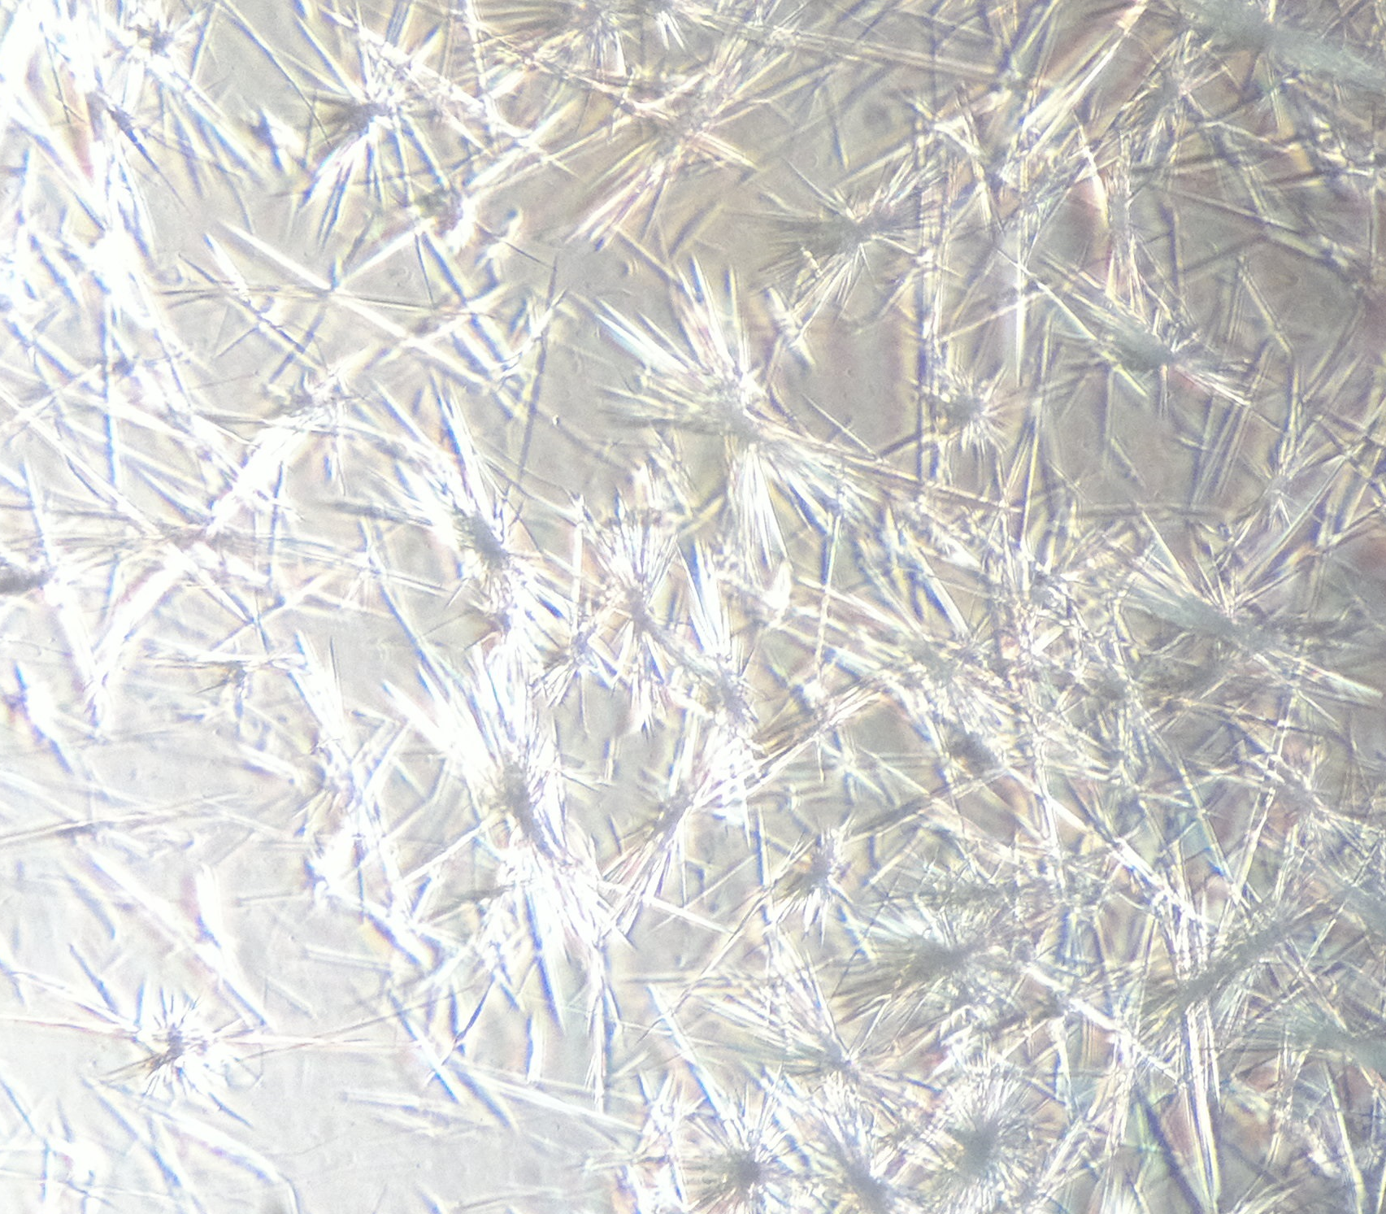
Figure S1. Tectoridin crystal (×100). (CX22; Olympus, Tokyo, Japan)

2. Melting point test.
Melting point was measured on a YRT-3 Melting Point Tester (Tianda Tianfa Technology Co., LTD, Tianjin, People’s Republic of China) and was presented uncorrected. Melting range of the isolated tectoridin was 265-266 °C. The narrow melting temperature range (≤ 1 °C) provided the high purity of the isolated tectoridin.

3. High performance liquid chromatography (HPLC) analysis.
We analyzed the isolated tectoridin and the crude extract of Belamcanda chinensis for comparison using an HP 1200 series HPLC system interfaced with a HP 1260 series diode-array detector (Agilent Technologies, Santa Clara, CA, USA). Different chromatographic columns and mobile phases were chosen. The chromatographic conditions and chromatograms could be seen in Figure S2(a, b), Figure S3(a, b) and Figure S4(a, b).
The purity of tectoridin were confirmed by HPLC area normalization method. The results were as follows: 98.6% (Figure S2a), 98.9% (Figure S3a), 99.5% (Figure S4a).
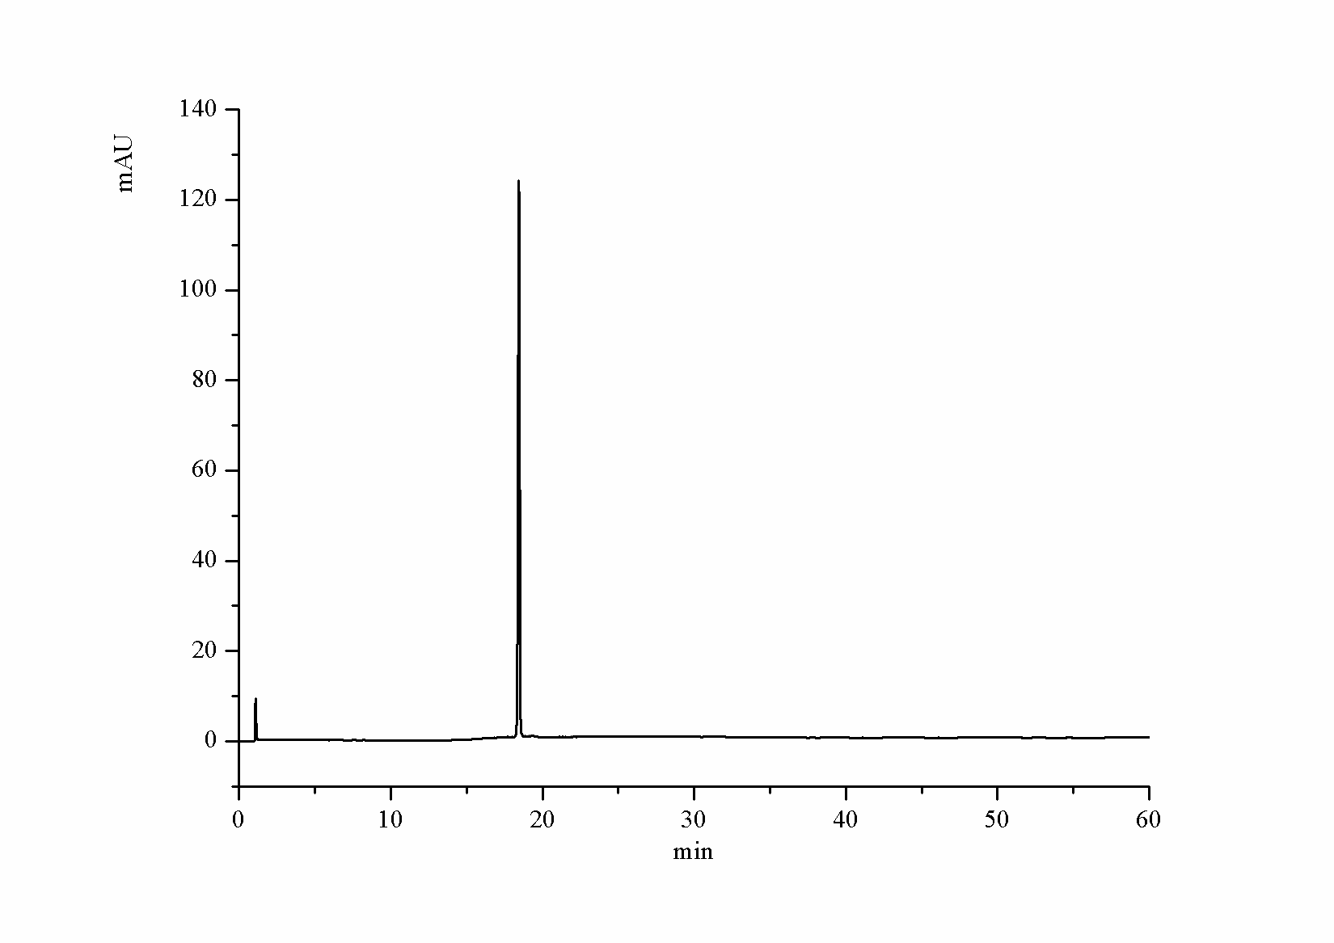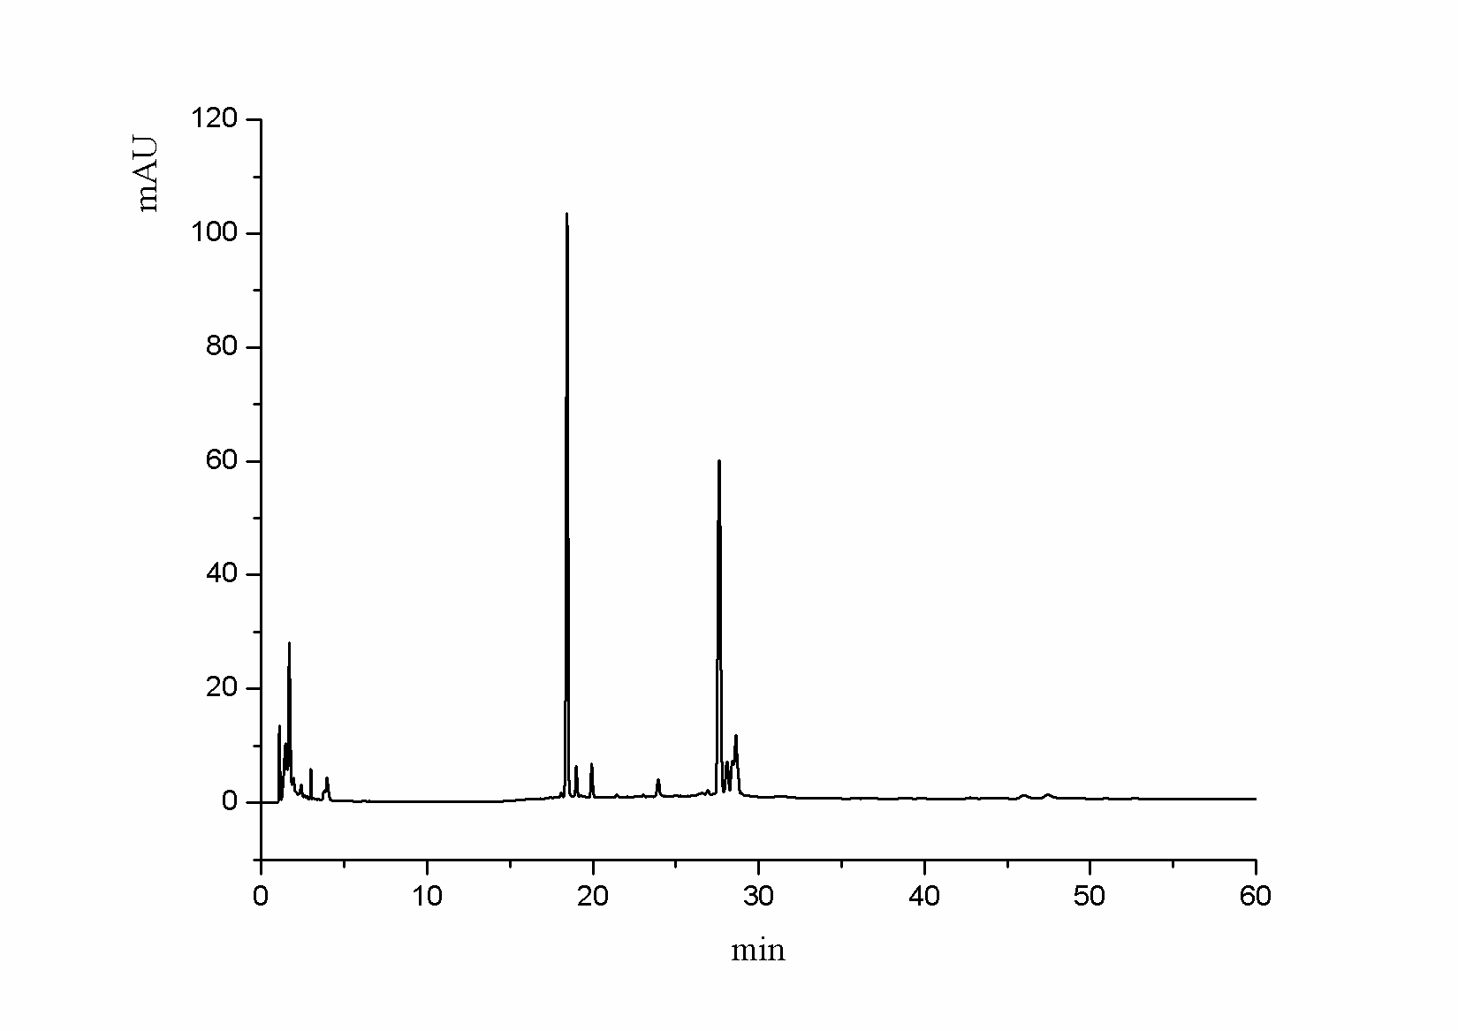
(a) (b)
Figure S2.Chromatograms of isolated tectoridin (a) and the crude extract of Belamcanda chinensis (b). Alltima C18 column (250 mm×4.6 mm, 5 μm), the gradient elution system was consisted of A (acetonitrile) and B (water), 17% A at 0-10 min, 17-46% A at 10-25 min, 46% A at 25-33 min.
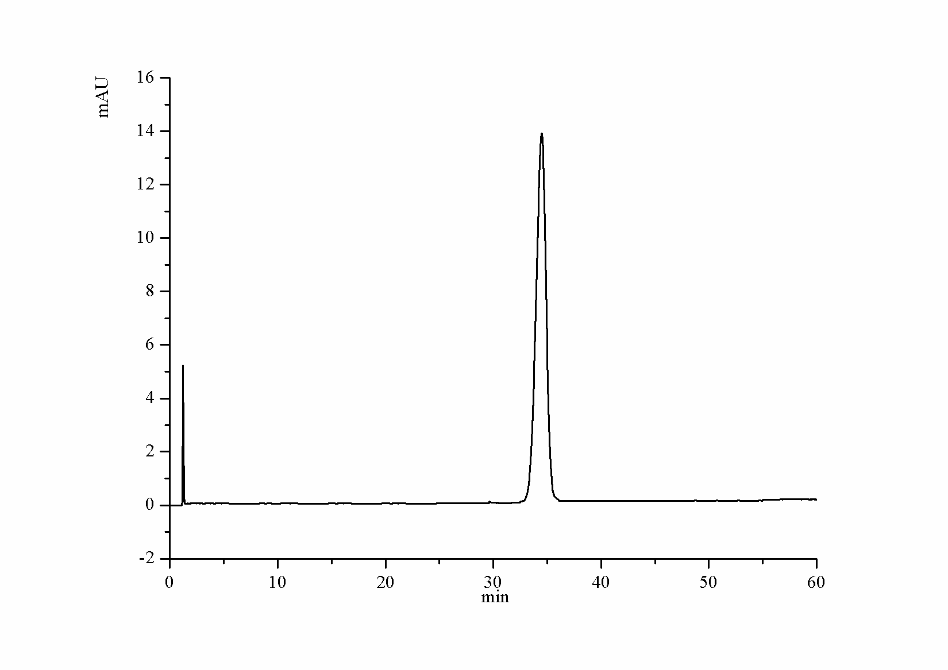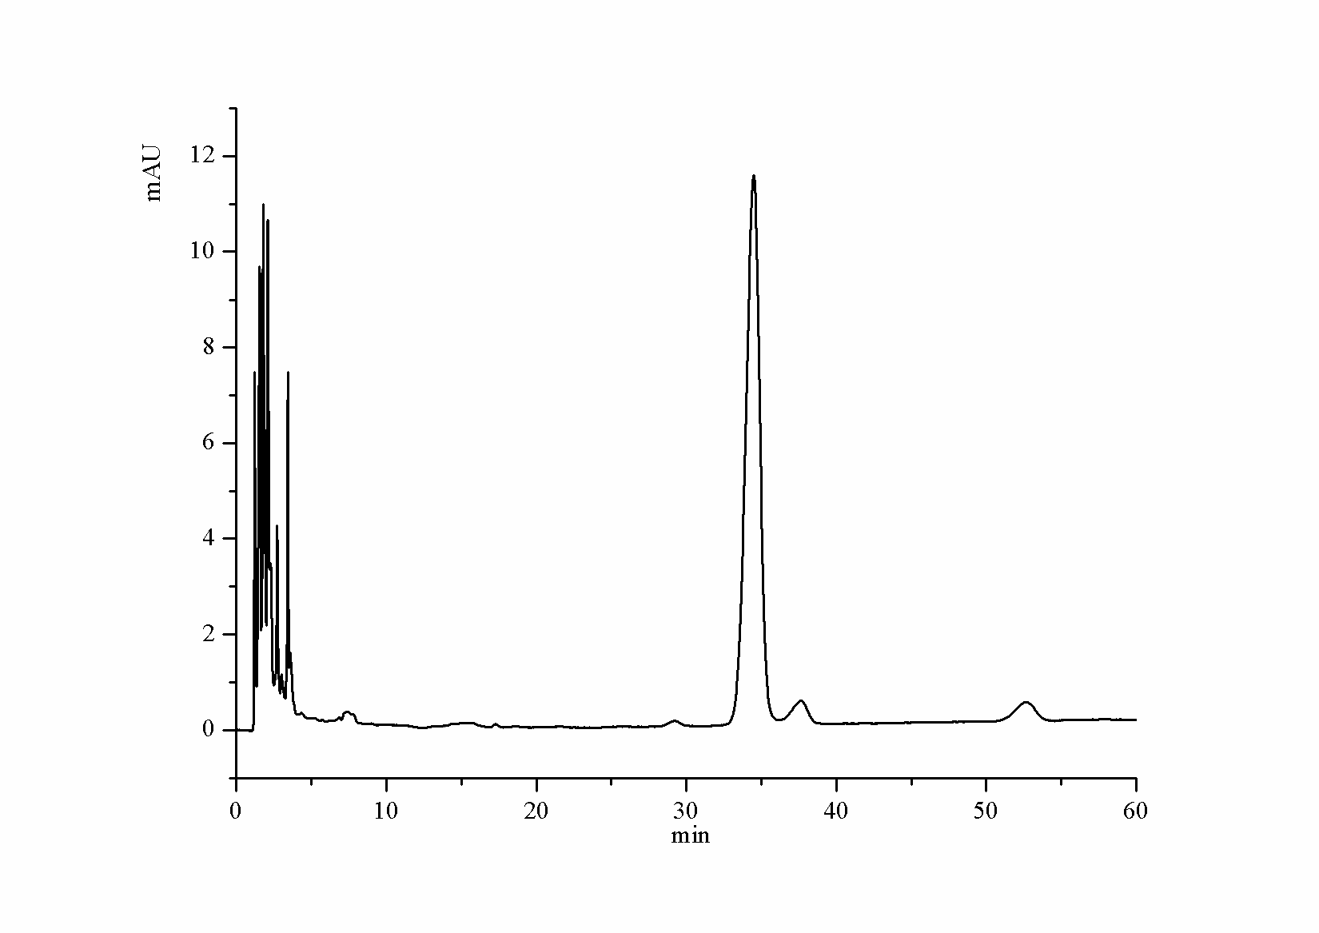
(a) (b)
Figure S3.Chromatograms of isolated tectoridin (a) and the crude extract of Belamcanda chinensis (b). Alltima C18 column (250 mm×4.6 mm, 5 μm), mobile phase water-methanol (68:32, v/v) was used.

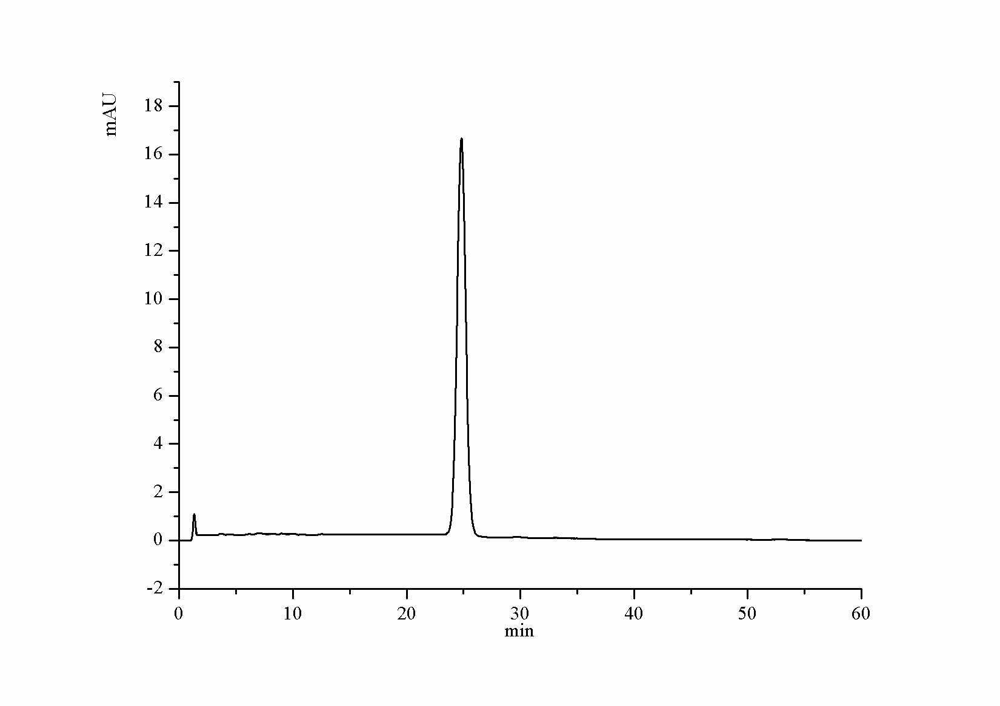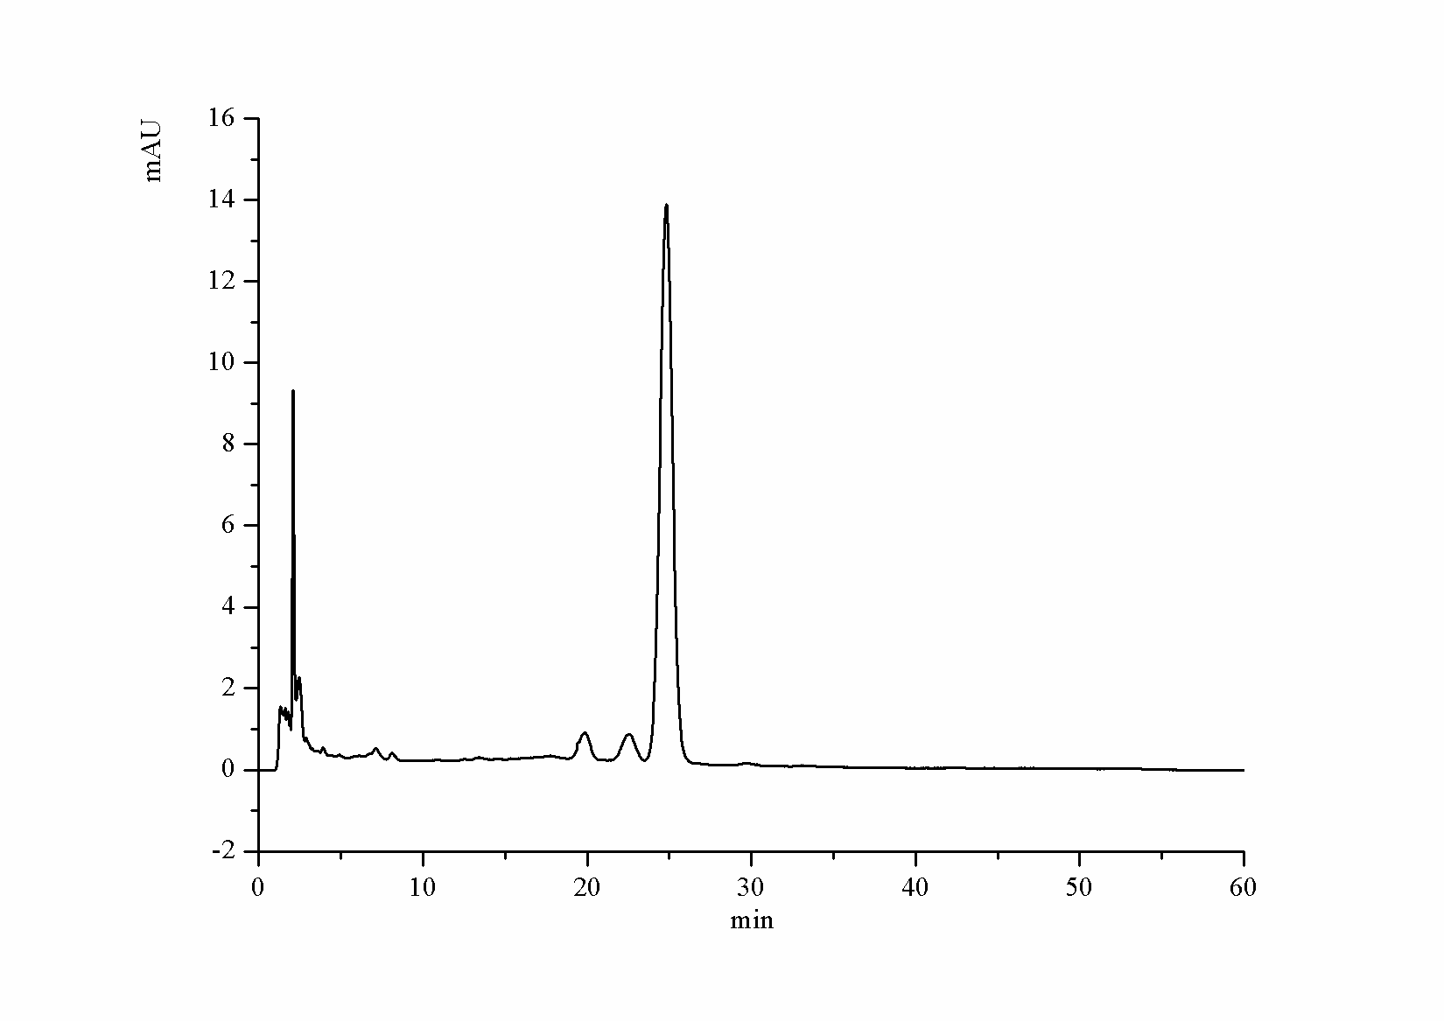
(a) (b)
Figure S4.Chromatograms of isolated tectoridin (a) and the crude extract of Belamcanda chinensis (b). waters symmetry C18 (150 mm×4.6 mm, 5 μm), mobile phase water-methanol (68:32, v/v) was used.

