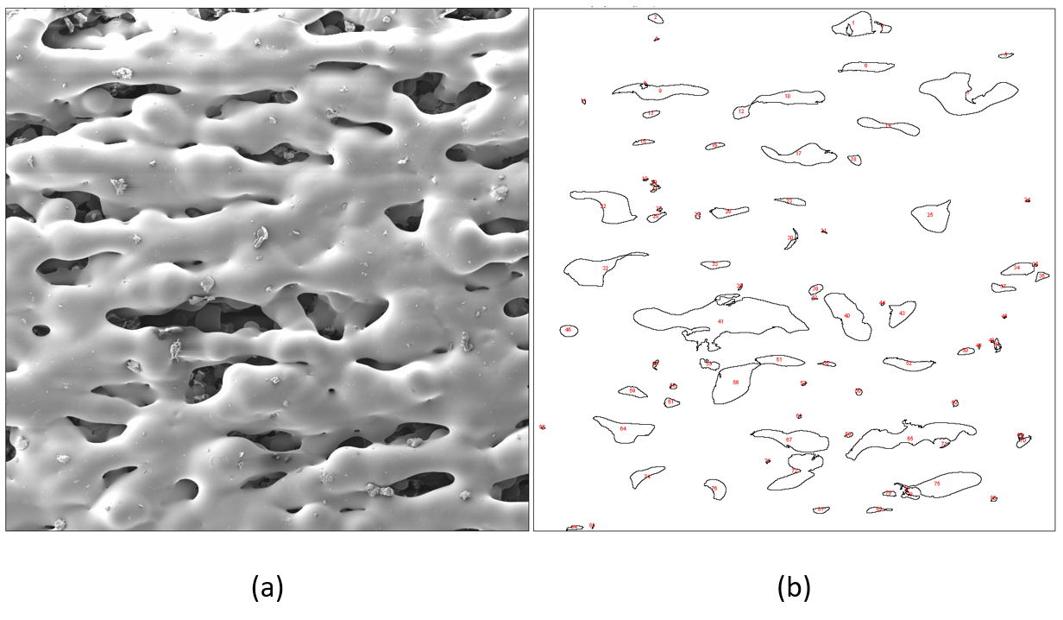
Figure S1. ImageJ porosity analysis, original photo (a), porosity area (b).

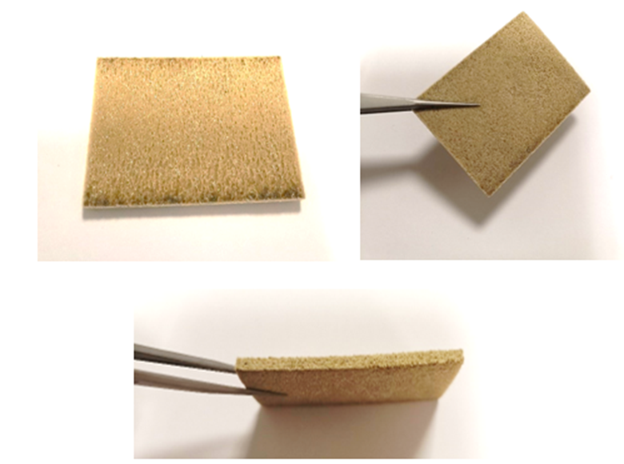
Figure S2 Multi-layer laser sintered PEI specimens
Table SI. Porosity analysis of single layer PEI
Power(W) | Speed(mm/s) | Energy density | Total Area(μm²) | Average Size(μm²) | %Area
9 | 362.3 | 0.046 | 3816882.075 | 9447.728 | 43.75
13 | 523.3 | 0.046 | 3618927.111 | 9399.811 | 41.67
20 | 805.2 | 0.046 | 2711668.252 | 10080.551 | 31.29
9 | 308.6 | 0.054 | 3117435.496 | 8448.335 | 35.65
13 | 445.8 | 0.054 | 3078016.987 | 10158.472 | 35.28
20 | 685.9 | 0.054 | 2741567.809 | 8257.734 | 31.42
9 | 267.9 | 0.062 | 3093304.742 | 7193.732 | 35.22
13 | 386.9 | 0.062 | 1798728.796 | 4553.744 | 20.44
20 | 595 | 0.062 | 1969587.936 | 3931.313 | 22.28
9 | 238.1 | 0.07 | 2311763.032 | 5882.349 | 26.62
13 | 343.9 | 0.07 | 1101928.049 | 5272.383 | 12.63
20 | 529.1 | 0.07 | 1713902.88 | 5026.108 | 19.73
9 | 213.7 | 0.078 | 2883107.673 | 7101.25 | 33.12
13 | 308.6 | 0.078 | 1460220.586 | 3126.811 | 16.85
20 | 474.8 | 0.078 | 2466795.352 | 4827.388 | 28.09

Table SII. porosity analysis on energy density of 0.062 J/mm²
Power(W) | Speed(mm/s) | Energy density | Total Area(μm²) | Average Size(μm²) | (%) Area
9 | 267.9 | 0.062 | 3093304.742 | 7193.732 | 35.224
11 | 327.4 | 0.062 | 2253830.587 | 5193.158 | 25.949
13 | 386.9 | 0.062 | 1798728.796 | 4553.744 | 20.436
15 | 446.4 | 0.062 | 2047022.591 | 5933.399 | 23.41
20 | 595 | 0.062 | 1969587.936 | 3931.313 | 22.278
30 | 892.86 | 0.062 | 1663862.87 | 4850.912 | 23.071

