Supplementary Information
A Strategy for Imaging-guided Cocktail Cancer Therapy Using Dual-colored Polymeric Drug Carriers with Amplified AIE behavior by D-A/FRET Adjustment
Mengxia Hua, Yi Zhou, Ziyu Wang, Cheng Wang, Lu Wang, Hong Yuan* and Daoben Hua*
Correspondence to: D. Hua (E-mail: dbhua_lab@suda.edu.cn);
H. Yuan (E-mail: yuanhong70@zju.edu.cn)

Content
- Materials and apparatus
- Synthesis procedure
- In vivo tumor distribution
- Animal model
- Statistical analysis
- NMR spectra
- Cyclic voltammograms
- Fluorescence lifetime
- TEM image and DLS data
- Immunohistochemical staining of tumor tissues

Materials and apparatus
All solvents and reagents were commercially available and of analytical reagent grade. NMR spectra were obtained from Bruker Avance 400 spectrometer 400 MHz for 1H NMR and reported as parts per million (ppm) from the internal standard TMS. The UV-vis absorbance spectra were obtained on Shimadzu UV-3600 spectropolarimeter. Fluorescence emission spectra were measured from an FLS-980 spectrometer. Molecular weight was determined by gel permeation chromatography (GPC) with a Waters 244 HPLC pump, and THF was used as solvent relative to polystyrene standards. The electrochemical measurements were conducted on a CHI-600 E electrochemical station. The drug loading content (DLC) and encapsulation efficiency (EE) of drugs in the Pdots was assessed by fluorescence spectrophotometer and high-performance liquid chromatography (HPLC), respectively. The Dox content was determined by fluorescence spectrophotometer (F-2500, Hitachi, Japan) at the excitation wavelength of 505 nm and emission wavelength of 565 nm. The Cur content was determined using HPLC (Agilent 1100 series, California, USA) with the following condition: Diamonsil TM C18 column (250 mm × 4.6 mm × 5 mm) with detection wavelength of 425 nm. The mobile phase was acetonitrile and 3% acetic acid (75:25, v/v) flowing at the speed of 1.0 mL/min (30 ℃).
Doxorubicin (Dox) and curcumin (Cur) were purchased from Dalian Meilun Biotech Co., Ltd. (Dalian, China). Dox was obtained from Bristol-Myers Squibb (New York, USA). All solvents and reagents were commercially available from Sigma-Aldrich (Missouri, USA) and of analytical reagent grade. MCF-7/ADR (human drug resistant breast carcinoma) cell line was purchased from Institute of Biochemistry and Cell Biology (Shanghai, China). Female BALB/c nude mice (4-5 weeks, 20 g) purchased from Shanghai Laboratory Animal Center (SLAC, China). Confocal laser scanning microscope (CLSM) was BX61W1-FV1000 (Olympus, Japan). The microplate reader for MTT assay was Model 680 (Bio-Rad, USA).
Synthesis procedure
Synthesis of M-2: M-1 (2.244 g, 3.00 mmol), 8 (3.850 g, 15 mmol) and KOAc (3.000 g, 15 mmol) were dissolved in 60 mL DMF with Pd(dppf)₂Cl₂ (0.3 g, 5% e. q.). The mixture was heated to 120ºC and stirred for 24 h under Ar Atmosphere. Then 300 mL water was added and extracted with DCM for 3 times (50 mL × 3). The organic phase was collected and dried by Na₂SO₄. Then the solvent was removed and the result mixture was purified with silica gel column chromatgraphy with PE : EA = 10 : 1 as the mobile phase and gave M-2 as a yellow solid (2.110 g, 84.9%). ¹H NMR (400 MHz, CDCl₃) δ 7.52 (d, J = 7.1 Hz, 4H), 7.00 (d, J = 7.1 Hz, 4H), 6.90 (d, J = 7.6 Hz, 4H), 6.60 (d, J = 7.6 Hz, 4H), 3.86 (s, 4H), 1.73 (s, 4H), 1.60 (s, 2H), 1.42 (s, 5H), 1.32 (s, 37H), 0.88 (s, 6H). ¹³C NMR (100 MHz, CDCl₃) δ 157.80, 147.34, 141.33, 138.76, 135.96, 134.10, 132.61, 130.84, 113.55, 83.66, 67.78, 31.82, 29.40, 29.33, 29.24, 26.09, 24.90, 22.67, 14.11.
Synthesis of M-6: Compound 6 (1.200 g, 6.00 mmol) and 7 (5k, 25.000 g) were dissolved in 200 mL DCM under Ar atmosphere. Then 60 mL DCM solution containing DCC (2.06 g, 10.00 mmol) and DMAP (0.06 g, 0.50 mmol) was added dropwise in ice bath. The mixture was stirred for 48 h at room temperature and the precipitate was filtered. The reaction mixture was concentrated and poured into large amount of cold diethyl ether. The precipitate was collected and this process was repeated for several times to obtain M-6 (21.210 g, 77.1%). ¹H NMR (400 MHz, CDCl₃) δ 7.92 (d, J = 8.6 Hz, 2H), 7.58 (d, J = 8.6 Hz, 2H), 3.64 (s, 820H). GPC data: M_{w} = 8180, M_{n} = 6300, PDI = 1.30.
Synthesis of P-1: M-2 (0.160 g, 0.190 mmol), M-3 (0.100 g, 0.190 mmol) and Pd(PPh₃)₄ (0.040 g, 5% e. q.) were dissolved in 10 mL toluene, 5 mL ethanol and 5 mL water with K₂CO₃ (1.30 g). The mixture was refluxed for 48 h under Ar atmosphere. The organic phase was dried by Na₂SO₄ and the solvent was removed. The result mixture was solved by THF and dropped into 300 mL hexane. The product was filtered and dried to give P-1 as dark yellow solid (0.102 g, 55.7%). ¹H NMR (400 MHz, CDCl₃) δ 8.07-8.00 (m, 4H), 7.75-7.64 (m, 6H), 7.56-7.55 (m, 2H), 7.47-7.42 (m, 5H), 7.13 (s, 4H), 6.98-6.97 (m, 3H), 6.83 (s, 3H), 6.66 (s, 3H), 3.88 (t, J = 5.9 Hz, 7H), 1.73-1.72 (m, 4H), 1.42 (s, 3H), 1.32-1.27 (m, 18H), 0.88-0.86 (m, 8H). GPC data: M_{w} = 11250, M_{n} = 8370, PDI = 1.36.
Synthesis of P-2: M-2 (0.160 g, 0.190 mmol), M-4 (0.100 g, 0.190 mmol) and Pd(PPh₃)₄ (0.040 g, 5% e. q.) were dissolved in 10 mL toluene, 5 mL ethanol and 5 mL water with K₂CO₃ (1.30 g). The reaction was proceeded as the method of P-1 to give P-2 as orange solid (0.100 g, 53.8%). ¹H NMR (400 MHz, CDCl₃) δ 8.06 - 8.00 (m, 3H), 7.73 - 7.62 (m, 4H), 7.55 - 7.48 (m, 3H), 7.46 - 7.37 (m, 6H), 7.13 - 7.11 (m， 3H), 6.99 - 6.94 (m, 3H), 6.77 - 6.76 (m, 2H), 6.66 - 6.64 (m, 3H), 6.52 - 6.51 (m, 3H), 3.89 - 3.86 (m, 4H), 2.88 (s, 6H), 1.80 - 1.67 (m, 4H), 1.42 (s, 4H), 1.34 - 1.22 (m, 17H), 0.87 - 0.86 (m, 5H). GPC data: M_{w} = 16000, M_{n} = 10350, PDI = 1.55.
Synthesis of P-3: M-1 (0.060 g, 0.080 mmol), M-4 (0.045 g, 0.080 mmol), M-5 (0.107 g, 0.160 mmol) and Pd(PPh₃)₄ (0.020 g, 5% e. q.) were dissolved in 10 mL toluene, 5 mL ethanol and 5 mL water with K₂CO₃ (0.60 g). The reaction was proceeded as the method of P-1 to give P-3 as orange solid (0.121 g, 67.0%). ¹H NMR (400 MHz, CDCl₃) δ 7.76 - 7.47 (m, 11H), 7.20 - 7.08 (m, 2H), 7.04-6.95 (m, 2H), 6.84 - 6.82 (m, 1H), 6.73 - 6.47 (m, 4H), 3.90 (s, 2H), 2.90 (s, 3H), 2.03 (s, 3H), 1.75 - 1.73 (m, 1H), 1.61 (s, 2H), 1.43 - 1.40 (m, 3H), 1.30 - 1.28 (m, 6H), 1.19 - 1.01 (m, 23H), 0.88 - 0.86 (m, 2H), 0.80 - 0.77 (m, 6H), 0.70 (s, 3H). GPC data: M_{w} = 11240, M_{n} = 6840, PDI = 1.64.
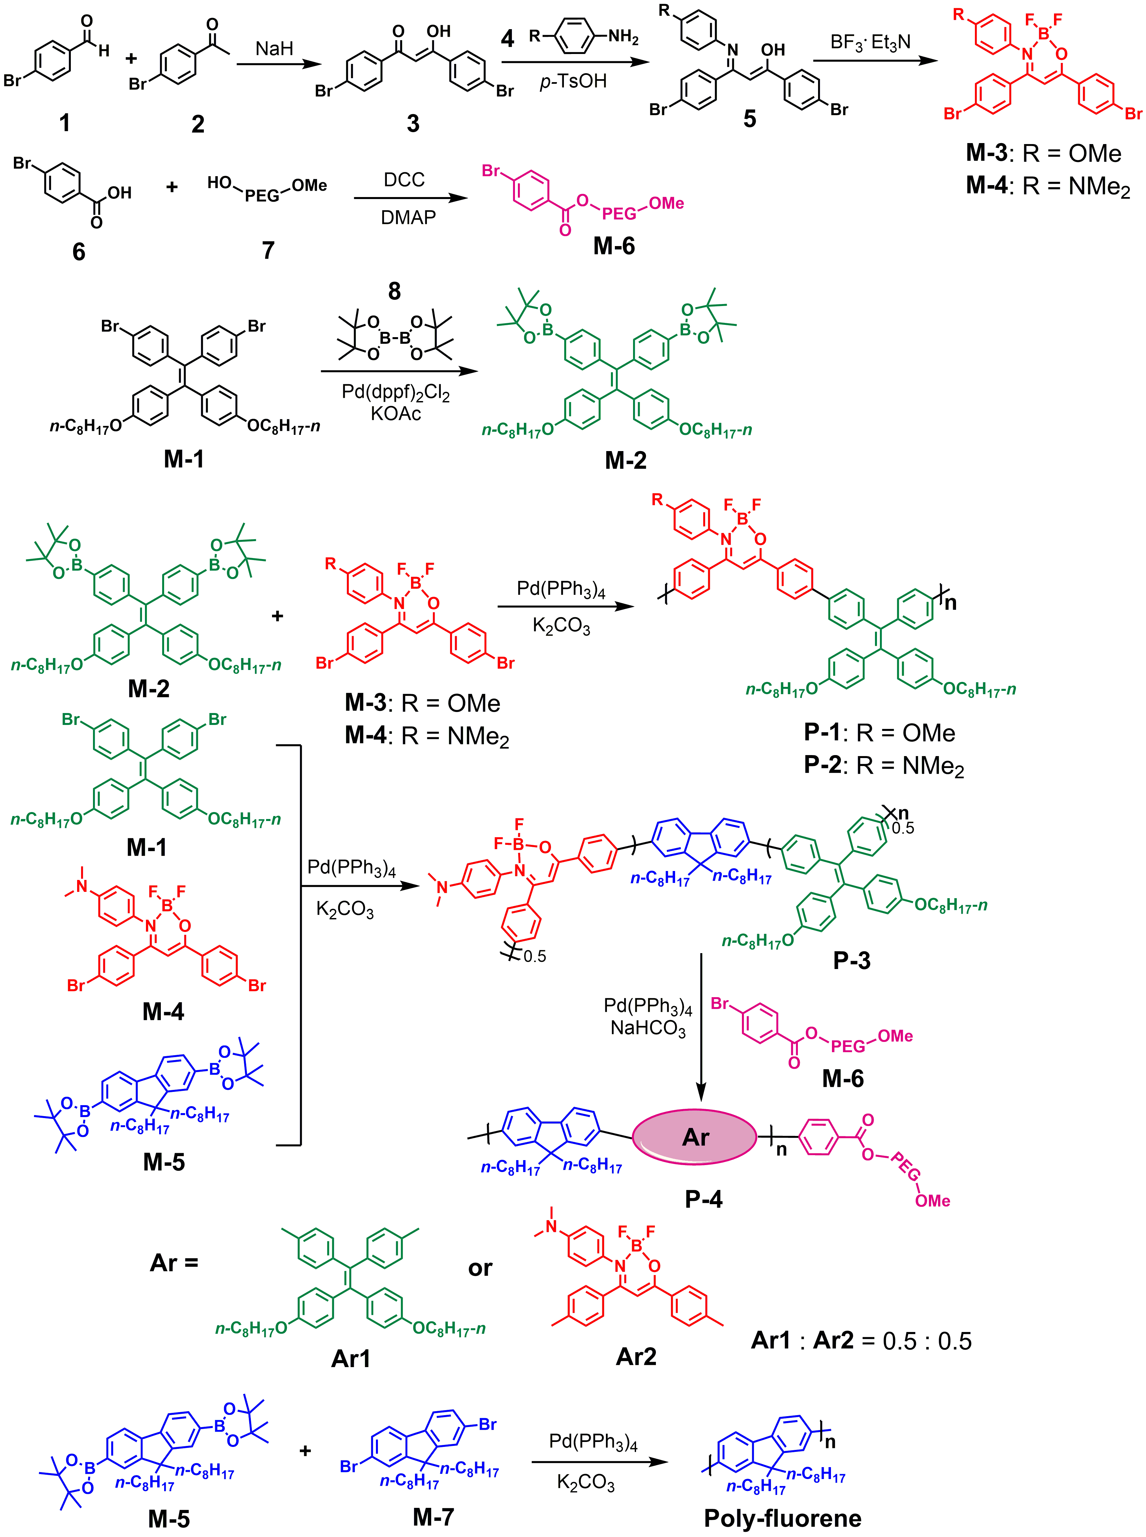
SCHEME S1. Detailed synthetic routes of P-1 to P-4.
Synthesis of P-4: M-1 (0.060 g, 0.080 mmol), M-4 (0.045 g, 0.080 mmol), M-5 (0.107 g, 0.160 mmol) and Pd(PPh₃)₄ (0.020 g, 5% e. q.) were dissolved in 10 mL toluene, 5 mL ethanol and 5 mL water with K₂CO₃ (0.60 g). The mixture was refluxed for 12 h under Ar atmosphere and the organic phase was collected to be dried with Na₂SO₄. Then M-6 (0.285 g), Pd(PPh₃)₄ (0.020 g, 5% e. q.) and NaHCO₃ (0.40 g) were added after the solvent removed. The mixture was further dissolved in 30 mL THF and 15 mL water and then refluxed for 36 h under Ar atmosphere. Afterward, the organic phase was collected and diluted by 50 mL CH₂Cl₂. After washed by 50 mL water for 3 times, the result solution was dried by Na₂SO₄ and the solvent was removed. The result mixture was solved by THF and dropped into 300 mL hexane. The product was filtered and dried to give P-4 as dark orange solid (0.310 g). ¹H NMR (400 MHz, CDCl₃) δ 7.94 - 7.71 (m, 2H), 7.69 - 7.47 (m, 12H), 7.21 - 6.97 (m, 4H), 6.70 - 6.54 (m, 2H), 3.90 (s, 2H), 3.65 (s, 275H), 2.93 - 2.90 (m, 3H), 2.42 (s, 6H), 2.04 (s, 3H), 1.75 (s, 1H), 1.43 (s, 1H), 1.30 - 1.28 (m, 6H), 1.17 - 1.07 (m, 22H), 0.90 - 0.67 (m, 10H). GPC data: M_{w} = 8940, M_{n} = 6550, PDI = 1.37.
In vivo tumor distribution
DiR dye was encapsulated into Pdots along with drug loading to prepare DiR loaded Pdots, and then followed by intravenous administration into the MCF-7/ADR tumor-bearing mice (50 μg DiR kg⁻¹, n = 3). At different time pints post injection, the in vivo location of Pdots was visualized by in vivo imaging system (Maestro In-vivo Imaging System, USA). After living imaging, mice were sacrificed to harvest main organs as well as tumor tissues for ex vivo imaging.
Animal model
Female BALB/c nude mice were housed in a standard SPFII condition with free access to diet. The animal experiments adopted in our study were all reviewed and approved by the Ethical Committee of Zhejiang University. The establishment of MCF-7/ADR tumor bearing mice was carried out by injecting cancer cells to living mice. In brief, 1×10⁷ MCF-7/ADR cells were suspended in 0.1 mL of PBS and subcutaneously injected to the flank of mice and allowed to grow into solid tumors.
Statistical analysis
Quantitative data were presented as mean ± standard deviation (S.D.) from triplicate experiments performed in a parallel manner unless otherwise noted.

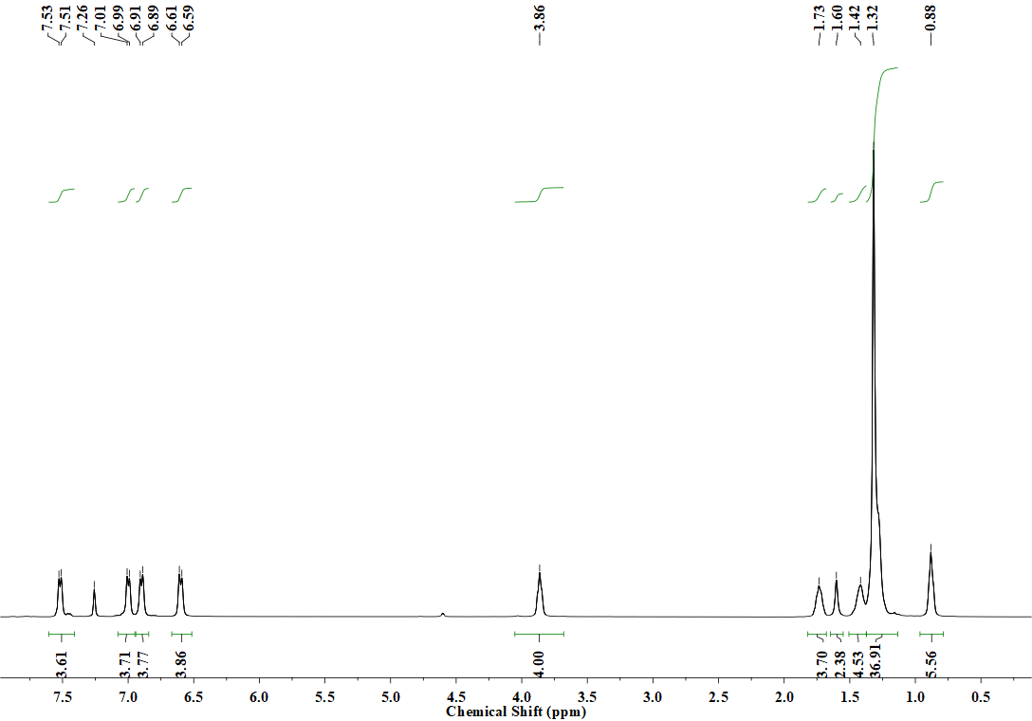
FIG. S1. ¹H NMR of M-2.
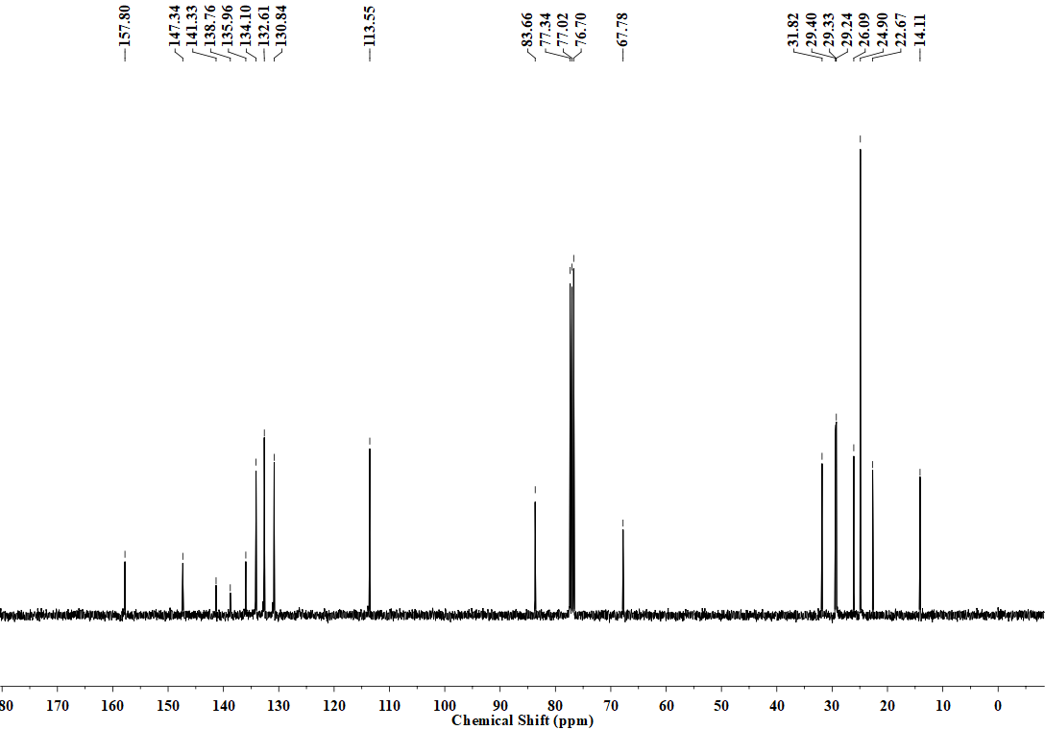
FIG. S2. ¹³C NMR of M-2.

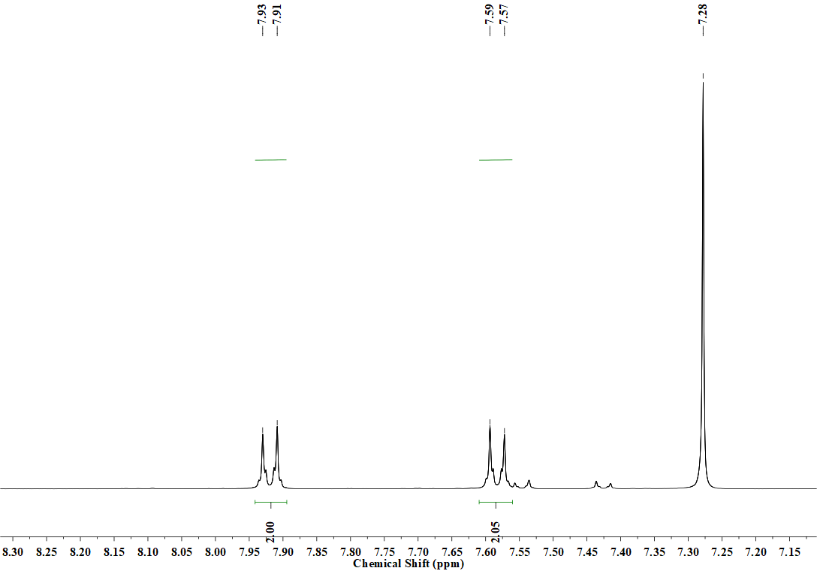
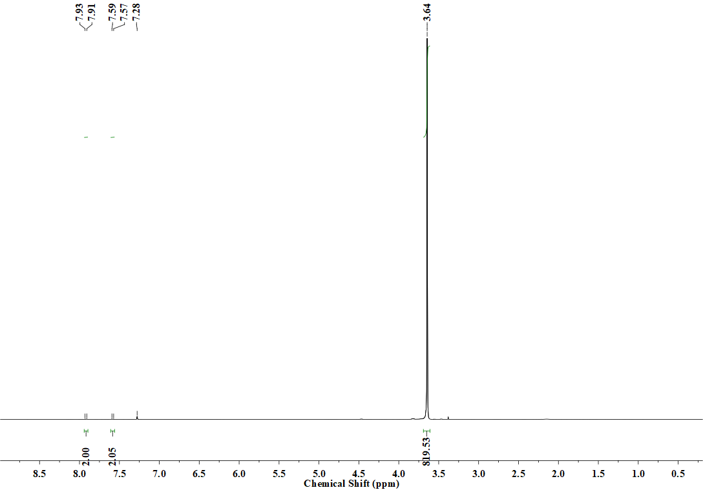
FIG. S3. ¹H NMR of M-6.
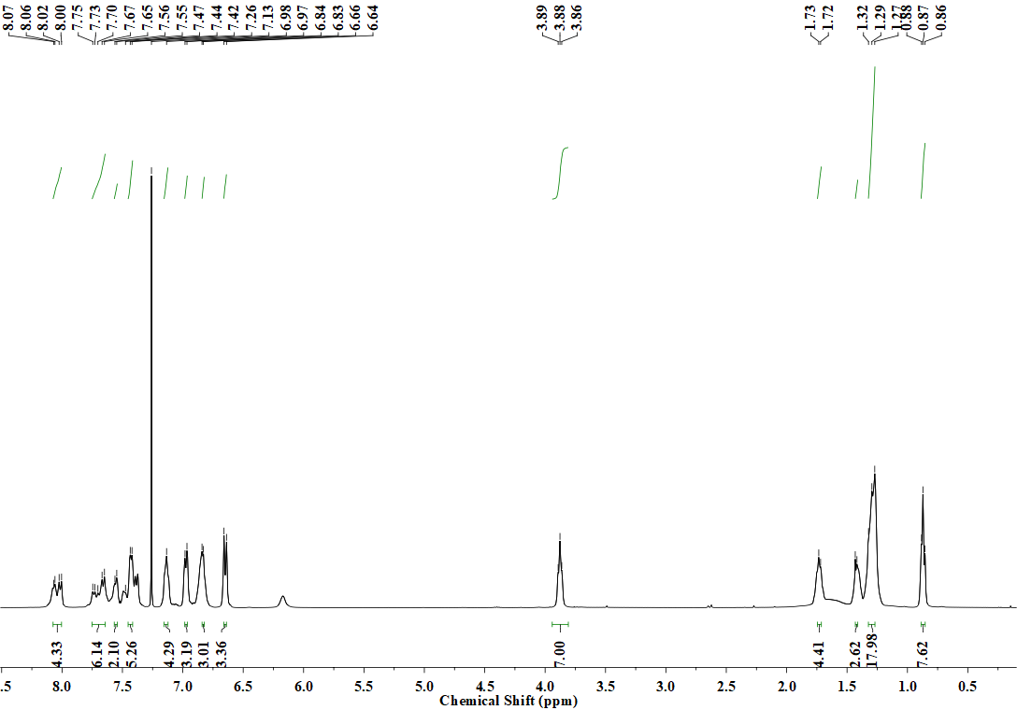
FIG. S4. ¹H NMR of P-1.
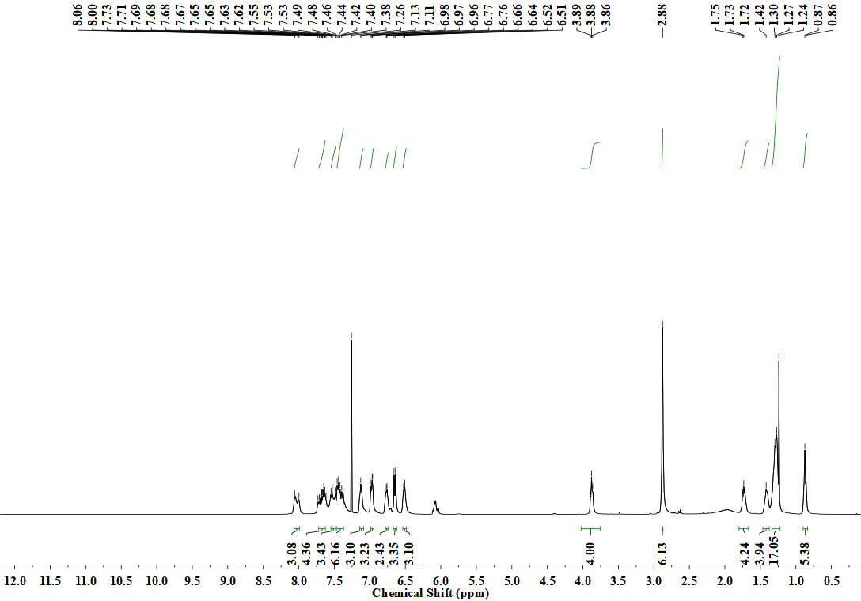
FIG. S5. ¹H NMR of P-2.
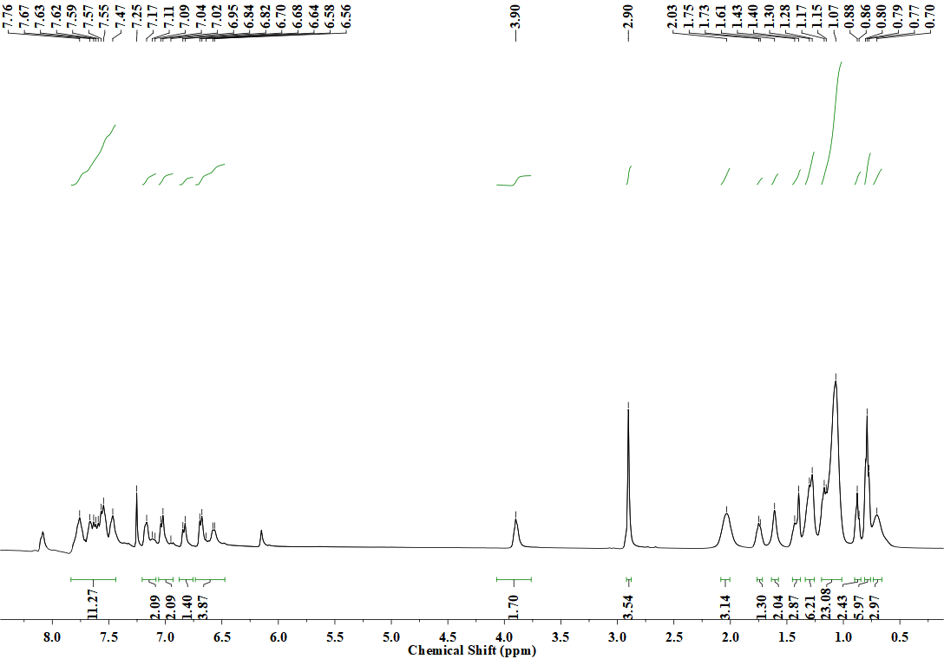
FIG. S6. ¹H NMR of P-3.
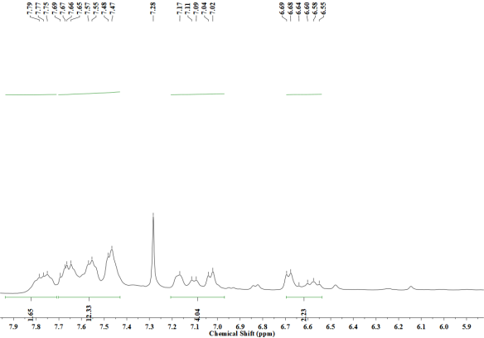
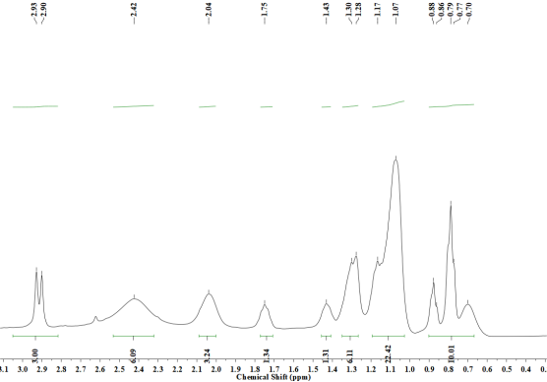
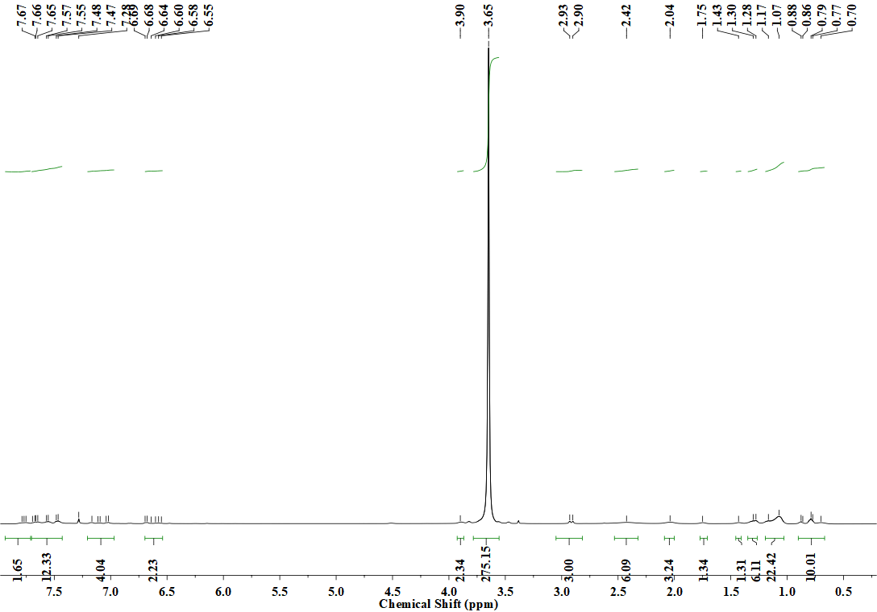
FIG. S7. ¹H NMR of P-4.

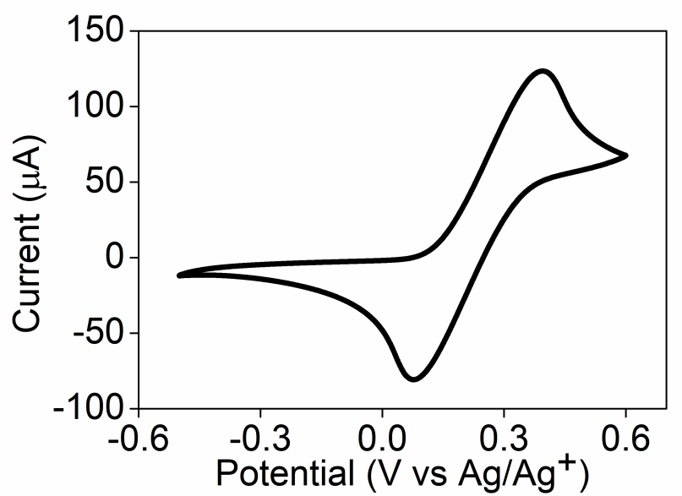
FIG. S8. CVs of ferrocene in 0.1 M Bu₄NBF₄ CH₂Cl₂ solution. Concentration: 1.0 mM. Scan rate: 100 mV s⁻¹.

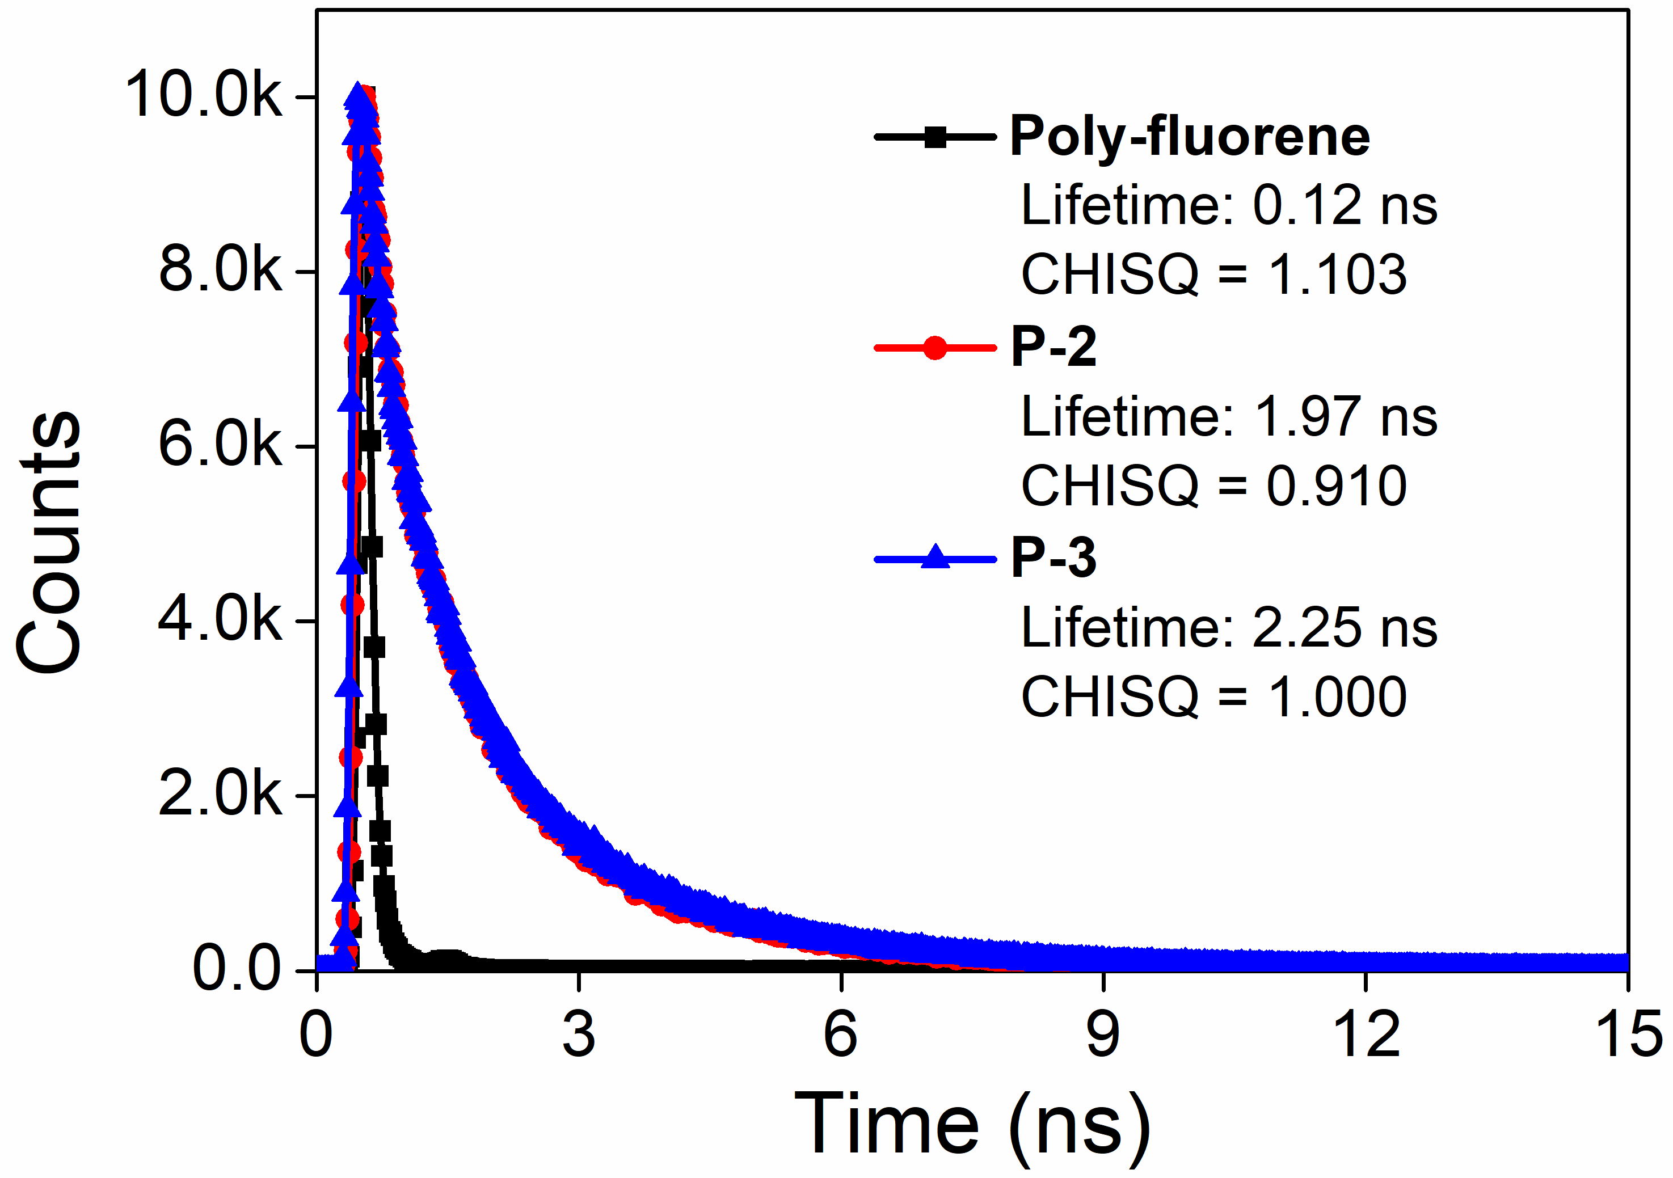
FIG. S9. The fluorescence lifetime of poly-fluorene, P-2 and P-3. Polymer concentration: 1×10⁻⁵ mol L⁻¹ corresponding to TPE (P-2) or fluorene (P-3) moiety, λ_{ex} = 374 nm.

FIG. S10. TEM images of PCur (A), PDox (B) and bared P-4 Pdots (C); size distribution of PCur (D), PDox (E) and bared P-4 Pdots (F). Scale bar: 100 nm.

TABLE SI. The size and zeta potential data of bared P-4 Pdots, PCur and PDox.
 | DLS data (nm) | Zeta potential (mV)
Bared P-4 Pdots | 38 | 1.93
PCur | 51 | -3.72
PDox | 51 | -6.72

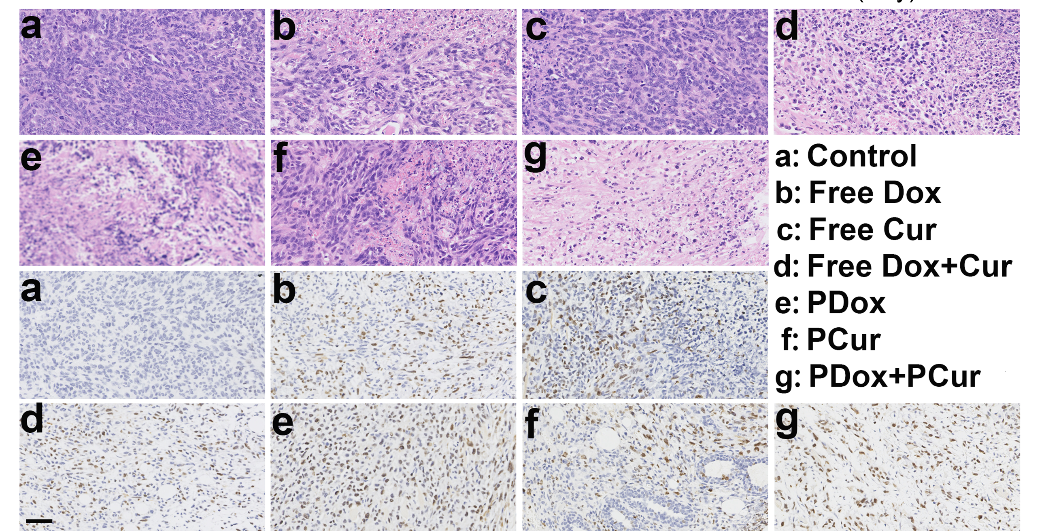
FIG. S11. Immunohistochemical staining (HE (a-g) and TUNEL (a’-g’)) of tumor tissues of MCF-7/ADR tumor xenograft BALB/c nude mice after intravenous administration of different formulations for 14 days. The measurement of tumor volumes and the injection of formulations were repeated every 2 days for two weeks. Dose: 5 mg kg⁻¹ Dox/Cur per mouse. Scale bar: 50 μm.

