A simple strategy for fabricating honeycomb patterns on commercially available polymer film under a wide humidity range
Kai Huang, Qi Cheng, Honglei Zhang, Ligang Lin*, Qiying Wang
State Key Laboratory of Separation Membranes and Membrane Processes, Tianjin
Polytechnic University, Tianjin 300387, P.R.China
*Corresponding author: Ligang Lin, E-mail: phdlinligang@163.com

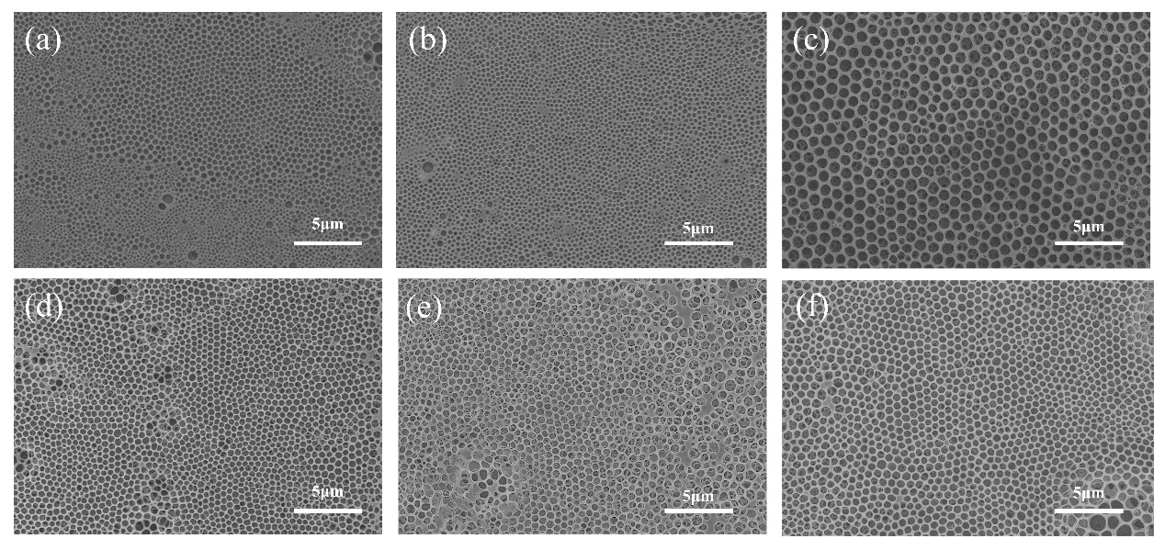
Figure S1. Changes of the surface morphology of the honeycomb patterned films through varying the preparation conditions of RH level (a) 40% ;(b) 50%;(c) 65% ;(d) 70%; (e) 80% and (f) 90%. Scale bar: 5μm. ( other conditions were kept constant with the concentration of 70 mg/ml, the methanol content of 33% and the temperature of 25℃).

Figure S2. With the water content in the mixed solution increases, the EC solution gradually changes from clarification to emulsion. (a) without water; (b) the water content in the mixed solution reached 3.2wt%.

