Supplementary Information on

Contact formation of C60 to thinfilms of formamidinium tin iodide

Jonas Horn1,2, and Derck Schlettwein1,2,\*

1Institute of Applied Physics, Justus Liebig University Giessen, Heinrich-Buff-Ring 16, 35392 Giessen, Germany

2Center for Materials Research (LaMa), Justus Liebig University Giessen, Heinrich-Buff-Ring 16, 35392 Giessen, Germany

\* Address all correspondence to this author schlettwein@uni-giessen.de



FIG. S 1 X-ray diffraction pattern of a pure FASnI3 film confirming the presence of the orthorhombic phase [1] .

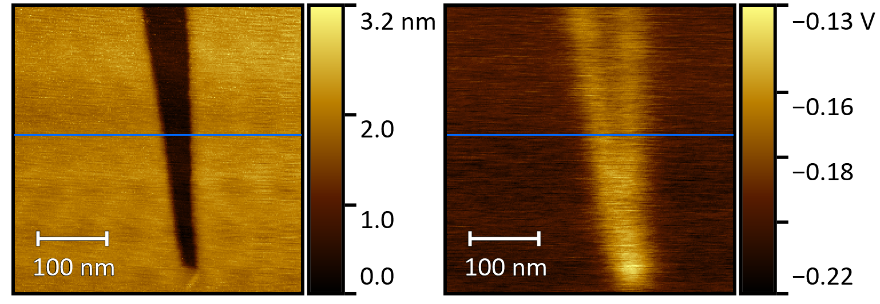    
(a) (b) (c)

FIG. S 2 Morphology of a crack in an imperfectly cleaved HOPG-surface (a) and the contact potential obtained during the second pass (b) and the corresponding data along one line scan (c) as indicated in (a) and (b). It serves to determine an upper limit of the lateral resolution of the KPFM-measurement. For a minimum crack width of 30 nm it was possible to separately resolve the CPD of HOPG at the bottom of the gap (vertical arrow) and the upper plains around -0.2 V (c). For smaller crack widths only the CPD of the upper plains and the walls of the crack are detected (b). Thus, the lateral resolution of the present KPFM-measurement is estimated to 30 nm.

C:\Users\gd1828\AppData\Local\Microsoft\Windows\INetCache\Content.Word\scan 465 - 20 nm C60 qscan.tifC:\Users\gd1828\AppData\Local\Microsoft\Windows\INetCache\Content.Word\scan 482 - 20 nm C60 - Lagerung über Nacht - vgl. scan 465_rescale.tifC:\Users\gd1828\AppData\Local\Microsoft\Windows\INetCache\Content.Word\scan 465 - 20 nm C60 qscan.tif

(a) (b)

FIG. S 3 Morphology obtained by AFM of 20 nm C60 deposited at 0.55 nm min-1 on a 350 nm FASnI3 thin film after deposition (a) and after overnight storage in vacuum (b).

(a) (b) (c) (d)

X:\PhD\VakAFM\HOPG_C60\scan 86 - 1 nm C60 - 0.3 nmmin_morphology.tif X:\PhD\VakAFM\HOPG_C60\scan 88 - 3 nm C60 - 0.3 nm min_morphology.tif X:\PhD\VakAFM\HOPG_C60\scan 92 - 5 nm C60_morphology.tif X:\PhD\VakAFM\HOPG_C60\scan 95 - 10 nm C60_ref-90mV_morphology_small2.tif X:\PhD\VakAFM\HOPG_C60\scan 86 - 1 nm C60 - 0.3 nmmin_WF_ohne_maske.tif X:\PhD\VakAFM\HOPG_C60\scan 88 - 3 nm C60 - 0.3 nm min_WF.tif X:\PhD\VakAFM\HOPG_C60\scan 92 - 5 nm C60_WF.tif

(e) (f) (g) (h)

FIG. S 4 Morphology and work function of C60 deposited at 0.3 nm min-1 onto highly oriented pyrolytic graphite surface (HOPG) at different thickness (1 nm: a,e; 3 nm: b,f; 5 nm: c,g; 10 nm: d,h).



FIG. S 5 Histograms corresponding to FIG S5 e-h. The dashed lines are Gaussian fits showing contribution of HOPG (4.6 eV) and C60 (4.63 eV). For 10 nm of C60, a single Gaussian distribution corresponding to C60 is sufficient indicating complete coverage of HOPG. The resulting work function of C60 showed no dependence on the deposited film thickness.

Project Path: X:\Publications\FASnI3 C60 KPFM\figures\Figure4.opju
PE Folder: /Figure4/
Short Name: Graph5

FIG. S 6 Fit of the data presented in Fig. 5 b of the main text according to $Φ\left(x\right)=Φ\left(∞\right)-\frac{eN}{2ϵ_{r}ϵ_{0}}(w-x)²,$ with $Φ$ as potential, $N$ as charge density and $w$ as the width of the space charge layer. The fit (red line) with $Φ(∞)$ = 4.63 eV (FIG S6) and $ϵ_{r}$ = 4.4 [2] formally represents the obtained data at, however, low significance (R²=0.927) and does not completely reproduce the generally observed trend in all our measurements (Fig. 4b of the main text). The obtained values of = 4.5x1015 cm-3 and  = 193 nm, therefore, can only provide a rough estimate (see main text).



FIG. S 7 Comparison of work functions of the sample and probe confirming the importance of referencing for each measurement. Despite strong decrease of the probe work function due to probe contamination during an intermediate measurement (data not usable and not shown), the values for the sample surface can be reliably determined following intermediate referencing to HOPG before and after each measurement.

References

[1] C.C. Stoumpos, C.D. Malliakas, M.G. Kanatzidis: Semiconducting tin and lead iodide perovskites with organic cations: phase transitions, high mobilities, and near-infrared photoluminescent properties. *Inorg. Chem.***52**(15), 9019 (2013).

[2] A.F. Hebard, R.C. Haddon, R.M. Fleming, A.R. Kortan: Deposition and characterization of fullerene films. *Appl. Phys. Lett.***59**(17), 2109 (1991).