Supplementary Information

**Improving Photovoltaic Performance of Benzothiadiazole-based Small Molecules:** **A Synergistic Effect of Non-covalent Interaction and Aryl terminal group**

Qian Liu,a Jiyong Deng,*a Dong Yan,a Xianwei Huang,a Yunfeng Liaoa and Qiang Tao*a

*a Hunan Provincial Key Laboratory of Environmental Catalysis & Waste Recycling, School of Materials and Chemical Engineering, Hunan Institute of Engineering, Xiangtan 411104, China.*

*\*To whom correspondence should be addressed. Email:*

*(J. D.) djyong@yeah.net*

*(Q. T.) qiangt_211@163.com*

1. Measurements and instruments

1H NMR spectra were collected on a Bruker DPX 400 spectrometer using chloroform-*d* as a solvent and tetramethylsilane (TMS) as an internal standard at a resonance frequency of 400 MHz for 1H at room temperature. Thermogravimetric analysis (TGA) was carried out using a Netzsch TG 209 analyzer at a heating rate of 10 °C min‒1 from room temperature to 600 °C. The differential scanning calorimetry (DSC) measurement was made on a TA DSCQ10 instrument at a heating rate of 10 °C min‒1 under a nitrogen atmosphere. UV–vis absorption spectra were recorded on a Perkin-Elmer Lambda 25 spectrometer. Cyclic voltammograms (CV) were recorded on a CHI 660 electrochemical workstation at scanning rate of 100 mV s–1. The measurements were carried out at room temperature using a three-electrode setup, in which two platinum electrodes were respectively used as the working electrode and counter electrode, Ag/AgCl was used for the reference electrode in an anhydrous acetonitrile solution with 0.1 M nitrogen-saturated tetrabutylammonium hexafluorophosphate (Bu4NPF6). The measured potentials were calibrated with a ferrocene/ferrocenyl couple (Fc/Fc+). The HOMO and LUMO energy levels (*E*HOMO and *E*LUMO) were calculated by the following equations:

*E*HOMO = −(*E*ox + 4.80) eV (1)

*E*LUMO = *E*HOMO + *E*gopt (2)

The hole mobility was measured by the space-charge-limited current (SCLC) method using a diode configuration of ITO/PEDOT:PSS/SM:PC71BM/Au and fitting the results to a space charge limited form.



Figure S1. TGA curves of Py-2DTBT, Py-2DTOBT and Py-2DTOBTPh.



Figure S2. DSC curves of Py-2DTBT, Py-2DTOBT and Py-2DTOBTPh.



Figure S3. *EQE* curves of optimized solar cells under simulated AM 1.5G irradiation.



Figure S4. *J–V* curve of the hole-only SM/PC71BM-based device under the optimized processing conditions.

2. 1H NMR and MS spectra of the related compounds

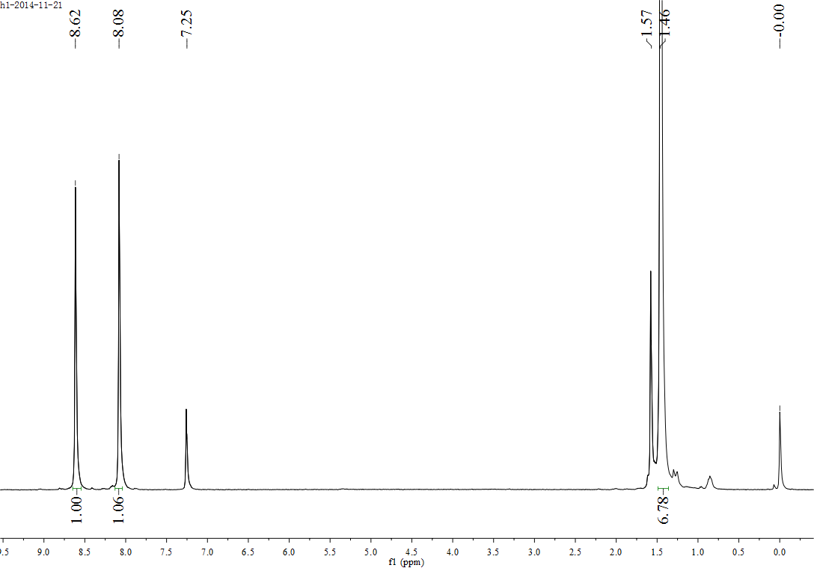

Figure S5 1H NMR spectrum of 1

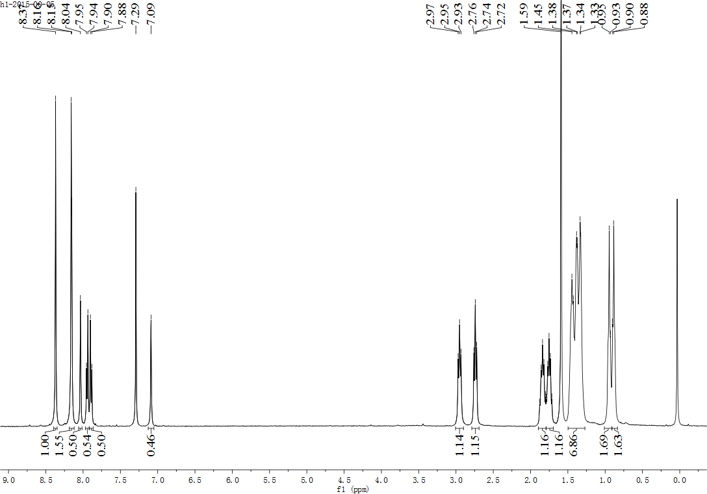

Figure S6 1H NMR spectrum of Py-2DTBT

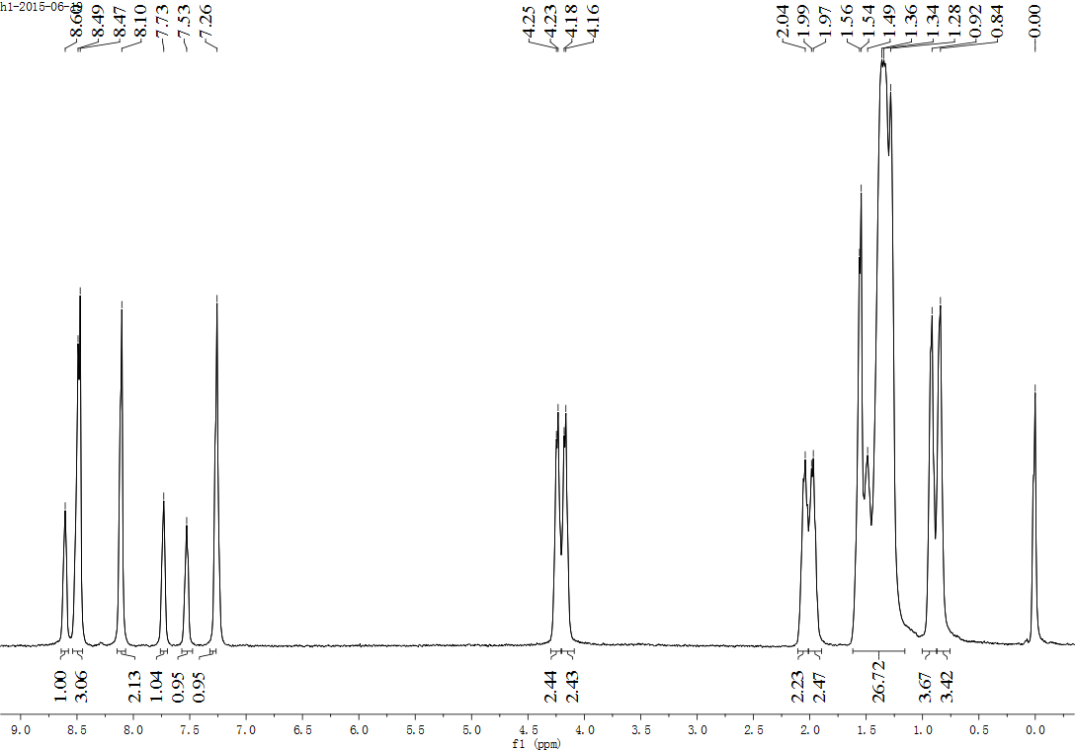

Figure S7 1H NMR spectrum of Py-2DTOBT

**E:\Google 云端硬盘\工程学院\文章相关\材料快报\Py-2DTOBTPh.tiff**

Figure S8 1H NMR spectrum of Py-2DTOBTPh

812

Figure S9. MS (MALDITOF) spectrum of DTOBTPh-Br

1134

Figure S10. MS (MALDITOF) spectrum of DTOBTPh-Br

1310

Figure S11. MS (MALDITOF) spectrum of Py-2DTOBT

1662

Figure S12. MS (MALDITOF) spectrum of Py-2DTOBTPh