Supplementary information
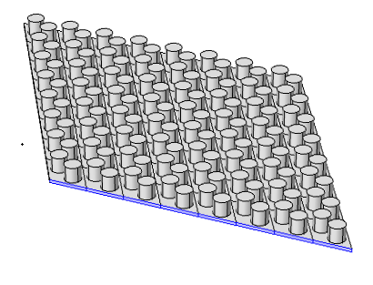
FIG. S1. exerts a boundary acceleration to phononic crystal
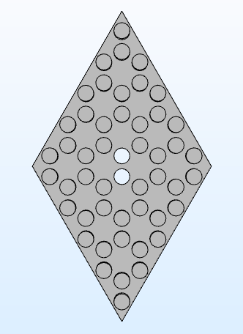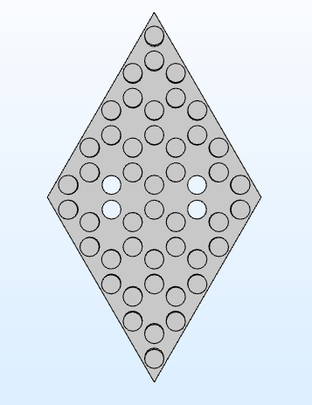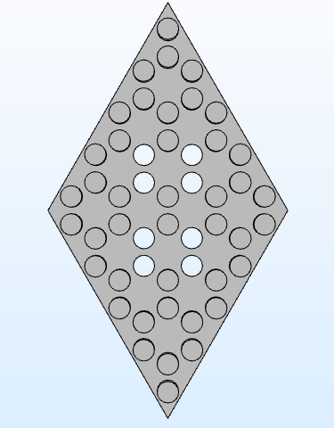
(a) (b) (c)
FIG. S2 (a) the model of two point defects, (b) the model of four point defects , (c) the model of eight point defects
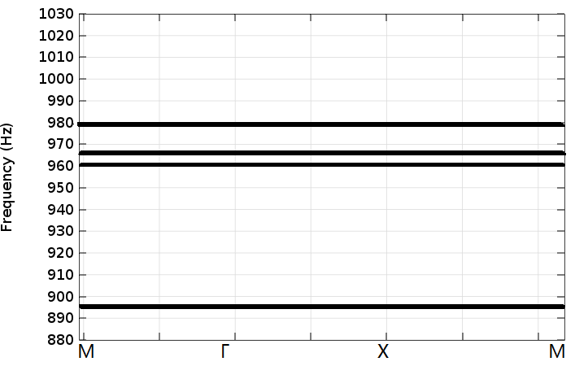
(a)
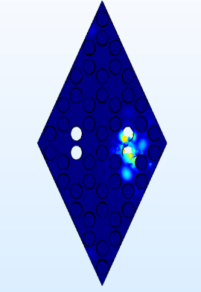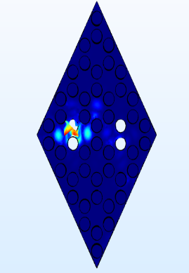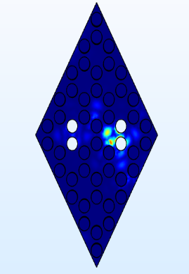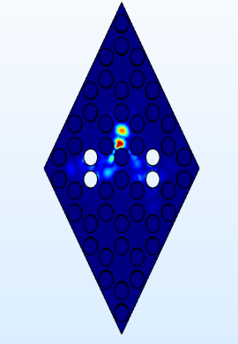
(b) (c) (d) (e)
FIG. S3 (a) the band structure with four defects, (b) defect eigenmodes of frequency 895.12Hz (c) defect eigenmodes of frequency 961.42Hz, (d) defect eigenmodes of frequency 966.89Hz , (e) defect eigenmodes of frequency 979.42Hz
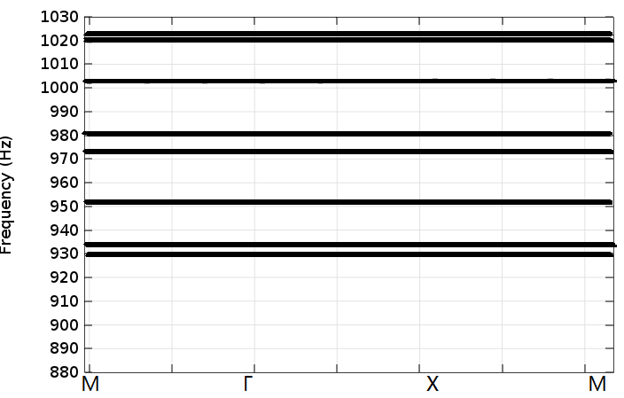
(a)
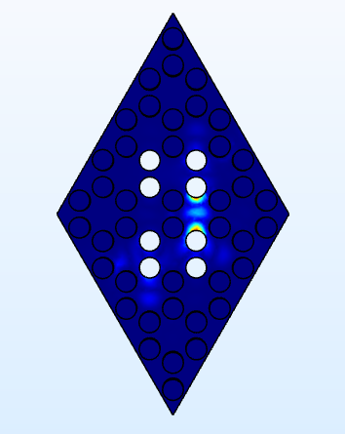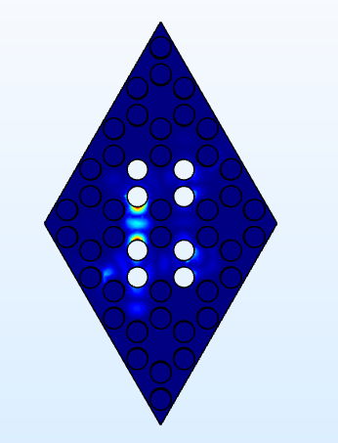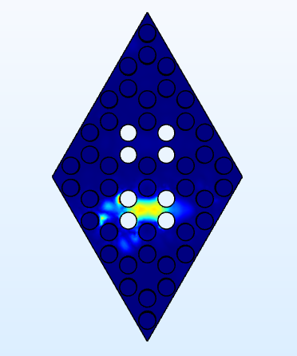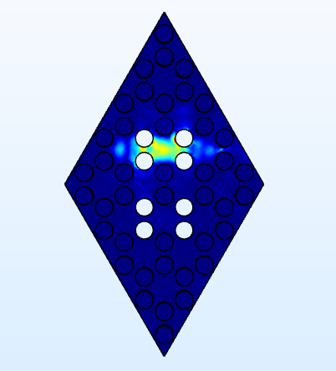
(b) (c) (d) (e)
FIG. S4 (a) the band structure with eight defects, (b) defect eigenmodes of frequency 929.05Hz (c) defect eigenmodes of frequency 934.23Hz, (d) defect eigenmodes of frequency 1020.06Hz , (e) defect eigenmodes of frequency 1023.32Hz

