Supplementary Information for
The Influence of Side Chain Isomerization on The Isothermal Crystallization Kinetics of Poly(3-alkylthiophenes) Investigated by Fast Scanning Chip Calorimetry
Zhiyuan Qian¹‡, Shaochuan Luo²‡, Tengfei Qu², Luke A. Galuska¹, Song Zhang¹, Zhiqiang Cao¹, Sujata Dhakal¹, Youjun He³, Kunlun Hong^{3,4}, Dongshan Zhou², Xiaodan Gu¹*

- School of Polymer Science and Engineering, Center for Optoelectronic Materials and Devices, The University of Southern Mississippi, Hattiesburg, MS, 39406, USA
- Department of Polymer Science and Engineering, School of Chemistry and Chemical Engineering, Key Laboratory of High Performance Polymer Materials and Technology of Ministry of Education, and The State Key Laboratory of Coordination Chemistry, Nanjing University, Nanjing 210093, P. R. China.
- Center for Nanophase Materials Sciences, Oak Ridge National Laboratory, Oak Ridge, Tennessee 37831, USA
- Department of Chemical and Biomolecular Engineering, University of Tennessee, Knoxville, TN, 37996, USA

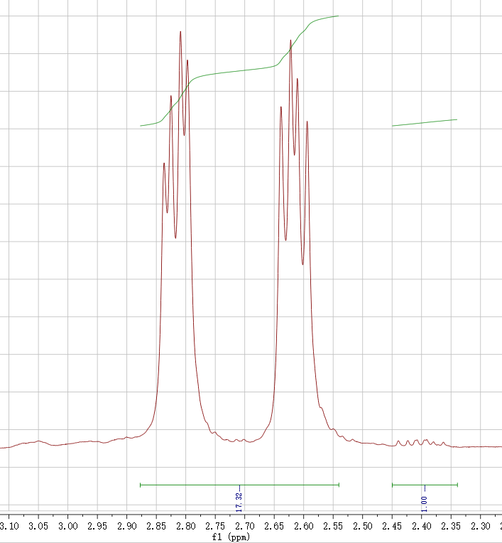
Figure S1. ¹H-NMR spectra of P3(2MP)T. The actual regioregularity of the P3HT-1,3 was calculated according to the integrated area of the peaks at δ 2.81 and δ 2.62 with δ 2.41.
Figure S2. Heating of (a) P3(4MP)T, (b) P3(3MP)T, (c) P3(2MP)T, and (d) P3(2EB)T at 30 °C/min after cooling at various cooling rates from 100 °C/min to 10 °C/min . A melting peak is observed for P3(4MP)T, P3(3MP)T, and P3(2MP)T after cooling up to 100 °C/min, indicating that the crystallization during cooling at those rates is inevitable . For P3(2EB)T, a cold crystallization peak is observed after cooling rate is higher than 30 °C/min, indicating the crystallization of P3(2EB)T is partially suppressed.
Figure S3. Reheating scans at 1,000 K/s for P3(2MP)T after isothermal crystallization at 110 °C for an extended annealing time from 0.01 s to 20,000 s.

Figure S4. Reheating scans at 1,000 K/s for P3(2EB)T after isothermal crystallization at 110 °C for an extended annealing time from 0.01 s to 6,000 s.

Figure S5. (a) Cooling scans of P3HT at various cooling rates from 1000 K/s to 4000 K/s with Flash DSC. Crystallization on cooling is observed and marked with arrows. (b). Reheating scans at 1000 K/s for P3HT after cooling at rates from 1000 K/s to 4000 K/s. Cold crystallization appears during heating and grows while cooling rate increases.
Figure S6. (a) Cooling scans of P3(4MP)T at various cooling rates from 1000 K/s to 4000 K/s with Flash DSC. Crystallization on cooling is observed and marked with arrows. (b). Reheating scans at 1000 K/s for P3(4MP)T after cooling at rates from 1000 K/s to 4000 K/s. Cold crystallization appears during heating and grows while cooling rate increases.
Figure S7. (a) Cooling scans of P3(3MP)T at various cooling rates from 1000 K/s to 4000 K/s with Flash DSC. Crystallization on cooling is observed and marked with arrows. (b). Reheating scans at 1000 K/s for P3(3MP)T after cooling at rates from 1000 K/s to 4000 K/s. Cold crystallization appears during heating and grows while cooling rate increases.
Figure S8. Schematic of calculating total enthalpy change (ΔH_{total}) for two cases: (a). only melting appears on heating, and (b). both cold crystallization and melting appear on heating. The dash line shows the baseline, which is determined as follows. In case (a), the baseline is obtained by extending the liquid line straight from the right to left and intersecting with the raw data; in case (b), the baseline is obtained by connecting between the points of the onset of cold crystallization and the end of melting.

Figure S9. Reheating scans at 10,000 K/s for P3(4MP)T after isothermal crystallization at 110 °C for an extended annealing time from 0.001 s to 2,000 s.

Figure S10. Reheating scans at 10,000 K/s for P3(3MP)T after isothermal crystallization at 110 °C for an extended annealing time from 0.001 s to 2,000 s.

Figure S11. Reheating scans at 10,000 K/s for P3HT after isothermal crystallization at 110 °C for an extended annealing time from 0.001 s to 2,000 s.

Table S1. In-plane alkyl lamellar packing for P3ATs
 | q vector | d-spacing (Å) | FWHM (Å⁻¹)
P3HT | 0.374 | 16.780 | 0.046
P3(4MP)T | 0.382 | 16.436 | 0.066
P3(3MP)T | 0.401 | 15.677 | 0.104
P3(2MP)T | 0.452 | 13.916 | 0.176
P3(2EB)T | 0.486 | 12.921 | 0.122

Figure S12. Specific enthalpy change of P3HT as a function of annealing time at different annealing temperatures.

Figure S13. Specific enthalpy change of P3(4MP)T as a function of annealing time at different annealing temperatures.

Figure S14. Specific enthalpy change of P3(3MP)T as a function of annealing time at different annealing temperatures.

Figure S15. Specific enthalpy change of P3(2MP)T as a function of annealing time at different annealing temperatures.

Figure S16. Specific enthalpy change of P3(2EB)T as a function of annealing time at different annealing temperatures.

