Supplementary Information
Figures
Figure S1: EDS elemental maps of AISI 430 surface corroded in Ar- 3%H₂ at 800°C for 100 h. See text.
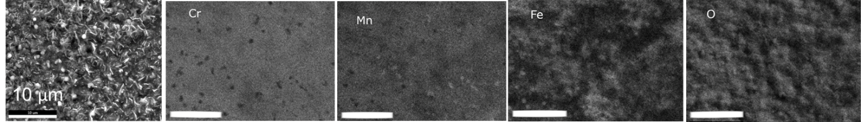

Figure S2: EDS elemental maps of uncoated, Ni coated, and Ni-P coated AISI 430 corroded in Ar- 3%H₂, and at 8 Ar- 3%H₂ – 3%H₂O at 800°C for 100 h. See text. Outermost nickel, beyond corroded reaction zone, electrodeposited to avoid spallation during metallographic sample preparation.
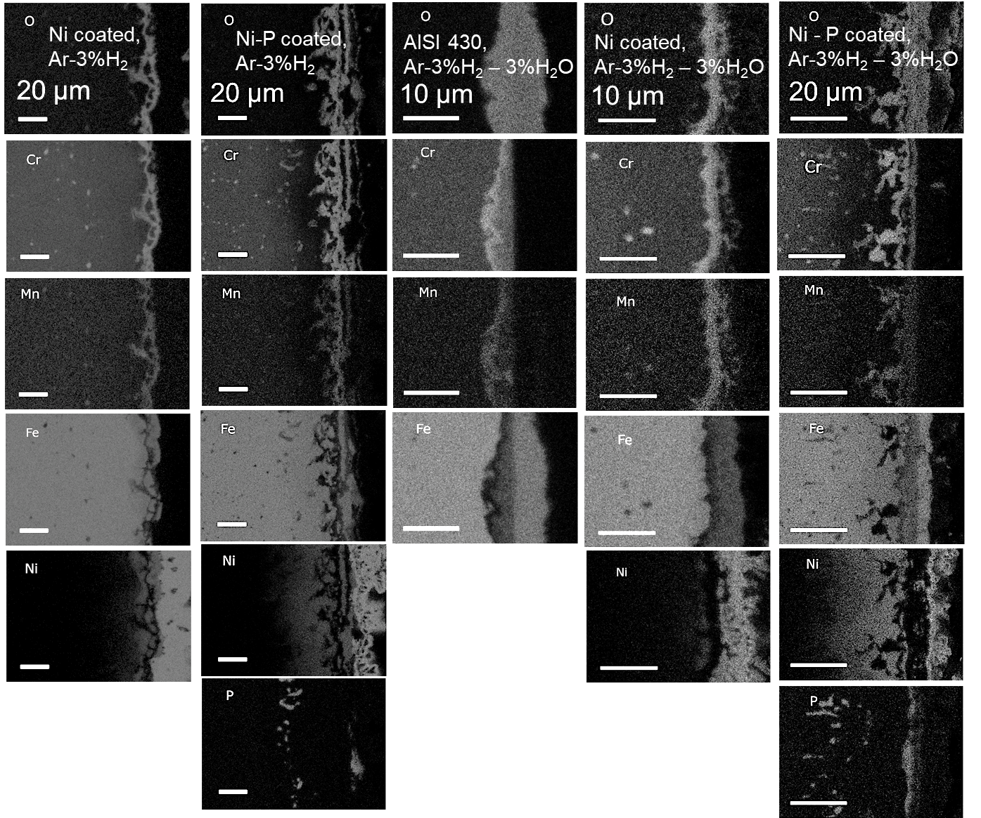

Figure S3: (a) EDS line scan profile of AISI 430 corroded in Ar- 3%H₂ -3%H₂O at 800°C for 100 h. (b) Corresponding SEM image showing solid horizontal line corresponds to the EDS line scan. The numbers corresponds to different spots of interest. See text.
(a) (b)
Figure S4: (a) EDS line scan profile of Ni-coated AISI 430 corroded in Ar- 3%H₂ at 800°C for 100 h. (b) Corresponding SEM image showing solid horizontal line corresponds to the EDS line scan. The numbers corresponds to different spots of interest. See text.
(a) (b)

Figure S5: (a) EDS line scan profile of Ni-coated AISI 430 corroded in Ar- 3%H₂ – 3%H₂O at 800°C for 100 h. (b) Corresponding SEM image showing solid horizontal line corresponds to the EDS line scan. The numbers corresponds to different spots of interest. See text.
(a) (b)
Figure S6: (a) EDS line scan profile of Ni – P coated AISI 430 corroded in Ar- 3%H₂ at 800°C for 100 h. (b) Corresponding SEM image showing solid horizontal line corresponds to the EDS line scan. The numbers corresponds to different spots of interest. See text.
(a) (b)

Figure S7: (a) EDS line scan profile of Ni – P coated AISI 430 corroded in Ar- 3%H₂ – 3%H₂O at 800°C for 100 h. (b) Corresponding SEM image showing solid horizontal line corresponds to the EDS line scan. The numbers corresponds to different spots of interest. See text.
(a) (b)

