Supplementary Information

Preparation of TiO₂-(B)/SnO₂ nanostructured composites and its performance as anodes for lithium ion batteries

Nayely Pineda-Aguilar^{a,b,*}, Margarita Sánchez-Domínguez^{b}, Eduardo M. Sánchez-Cervantesª, Lorena L. Garza-Tovar^{a,}*

ªUniversidad Autónoma de Nuevo León, Facultad de Ciencias Químicas, Av. Universidad S/N Cd. Universitaria, San Nicolás de los Garza, Nuevo León 66455, México
^{b}Centro de Investigación en Materiales Avanzados, S.C. (CIMAV), Unidad Monterrey, Alianza Norte 202, Parque de Investigación e Innovación Tecnológica, C.P. 66628, Apodaca, Nuevo León, México

*Corresponding authors email: lorena.garzatv@uanl.edu.mx, nayely.pineda@cimav.edu.mx

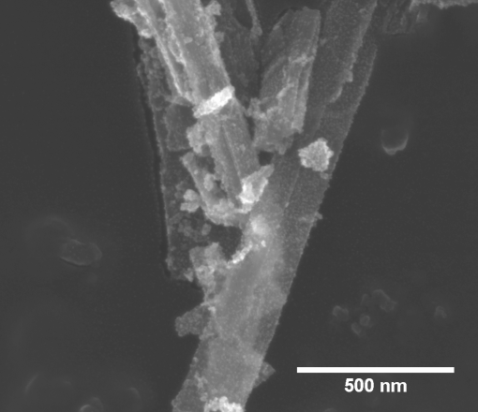  TiO₂/SnO₂ 50/50 | 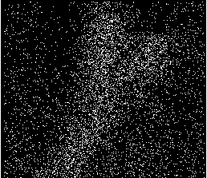  Oxygen (O)
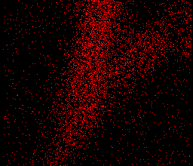  Titanium (Ti) | 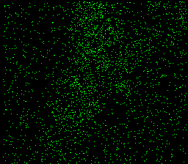  Tin (Sn)
Element | % wt | % at
O | 17.83 | 43.08
Ti | 62.66 | 50.57
Sn | 19.51 | 6.35
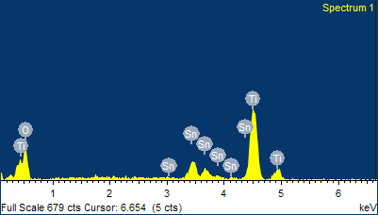

Figure SI-1. Energy dispersive X-ray spectroscopy (EDX) elemental mapping for TiO₂-(B)/SnO₂ 50/50: a nanoribbon of TiO₂-(B) in which SnO₂ nanoparticles are distributed on its surface. Higher intensities of Ti (red) detected in the region of the nanoribbon while the Sn (green) is uniformly distributed along the nanoribbon.

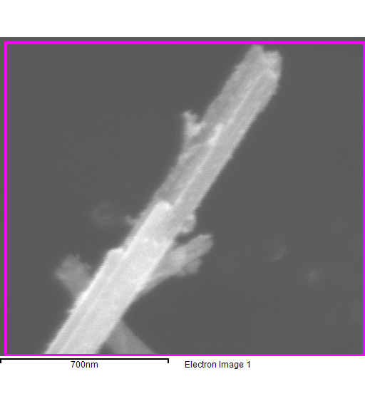
TiO₂/SnO₂ 70/30
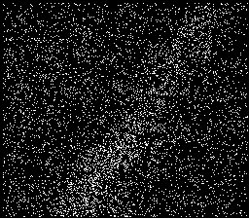
Oxygen (O)
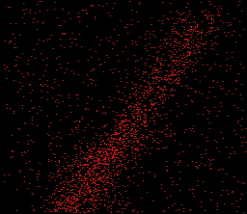  Titanium (Ti) | 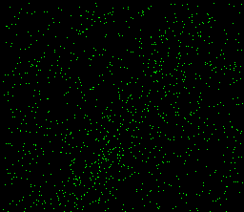  Tin (Sn)
Element | % wt | % at
O | 54.77 | 80.60
Ti | 35.57 | 17.48
Sn | 9.66 | 1.92
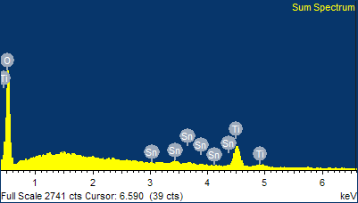

Figure SI-2. Energy dispersive X-ray spectroscopy (EDX) elemental mapping for TiO₂-(B)/SnO₂ 70/30: a nanoribbon of TiO₂-(B) in which SnO₂ nanoparticles are distributed on its surface.

Figure SI-3. (a) N₂ adsorption-desorption isotherms of samples: TiO₂-(B)-AME, SnO₂, TiO₂-(B)/SnO₂ 50/50 and TiO₂-(B)/SnO₂ 70/30. Solid and empty geometric figures refer to adsorption and desorption isotherms respectively. (b) The pore size distribution from BJH adsorption branch of the respectively samples.

To examine structural integrity the coin cells were disassembled, and the TiO₂-(B)/SnO₂ 50/50 and 70/30 electrodes were taken out and immersed in ethanol to remove the electrolyte. It is important to remember that electrodes were prepared with a mixture containing 80:10:10 wt % of active material, carbon black and Teflon and pasting the mixture on a stainless steel mesh. Later the electrode was assembled and put into contact with LiPF₆ (1 M) in ethylene carbonate (EC) and diethyl carbonate (DEC) used as the electrolyte.
The morphological study was performed on the non-cycled electrodes as well as on the electrodes after 50 cycles, and the results for TiO₂-(B)/SnO₂ 50/50 and 70/30 electrodes are shown in Figures SI-4 and SI-5, respectively. It can be seen that the morphologies of the electrode composite are significantly different compared to TiO₂-(B) nanoribbons with SnO₂ nanoparticles comprising the active material. It is found that the non-cycled electrodes show aggregates of particles in the form of granules or flakes, whereas after cycling they present smoother edges. Whereas, the initial morphology still can be identified even after 50 cycles, micrographs of both cycled electrodes TiO₂-(B)/SnO₂ 50/50 and 70/30 look very similar, irregular-shaped particles were found, no pulverization of the material was observed. This structure on the cycled electrode can be described as a gel-type layer formed on the electrodes which may be due to reaction of electrolyte to electrode materials. The smooth and uniform distribution of the TiO₂-(B)/SnO₂ 50/50 after 50 cycles leads to a high electrochemical performance. In order to confirm the distribution of Ti and Sn on the nanocomposites after 50 cycles, elemental mapping by EDX were conducted. As can be seen in the Figures SI-4 and SI-5, the elemental mapping clearly indicates that the Ti and Sn were homogeneously dispersed.

TiO₂/SnO₂ 50/50
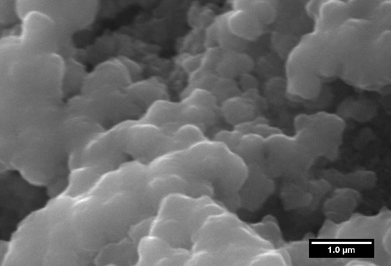  Non-cycled electrode | 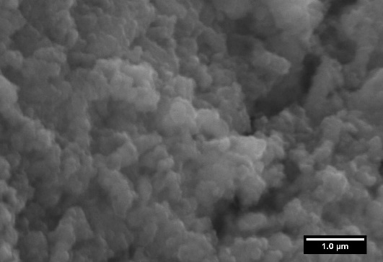  Cycled electrode  Cycled electrode | 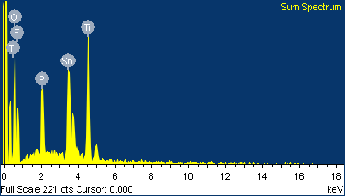  Cycled electrode  Element wt % at %  C 14.10 24.24  O 32.25 41.64  F 21.62 23.51  P 3.66 2.44  Ti 12.56 5.44  Sn 15.81 2.75
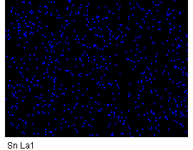
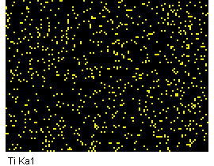

Figure SI-4. Morphology study of TiO₂-(B)/SnO₂ 50/50 non-cycled electrode and after 50 cycles.

TiO₂/SnO₂ 70/30
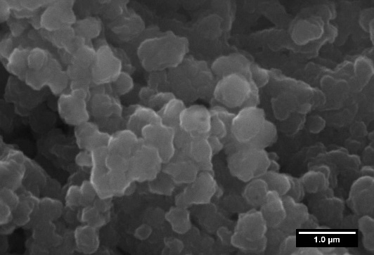  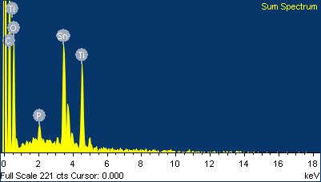  Element wt % at %  C 34.48 50.26  O 39.99 43.76  P 0.93 0.53  Ti 8.38 3.06  Sn 16.21 2.39  Non-cycled electrode | 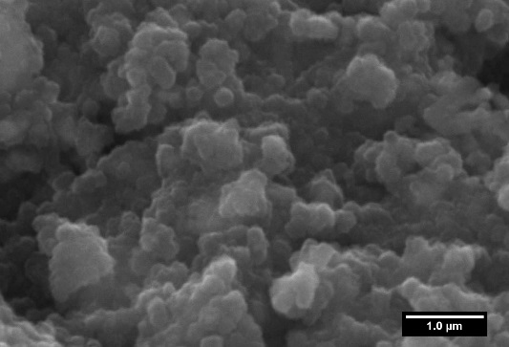  Cycled electrode | Cycled electrode
Cycled electrode

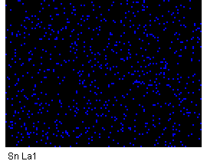
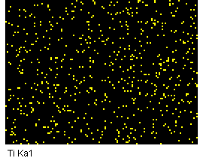

Figure SI-5. Morphology study of TiO₂-(B)/SnO₂ 70/30 non-cycled electrode and after 50 cycles.

