Supplementary Information
Hydroxyapatite-Dextran Methacrylate Core/Shell Hybrid Nanocarriers for Combinatorial Drug Therapy

S. Ram Prasad ^{1, 2}, A. Jayakrishnan ^{1¶, a)} T. S. Sampath Kumar ^{2, b)}
¹ Biomaterials Laboratory, Department of Biotechnology, Bhupat and Jyoti Mehta School of Biosciences
² Medical Materials Laboratory, Department of Metallurgical and Materials Engineering,
Indian Institute of Technology Madras,
Chennai 600 036, Tamil Nadu, India.

¶ Present address: Raja Ramanna Fellow, Rajiv Gandhi Centre for Biotechnology, Jagathy, Trivandrum 695 014, Kerala, India.
*Corresponding authors email address:
a) A. Jayakrishnan (jayakrishnan1953@gmail.com, jayakrishnana@rgcb.res.in)
b) T. S. Sampath Kumar (tssk@iitm.ac.in)
Materials
Dextran (MW 35,000-45,000 Da), Hoechst 33342 and fluorescein diacetate (FDA) were obtained from Sigma Aldrich (USA). Methacrylic anhydride was from Alfa Aesar (Mumbai, India). DMF was dried over barium oxide, distilled under reduced pressure and stored over 4 Å molecular sieves. Dulbecco’s Minimum Essential Medium (DMEM), fetal bovine serum (FBS) and MTT [3-(4,5-dimethylthiazol-2-yl)-2,5-diphenyltetrazolium bromide] were procured from Hi Media Laboratories (Mumbai, India). Dialysis membranes of molecular weight cut off (MWCO) 6000-8000 were from Spectrum Laboratories (CA, USA). Cell culture grade dimethyl sulfoxide (DMSO) was sourced from MP Biomedicals, Illkrich, France. Mouse fibroblast cells (L929) and osteosarcoma MG63 (OMG63) cells were procured from NCCS (National Center for Cell Science, Pune, India). DOX and MTX were received as gifts from Celon Laboratories (Hyderabad, India) and Cipla Laboratories (Mumbai, India) respectively. TRIzol reagent was purchased from Thermo Fischer scientific (Chennai, India). The primers (BAX, Caspase-3 and β-actin) were obtained from Bio Serve (Hyderabad, India). All other chemicals employed such as lithium chloride, sodium chloride, disodium hydrogen phosphate, potassium chloride, potassium dihydrogen ortho phosphate, ammonium hydroxide, sodium meta periodate, potassium persulphate, calcium nitrate, ethylene glycol, isopropyl alcohol etc., were of analytical or equivalent grade. Milli Q water was used in all experiments.

Characterization
Fourier transform infrared spectra (FTIR) were taken using KBr pellets using a JASCO (Germany) spectrophotometer. UV-visible spectra were recorded using a UV- Visible spectrophotometer (JASCO, Model V630, USA) Transmission electron microscopy (TEM) was carried out using JEOL (JSM-5600, Japan) microscope. The NP samples were sonicated using probe sonicator in Milli Q water, diluted and a drop was placed on the carbon coated copper grids, dried in a vacuum desiccator and imaged. Particle size analysis was done using a particle size analyzer (Micotrack, Germany). The NPs (5 mg) were added to the water (20 mL) and sonicated using a probe sonicator for 15 min before analysis. X-ray diffraction (XRD) was carried out using a Bruker instrument (Model D8, Discover, USA) and crystal size of the NPs was calculated by using Scherrer equation. Thermo gravimetric analysis (TGA) was carried out using a TG-DSC instrument (SDT Q600, USA) at a heating rate of 5 °C/min in nitrogen atmosphere. Elisa microplate reader used was Spectrum Max 5 (Molecular Devices, USA).

Figure S1: TGA spectra of HA NPs (a), DM-g-HA NPs (b), ODM-g-HA NPs (c), DOX-ODM-g-HA NPs (d) and MTX-DOX-ODM-g-HA NPs (e).

Figure S2: In vitro drug release profile of DOX from DOX-ODM-g-HA NPs at pH 5 (Δ) and pH 7.4 (▲) (a) and MTX from MTX-ODM-g-HA NPs at pH 5(Δ) and pH 7.4(▲) (b).

Figure S3: Equilibrium swelling of different NPs in PBS at room temperature

Figure S4: In vitro drug release data fitted to Koresmeyer Peppas model. a, b corresponds to MTX release from pH 7.4 and c, d corresponds to the DOX release from pH 5. [Note: The observed values are presented as dots and the predicted values are presented as line].

Figure S5: In vitro drug release data fitted to Weibull model. a, b corresponds to MTX release from pH 7.4 and c, d corresponds to the DOX release from pH 5. [Note: The observed values are presented as dots and the predicted values are presented as line].

Figure S6: Biocompatibility assay on L929 cells for HA NPs, DM-g-HA NPs and ODM-g-HA NPs at 24 h incubation

Figure S7: Combination Index plot for MTX-DOX-ODM-g-HA NPs at 72 h

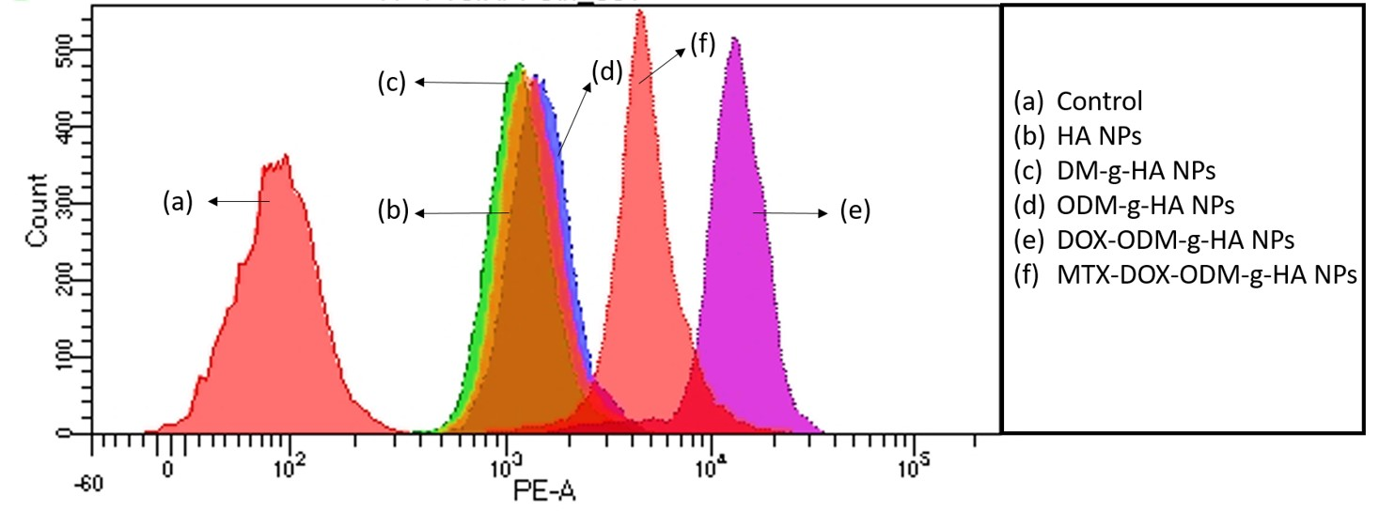

Figure S8: Flow cytometry study of internalization of RhB labelled NPs with OMG 63 cells incubated at 24 h

Figure S9: Hemolysis percentage for NPs at different concentrations.

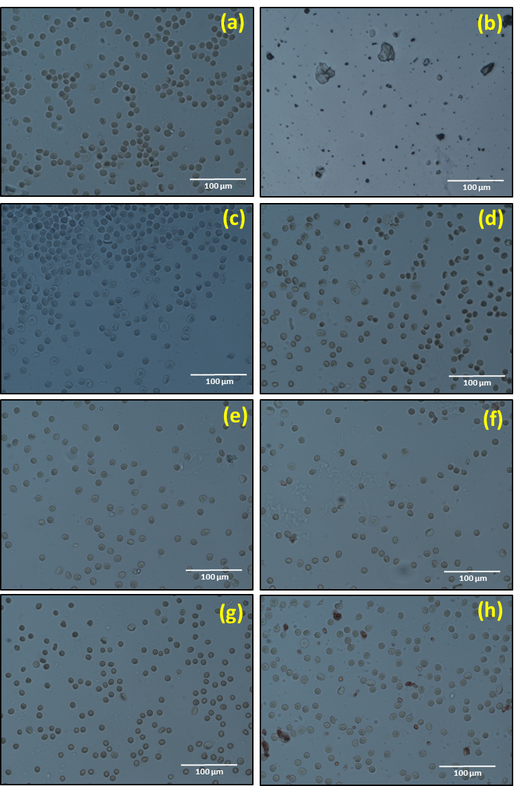

Figure S10: Morphology of RBCs after incubation of NPs at the concentration of 1 mg/mL. (a) Negative Control (PBS), (b) Positive Control (Water), (c) HA NPs, (d) DM-g-HA NPs, (e) ODM-g-HA NPs, (f) DOX-ODM-g-HA NPs, (g) MTX-ODM-g-HA NPs, (h) MTX-DOX-ODM-HA NPs

Table SI. Particle Size Analysis
Sample | Particle Size | Zeta Potential
HA NPs | 140 ± 26 | - 7 ± 2
ODM-g-HA NPs | 161 ± 55 | +15 ± 3
DOX-ODM-g-HA NPs | 163 ± 53 | +20 ± 6
MTX-DOX-ODM-g-HA NPs | 158 ± 27 | +24 ± 4

Table SII: In vitro drug release kinetic model fit for MTX-DOX-ODM-HA NPs
Kinetic model | Equation | Drug release parameters | Drug release from  MTX-DOX-ODM-g-HA NPs PBS pH 7.4 |  | Drug release from  MTX-DOX-ODM-g-HA NPs PBS pH 5
 |  |  | DOX | MTX | DOX | MTX
Zero Order | F = k₀*t | R²  K₀ | -4.854  0.064 | -4.3275  0.463 | -2.2934  0.274 | -4.2448  0.544
First Order | F = 100*[1-Exp(-k₁*t)] | R²  K₁ | -4.7367  0.001 | -0.4224  0.15 | -1.6398  0.004 | 0.5603  0.18
Higuchi | F = k_{H}*t^{0.5} | R²  K_{H} | -2.068  0.945 | -1.7171  6.857 | -0.283  3.968 | -1.5154  8.073
Koresmeyer Peppas | F = k _{KP}*t^{n} | R²  KKp  n | 0.9878  6.49  0.111 | 0.9899  41.259  0.173 | 0.9648  18.735  0.191 | 0.9966  40.025  0.254
Hixson Crowell | F = 100*[1-(1-k_{HC}*t)³] | R²  K_{HC} | -4.7757  0 | -2.6994  0.006 | -1.8022  0.001 | -2.0517  0.007
Hopfenberg | F = 100*[1-(1-k_{HB}*t)^{n}] | R²  n | -4.7378  112.714 | -0.423  135.99 | -1.6406  775.262 | 0.5602  1757.3
Weibull | F = 100*{1-Exp[-(t^{β})/α]} | R²  α  β | 0.9803  14.371  0.092 | 0.9801  1.706  0.178 | 0.9835  4.723  0.202 | 0.9786  1.626  0.225

Table SIII. Primer sequence used for RT PCR
Gene | Forward primer | Reverse primer
Caspase -3 | ATCACAGCAAAAGGAGCAGTTT | ACACCACTGTCTGTCTCAATGC
BAX | AAGCTGAGCGAGTGTCTCAAG | CAAAGTAGAAAAGGGCGACAAC
β-actin | CTGGTGCCTGGGGCG | AGCCTCGCCTTTGCCGA

