Supporting Information

Nanoporous Metal-Polymer Composite Membranes for Organics Separations and Catalysis

Michael J Detisch, T. John Balk, Mariah Bezold, Dibakar Bhattacharyya*

Department of Chemical & Materials Engineering, University of Kentucky, Lexington, KY 40506

*Corresponding author, email: db@uky.edu, Tel.: 859-257-2794.
Figure S1. XPS spectra of base PSf membrane before (A & C) and after plasma treatment (B & D). For the carbon region of the spectrum it is clear that C-C bonding is decreased with plasma treatment, possibly due to removal of adventitious carbon from the membrane’s surface. The chemical state of the sulfur atoms is also changed with plasma cleaning. Before cleaning the sulfone peak is strong as is another higher binding energy sulfur-oxygen bonding peak, which likely corresponds to sulfonate. With plasma cleaning this peak disappears and more lower energy sulfide bonds are detected.

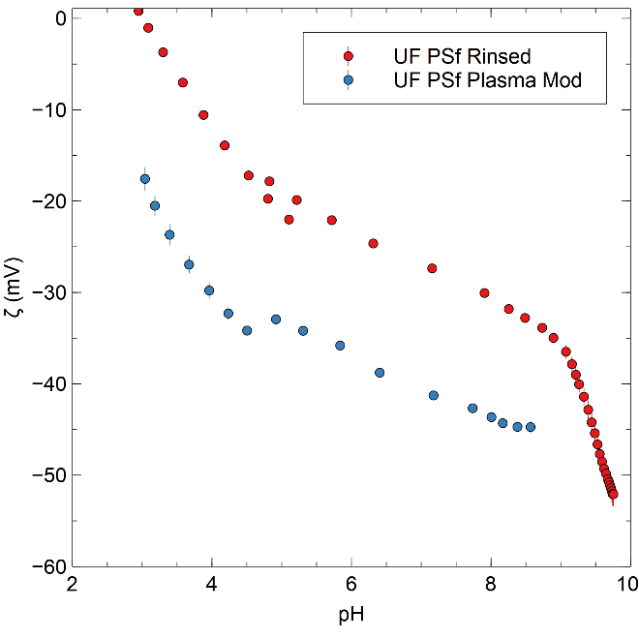
Figure S2. Zeta potential measurements of unmodified UF PSf in red compared to the UF PSf after plasma cleaning. It is clear that there is increased negative surface charge on the PSf after plasma cleaning.
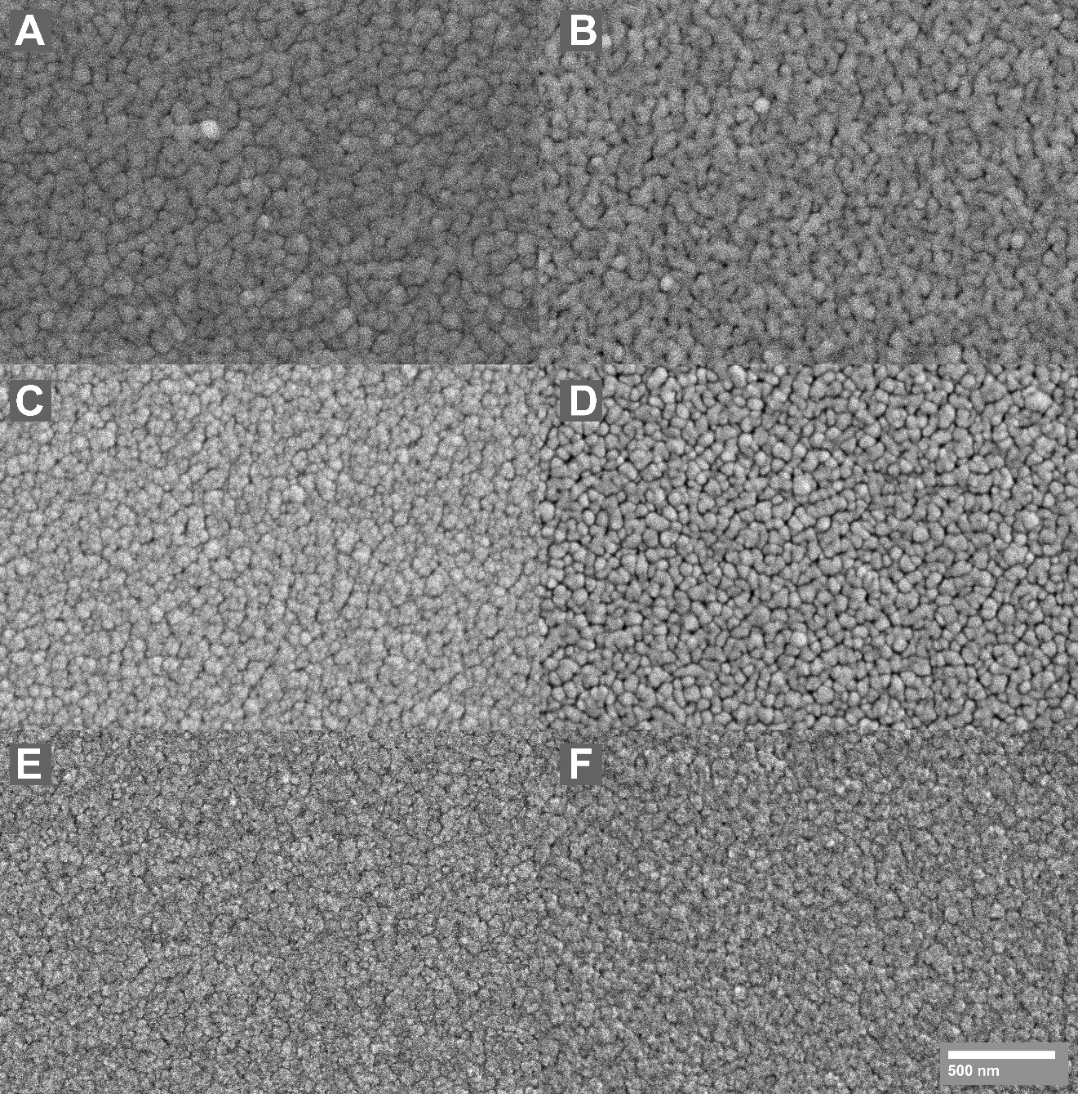
Figure S3. As deposited films imaged in plan view, scale bar applies to all images. Films deposited at different pressures with or without substrate biasing. (A) 2.5 mtorr working pressure, no substrate bias. (B) 2.5 mtorr working pressure, 10 W RF substrate bias. (C) 5.0 mtorr working pressure, no substrate bias. (D)5.0 mtorr working pressure, 10 W RF substrate bias. (E) 10 mtorr working pressure, no substrate bias. (F) 10 mtorr working pressure, 10 W RF substrate bias.

Z | Element | Family | Atomic Fraction (%) | Atomic Error (%)
6 | C | K | 49.5 | 5.2
8 | O | K | 12.0 | 2.9
12 | Mg | K | 0.8 | 0.2
16 | S | K | 0.1 | 0.03
29 | Cu | K | 17.8 | 2.9
46 | Pd | L | 15.0 | 2.3
73 | Ta | L | 4.8 | 0.7

Table SI. EDS results from a selected region of the TEM lamella of the npMTFC dealloyed structure. Cu signal is ascribed to noise from the copper TEM grid the lamella was attached to.

Figure S4. Individual flux experiments for membrane samples used for flux determination. (A) Unmodified UF PSf membrane. (B) MTFC membrane flux trials, UF PSf with 10 nm Ta layer deposited on its surface. (C) npMTFC membrane flux results, UF PSf with 10 nm Ta layer and 60 nm nanoporous Pd layer. Each data set is from a different 13.2 cm² membrane sampled from a 1 m wide roll of commercial UF PSf. Some variability in the membrane flux as seen in (A) is expected due to the varied nature of the UF pore structure. However, a larger variation in measured fluxes is seen in the MTFC tests than can be explained based on permeance variability of the substrate material. It is likely then, that some variability of the deposited Ta structure is the cause of this permeance distribution.

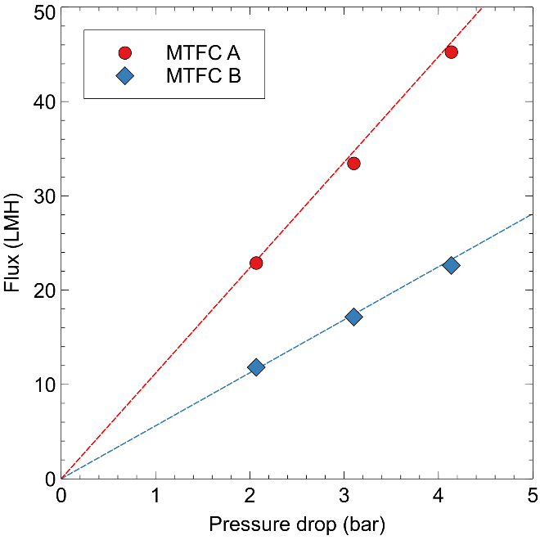
Figure S5. Summary of cross-flow cell results for two different MTFC membranes. Testing proceeded for over 24 hours of continuous operation with no damage to membrane performance or surfaces. Two MTFC membranes were produced and tested under similar conditions. MTFC A had a permeability of 11.2 LMH/bar and MTFC B had a permeability of 5.6 LMH/bar. This spread of permeabilities was somewhat higher than was typically seen in dead-end cell testing. MTFC membranes show more variability in flux than the other membranes. The variability is likely due to a combination of factors. There is variability in UF PSf substrate flux as shown in Figure S4, this is likely carried through to the MTFC structure since the film is templated by the substrate pores. This variance is exacerbated in the MTFC structure. Small differences in the thin Ta film could also lead to a change in flux, meaning close control of deposition parameters is needed during synthesis.

Figure S6. Series of flux determination experiments for a different UF membrane made from polyethersulfone (PES). (A) The base membrane, UF PES, is ‘tighter’ than the UF PSf used in the rest of this study, displaying a lower permeance of 136.7 LMH/bar. (B) The MTFC produced by depositing 10 nm of Ta on the surface of the UF PES shows a decreased permeance of 9.7 LMH/bar. Exhibiting the same trend of flux drop that is seen in the PSf composites. (C) An additional MTFC was studied here with a 20 nm Ta layer. Flux decreases even further with this thicker Ta layer, down to 1.5 LMH/bar.

Molecule | MW  (Da) | Diameter (nm) | % Rejection
 |  |  | UF PSf | MTFC | npMTFC
Dextran | 70000 | 19.2 | 86 ± 3% | 97 ± 3% | 96 ± 3%
Dextran | 40000 | 15.0 | 44 ± 4% | 95 ± 3% | 97 ± 3%
Dextran | 10000 | 8.2 | 42 ± 5% | 93 ± 4% | 100 ± 3%
Dextran | 5000 | 6.0 | 25 ± 6% | 100 ± 4% | 100 ± 3%
Sucrose | 342 | 1.0 | - | 20 ± 5% | 40 ± 4%

Table SII. Summary of rejection values of UF PSf, MTFC, and npMTFC membranes of dextran molecules of various weights and sucrose. All separations were performed at 4 bar with N₂ pressurization.

Figure S7. Dechlorination experiments were performed in dead-end permeation mode of the membrane, to take advantage of the favorable mass transfer of species to catalyst surface that comes with permeation of the solution through the membrane supported catalyst. Headspace of the dead-end cell was pressurized with nitrogen for a control run, and then hydrogen gas at 4 and 8 bar. Both permeate (A) and retentate (B) concentrations of PCB-1 and biphenyl were analyzed. As expected, no biphenyl was produced with nitrogen pressurization, since there was no dissolved hydrogen present. When the headspace was pressurized with hydrogen however, 72% of the initial PCB-1 concentration was removed from the permeate at both 4 and 8 bar H₂ pressurization, with 60 and 65% of that concentration being detected as biphenyl respectively.
These permeation runs were also performed sequentially. It is clear from the mass balances seen that the initial control run includes a significant amount of loss, this is explained as adsorption of PCB-1 the membrane polymer itself as the PSf and its backing material are both hydrophobic materials which would attract these compounds. Subsequent runs show improved mass balance, above 85% in the permeate and retentate indicating a steady state has been reached. In the nitrogen control run, mass balance for the retentate is nearly 100%, while it is 66% for the permeate of the same run. This reinforces the idea that the polymer membrane backing is the cause of the initial adsorption, as only the permeate contacts this layer of the composite.
It is clear that a significant amount of dechlorination has occurred even in the retentate samples. This is to be expected, since the nanoporous Pd is on the membrane surface. Thus the PCB-1 solution is in contact with the catalyst and dissolved H₂ even before permeation, effectively in a batch reactor. It fits expectations then, that the lower pressure 4 bar H₂ run which ran for a longer time (approximately twice as long to permeate the same volume as the 8 bar H₂ run) shows increased dechlorination in the retentate. Both tests show further dechlorination in the permeate after passing through the membrane. The same composite membrane was used for all these runs and remained stable with no measurable performance decline over the course of several permeation experiments.
Figure S8. Permeation mode dechlorination of PCB-1 with a 5/95 H₂/Ar gas mixture. Comparison of the permeate concentrations (A) with the retentate results (B) again shows that some degradation occurs above the membrane, essentially in a batch mode process. For both separate runs 10-20% PCB-1 is dechlorinated in the retentate. It is clear, however, that further dechlorination takes place as the solution passes through the membrane itself as the permeate concentration of PCB-1 is much lower than that of the retentate. Even though the metallic portion of the membrane is only 60 nm thick, approximately 40% of the initial PCB-1 concentration is degraded in this portion. Residence time calculations emphasize how active the nanoporous structure is. Calculated residence times for the 17.2 and 27.6 bar runs were 4 and 2 ms respectively.

Figure S9. Dechlorination of 30 ppm TCE (by chloride formation data) permeation mode with npMTFC membrane. Control performed with no H₂ supplied to show no chloride generation. Subsequent runs with H₂ headspace pressurization indicate significant dechlorination of TCE through chloride evolution.

