Supplementary Information
- Algorithm for calculating average cluster spacing
The coordination of the center of each cluster was recorded from the local concentration method (LCM) cluster analysis. Instead of calculating the distances between every two clusters, we used a so-called Delaunay triangulation method [1] to count the distances only between the adjacent clusters, Figure A1(a). After such triangulation, there will be no point inside the circumcircle of any triangle that maximizes the minimum angle of all the angles of the triangles in the triangulation. The length of blue lines between the red dots was used for the statistics of the spacing between clusters.
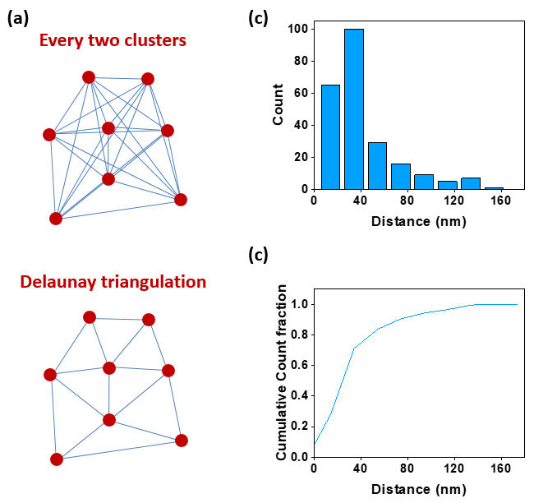
Figure S1 (a) Illustration of the Delaunay triangulation method for finding the representative spacing between adjacent clusters. (b) Distribution and (c) Cumulative count fraction of the spacing measured between adjacent clusters in Cu-7V 400 °C/1 h annealed sample.
Figure A1(b) and A1(c) are distribution and cumulative count fraction of the spacing measured between adjacent clusters in the Cu-7V 400 °C /1 h annealed sample. The average spacing between V clusters is 46 ± 32 nm.

- Maximum separation method
The maximum separation method (MSM) was also applied for the quantification of the cluster characteristics [2-4]. In this method, a distance d_{max} is chosen and a pair of solute atoms separated by less than this distance is deemed to be clustered. A group of atoms are then defined as one cluster. The assumption for MSM was the binomial separation in the distribution of nearest neighbor distances. Within the identified clusters, there are randomly organized atoms and non-randomly organized atoms.
A cut-off limit for the minimum size of a cluster, N_{min}, needs to be set to filter out the clusters from random solid solution. d_{pair} and N_{min} are two most important parameters to find the correct clusters. If the d_{pair} is too large, unphysical clusters will be selected. However, if the d_{pair} is too small, large clusters will be broken up and identified as several individual clusters. The cut-off limit, N_{min}, will determine whether random solute clusters were mistaken or some physical clusters were ignored. Therefore, they were tested before the cluster analysis [5]. A high order of nearest neighbors was chosen to eliminate the unphysical composition variation with the surrounding distance and erosion distance set to better determine the boundary of a cluster by adding a shell around the cluster and removing the matrix atoms.
A standardized approach to defining the parameters used in MSM is required to ensure that the clusters can be compared from one dataset to another. As an example, we take Cu-27V film annealed at 800 °C to illistrate the determination of the cluster search parameters. A high order nearest neighbor (NN) distribution was used to increase the contrast between matrix and clusters and to select an optimized value for d_{max}. The underlying mechanism is to ignore small density fluctuations and find a more compact and denser cluster. Figure A2(a) shows the nearest neighbor distance distribution for both the experimental and random vanadium atoms based on nearest neighbor orders between one and five. The experimental and random distributions move further apart with increasing order. The d_{max} for each order was determined by the crossover between the experimental and random distribution. However, the broadening of the NN distribution curve was noticed to increase with increasing order. This broadening results in a decrease in the spatial resolution [3]. A moderate order, four, was then chose and the d_{max} was determined to be 1.1. N_{min} was then selected to be the maximum cluster size observed for randomized APT data with the same concentration, 300, Figure A2(b). Finally, the envelope parameter, L, and erosion distance, d_{e}, are set as d_{max}. Using the above parameters, the clusters found in Cu-27V annealed at 800 °C are shown in Figure A2(c) with different colors representing different clusters.
Using the same method, the cluster search parameters for Cu-7V films annealed at 400 °C and Cu-27V film annealed at 800 °C were determined. The MSM cluster searching algorithm could not be applied to find the clusters for the Cu-27V film annealed at 400 °C because the clusters were at their initial forming stage with most of them physically connected by solute atoms. Furthermore, local magnification effects in the reconstruction at and near the grain boundary convoluted these particular findings. Note that the density variation of solute atoms was strongly modulated by the grain structure in Cu-27V.

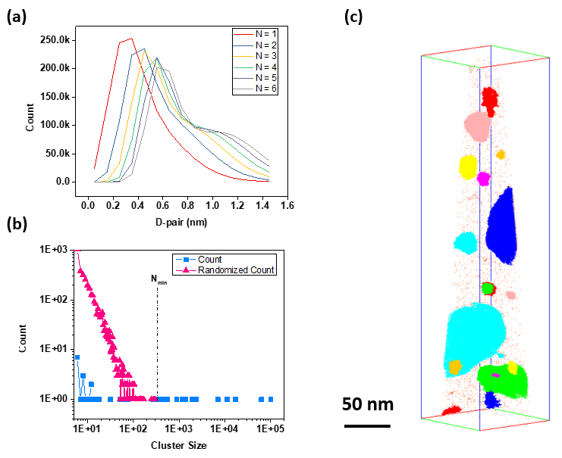
Figure S2 (a) V-V nearest neighbor distributions for orders from 1 to 6 (b) V cluster size distribution based on the d_{max} value determined from (a) and (c) V map for the identified clusters. Different colors represent different clusters.

Table S1 Bulk composition, V clusters number, number density, volume fraction, cluster spacing, and the ratio of V ions that found within V clusters to all V ions measured in the APT tips shown in Figure 1. The clusters were found by using MSM. The annealing time is 1 h for all films.
Parameters | Cu-7V @400 °C | Cu-27V @400 °C | Cu-7V @800 °C | Cu-27V @800 °C
Vanadium bulk composition | 7.0% | 27.1% | 0.1% | 4.8%
Clusters Number | 41 | - | 82 | 17
Number density (×10²⁴ m⁻³) | 0.06 | - | 0.15 | 0.02
Volume fraction | 7% | - | 1% | 15%
Cluster spacing (nm) | 41 ± 30 |  | 30 ± 21 | 86 ± 61
V_{in clusters}/V_{all ions} | 0.37 | - | 0.87 | 0.98

Table A1 includes the quantification result from the MSM cluster analysis, with those results providing verification of the LCM quantification. For LCM, we used the same 50 at.% V isoconcentration surface to find vanadium clusters in all alloys. This ‘only’ selection could be too rigid because the selection of an isoconcentration surface normally impacts the number selection [6]. However, the MSM quantification revealed good agreement with LCM quantification adding confidence in the LCM cluster selection, e.g. the result from the Cu-7V 400 °C/1 hr annealed and Cu-27V 800 °C/1 hr annealed samples. It is worth to mention that fewer clusters have been selected via the LCM than MSM for the Cu-27V 800 °C/1 h annealed sample. This is because some visualized vanadium clusters have a low concentration than the selected isoconcentration values. Since the formation of a new phase in the Cu-V system is a nucleation-based process, we chose a high isoconcentration value, 50 at.% V, to filter out regions with small local composition fluctuation.

- Mass spectrum
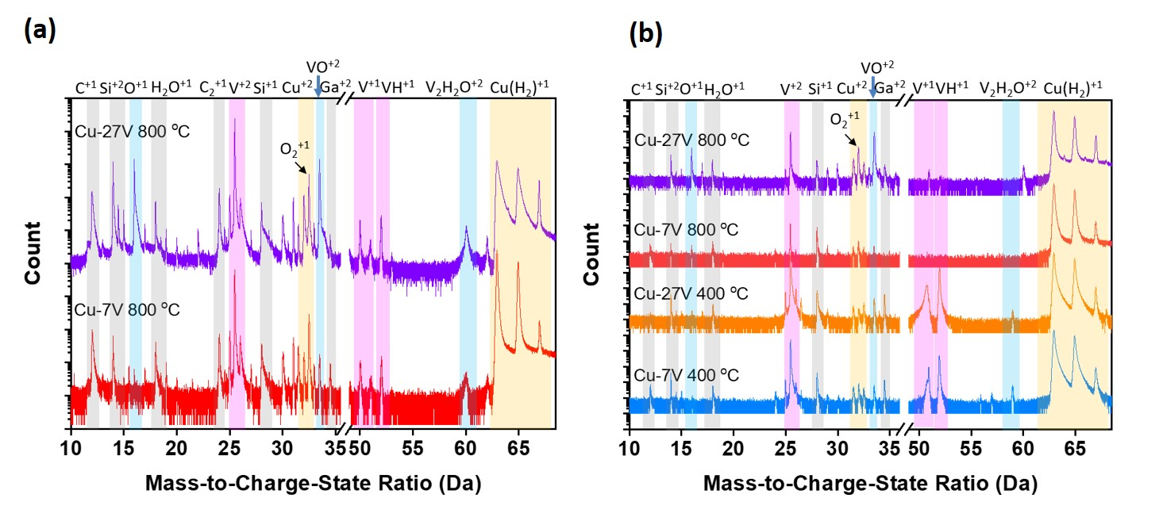
Figure S3 (a) Mass spectrum analysis from a interface region of the Cu-7V and Cu-27V alloy films annealed at 800ºC for 1 hr. (b) Mass spectrum analysis from Cu-7V and Cu-27V films annealed at 400ºC and 800ºC for 1hr.

- 1D compositional profiles from APT datasets
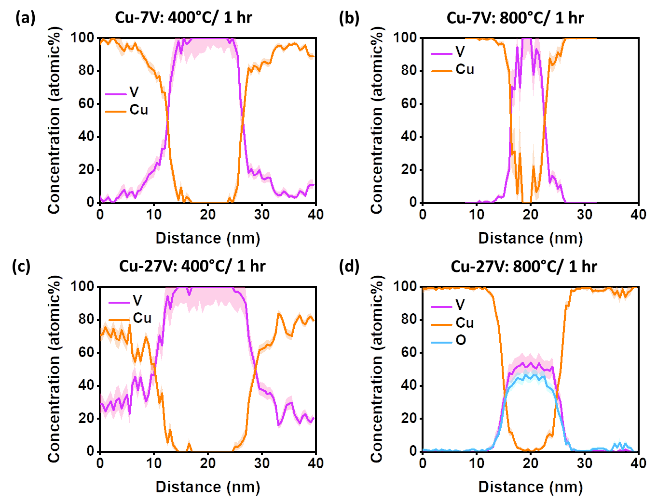

Figure S4 1D compositional profiles from Cu-7V and Cu-27V films annealed at 400 °C and 800 °C for 1 hr. A 40 nm long with a 3 nm diameter cylinder was manually put across a V related phase for measuring 1D compositional profile.

Supplementary References
[1] S. Fortune, Voronoi diagrams and Delaunay triangulations, in: E.G. Jacob, O.R. Joseph (Eds.) Handbook of discrete and computational geometry, CRC Press, Inc., 1997, pp. 377-388.
[2] Y.M. Chen, P.H. Chou, E.A. Marquis, Quantitative atom probe tomography characterization of microstructures in a proton irradiated 304 stainless steel, Journal of Nuclear Materials, 451 (2014) 130-136.
[3] L.T. Stephenson, M.P. Moody, P.V. Liddicoat, S.P. Ringer, New techniques for the analysis of fine-scaled clustering phenomena within atom probe tomography (APT) data, Microscopy and Microanalysis, 13 (2007) 448-463.
[4] E. Marquis, J. Hyde, Applications of atom-probe tomography to the characterisation of solute behaviours, Materials Science & Engineering R-Reports, 69 (2010) 37-62.
[5] C.A. Williams, D. Haley, E.A. Marquis, G.D.W. Smith, M.P. Moody, Defining clusters in APT reconstructions of ODS steels, Ultramicroscopy, 132 (2013) 271-278.
[6] D.J. Barton, B.C. Hornbuckle, K.A. Darling, G.B. Thompson, The Influence of Isoconcentration Surface Selection in Quantitative Outputs from Proximity Histograms, Microscopy and Microanalysis, 1-9.

