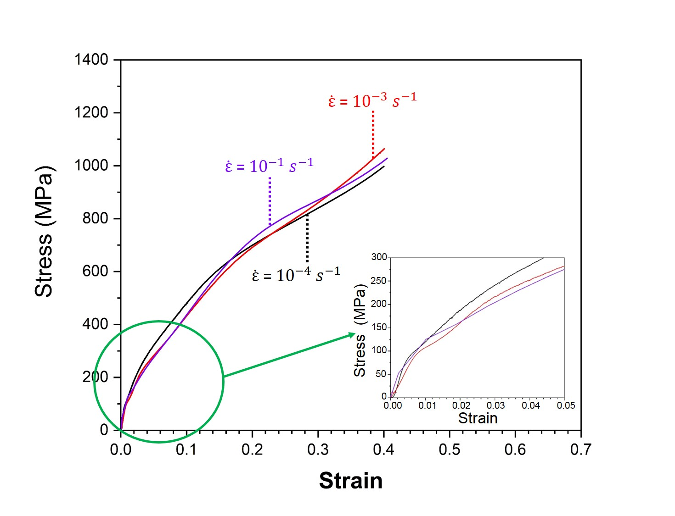
FIG. S1. Stress-strain curves of the T400 sample obtained in compression under three different strain rates. The inset in the bottom right corner is a magnification of the elastic region of these curves. These curves were obtained at room temperature using an Instron 5869 located at the Leibniz-Institut für Festkörper- und Werkstoffforschung Dresden.
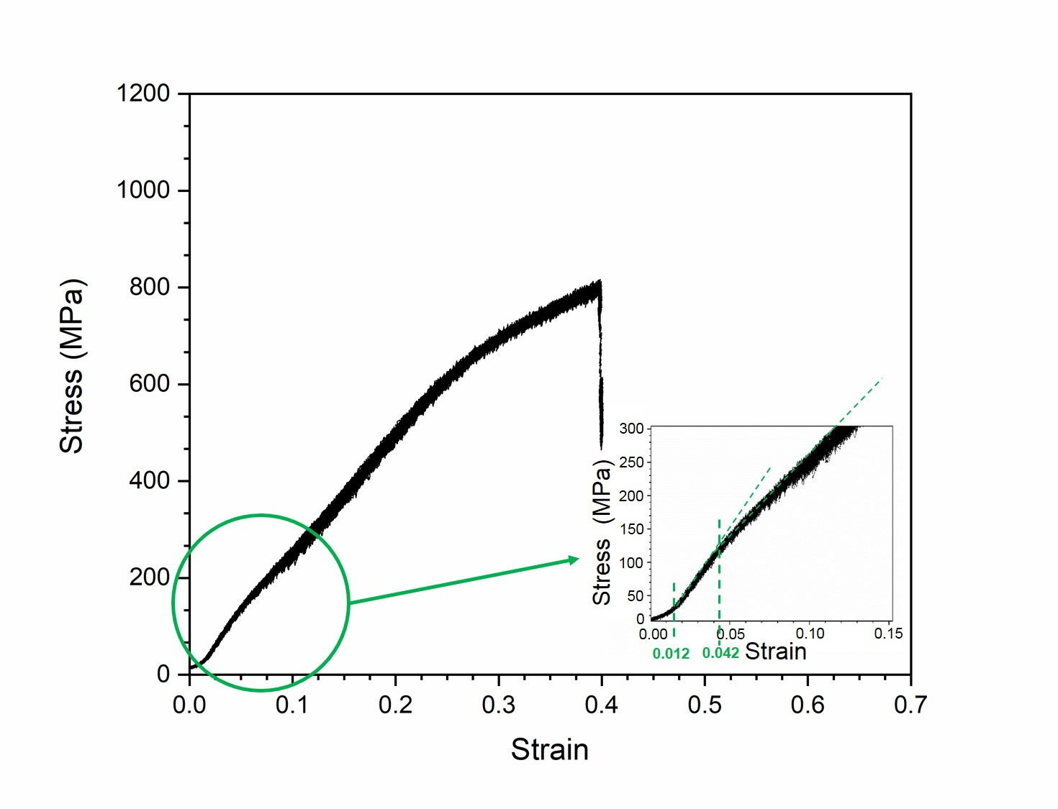
FIG. S2. Stress-strain curve for the T400 sample obtained in compression at a strain rate of 10⁻⁴ s⁻¹. It can be seen two changes in slope in the elastic region. The first at a strain of 0.012 and the second at 0.042.

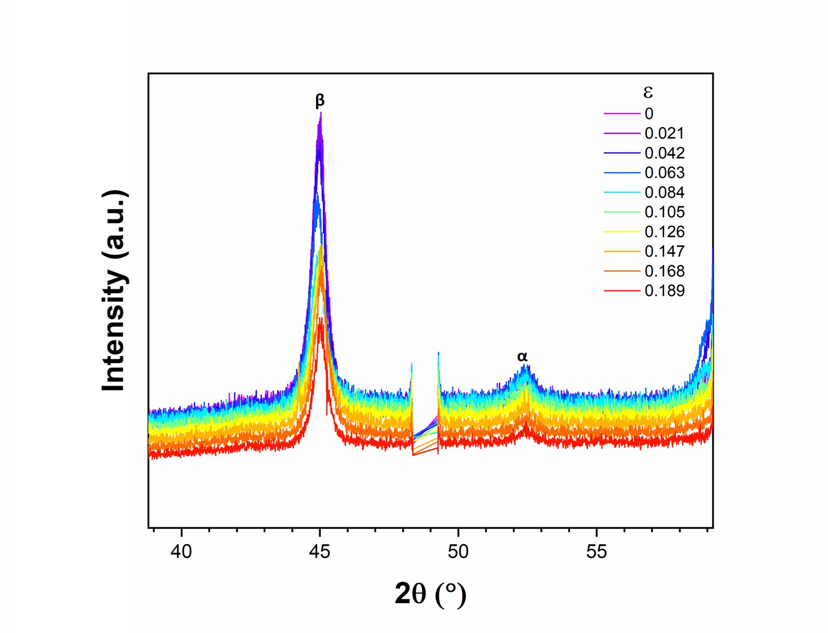FIG. S3. In situ X-ray diffraction patterns during compression test of the T3600 sample at a strain rate of 10⁻³ s⁻¹.

