Supporting Information

Temperature-Dependent Mechanical Behavior of 3-Dimensionally Ordered Macroporous Tungsten
Kevin M. Schmalbach^{1,a)}, Zhao Wang^{2,a)}, R. Lee Penn², David Poerschke¹, Antonia Antoniou³, Andreas Stein^{2,b)}, Nathan A. Mara^{1,b)}

¹Department of Chemical Engineering and Materials Science, University of Minnesota, Minneapolis, Minnesota 55455, USA
²Department of Chemistry, University of Minnesota, Minneapolis, Minnesota 55455, USA
³George W. Woodruff School of Mechanical Engineering, Georgia Institute of Technology, Atlanta, Georgia 30332, USA
^{a)}These authors contributed equally to this work.
^{b)}Address all correspondence to these authors. e-mail: a-stein@umn.edu, mara@umn.edu

Synthesis of monolithic 3DOM W
Monolithic 3DOM W was synthesized following a previously reported method.¹ Monolithic pieces of PMMA were used as the templates and were placed in a vacuum flask. The vacuum flask was sealed with a rubber stopper and evacuated under house vacuum for 30 min. The house vacuum was then turned off, and the APTA precursor was injected into the flask by syringe. The precursor was added dropwise to the side of the monolithic PMMA template. To avoid the collapse of the PMMA monolith from the precursor solution, a new drop was only added when the last one had infiltrated the template.
After all PMMA template pieces had been infiltrated, they were removed from the flask. Excess precursor solution was wiped off with Kimtech wipes, and the infiltrated PMMA monoliths were dried in air overnight. The infiltration step was repeated twice. The infiltrated PMMA pieces were then heated under H₂ (2 °C/min to 310 °C, remaining at 310 ˚C for 2 h, then 5 °C/min to 800 °C, remaining at 800 ˚C for 1 h). PMMA was removed during this process, and monolithic 3DOM W formed.

Additional Data
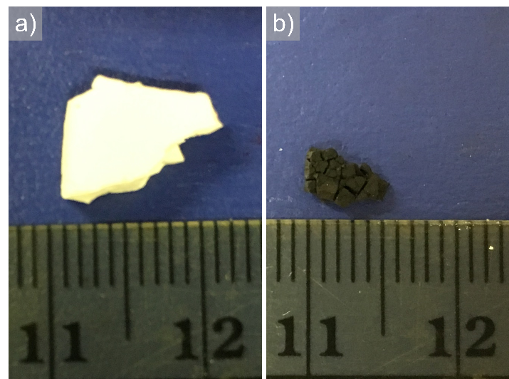
Figure S1. Photos of (a) the monolithic PMMA template and (b) the 3DOM W monolith derived from infiltrating this template with APTA precursor, followed by thermal treatment under H₂. The numbers on the ruler refer to cm.

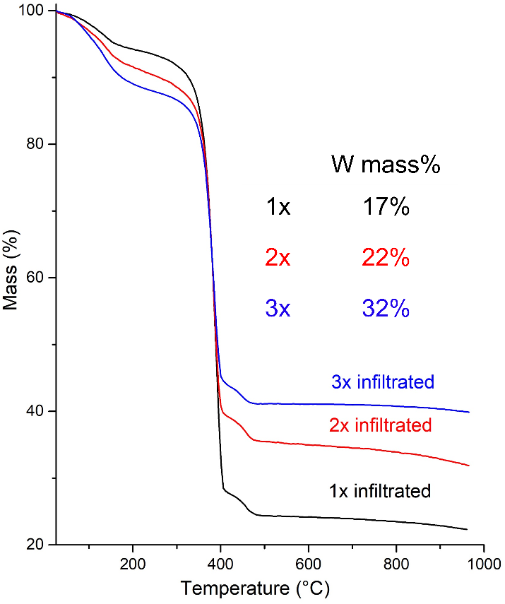
Figure S2. TGA curves for PMMA monoliths that had been infiltrated with APTA once, twice, or three times. The experiments were performed in air. To determine the W mass% values, it was assumed that the final product was WO₃. The amount of tungsten incorporated in the composite piece increased with the number of APTA infiltration steps.

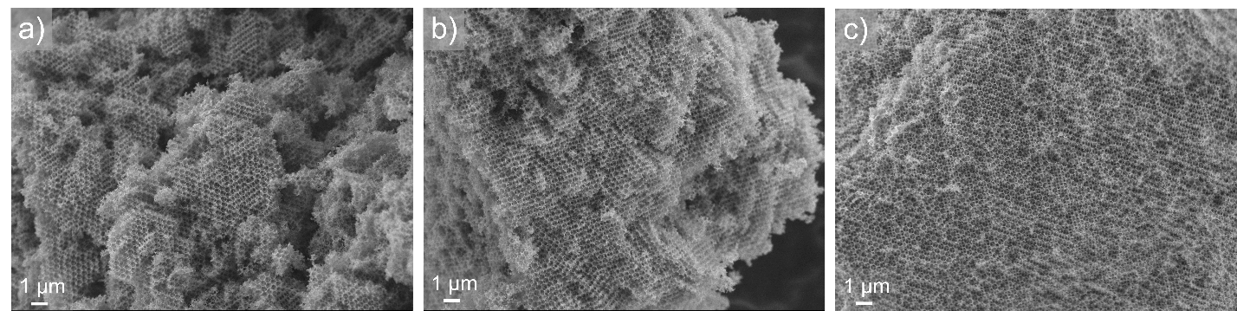
Figure S3. SEM images of fragments from 3DOM W monoliths synthesized using (a) one, (b) two, or (c) three steps of APTA infiltration into the colloidal crystal templates. More extended, well-defined 3DOM structures were observed with more infiltration steps as remaining voids were filled with additional precursor material, mitigating crack formation during reduction. With more than three infiltration steps, the monolithic PMMA template pieces tended to collapse.

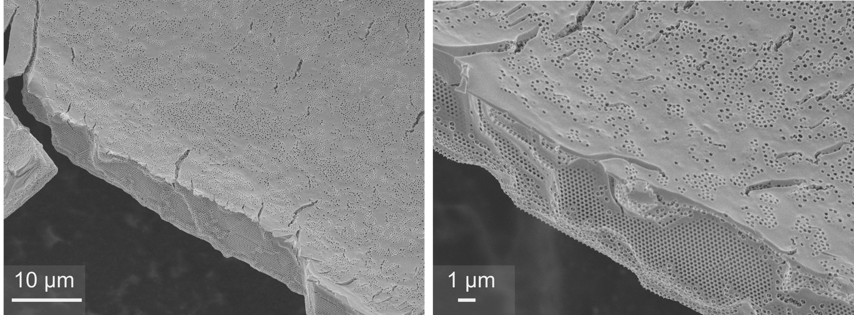
Figure S4. SEM images taken at different magnification of 3DOM W films synthesized using two APTA infiltration attempts. A W overlayer formed and covered the surface of the 3DOM structure.

References
1. Denny, N. R.; Han, S.; Turgeon, R. T.; Lytle, J. C.; Norris, D. J.; Stein, A. In Synthetic approaches toward tungsten photonic crystals for thermal emission, Optics East 2005, SPIE: 2005; p 13.

