Supplementary Information

Influence of processing route on the alloying behavior, microstructural evolution and thermal stability of CrMoNbTiW refractory high entropy alloy
Lavanya Raman¹, G Karthick¹, K Guruvidyathri¹, Daniel Fabijinic², S.V.S Narayana Murty³, B. S. Murty¹ and Ravi Sankar Kottada¹
¹Department of Metallurgical and Materials Engineering, Indian Institute of Technology Madras, Chennai 600036, India
²Institute for Frontier Materials, Deakin University, Geelong VIC 3220, Australia
³Materials and Metallurgy Group, Vikram Sarabhai Space Center, Trivandrum 695022, India

S1. Summary of the literature reports on Refractory High Entropy Alloys (RHEAs) with multiple phases
TABLE S1: Literature reports on the processing of RHEAs in which more than one phase was formed. Additional remarks on the secondary phases are also provided.
S.No | RHEA | Processing method | Phases observed | Density  (g cm⁻³) | H_{v}  (GPa) | T_{m} (K) | Remarks on the secondary phases | Ref
1. | AlMo_{0.5}NbTa_{0.5}TiZr | VAM, HIP at 1400 °C/207 MPa/2 h,  1400 °C/24h | BCC + B2 | 7.40 | 5.8 | 2046 | Al promotes B2 formation | ¹
2. | Al_{0.3}NbTaTi_{1.4}Zr_{1.3} | VAM | BCC + BCC | 8.2 | 4.8 | 2360 | Two BCC phases form interpenetrating nano-lamella resulting in basket-weave structure inside grains. One BCC is rich in Nb and another BCC is rich in Zr | ²
3. | Al_{0.5}NbTa_{0.8}Ti_{1.5}V_{0.2}Zr |  | B2 + BCC | 7.4 | 5.2 | 2234
4. | Al_{a}Mo_{b}NbTa_{c}TiZr  (a = 0.25, 0.5, b = 0, 0.05, c = 0.5) | VAM, HIP at 1400 °C/207 MPa/2 h,  Annealing at 1400 °C/6h | B2 + BCC | 8.1 – 9.4 | 4.9 – 6.4 | - | Needle-like precipitates were found in Al_{0.5}Mo_{0.5}NbTa_{0.5}TiZr. A two-phase nanoscale interpenetrating microstructure was found in Al_{0.25}NbTaTiZr | ³
5. | Al_{0.5}CrNbTi₂V_{0.5} | VAM, Annealing at 1200 °C/24h | BCC + Laves | 5.76 | 3.72 | 1831 | C14 Laves phase composed of Cr, Nb, and Ti formed after annealing | ⁴
6. | AlNbTiVZr_{x}  (x = 0.1 -1) | VAM, Annealing at 1200 °C/24h | B2 + Al₃Zr₅ + Laves | 5.59 – 5.87 | 3.87 – 4.62 | - | Al₃Zr formed in Zr_{0.1 -1} alloys, whereas C14 Laves (ZrAlV type) formed in alloys with greater than 0.5 Zr | ⁵
7. | AlCr_{x}NbTiV  (x = 1, 1.5) | VAM , Annealing at 1200 °C/24h | BCC + Laves | 5.59 – 5.9 | 3.0 – 5.1 | 1863 – 1973 | Laves phase forms above 0.5 mole fraction Cr | ⁶
8. | AlCrMoTaTi | VAM | B2/BCC + Laves | - | - | - | The Laves phase was found to be rich in Cr, Ta, Al. It exists in C14, C15, and C36 structure. | ⁷
9. | AlHfNbTaTiZr | VAM | BCC + BCC | 8.91 – 9.72 | 2.9 – 4.32 | - | One BCC was found to be rich in Nb, Ta, and other was rich in Al, Hf, and Zr. Al promotes BCC formation. | ⁸
10 | CoCrMoNbTi_{x}  (x = 0 - 1) | VAM | BCC + Laves | 8.3 | 8.14 – 9.41 | 2310 – 2445 | Two types of Laves phase were observed. Alloys with Ti < 0.5 mole fraction showed (Co, Cr)₂Nb type Laves whereas alloys with Ti > 0.5 mole fraction showed (Co, Cr)₂Ti type Laves phase | ⁹
11. | CrHfNbTiZr | IM + Annealing | BCC + Laves + Laves | - | 3.8 – 4.55 | - | Presence of Cr leads to Laves phase formation | ¹⁰
12. | CrMo_{0.5}Ta_{0.5}TiZr | VAM,  HIP at 1450 °C /207 MPa/2 h,  Annealing at 1200 °C /24h | BCC + BCC + Laves | 8.23 | 5.29 | 1845 – 1880 | Cr-rich Laves phase was reported | ¹¹
13. | CrNbTiVZr | VAM,  HIP at 1200 °C /207 MPa/2 h,  Annealing at 1200 °C /24h | BCC + Laves | 6.52 | 4.72 | - | Presence of Cr beyond 0.5- mole fraction and V leads to Laves phase | ¹²
14. | CrNbTiZr |  |  | 6.70 | 4.10 | -
15. | Cr_{x}MoNbTaVW  (x = 0 – 2) | VAM | BCC + Laves | 11.2 – 11.5 | 6.62 – 7.4 | > 2173 | Increasing Cr destabilizes the BCC phase. Experimentally two BCC phases were observed. One BCC rich in Cr, Nb, V, and other BCC rich in remaining elements. The Calphad prediction shows the formation of C14/C15 Laves when Cr ~2-mole fraction. | ¹²
16. | CrMoNbReTaVW | VAM | BCC + BCC | - | - | 2916 | One BCC is rich in Cr, Nb, V and other is rich in Mo, Re, Ta and W | ¹³
17. | Mo_{x}NbTiV_{y}Zr  (x = 0.1 – 2,  y = 0.3 & 1) | VAM | BCC + Laves | 6.46 – 7.53 | - | - | Laves phase forms when x > 1.5 and y = 1 | ¹⁴
18. | CrMoNbTiVWZr and  Al_{x}Cr_{y}NbMoTiV_{z}Zr_{y} | VAM + Annealing at 1350 °C for 3 h in a HT-DSC | BCC + Laves + hcp | - | 6.0 – 7.13 | - | Based on the empirical parameters, to obtain BCC multicomponent solid solution, x, y, and z were identified to be 0.6, 0.3 and 0.3, respectively. | ¹⁵
19. | MoNbTaTi | MA + Annealing at 800–1200 °C for 5–10 min | BCC + TiO/TiN | - | - | - | Dry milling in SS vial in Ar atmosphere. TiO and TiN formed at 1200 °C due to reaction of Ti with residual air. | ¹⁶
20. | W_{x}TaTiVCr | MA + SPS | BCC + TiC + Laves | 13.4 – 16.5 | 4.8 – 7.8 | - | C15 Laves phase were found to be V and Cr rich. They formed when W > 70 at%. | ¹⁷
21. | CrTaTi_{x}VW | MM + SPS | BCC + Laves + TiC | - | 7.4 – 7.8 | - | TiC and (Cr,V)₂Ti Laves phase (C15) formed during SPS of MA powder | ¹⁸
22. | MoNbTaTiVW | MA + SPS | 2BCC + TiO | 10.6 | 7.7 | - | BCC2 is depleted in W, Mo, and Ta | ¹⁹
23. | NbMoTaWVCr | MA + SPS  (MA – dry milling in Ar) | BCC + Laves + Ta₂VO₆ | 11.02 – 11.23 | 9.69 – 10.52 | - | The C15 Laves phase was found to be (Cr, V)₂(Ta, Nb). The brittle fracture was observed along the Laves phase boundaries. | ²⁰
24. | MoNbTaVW | MA + SPS | BCC + oxides | - | 7.8 | - | Ta₂VO₆ were observed in addition to BCC phase after sintering | ²¹
25. | CrMoNbTiW | MA + SPS  (MA – wet milling with toluene as PCA) | 3 BCC + Laves + TiC | 9.85 | 8.9 | - | The compromise in the extent of alloying in view of having minimum contamination during MA led to the formation of the Laves phase and TiC during SPS. | ²²
26. | CrMoNbTiW | MA + HPS  (MA – dry milling with stearic acid as PCA in Ar) | BCC + Laves+ (Ti, Nb) C | 9.65 | 8.26 | - | The PCA decomposed and reacted with Ti and Nb resulting in the formation of mixed carbides. The negative ΔH_{mix} resulted in the formation of Laves phase. | ²³
27. | CrMoNbTiW | MA + SPS  (MA – dry milling in Ar) | 2 BCC + Laves | 9.67 – 9.80 | 10.4 | - | The influence of milling duration on phase formation is studied. W rich BCC and Ti-rich BCC along with Cr₂Nb Laves phase is observed in all cases. | ²⁴
28. | NbMoTaW and  Ti₈Nb₂₃Mo₂₃Ta₂₃W₂₃ | MA + SPS | BCC + carbide | - | 7.78  7.35 | - | TEM studies revealed the formation of TaNb rich BCC precipitates after SPS. The reason for the formation of carbide is not discussed | ²⁵
29. | MoNbTaVW | MA + HPHT | 2 BCC + carbide | 8.75 – 10.75 | 8.8 – 11.4 | - | HPHT was done over a range of T from 800 – 1500 C. The carbides were observed after 1150 C. | ²⁶
30. | Nb₄₂Mo₂₀Ti₁₃Cr₁₂V₁₂Ta₁ | MA + SPS  (MA – dry milling in Ar and n-heptane as PCA) | BCC + TiC | - | 7.27 | - | The high hardness and excellent mechanical property was attributed to dispersion strengthening due to TiC | ²⁷
31. | TiC/ RHEA composite  (WC-VC-Mo₂C, TaC, NbC) | MA + SPS  (MA in Ar) | BCC + TiC | - | 1.9 | - | Although the starting materials were individual carbides, it resulted in the formation of a simple TiC and BCC phase after SPS. | ²⁸
32. | MoNbTaW | DMD | BCC | - | - | - | The deposited layer is a strong function of laser parameters and temperature. | ²⁹
33. | TiZrNbTa | LMD | BCC | - | - | - | During the deposition, Nb and Zr were varied (0 – 25). It was observed that Nb rich (low Zr) gives rise to single BCC whereas Zr rich (low Nb) results in two BCC. | ³⁰
Terminology: VAM (vacuum arc melting), IM (induction melting), HIP (hot isostatic pressed), MM (mechanical mixing), MA (mechanical alloying), SPS (spark plasma sintering), HPS (hot press sintering), PCA (process control agent), Ar (argon), HPHT (high pressure/high temperature), HT (high temperature), DSC (differential scanning calorimeter) DMD (Direct metal deposition) and LMD (laser metal deposition)

S2. Summary of the literature reports on various well studied High Entropy Alloys (HEAs) synthesized through mechanical alloying and casting route
TABLE SII: Literature reports on the processing of few HEAs through mechanical alloying and casting
S.No | Composition | Phases observed |  |  | Ref
 |  | Mechanical Alloying | After consolidation | Casting
1. | CoCrFeNi | FCC + BCC | SPS: FCC + Cr₇C₃ + Cr₂O₃ | FCC | ³¹
2. | CoCrCuFeNi | FCC + BCC | SPS: 2 FCC + σ | FCC | ^{32,33}
3. | AlCoCrFe | BCC | SPS: B2 + Cr₂₃C₆ | BCC | ³⁴
4. | AlCoCrFeNi | MA in Ar: BCC  MA-5 h: FCC + BCC | SPS: FCC + BCC | B2 + BCC  FCC + BCC | ^{35–38}
5. | AlCoCrCuFeNi | - | Hydraulic press: FCC + BCC | 2 FCC + B2 + BCC | ^{39,40}
6. | AlCoFeMoNiTi | 2 BCC | Hydraulic press: FCC + BCC + TiO₂ + Al₂O₃ + µ | FCC + BCC + TiO₂ | ⁴¹
7. | CoCrFeNiSi | - | 2 FCC + σ | FCC + Ni₃Si | ⁴²
8. | MoNbTaW | BCC  MA+Ann: BCC + nitrides | BCC + carbide | BCC | ^{25,43,44}
9. | MoNbTaVW | 2 BCC | HPHT: 2BCC + carbide | BCC | ^{26,43}
10. | HfNbTaTiZr | Atomized powder: 2 BCC | SPS: 2 BCC till 1000 ºC and single BCC above 1000 ºC | BCC | ^{45,46}
Terminology: MA (mechanical alloying), SPS (spark plasma sintering), Ar (argon), Ann (annealing), HPHT (high pressure/high temperature)
S3. Detailed rationale in choosing the heat-treatment (HT) condition of 1300 °C for 240 h
The CrMoNbTiW alloy in the following conditions: MA-air-6h+SPS, MA-Ar-4h+SPS and cast were subjected to heat-treatment to check their microstructural stability. The heat-treatment temperature was decided based on the liquidus of the alloy predicted from Calphad studies (Fig. 8). For the MA (in air and Ar) + SPS condition, the liquidus is ~1500 °C, whereas for the cast alloy, the liquidus is ~2400 °C. Thus, to strike a balance between these two conditions, a highest temperature of 1300 °C was chosen. This temperature (1300 °C) is high enough for the MA+SPS alloys to approach towards equilibrium. At the same time, 1300 °C turns out to be ~0.5 of the liquidus of the cast alloy. As far as the heat-treatment time is concerned, it was decided based on the diffusivity of the slowest diffusing species and using the equation E.1.
$x= \sqrt{Dt}$ E.1
where, D is the diffusivity (m² s⁻¹), t is time in s, $x$is the diffusion distance in µm. From the EBSD data, the grain size of BCC phase was found to be 270 nm. Assuming the diffusion distance to be thrice the grain size (~ 1 µm), the time required for heat-treatment was calculated based on the D of the slowest diffusing species. At 1300 °C, among the alloying elements, Nb is found to have the lowest D value of $8.7 × {10}^{-19} m^{2}s^{-1}.$ Thus depending on D and $x,$ the time was calculated to be around 10 days (240 h).

S4. XRD patterns of MA-air powders
The XRD patterns of MA-air powder as a function of milling duration (up to 6 h) are shown in Fig. S1a.
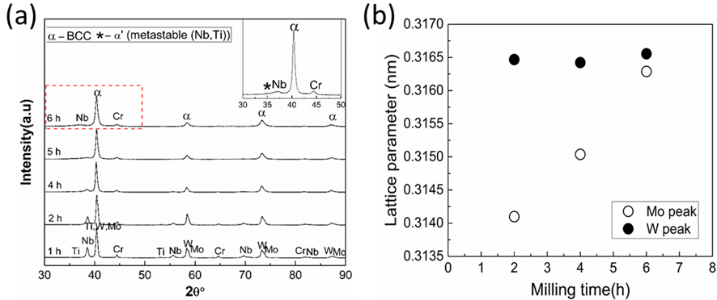
Fig. S1: (a) XRD patterns showing the phase evolution of MA-air powder with increasing milling time (b) variation of the lattice parameter calculated using Nelson-Riley function with increasing milling time with reference to W and Mo peaks.
The elemental peaks except for Cr and Nb disappear at the end of 6 h. After 6 h, a BCC solid solution along with residual Cr and Nb was observed. Moreover, a hexagonal metastable α′(Nb, Ti) phase formed after 6 h of MA as shown in the inset of Fig. S1b. The lattice parameter of the Mo phase calculated using the Nelson-Riley function after 6 h of MA (0.3165 ± 0.0088 nm) is close to that of W (0.3164 nm) as in the ICSD PDF #04-0806. Based on the close inspection of Fig. S1a, it is evident that the Mo peak position shifts towards the W peak, while the W peak position is minimally altered as the milling progresses. Hence, it can be concluded that the alloying elements dissolve preferentially in Mo relative to W. This observation is also confirmed from the change in lattice parameters of Mo and W.
S5. Characterization of MA powders
The elemental mapping of the MA-air-6 h and MA-Ar-4h is shown in Fig. S2 (a) and (b), respectively. It can be inferred that, except for Cr, Nb and W, which are present in residual form, the elements are homogenously mixed throughout the microstructure. In addition to the alloying elements, Fe is also seen, which is a contamination coming from the milling media. Moreover, it can be seen that there is some solubility of Fe in the solid solution.
(a)
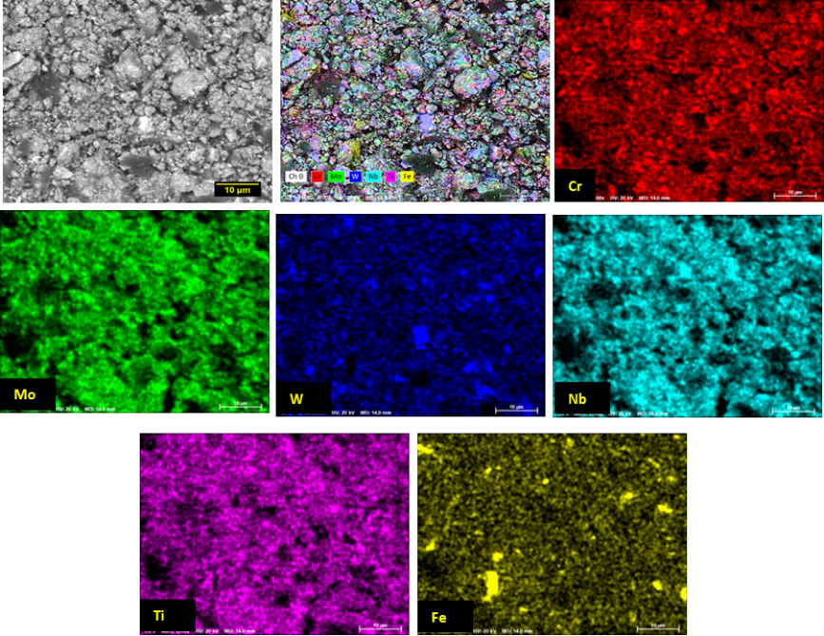

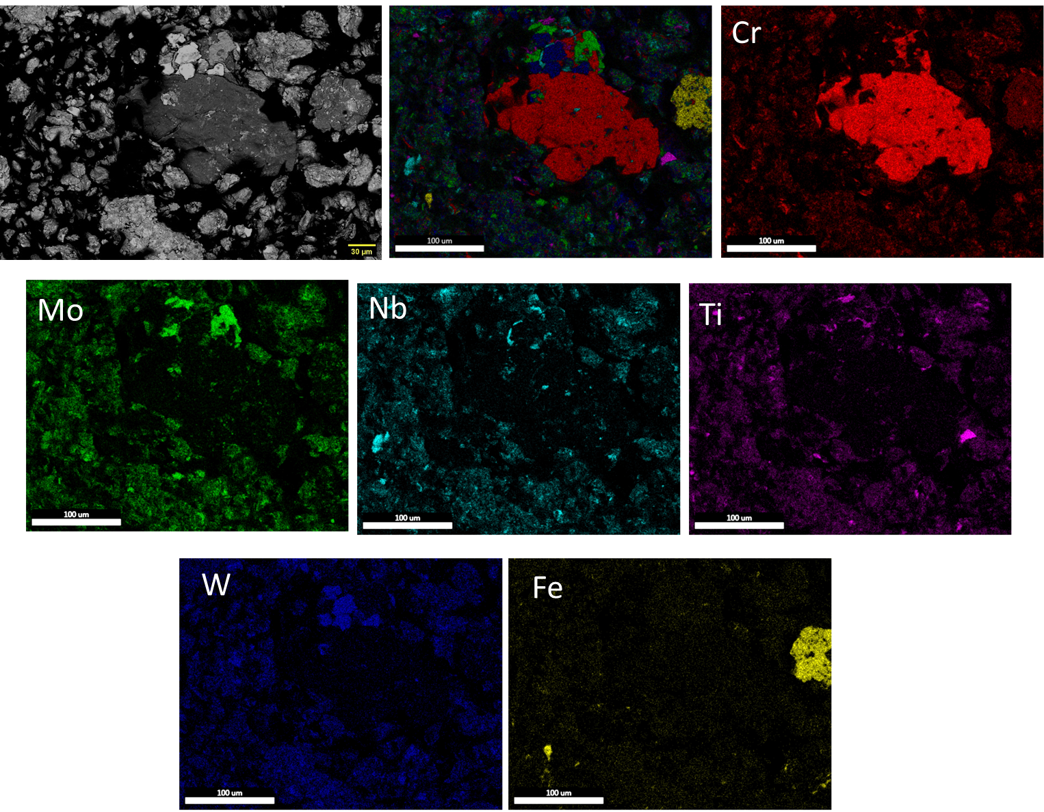
(b)

Fig. S2: (a) Elemental mapping of the (a) MA-air-6h and (b) MA-Ar-4h powders showing the distribution of alloying elements

S6. Calculation of theoretical density
The density calculation using the conventional method “rule of mixtures” (RoM) does not hold good for a multicomponent alloy, due to the presence of multiple elements in large proportions and lattice distortion as reported by Sriharitha et al.,⁴⁷. Hence, the vol.% of phases obtained using EBSD has been taken as input for the calculation of theoretical density as per the equation S.1.
$Density of the phase i ρ_{i}= n\frac{\sum_{j=1}^{j}{f_{j}A_{j}}}{volume of unit cell × N_{a}}$ S.1

where, i is the number of phases, n is the number of atoms per unit cell, j is number of elements in the alloy, f_{j} is the fraction of element j in the phase, A_{j} is the atomic weight of the element j in g mol⁻¹, and N_{a} is the Avogadro number of atoms (6.023 $×$ 10²³ atoms). The volume of the unit cell can be calculated from the lattice parameter of the individual phases. The total density of the alloy can be calculated using the following equation S.2

$Density of the alloy ρ_{A}= \sum_{i=1}^{i}{ρ_{i}F_{i}}$ S.2

where, F_{i} is the phase fraction calculated using EBSD analysis. The lattice parameter of the phases, no: of atoms and the calculated theoretical density using RoM and from the phase fraction is given in Table SIII.

TABLE SIII: Theoretical and experimental density of CrMoNbTiW

Phase | Lattice parameter (nm) | Atom per unit cell (n) | Volume in m³ ($× {10}^{-29}$) | Theoretical density  (g cm⁻³) |  | Experimental density
BCC | a = 0.3114 | 2 | a³ = 3.0196 | D_{e} | ρ_{A} | g cm⁻³ | Relative to D_{e} | Relative to ρ_{A}
σ | a = 0.8799,  c = 0.4546 | 30 | a²c = 3.520
Carbide | a = 0.3069 | 4 | a³ = 2.890 | 9.95 | 10.44 | 9.85 | 99 % | 94 %
Oxide | a = 0.3784,  c = 0.9515 | 4 | a²c = 1.360

D_{e} is calculated using RoM for equiatomic CrMoNbTiW.

S7. Optimization of sintering temperature for MA-Ar-4h powders
The MA-Ar-4h powder was sintered at 1300, 1400 and 1500 °C to obtain a dense pellet. The sintered samples showed the presence of 2 BCC solid solutions, Cr₂Nb Laves phase, and TiO_{1-x}N_{x} phase as shown in the XRD pattern (Fig. S3).
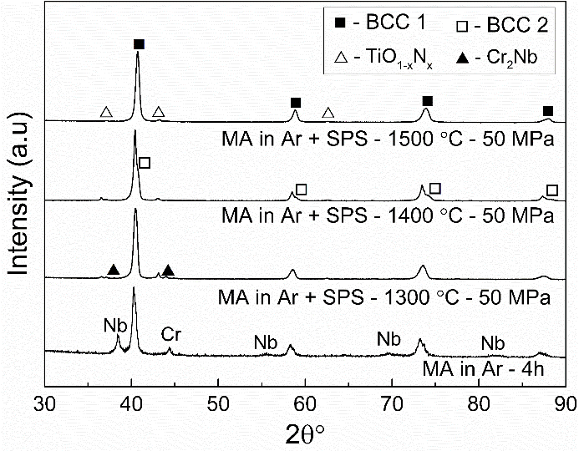
Fig. S3: XRD patterns of the powder (MA-Ar-4h) and after sintering at different temperatures.

From the XRD peak intensity, it can be inferred that the vol.% of the Laves phase decreases with an increase in the sintering temperature from 1300 to 1500 °C. The density of the samples sintered at 1300, 1400 and 1500 °C was found to be 93, 95 and 97 %, respectively. Based on the density of the sintered samples, 1500 °C was identified as the optimum sintering temperature. The microstructure of the MA-Ar-4h+SPS samples sintered at 1300, 1400 and 1500 °C is as shown in Fig. S4. The sample sintered at 1300 °C exhibits particle – particle boundaries. This feature disappears when the temperature is increase to 1400 °C. The microstructure at 1400 °C exhibits characteristic of liquid phase sintering. The grey phase holds the other phases together. Further, at 1500 °C, the microstructure looks closer to equilibrium. Based on the density, SPS at 1500 °C is considered as the optimum temperature for sintering.
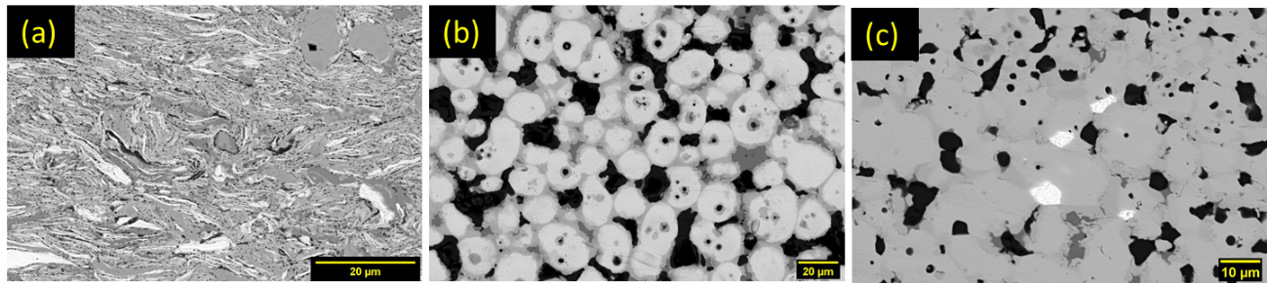
Fig. S4: Microstructure of the MA in Ar + SPS sample sintered at (a) 1300 °C (b) 1400 °C and (c) 1500 °C.
S8. Vol.% of phases in MA-air-6h+SPS and MA-Ar-4h+SPS
The vol.% of phases calculated from EBSD and SEM-image analysis is given in Table SIV.
TABLE SIV: Vol.% of phases in MA+SPS CrMoNbTiW
MA-air-6h+SPS |  |  | MA-Ar-4h+SPS
Phases present | SEM-image analysis (%) | EBSD analysis  (%) | Phases present | SEM-image analysis (%) | EBSD analysis (%)
BCC | 56 ± 2 | 52.8 | BCC1 | 84.4 ± 0.9 | 85.8
σ | 7 ± 0.2 | 13.3 | BCC2 | 0.3 ± 0.2
(Nb,Ti)C | 17 ± 1.6 | 20.1 | Laves | 3.6 ± 1.6 | unindexed
TiO₂ | 20 ± 1.2 | 13.8 | TiO_{1-x}N_{x} | 11.7 ± 1.3 | 10

S9. Type and amount of contamination in MA+SPS CrMoNbTiW
During MA, contamination comes from the milling media – SS container with hard chrome steel balls (Fe), PCA – stearic acid (C) and atmosphere – air and Ar (O, N). Thus, the contaminants such as carbon, nitrogen, and oxygen content of the MA powder were quantified using a LECO CS477 and LECO ONH836 analyzer, respectively, whereas the Fe contamination was quantified through SEM-EDS analysis. The characteristics of contaminants in MA+SPS RHEA is given in table SV.
TABLE SV: Nature of contaminants in MA+SPS RHEA
S. No | Type of impurity/Quantity (wt.%) | MA-air-6h+SPS | MA-Ar-4h+SPS
1. | C – from PCA | 1.19 | 0.11
2. | O – milling atmosphere | 4.44 | 1.22
3. | N – milling atmosphere | - | 0.17
4. | Fe – milling media | 2.8 | 1.4

S10. Characterization of cast CrMoNbTiW
The elemental mapping on the as cast alloy is as shown in Fig. S5. The bright region is rich in W, the grey region comprises of Nb and Mo, and the black region consists of Cr and Ti.
Fig. S5: Elemental mapping of cast alloy showing marginal segregation

S11. Characterization of RHEAs after HT at 1300 ºC for 240 h
The vol.% of phases after HT as given in Fig. S6 was obtained using BSE-SEM image analysis. The grain size of the HT samples was obtained through EBSD analysis. The phase map of MA+SPS RHEA along with IPF of cast RHEA is given in Fig. S7.
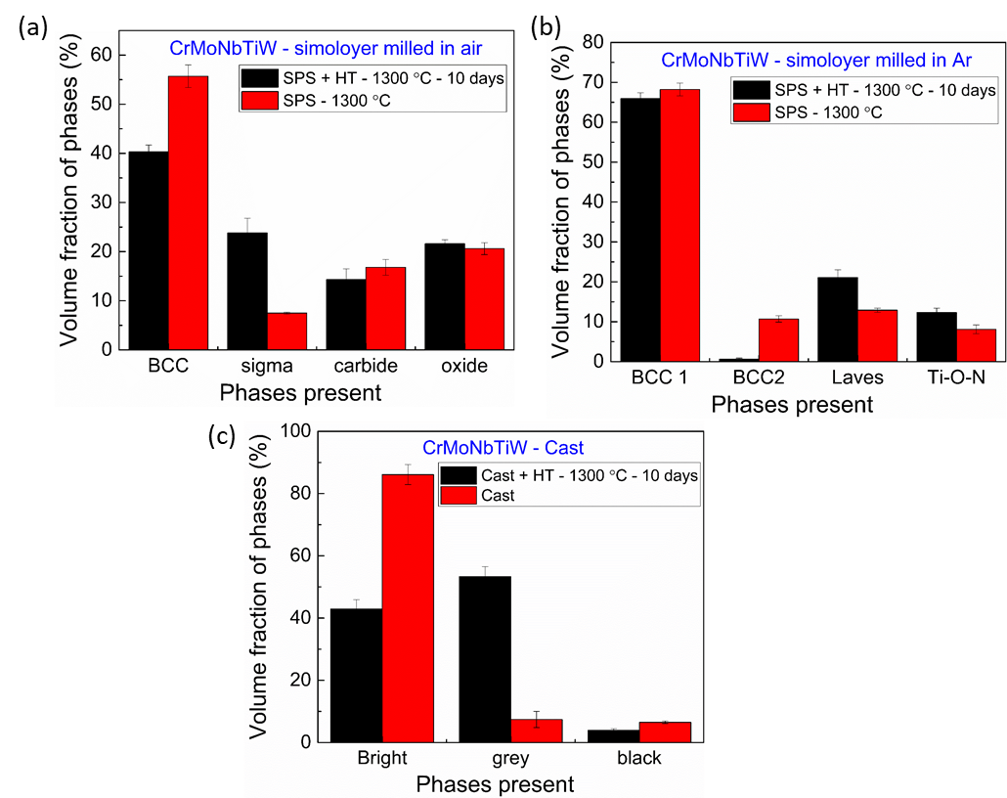
Fig. S6: Vol.% of phases of CrMoNbTiW synthesized through (a) MA-air-6h+SPS (b) MA-Ar-4h+SPS and (c) VAM before and after HT
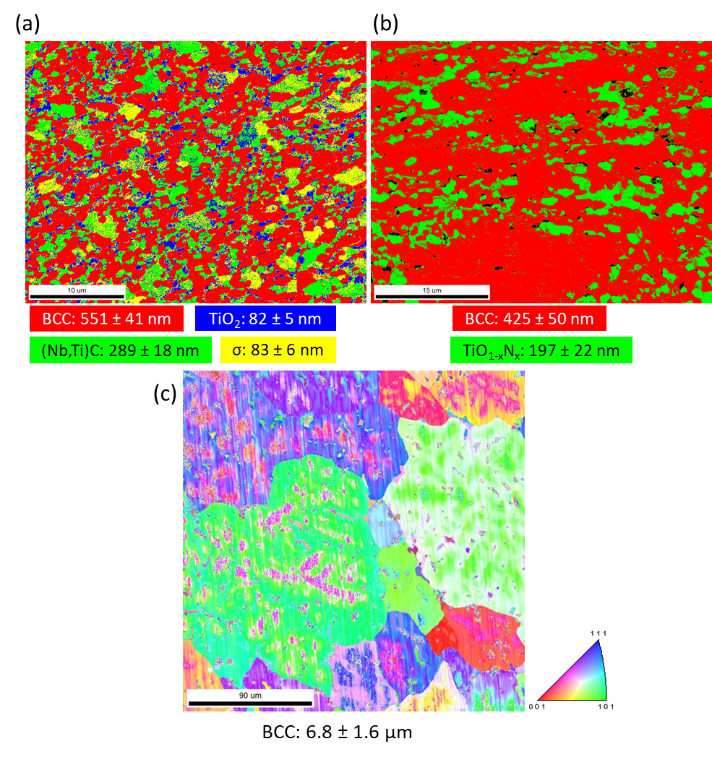
Fig. S7: Phase map of (a) MA-air-6h+SPS+HT (b) MA-Ar-4h+SPS+HT (c) IPF of cast+HT RHEA along with their grain size.

References
1. O. N. Senkov, S. V. Senkova, and C. Woodward: Effect of aluminum on the microstructure and properties of two refractory high-entropy alloys. Acta Mater. 68, 214 (2014).
2. O. N. Senkov, C. Woodward, and D. B. Miracle: Microstructure and Properties of Aluminum-Containing Refractory High-Entropy Alloys. JOM 66(10), 2030 (2014).
3. O. N. Senkov, J. K. Jensen, A. L. Pilchak, D. B. Miracle, and H. L. Fraser: Compositional variation effects on the microstructure and properties of a refractory high-entropy superalloy AlMo_{0.5}NbTa_{0.5}TiZr. Mater. Des. 139, 498 (2018).
4. N. D. Stepanov, N. Y. Yurchenko, E. S. Panina, M. A. Tikhonovsky, and S. V. Zherebtsov: Precipitation-strengthened refractory Al0_{.5}CrNbTi₂V_{0.5} high entropy alloy. Mater. Lett. 188, 162 (2017).
5. N. Y. Yurchenko, N. D. Stepanov, S. V. Zherebtsov, M. A. Tikhonovsky, and G. A. Salishchev: Structure and mechanical properties of B2 ordered refractory AlNbTiVZr_{x} (x = 0–1.5) high-entropy alloys. Mater. Sci. Eng. A 704, 82 (2017).
6. N. D. Stepanov, N. Y. Yurchenko, D. V. Skibin, M. A. Tikhonovsky, and G. A. Salishchev: Structure and mechanical properties of the AlCr_{x}NbTiV (x = 0, 0.5, 1, 1.5) high entropy alloys. J. Alloys Compd. 652, 266 (2015).
7. F. Müller, B. Gorr, H.-J. Christ, H. Chen, A. Kauffmann, and M. Heilmaier: Effect of microalloying with silicon on high temperature oxidation resistance of novel refractory high-entropy alloy Ta-Mo-Cr-Ti-Al. Mater. High Temp. 3409, 1 (2017).
8. C. M. Lin, C. C. Juan, C. H. Chang, C. W. Tsai, and J. W. Yeh: Effect of Al addition on mechanical properties and microstructure of refractory Al_{x}HfNbTaTiZr alloys. J. Alloys Compd. 624, 100 (2015).
9. M. Zhang, X. Zhou, and J. Li: Microstructure and Mechanical Properties of a Refractory CoCrMoNbTi High-Entropy Alloy. J. Mater. Eng. Perform. 26(8), 3657 (2017).
10. É. Fazakas, V. Zadorozhnyy, L. K. Varga, A. Inoue, D. V Louzguine-Luzgin, F. Tian, and L. Vitos: Experimental and theoretical study of Ti₂₀Zr₂₀Hf₂₀Nb₂₀X₂₀ (X=V or Cr) refractory high-entropy alloys. Int. J. Refract. Met. Hard Mater. 47, 131 (2014).
11. O. N. Senkov and C. F. Woodward: Microstructure and properties of a refractory NbCrMo_{0.5}Ta_{0.5}TiZr alloy. Mater. Sci. Eng. A 529, 311 (2011).
12. B. Zhang, M. C. Gao, Y. Zhang, and S. M. Guo: Senary refractory high-entropy alloy Cr x MoNbTaVW. Calphad 51, 193 (2015).
13. B. Zhang, Y. Mu, M. C. Gao, W. J. Meng, and S. M. Guo: On single-phase status and segregation of an as-solidified septenary refractory high entropy alloy. MRS Commun. 7(1), 78 (2017).
14. Y. D. Wu, Y. H. Cai, X. H. Chen, T. Wang, J. J. Si, L. Wang, Y. D. Wang, and X. D. Hui: Phase composition and solid solution strengthening effect in TiZrNbMoV high-entropy alloys. 83, 651 (2015).
15. M.G. Poletti; C.M. McCaughey; G. Fiore; R. Goodall; L. Battezzati; Refractory high entropy alloys: CrMoNbTiVWZr and Al_{x}Cr_{y}NbMoTiV_{z}Zr_{y} (x=0,0.6;y=0.3,z=0,0.6). Int. J. Refract. Met. Hard Mater. 76, 128 (2018).
16. G. Wang, Q. Liu, J. Yang, X. Li, X. Sui, Y. Gu, and Y. Liu: Synthesis and thermal stability of a nanocrystalline MoNbTaTiV refractory high-entropy alloy via mechanical alloying. Int. J. Refract. Met. Hard Mater. 84, 104988 (2019).
17. O. A. Waseem and H. J. Ryu: Powder Metallurgy Processing of a W_{x}TaTiVCr High-Entropy Alloy and Its Derivative Alloys for Fusion Material Applications. Sci. Rep. 7(1), 1 (2017).
18. O. A. Waseem, J. Lee, H. M. Lee, and H. J. Ryu: The effect of Ti on the sintering and mechanical properties of refractory high-entropy alloy Ti_{x}WTaVCr fabricated via spark plasma sintering for fusion plasma-facing materials. Mater. Chem. Phys. 210, 87 (2018).
19. Y. Long, K. Su, J. Zhang, X. Liang, H. Peng, and X. Li: Enhanced strength of a mechanical alloyed NbMoTaWVTi refractory high entropy alloy. Materials (Basel). 11(5), 1 (2018).
20. Y. Long, X. Liang, K. Su, H. Peng, and X. Li: A fine-grained NbMoTaWVCr refractory high-entropy alloy with ultra-high strength: Microstructural evolution and mechanical properties. J. Alloys Compd. 780, 607 (2019).
21. B. Kang, J. Lee, H. J. Ryu, and S. H. Hong: Ultra-high strength WNbMoTaV high-entropy alloys with fine grain structure fabricated by powder metallurgical process. Mater. Sci. Eng. A 712, 616 (2018).
22. L. Raman, K. Guruvidyathri, G. Kumari, S. V. S. Narayana Murty, R. S. Kottada, and B. S. Murty: Phase evolution of refractory high-entropy alloy CrMoNbTiW during mechanical alloying and spark plasma sintering. J. Mater. Res. 34(5), 756 (2019).
23. S. Lv, Y. Zu, G. Chen, X. Fu, and W. Zhou: An ultra-high strength CrMoNbWTi-C high entropy alloy co-strengthened by dispersed refractory IM and UHTC phases. J. Alloys Compd. 788, 1256 (2019).
24. J. Yan, K. Li, and Y. I. Wang: Microstructure and Mechanical Properties of WMoNbCrTi HEAs Sintered from the Powders Milled for Different Durations. JOM (2019).
25. J. Pan, T. Dai, T. Lu, X. Ni, J. Dai, and M. Li: Microstructure and mechanical properties of Nb₂₅Mo₂₅Ta₂₅W₂₅ and Ti₈Nb₂₃Mo₂₃Ta₂₃W₂₃ high entropy alloys prepared by mechanical alloying and spark plasma sintering. Mater. Sci. Eng. A 738, 362 (2018).
26. S. W. Xin, M. Zhang, T. T. Yang, Y. Y. Zhao, B. R. Sun, and T. D. Shen: Ultrahard bulk nanocrystalline VNbMoTaW high-entropy alloy. J. Alloys Compd. 769, 597 (2018).
27. B. Kang, T. Kong, A. Raza, H. J. Ryu, and S. H. Hong: Fabrication, microstructure and mechanical property of a novel Nb-rich refractory high-entropy alloy strengthened by in-situ formation of dispersoids. Int. J. Refract. Met. Hard Mater. 81, 15 (2019).
28. B. Liu, J. Wang, J. Chen, Q. Fang, and Y. Liu: Ultra-High Strength TiC/Refractory High-Entropy-Alloy Composite Prepared by Powder Metallurgy. JOM 69(4), 651 (2017).
29. H. Dobbelstein, M. Thiele, E. L. Gurevich, E. P. George, and A. Ostendorf: Direct metal deposition of refractory high entropy alloy MoNbTaW. Phys. Procedia 83, 624 (2016).
30. H. Dobbelstein, E. L. Gurevich, E. P. George, A. Ostendorf, and G. Laplanche: Laser metal deposition of compositionally graded TiZrNbTa refractory high-entropy alloys using elemental powder blends. Addit. Manuf. 25, 252 (2019).
31. S. Praveen, J. Basu, S. Kashyap, and R. Sankar: Exceptional resistance to grain growth in nanocrystalline CoCrFeNi high entropy alloy at high homologous temperatures. J. Alloys Compd. 662, 361 (2016).
32. S. Praveen, B. S. Murty, and R. S. Kottada: Alloying behavior in multi-component AlCoCrCuFe and NiCoCrCuFe high entropy alloys. Mater. Sci. Eng. A 534, 83 (2012).
33. C.-J. Tong, Y.-L. Chen, J.-W. Yeh, S.-J. Lin, S.-K. Chen, T.-T. Shun, C.-H. Tsau, and S.-Y. Chang: Microstructure characterization of Al_{x}CoCrCuFeNi high-entropy alloy system with multiprincipal elements. Metall. Mater. Trans. A 36(4), 881 (2005).
34. S. Praveen, A. Anupam, R. Tilak, and R. S. Kottada: Phase evolution and thermal stability of AlCoCrFe high entropy alloy with carbon as unsolicited addition from milling media. Mater. Chem. Phys. 210, 57 (2018).
35. Y. P. Wang, B. S. Li, M. X. Ren, C. Yang, and H. Z. Fu: Microstructure and compressive properties of AlCrFeCoNi high entropy alloy. Mater. Sci. Eng. A 491(1–2), 154 (2008).
36. W. Ji, Z. Fu, W. Wang, H. Wang, J. Zhang, Y. Wang, and F. Zhang: Mechanical alloying synthesis and spark plasma sintering consolidation of CoCrFeNiAl high-entropy alloy. J. Alloys Compd. 589, 61 (2014).
37. A. Anupam, S. Kumar, N. M. Chavan, B. S. Murty, and R. S. Kottada: First report on cold-sprayed AlCoCrFeNi high-entropy alloy and its isothermal oxidation. J. Mater. Res. 34(5), 796 (2019).
38. S. Uporov, V. Bykov, S. Pryanichnikov, A. Shubin, and N. Uporova: Effect of synthesis route on structure and properties of AlCoCrFeNi high-entropy alloy. Intermetallics 83, 1 (2017).
39. X. W. Qiu: Microstructure and properties of AlCrFeNiCoCu high entropy alloy prepared by powder metallurgy. J. Alloys Compd. 555, 246 (2013).
40. D. G. Shaysultanov, N. D. Stepanov, A. V. Kuznetsov, G. A. Salishchev, and O. N. Senkov: Phase composition and superplastic behavior of a wrought AlCoCrCuFeNi high-entropy alloy. Jom 65(12), 1815 (2013).
41. F. J. Baldenebro-Lopez, J. M. Herrera-Ramírez, S. P. Arredondo-Rea, C. D. Gómez-Esparza, and R. Martínez-Sánchez: Simultaneous effect of mechanical alloying and arc-melting processes in the microstructure and hardness of an AlCoFeMoNiTi high-entropy alloy. J. Alloys Compd. 643(S1), S250 (2015).
42. A. Kumar, A. Kumar, A. Basu, and M. Chopkar: Effects of processing route on phase evolution and mechanical properties of CoCrCuFeNiSi_{x} high entropy alloys. J. Alloys Compd. 748, 889 (2018).
43. O. N. Senkov, G. B. Wilks, D. B. Miracle, C. P. Chuang, and P. K. Liaw: Refractory high-entropy alloys. Intermetallics 18(9), 1758 (2010).
44. J. A. Smeltzer, C. J. Marvel, B. C. Hornbuckle, A. J. Roberts, J. M. Marsico, A. K. Giri, K. A. Darling, J. M. Rickman, H. M. Chan, and M. P. Harmer: Achieving ultra hard refractory multi-principal element alloys via mechanical alloying. Mater. Sci. Eng. A 763 (2019).
45. F. Lukac, M. Dudr, R. Musalek, J. Klecka, J. Cinert, J. Cizek, T. Chraska, J. Cizek, O. Melikhova, J. Kuriplach, J. Zyka, and J. Malek: Spark plasma sintering of gas atomized high-entropy alloy HfNbTaTiZr. J. Mater. Res. 33(19), 3247 (2018).
46. O. N. Senkov and S. L. Semiatin: Microstructure and Properties of a Refractory High-Entropy Alloy after Cold Working. J. Alloys Compd. (2015).
47. R. Sriharitha, B. S. Murty, and R. S. Kottada: Alloying , thermal stability and strengthening in spark plasma sintered Al_{x}CoCrCuFeNi high entropy alloys. 583, 419-426 (2014).

