Supplemental Information
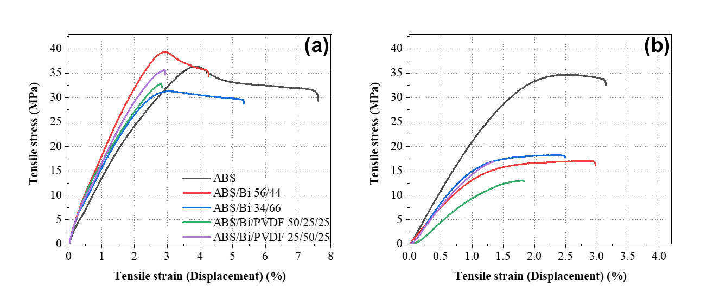
Figure SI1: Tensile stress and strain for (a) 1.75E filaments and (b) 0.5P filaments

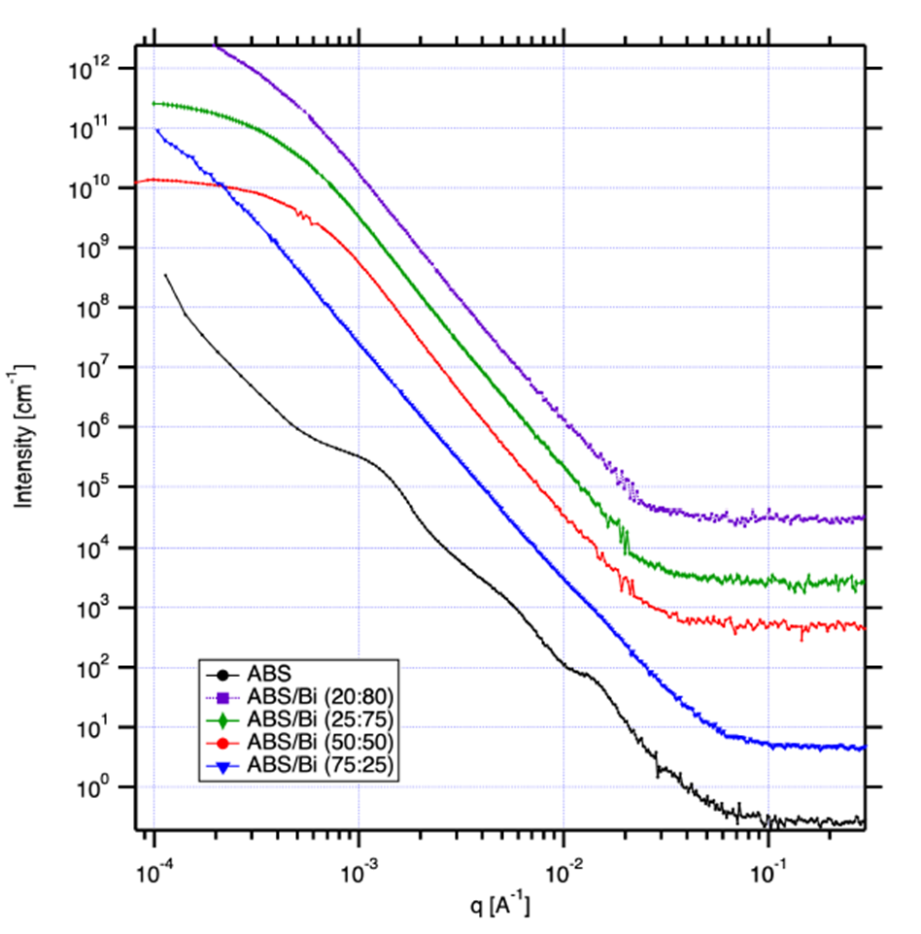

Figure SI2: USAXS and SAXS profiles of pure ABS and ABS/Bi composites

