Supporting information
Figure.S1 SERS spectra of p-aminothiophenol (PATP) with a concentration of 10⁻⁵ M on 5 kinds of candidate fabrics substrates.

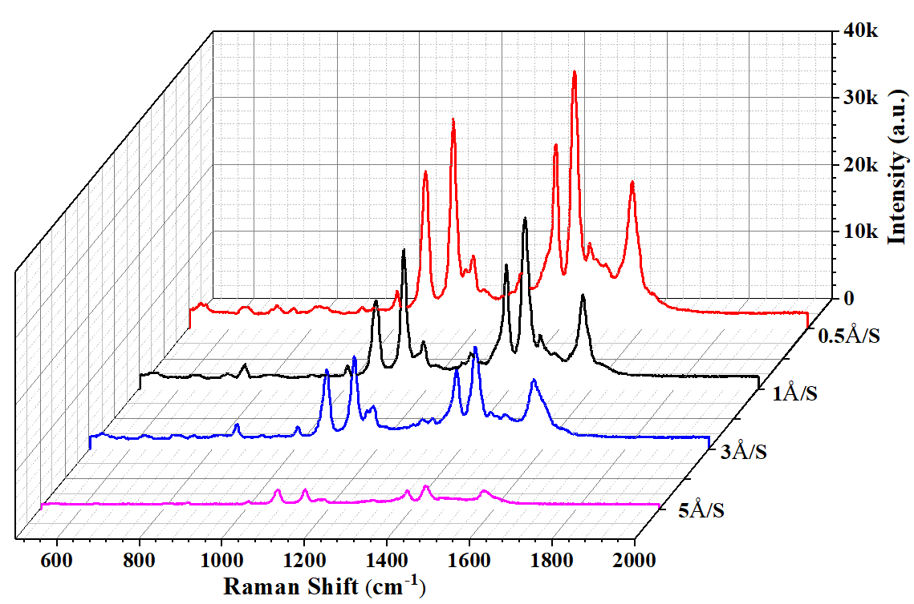
Figure.S2 Spectra of p-aminothiophenol (PATP) with a concentration of 10⁻⁶ M on nylon fabrics substrates with different evaporation rate of silver.

