SUPPORTING INFORMATION
Hydrothermal Synthesis of Carbon Nanotube-Titania Composites for Enhanced Photocatalytic Performance
Brian M. Everhart,ª Montgomery Baker-Fales,ª Haider Almkhelfe,ª Eric Banning,ª Tyson C. Back,ª Bailey McAuley, Placidus B. Amamaª

ªTim Taylor Department of Chemical Engineering, Kansas State University, Manhattan, KS 66506, USA.
^{b}Materials and Manufacturing Directorate, Air Force Research Laboratory, WPAFB, OH 45433

TABLE SI. Summary of phase composition of photocatalysts: calculated ratio of anatase and rutile determined from Equation 1 and the phase composition determined via RIR method.
 | Calculated Ratio (%) |  | RIR Method (wt%)
 | Anatase | Rutile | Anatase | Rutile | Brookite
TiO₂ | 92 | 8 | 82.5 | 9.6 | 7.9
TiO₂/MWCNT-1% | 98 | 2 | 87.6 | 9.7 | 2.7
TiO₂/MWCNT-5% | 66 | 34 | 58.6 | 15.5 | 25.9

“The Reference Intensity Ratio (RIR) is a general, instrument-independent constant for use in quantitative phase analysis by the X-ray powder diffraction internal standard method.”¹

1. Hubbard, C. R.; Snyder, R. L., RIR - Measurement and Use in Quantitative XRD. Powder Diffraction 1988, 3 (2), 74-77.

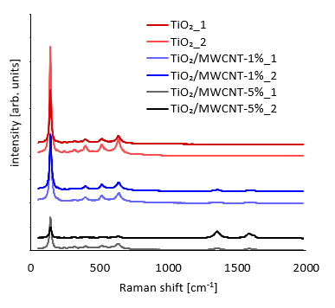

FIG. S1. Raman spectra of TiO₂, TiO₂/MWCNT-1%, and TiO₂/MWCNT-5% using 514 nm laser excitation.

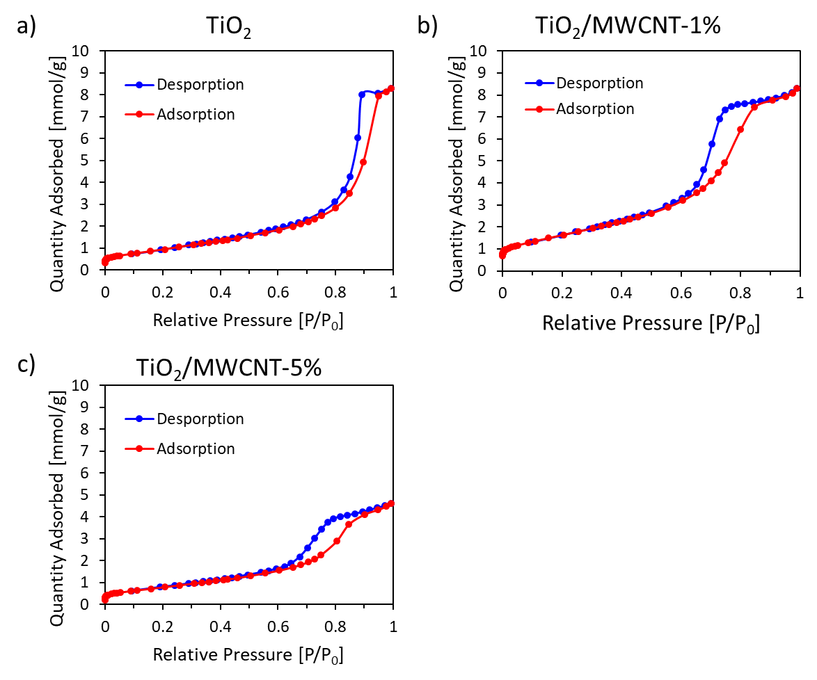

FIG S2. Adsorption-desorption isotherms of TiO₂, TiO₂/MWCNT-1%, and TiO₂/MWCNT-5% photocatalysts.

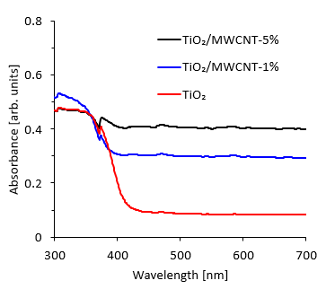

FIG S3. UV-Vis absorbance spectra of TiO₂, TiO₂/MWCNT-1%, TiO₂/MWCNT-5%, and P25 as a reference sample.

