Supplement
Figure S1 selection of reference region for GPA measurement. The two selected apertures on diffractogram is shown in inset of left figure by blue circles, which representing the aluminum matrix. The chosen reference region is shown in the right figure, which is the phase image of original TEM figure. The selected region is far from precipitates to be free from lattice distortion.
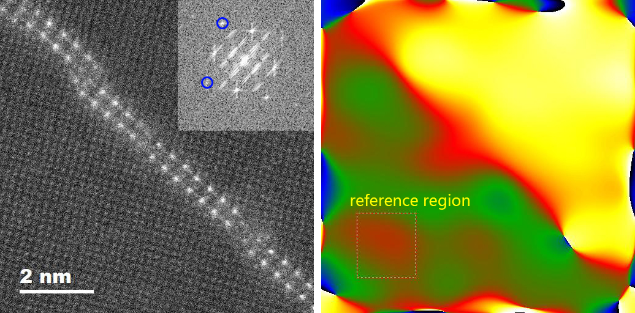

Figure S2 Measurement of interplanar distance of S' phase in 20-hour aged samples. All measurement was done by DigitalMicrograph (GMS3) software.
