Supporting information
Agglomerated Nickel-cobalt Layered Double Hydroxide nanosheets on Reduced Graphene Oxide clusters as Efficient Asymmetric Supercapacitor Electrodes

Lu Liu¹, Anru Liu¹, Yuhan Xu¹, Haoming Yu¹, Fangqi Yang¹, Jun Wang^{1*}, Zheling Zeng¹, Shuguang Deng ^{2*}
1. School of Resource, Environmental and Chemical Engineering, Nanchang University, Nanchang 330031, Jiangxi, PR China
2. School for Engineering of Matter, Transport and Energy, Arizona State University, 551 E. Tyler Mall, Tempe, AZ 85287, USA

*Corresponding authors:
1. Dr. Shuguang Deng; E-mail: shuguang.deng@asu.edu (S. Deng)
2. Dr. Jun Wang; E-mail: jwang7@ncu.edu.cn (J. Wang)

Material:
In this work, all chemicals were used as purchased without any further purification. Graphite was purchased from Aladdin Bio-Chem Technology Co., Ltd. Nickel nitrate hexahydrate (Ni(NO₃)₂∙6H₂O) and cobalt nitrate hexahydrate (Co(NO₃)₂∙6H₂O) were purchased from Damao Chemical Co., Ltd and Sinopharm Chemical Reagent Co., Ltd, respectively. Urea (CO(NH₂)₂) was obtained from Xilong Chemical Co., Ltd. Deionized (DI) water was employed throughout the experiment.
Material Characterization
The Scanning electron microscopy (SEM) images and energy dispersive X-ray spectroscopy (EDS) mapping images were carried out with JSM-6701F instrument. High-resolution transmission-electron microscopy (HRTEM) images were collected by using on a JEM-2100 microscope. The crystal phases of prepared products were characterized by Powder X-ray diffraction (XRD) patterns (PANalytical empyrean series2 diffractometer ; Cu-Ka radiation; step size of 0.0167º; scan time of 15s per step). The surface element composition of materials were examined by X-ray photoelectron spectroscopy (XPS) analysis (ThermoFisher Scientific ESCALEAB 250Xi; monochromated Al Kα excitation source). Raman spectra were recorded on a HR Evolution Raman microscope instrument (532 nm laser excitation). Fourier transformed infrared (FT-IR) spectra were collected by a Nicolet 5700 (KBr pellet method). N₂ adsorption isotherm data were investigated by adsorption apparatus (Micromeritic Instruments, USA).pore size distributions is calculated using Barrett–Joyner–Halenda (BJH).
2.4 Electrochemical measurements
The working electrode was prepared by pressing mixed slurry onto a nickel foam and dried at 60 °C for 12 h in a vacuum oven. The mixed slurry had a composition of 70 wt% the active materials, 20 wt% acetylene black and 10 wt% poly(vinylidene fluoride) (PVDF) binder. The mass loading of active electrode materials on each nickel foam was ~2.5 mg cm⁻². All electrochemical measurements were conducted in a three-electrode electrochemical configuration (CHI 760E Chenhua, Shanghai) with Pt foil counter electrode and Hg/HgO (in saturated 1 M NaOH) reference electrode, respectively. Before tests, all electrodes dip in the 6 M KOH electrolyte for more than 6 h. The specific capacitance (Cs) in a three-electrode was calculated based on:
$C_{S}=\frac{IΔt}{m}$ (1)
where Cs (C g⁻¹) is the specific capacitance of electrodes; I (A) represents the charge–discharge current; Δt (s) and m (mg) is the discharge time and designated mass of the active materials, respectively.
The fabrication of ACSs was conducted using NiCo-LDH/rGO, commercial activated carbon (CAC, YEC-8B), and 6 M KOH aqueous solution as the cathode, anode, and electrolyte, respectively. Prior to the ASC fabrication, the mass balance was based on following equation:
$\frac{m_{+}}{m_{-}}=\frac{C_{S-}{ΔV}_{-}}{C_{S+}{ΔV}_{+}}$ (2)

For the two-electrode electrochemical cell, The specific capacitance C (F/g), the energy density E (W h kg⁻¹) and power density P (W kg⁻¹) are calculated as:
$C=\frac{IΔt}{(mΔV)}$ (3)
:
$E=\frac{(C*V^{2})}{7.2}$ (4)
$P=\frac{(E*3600)}{t}$ (5)
In those equations, I (A) represents the charge–discharge current; Δt (s) is the discharge time; ΔV(V) represents the voltage window of this device。

FIG. S1. FTIR and SEM images of rGO

FIG. S2. SEM images of 3:1 NiCo-LDH/rGO and 2:1 NiCo-LDH
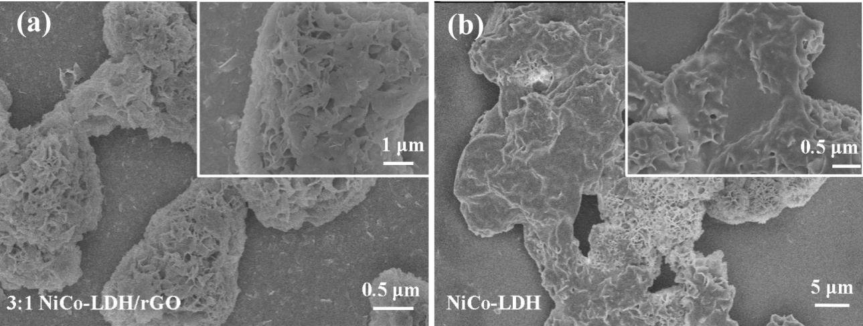

TABLE SⅠ. Element contents of all samples determined by EDS spectra
Sample | C | O | Co | Ni
3:1 NiCo LDH/rGO | 10.87 | 62.93 | 7.93 | 18.27
3:2 NiCo LDH/rGO | 7.75 | 70.50 | 9.27 | 54.49
2:1 NiCo LDH | 1.82 | 73.92 | 8.72 | 15.53
2:1 NiCo LDH/rGO | 22.37 | 54.49 | 8.08 | 15.06

FIG. S3. BET and PSD curves of 3:2 NiCo-LDH/rGO and 3:1 NiCo-LDH/rGO.

FIG.S4. CV curves of pure rGO at 30 mV s⁻¹
FIG. S5. GCD curves of all electrodes at 1 A g⁻¹

FIG. S6. rate performances of all electrodes

TABLE SⅡ. Comparison of capacitance and rate retention of reported NiCo-based electrodes.
Electrode | SC | Rate performance | SC of ASC | Energy density & power density | Journal
Ni-Mn LDH/rGO | 1635 F g⁻¹  at 1 A g⁻¹ | 1169 F g⁻¹  at 10 A g⁻¹ | 84.26 F g⁻¹  at 1 A g⁻¹ | 33.8 Wh kg⁻¹  at 850W kg⁻¹ | Electrochimica Acta, 2016, 206,108
Ni₅₀Co₅₀-LDH | 1537 F g⁻¹  at 0.5 A g⁻¹ | 1181 F g⁻¹  at 10 A g⁻¹ | / | 33.7 Wh kg⁻¹  at 551 W kg⁻ | Scientific Reports 2016, 6,18737,
NiCoLDH/G/NF | 1410 F g⁻¹  at 2 A g⁻¹. | 1328 F g⁻¹  at 4A g⁻¹ | 108 F g⁻¹  at 1 A g⁻¹ | 33.75 W h kg⁻¹  at 750 W kg⁻¹ | J. Mater. Chem. A, 2015, 3, 12530
Ni-Co LDH/3D RGO/NF | 1054 F g⁻¹  at 2.5 mA cm⁻² | 632 F g⁻¹  at 150 mA cm² | 108.7 F g⁻¹  at 2 mA cm⁻² | 38.6 Wh kg⁻¹  at 69.5 W kg⁻¹  3.66 Wh kg⁻¹  at 7231.6 W kg⁻¹ | Electrochimica Acta, 2016, 215, 492
CoAl-LDH | 616.9 F g⁻¹  at 1 A g⁻¹. | 454.4 F g⁻¹  at 20 A g⁻¹ | 1.77F cm⁻²  at 2 mA cm⁻² | 0.71 mWh cm⁻² at 17.05 mW cm⁻² | Nano-Micro Lett. 2017, 9, 31
NiCo₂O₄/3OPC | 1297 F g⁻¹  at 0.5 A g⁻¹ | 1253.6 F g⁻¹  at 5 A g⁻¹ | 82.2 F g⁻¹  at 1A g⁻¹ | 29.23 Wh kg⁻¹  at 1.55 kW kg⁻¹ | Journal of Alloys and Compounds, 2019, 783, 19
NiCo₂O₄@Co-Fe LDH | 1557.5 F g⁻¹  at 1 A g⁻¹ | 550 F g⁻¹  at 10 A g⁻¹. | 64.76 F g⁻¹  at 1 A g⁻¹ | 28.94 Wh kg⁻¹  at 950 W kg⁻¹ | Applied Surface Science, 2018, 451, 280
NiCo₂O₄ | 772 F g⁻¹  at 1A g⁻¹ | 760 F g⁻¹  at 10 A g⁻¹ | 136.05 F cm⁻²  at 5 mA cm⁻² | 27.4 W h kg⁻¹  at 493.2 W kg⁻¹ | New J. Chem., 2018, 42, 7399
NiCo₂O₄ | 1132.5 F g⁻¹  at 0.5 A g⁻¹ | 790 F g⁻¹  at 20 A g⁻¹, | 73.07 F g⁻¹  at 0.1 A g⁻¹ | 22.83 Wh kg⁻¹  at 74.38 W kg⁻¹ | Nanotechnology, 2019, 30, 235402
NiCo(CO₃)(OH)₂/  NiMn(CO₃)(OH)₂ | 1673.3 F g⁻¹  at 453.0 F g⁻¹ | 453.0 F g⁻¹  at 15 A g⁻¹ | 118.4 F g⁻¹  at 2 A g⁻¹ | 27.2 W h kg⁻¹  at 702.7 W kg⁻¹ | Journal of Alloys and Compounds, 2019, 789, 119
Ni-Co LDH/rGO | 1759 F g⁻¹  at 0.5 A g⁻¹ | 1231.4 F g⁻¹  at 10 A g⁻¹  970 F g⁻¹  at 20 A g⁻¹ | 136.8 F g⁻¹  at 0.5 A g⁻¹ | 48.7 Wh kg⁻¹  at 401 W kg⁻¹  18.1 W h kg⁻¹  at 11219 W kg⁻¹ | This work
Sample | R1 | R2 | W₁-R | W₁-T | W₁-P
3:1NiCoLDH/rGO | 0.60799 | 3.071 | 2.7900 | 10.893 | 0.18287
3:2NiCoLDH/rGO | 0.5300 | 0.83404 | 0.96713 | 0.23605 | 0.4035
2:1 NiCoLDH | 0.43782 | 0.44968 | 3.555 | 0.33774 | 0.17453
2:1NiCoLDH/rGO | 0.5081 | 0.41304 | 0.17636 | 0.02958 | 0.32994
TABLE SⅢ. Simulated Nyquist-plot parameters

FIG. S7. N₂ adsorption-desorption isotherm at 77 K and pore-size distribution curves of CAC.

FIG.S8. (a) CV and (b) GCD curves of CAC
FIG.S9. rate performances of NiCo-LDH/rGO//CAC

