Supplementary Information to Relaxor behavior and electrothermal properties of Sn and Nb modified (Ba,Ca)TiO₃ Pb-free ferroelectric

FIG. S1: Logarithmic variations of the difference in the reciprocal values of the relative dielectric permittivity i.e, log(1/ɛ′-1/ɛ′_{m}) as a function of log(T-T_{m}) for BCST-Nb_{0.04} ceramics.

FIG. S2: The logarithmic frequency variation with inverse transition temperature 1/T_{max} (shown by hollow symbols) and the corresponding solid continuous lines are the best fits to the Arrhenius equation.
Arrhenius model can be expressed by: where ω = 2πf (f is the measured frequency), ω_{o} = 2πf_{o} (f_{o} is the attempt jump frequency), E_{a} is the activation energy and k_{B} are the Boltzman constant. Figure S2 presents the ln ω versus 1/T_{m} plot fitted using the Arrhenius model. The values of f_{o} and E_{a} are found to be ~10²⁴ Hz and ~ 1.062 eV, respectively. Such high and unphysical values suggest that the electrical dipoles are not dynamic for all temperatures above absolute zero.

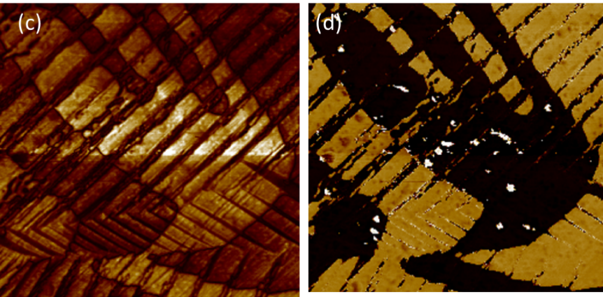
FiG. S3: (a, b) Piezo force microscopy images, (a) amplitude and (b) phase, of Ba_{0.77}Ca_{0.21}Sn_{0.02}(Ti_{0.94}Nb_{0.04}Sn_{0.02})O₃(BCST-Nb_{0.04}) ceramics showing presence of nanoscale domains. (c,d) Comparable images from ceramic sample of similar composition without Nb-doping shows presence of large domains.

FIG. S3: Comparison of XPS spectra of Ba_{0.77}Ca_{0.21}Sn_{0.02}(Ti_{0.94}Nb_{0.04}Sn_{0.02})O₃(BCST-Nb_{0.04}) ceramics with those of pure SnO and SnO₂ indicating presence of both Sn²⁺ and Sn⁴⁺ state in the synthesized ceramics.
The X-ray peak positions for Sn-3d_{5/2} and Sn-3d_{3/2} are identified based on refs. [1-2]. The relevant peak positions for Sn in Ba_{0.77}Ca_{0.21}Sn_{0.02}(Ti_{0.94}Nb_{0.04}Sn_{0.02})O₃(BCST-Nb_{0.04}) are at lower binding energies as compared to Sn in SnO/SnO₂, which is likely due to higher electron density around Sn in the ternary oxide.

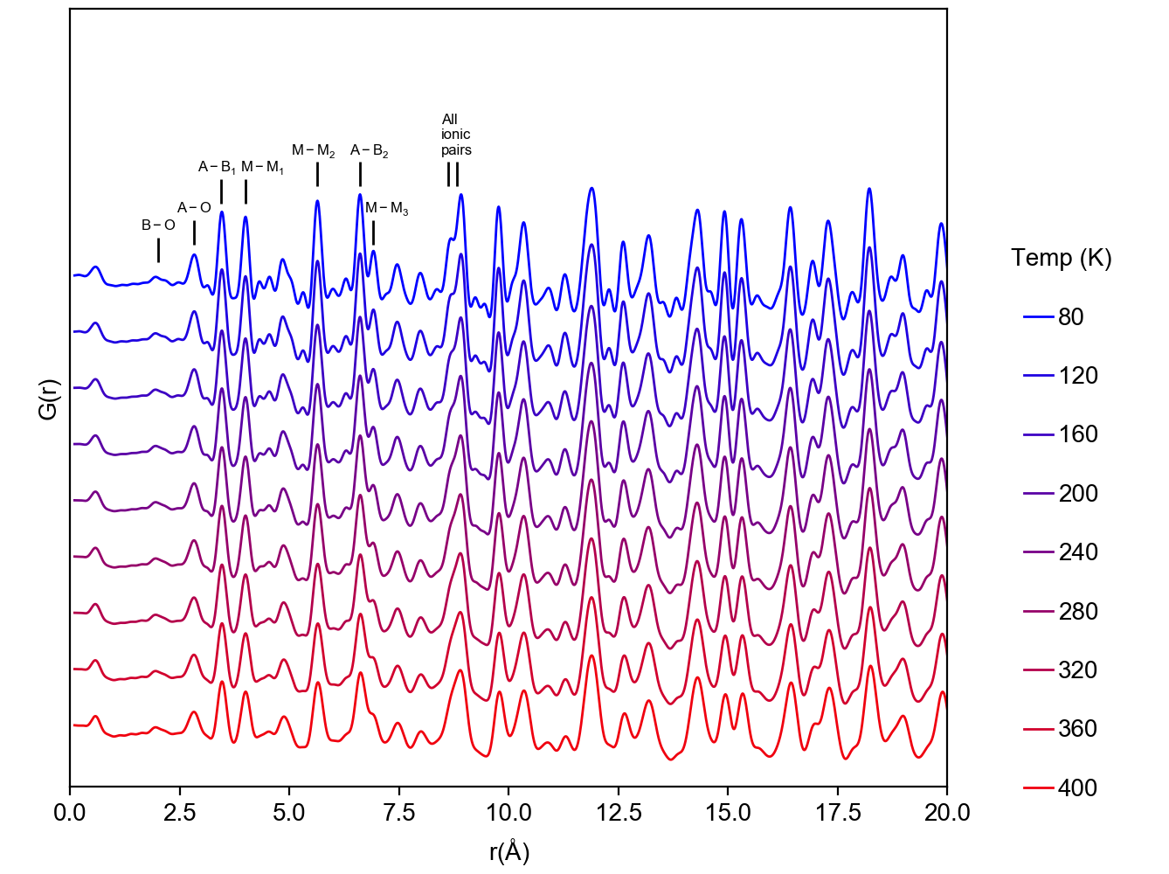
FIG. S4: Temperature dependent PDF patterns over full scale extracted from X-ray total scattering patterns.

References:
[1] Handbook of X-ray Photoelectron Spectroscopy by J. F. Moulder, W. F. Stickle, P. E. Sobol, K. D. Bomben, published by Perkin-Elemer Corporation, 1992
[2] National Institute of Standards and Technologies (NIST) XPS database (https://srdata.nist.gov/xps/Default.aspx).

