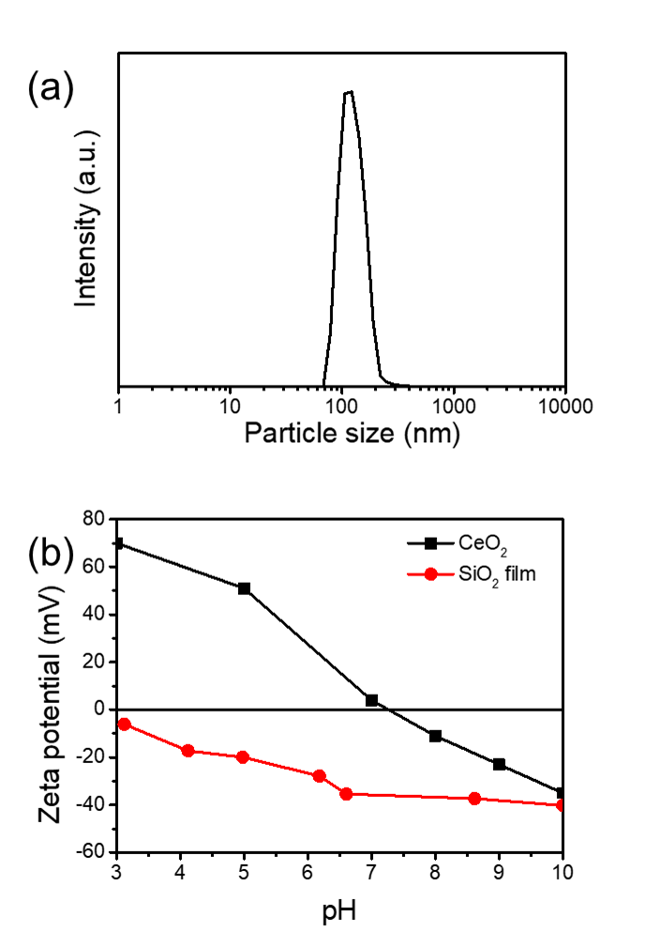

**FIG. S1.** (a) Particle size distribution of ceria particle and

(b) the ζ-potentials of ceria particle and silicon dioxide film.

For a single particle of radius *r* immersed in a solvent of viscosity η, the diffusion coefficient D is given by the Stokes– Einstein–Sutherland equation;D0 = *k*T/6πηr

where *k* is Boltzmann’s constant and T is the temperature. Diffusion coefficient of ceria particle obtained from DLS method is 3.0 μm2/s.



**FIG. S2.** Summary of the EW microscopy results and data analysis obtained from three-different single ceria particles placed on the glass surface at pH 3.

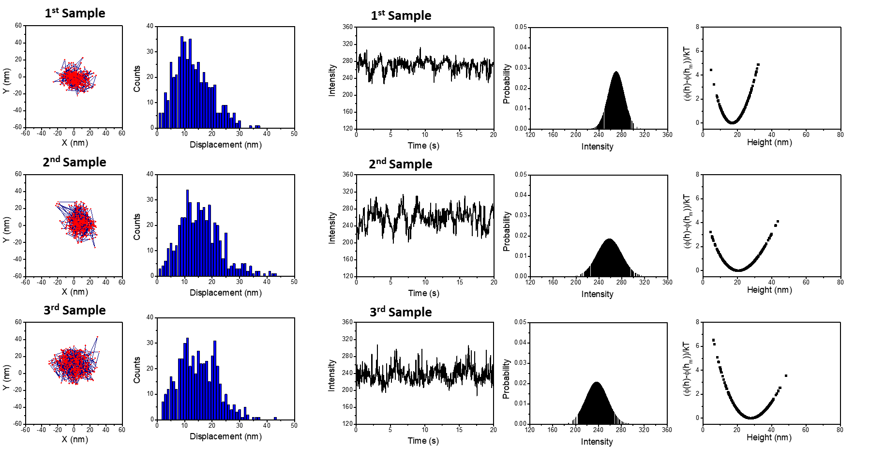

**FIG. S3.** Summary of the EW microscopy results and data analysis obtained from three-different single ceria particles placed on the glass surface at pH 5.

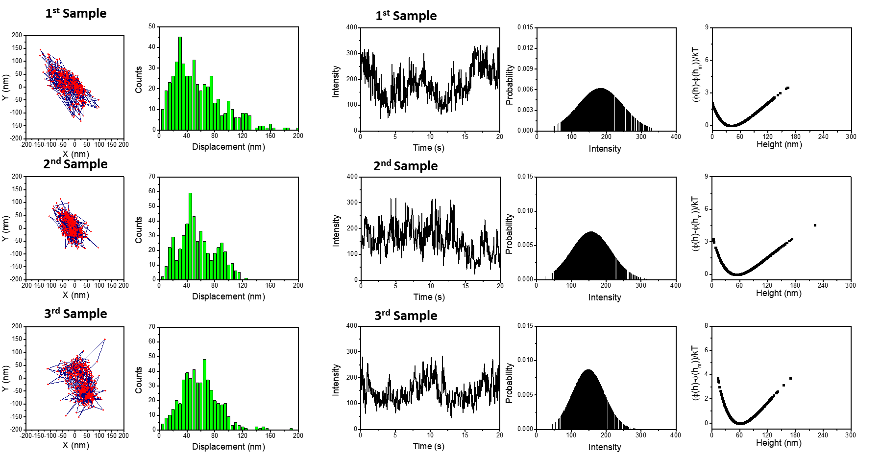

**FIG. S4.** Summary of the EW microscopy results and data analysis obtained from three-different single ceria particles placed on the glass surface at pH 7.