Novel Tm³⁺/Yb³⁺ co-doped Bi₂MoO₆: Synthesis, characterization and enhanced photocatalytic activity under visible-light irradiation
Zuowei Zhangª, Hongshun Hao^{a,b,}∗, Shanshan Jinª, Yunxia Hou^{a,b}, Hongman Hou^{b,}∗, Gongliang Zhang^{b}, Jingran Bi^{b}, Shuang Yanª, Guishan Liuª, Wenyuan Gaoª
ª Department of Inorganic Nonmetallic Materials Engineering, Dalian Polytechnic University, Dalian 116034, China
^{b} Liaoning Key Lab for Aquatic Processing Quality and Safety, Dalian Polytechnic University, Dalian 116034, China

Fig. S1 FE-SEM images of samples BMO-0/0 (a), BMO-0.5/5 (b), BMO-0.1/5 (c), BMO-0.3/5 (d), BMO-0.7/5 (e).
Fig. S2 TEM images (a)(b)(d)(e), HRTEM image(c) and SADE patterns(f) of sample BMO-0.5/5. A in (e) is the selected electron area diffraction section in (f).
Fig. S3 TEM images of samples BMO-0/0
Fig. S4 TEM images of samples BMO-0.1/5

Fig. S5 TEM images of samples BMO-0.3/5

Fig. S6 TEM images(a)(b) and SADE patterns(c) of sample BMO-0.7/5

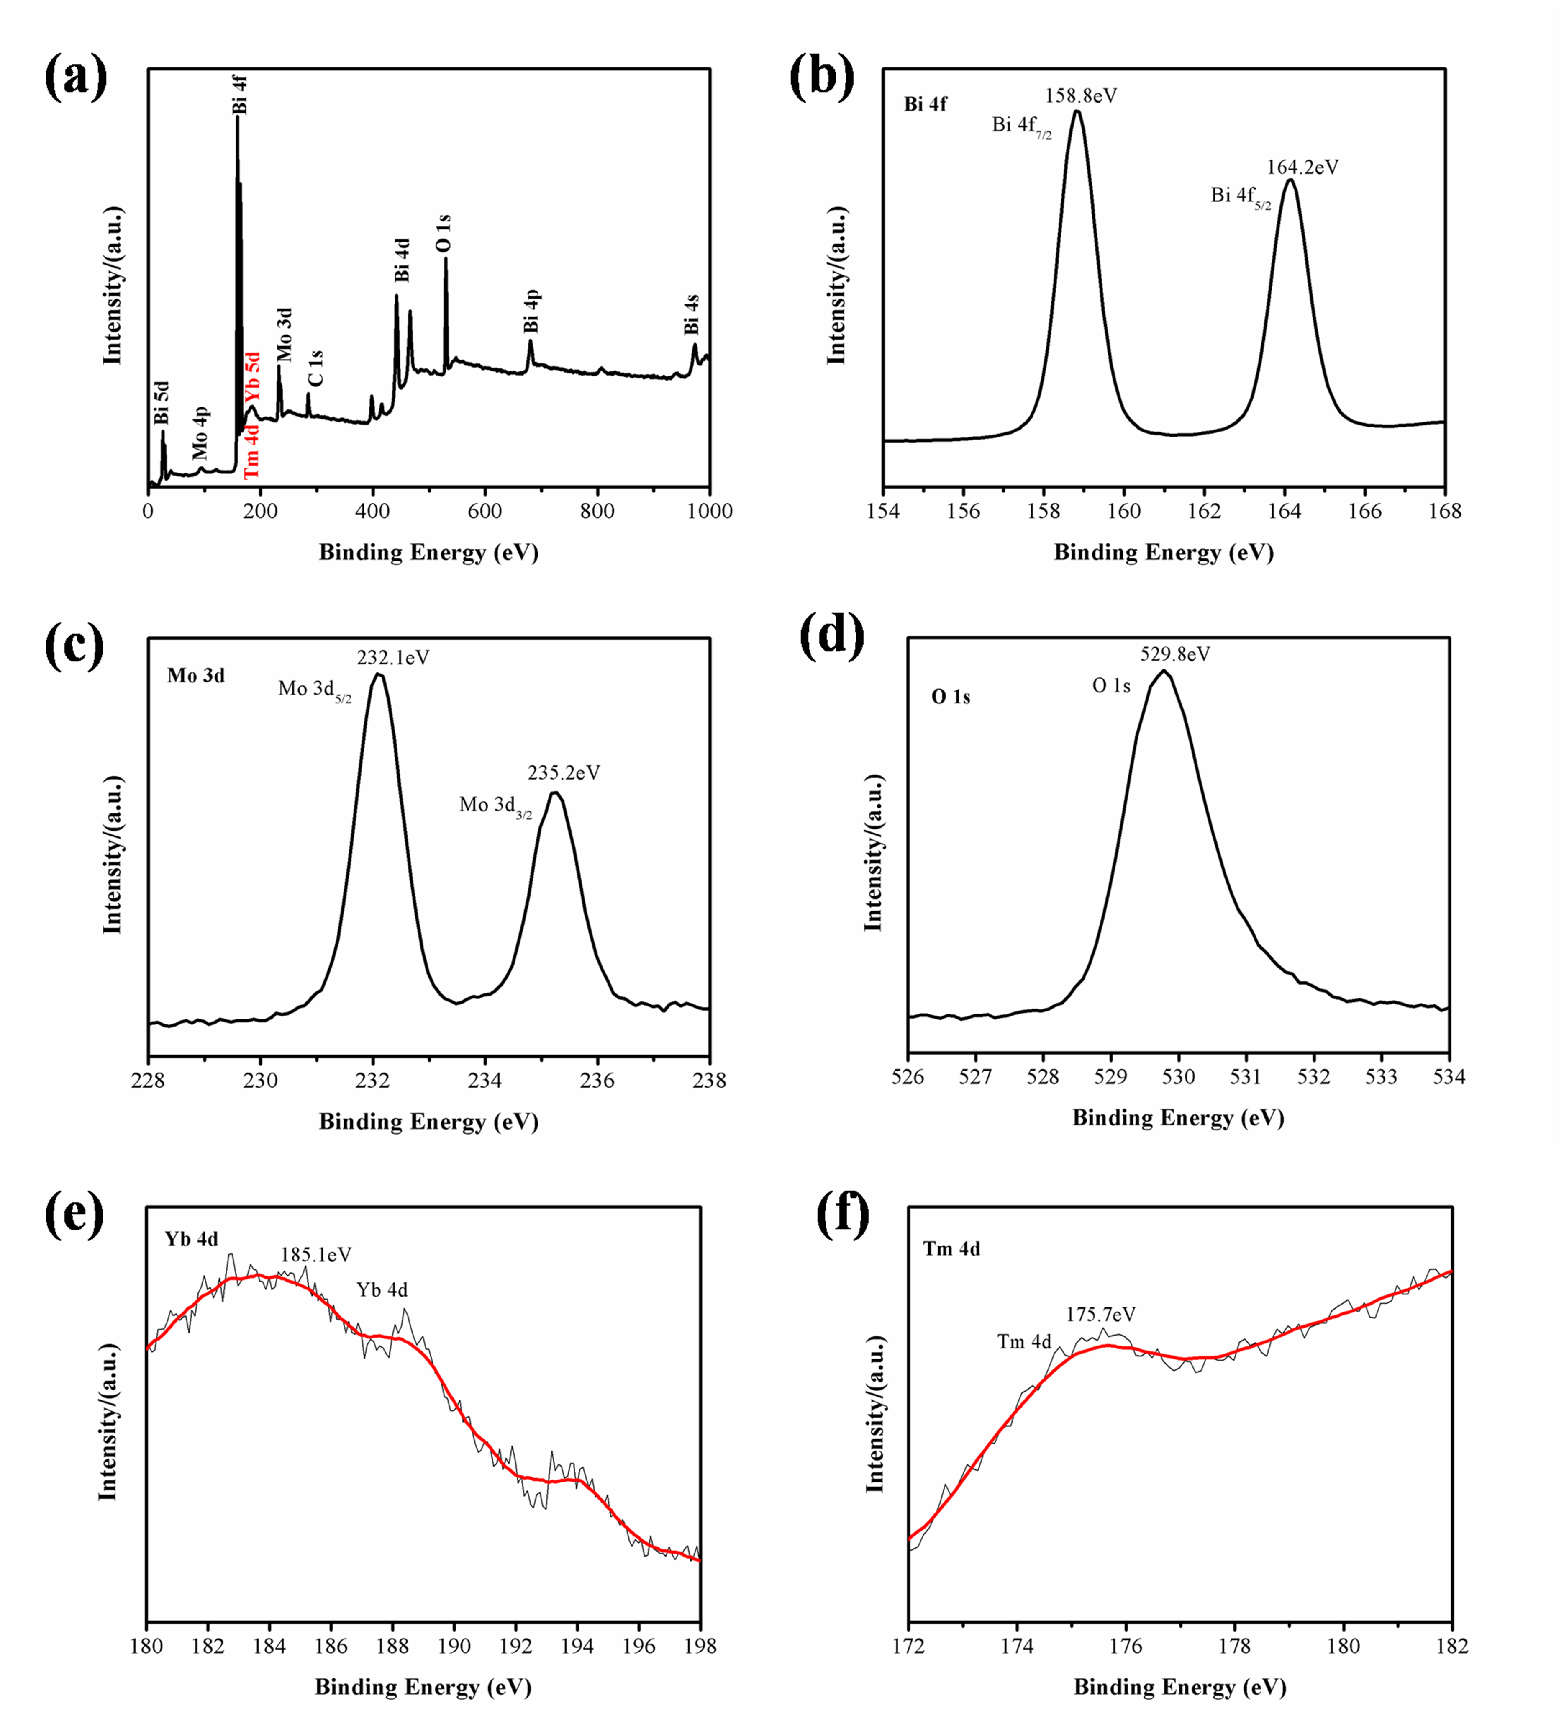
Fig. S7 Survey (a) and high-resolution Bi 4f (b), Mo 3d (c), O 1s (d), Yb 4d (e) and Tm 4d (f) XPS spectra of sample BMO-0.5/5.

Fig. S8 The specific surface area of BMO-0/0 and BMO-0.5/5

Fig. S9 The N₂ adsorption desorption isotherm of BMO-0/0 and BMO-0.5/5

Fig. S10 Photocurrent intensity of BMO-0/0 and BMO-0.5/5

Fig. S11 The photocatalytic activity under near-infrared light (a) and photocatalytic kinetics(b)
Fig. S12 The phenol standard curve (a), photocatalytic kinetics (b) and photocatalytic degradation efficiency of phenol (c)

Fig. S13 Cr (VI) reduction experiments of BMO-0/0 and BMO-0.5/5
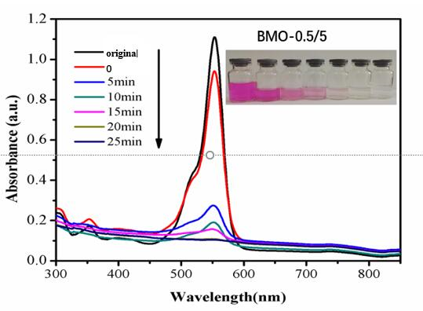
Fig. S14 The UV-vis spectral changes of RhB with photocatalytic time

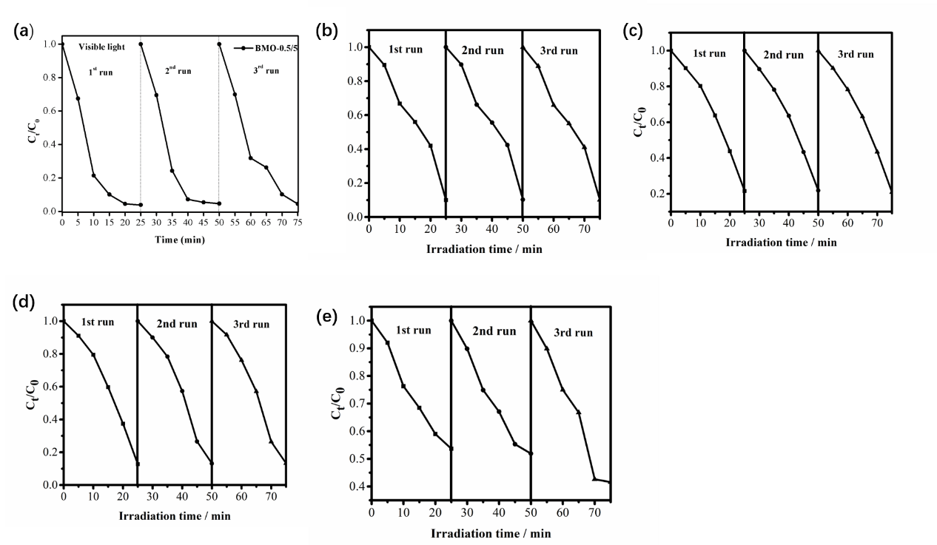
Fig. S15 Cycling test of samples BMO-0.5/5(a), BMO-0/0 (b), BMO-0.1/5 (c), BMO-0.3/5 (d), BMO-0.7/5 (e).

∗ Corresponding author. E-mail address: beike1952@163.com (H.S. Hao), houhongman@dlpu.edu.cn (H.M. Hou).

