Supplementary Material
Synthesis of Metal-Organic Framework Nanocrystals immobilized with 3D ﬂowerlike Cu-Bi layered double hydroxides for iodine efficient removal
Fang Yu, Yuantao Chen*, Yunsheng Wang, Chen Liu, Jianxian Qin
School of Chemistry and Chemical Engineering, Qinghai Normal University, Xining, Qinghai 810008, P. R. China

* Corresponding author. Tel.: +86-0971-6303374; Fax: +86-0971-6303374.
E-mail: chenyt@qhnu.edu.cn (Y.T. Chen)

FIG. S1: XRD patterns of before and after ZIF-67 loaded on CuBi-CO₃-LDH (CuBi-CO₃-LDH(★), Cu₄(OH)₆CO₃·H₂O phase (▲) and Bi₂(OH)₆CO₃·H₂O phase (●) were
marked.)

FIG. S2: High resolution XPS spectra of Co 2p.

FIG. S3: High resolution XPS spectra of Cu 2p.

FiG. S4: N₂ adsorption-desorption isotherms

TABLE SⅠ: The weight percentages of atoms in ZIF-67/ CuBi-CO₃-LDH.

Element | Cu | Bi | Co | N | O
Weight% | 20.4 | 36.9 | 1.6 | 16.8 | 24.3

TABLE SⅡ: Iodine adsorption capacity of various absorbents in this work and references.
Adsorbent | Adsorption capacity(mg g⁻¹) | References
MgAl-NO₃-LDH | 10.1 | [1]
Modified silica magnetite nanoparticles | 141 | [2]
HOF-21 | 172.9 | [3]
n-CF | 28.1 | [4]
HCP-V2 | 97.1 | [5]
BN foam | 151.6 | [6]
Al-O-F | 49.0 | [7]
ZIF-67/CuBi-CO₃-LDH | 180.2 | this work

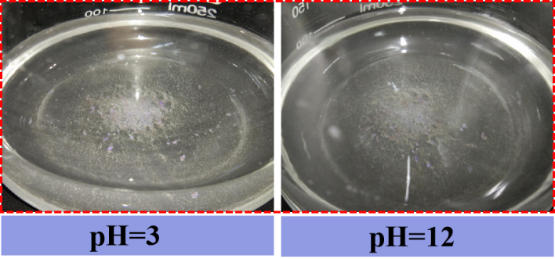

FIG. S5: Photograph of the ZIF-67/ CuBi-CO₃-LDH in the strong alkali and acid solution.

Reference
- L. Kentjono, J. Liu, W. Chang, C. Irawan: Removal of boron and iodine from optoelectronic wastewater using Mg-Al(NO₃) layered double hydroxide, Desalination, 262, 280 (2010).
- T. Madrakian, A. Afkhami, M.A. Zolfigol, M. Ahmadi, N. Koukabi: Application of modified silica coated magnetite nanoparticles for removal of iodine from water samples, Nano-Micro Lett. 4, 57(2012).
- Y.B. Xie, F.Y. Zhong, H.X. Chen, D.N.Chen, J.W. Wang, J.K. Gao, J.M. Yao: Fabrication of hydrogen-bonded metal-complex frameworks for capturing iodine, J. Solid State Chem. 277, 525(2019).
- B.Z. Zheng, X.X. Liu, J. Hua, F.Y. Wang, X. Hua, Y. Zhua, X. Lv, J. Du, D. Xiao: Construction of hydrophobic interface on natural biomaterials for higher efficient and reversible radioactive iodine adsorption in water, J.Hazard. Mater. 368, 81(2019).
- X.M. Li, G. Chen, Q. Jia: One-pot synthesis of viologen-based hypercrosslinked polymers for efficient volatile iodine capture, Micropor. Mesopor. Mat. 279, 186(2019).
- G. Li, Y. Huang, J. Lin, C. Yu, Z.Y. Liu, Y. Fang, Y.M. Xue, C.C. Tang: Effective capture and reversible storage of iodine using foam-like adsorbents consisting of porous boron nitride microfibers,Chem. Eng. J. 382, 122833(2020).
- A. Miller, Y. Wang: Al-O-F materials as novel adsorbents for gaseous radioiodine capture, J. Environ. Radioactive 133, 35(2014).

