Supplementary File: Structural and magnetic properties of FeCoMnCrSi multi-principle alloy
Rahul Jangid¹, Kenneth B. Ainslie¹, Roopali Kukreja^{1, a}
1 – Department of Materials Science and Engineering, University of California Davis, Davis, CA 95616

Energy Dispersive Spectroscopy (EDS) Measurements

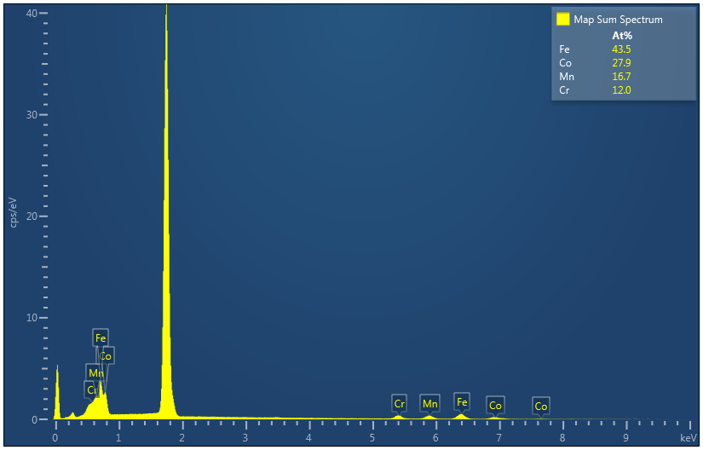
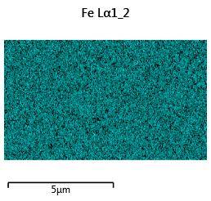
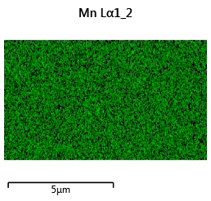
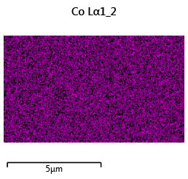
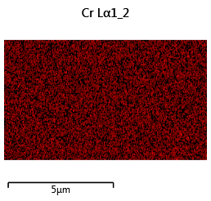
Figure S1 shows the EDS measurements for 65nm thin film. The peaks in the EDS spectra are labeled with respective element and the largest peak is from the silicon substrate. The composition is homogeneous across the sample as shown by the elemental maps for Fe, Co, Mn, and Cr.
Figure S1: EDS measurements for 65nm sample. Indexed spectra shows the elements present and the atomic percentage.

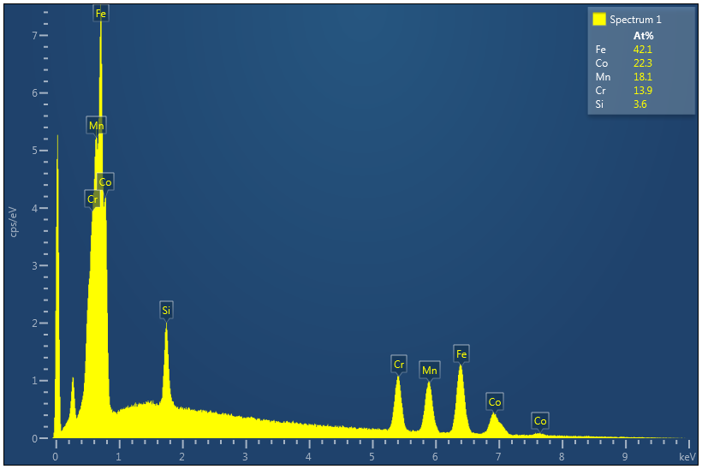
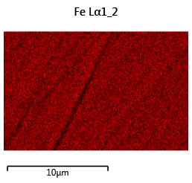
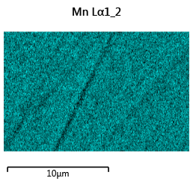
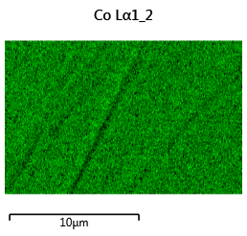
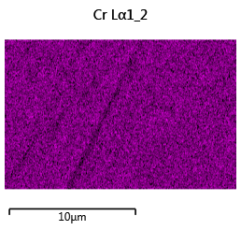
Figure S2 shows the EDS measurements for bulk sample. The peaks in the EDS spectra are labeled with respective element. The composition is homogeneous across the sample as shown by the elemental maps for Fe, Co, Mn, Cr and Si.

Figure S2: EDS measurements for bulk sample. Indexed spectra shows the elements present and the atomic percentage.

