Controlled Nanostructures and Simultaneous Passivation of Black Phosphorus (Phosphorene) with Nafion
Avneesh Kumar*§
International Center for Materials Science, JNCASR, Jakkur, Bangalore, 560064, India
§Institute of Organic Chemistry, L2-02, 554, TU Darmstadt, Alarich-Weisss-Str. 4, 64287, Darmstadt, Germany
*Email: avneesh.kumar@chemie.tu-darmstadt.de

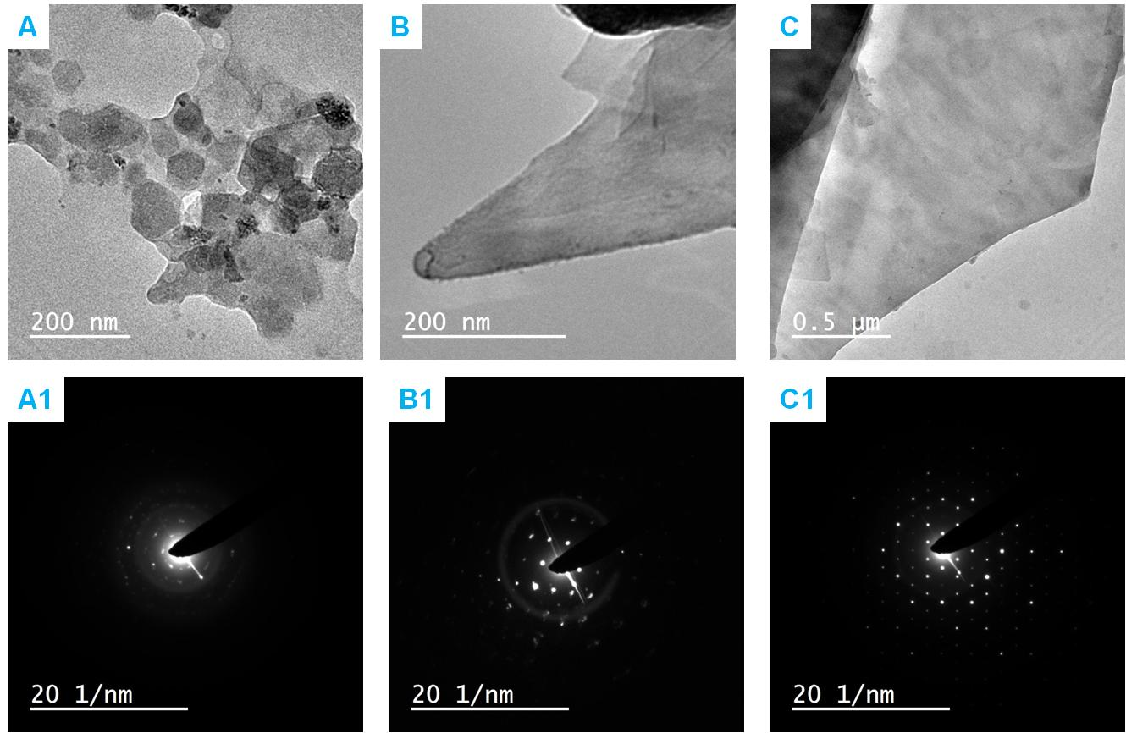
FIG. S1. TEM micrographs of A) phosphorene nanosheets embedded in polymer B) phosphorene nanoneedle C) very thin and transparent nanosheet; A1 B1 and C1 are the SAED patterns of samples A, B and C respectively.

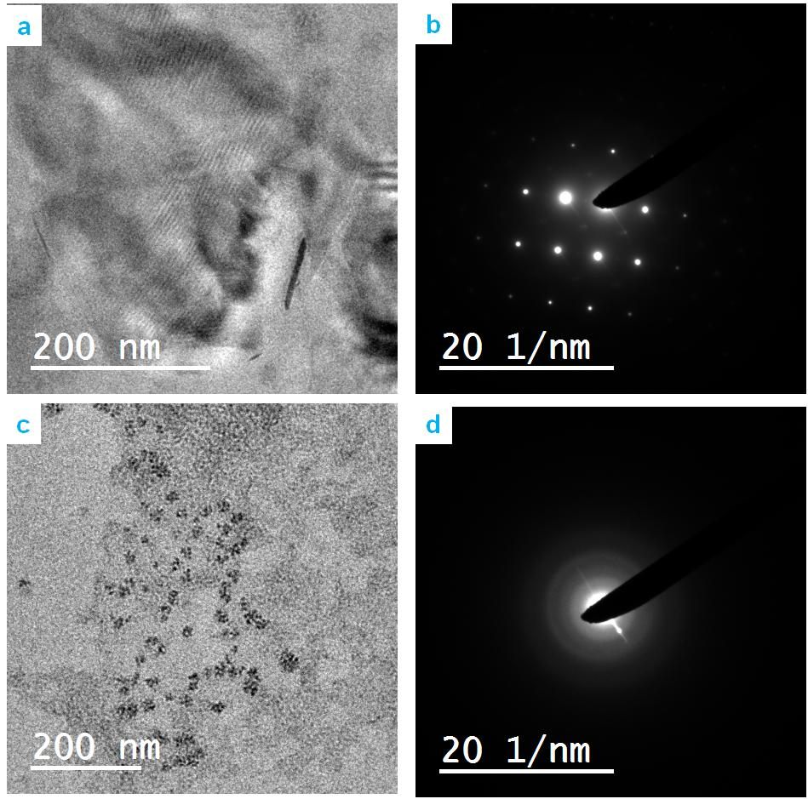
FIG. S2. a) HRTEM micrograph of phosphorene nanosheet and its corresponding b) SAED patterns; c) irregular morphology of Nafion and d) SAED patter of Nafion in which an amorphous region is associated with the diffuse rings.

