Supporting Information
Fiber-shape Electrodes Based on Graphene/Cellulose Nanofibrils by Interfacial Polyelectrolyte Complexation Spinning

Yufan Lin¹, Shengping Wen¹, Xiangfang Peng², Yuhua Cai², Lihong Geng^{2*}, Binyi Chen^{1*}

¹Department of Industrial Equipment and Control Engineering, School of Mechanical & Automotive Engineering, South China University of Technology, Guangzhou, Guangdong, 510640, China
²Department of Materials Science and Engineering, Fujian University of Technology, Fuzhou, Fujian, 350108, China

Corresponding author: Lihong Geng (glhfjut@fjut.edu.cn) and Binyi Chen (mebychen@scut.edu.cn)

Figure S1 the CV curve of (a) CNF/rGO30 fibers, (b) CNF/rGO60 fibers, (c) CNF/rGO100 fibers at different scan rates

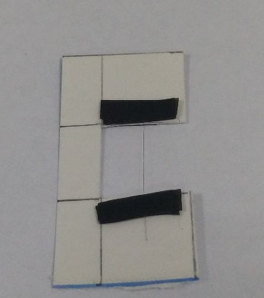
Figure S2 the mechanical test sample of fibers

